# An Energy Rating Icon can improve the energy

# efficiency of consumer choices online

**A summary of the research findings**

The legislation which compels retailers to display the energy rating label on appliances in-store applies only to physical products and not to ‘products’ displayed for sale online. Consequently, consumers are less likely to see energy rating information when purchasing or researching a potential purchase online.

Research was undertaken to understand if people exposed to energy rating information in an online environment choose more energy efficient products than those who are not; if having the information as an icon is more effective than text; at what point in the online purchase journey does it have the biggest effect on the energy efficiency of the product ultimately chosen; and whether the simplified version of the Energy Rating Label (the Energy Rating Icon) is understood.

An online survey was conducted within Australia in February 2018 with a sample size of 4,818 participants involving both a virtual online shopping experiment that mimicked the normal shortlisting and final choice purchasing stages and a questionnaire. Participants were randomly allocated equally to one of six groups.

|  |  |  |
| --- | --- | --- |
| **Sample groups** | **Consideration stage** | **Choice stage** |
| 1 (control group) | No energy rating information | No energy rating information |
| 2 | No energy rating information | Energy rating in text |
| 3 | No energy rating information | Energy Rating Icon |
| 4 | Energy rating in text | Energy rating in text |
| 5 | Energy rating in text | Energy Rating Icon |
| 6 | Energy Rating Icon | Energy Rating Icon |

**The research found that:**

1. **People who are exposed to energy rating information choose more energy efficient products**
2. **The Energy Rating Icon is more effective than text only AND especially when shown at both the shortlisting and choice stages**
3. **The simplified version of the Energy Rating Label (the Energy Rating Icon) is generally understood.**

**The first figure below summarises the key findings that people who are exposed to energy rating information choose more energy efficient products and the Energy Rating Icon is more effective than text.**

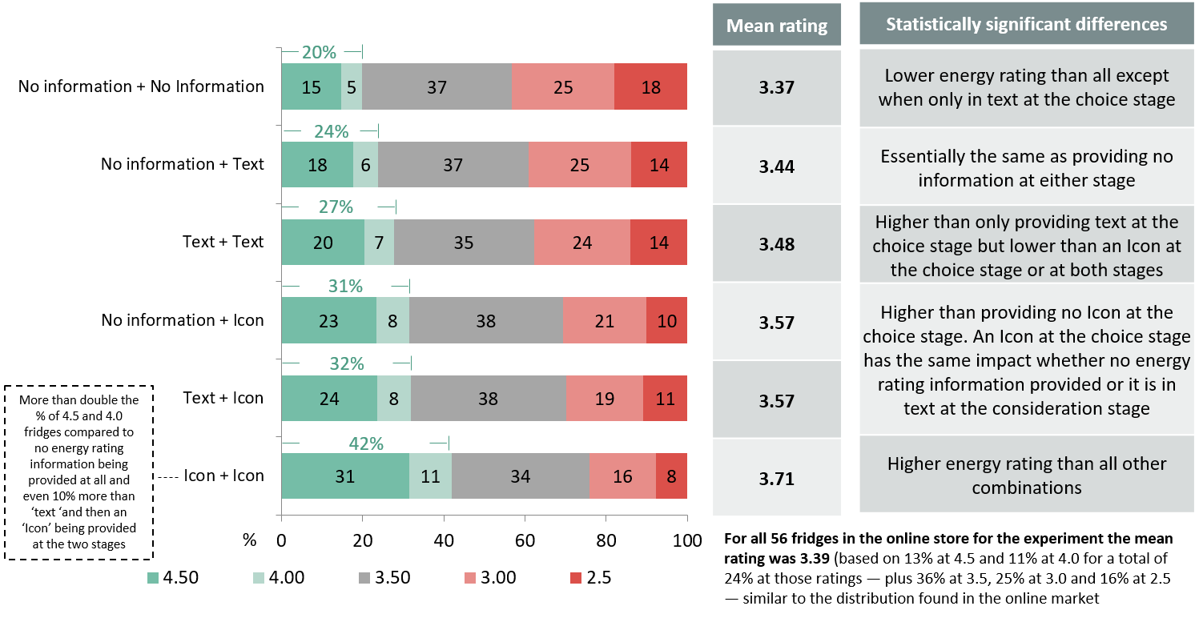

**The next figure shows findings that the simplified version of the Energy Rating Label (the Energy Rating Icon) is generally understood**

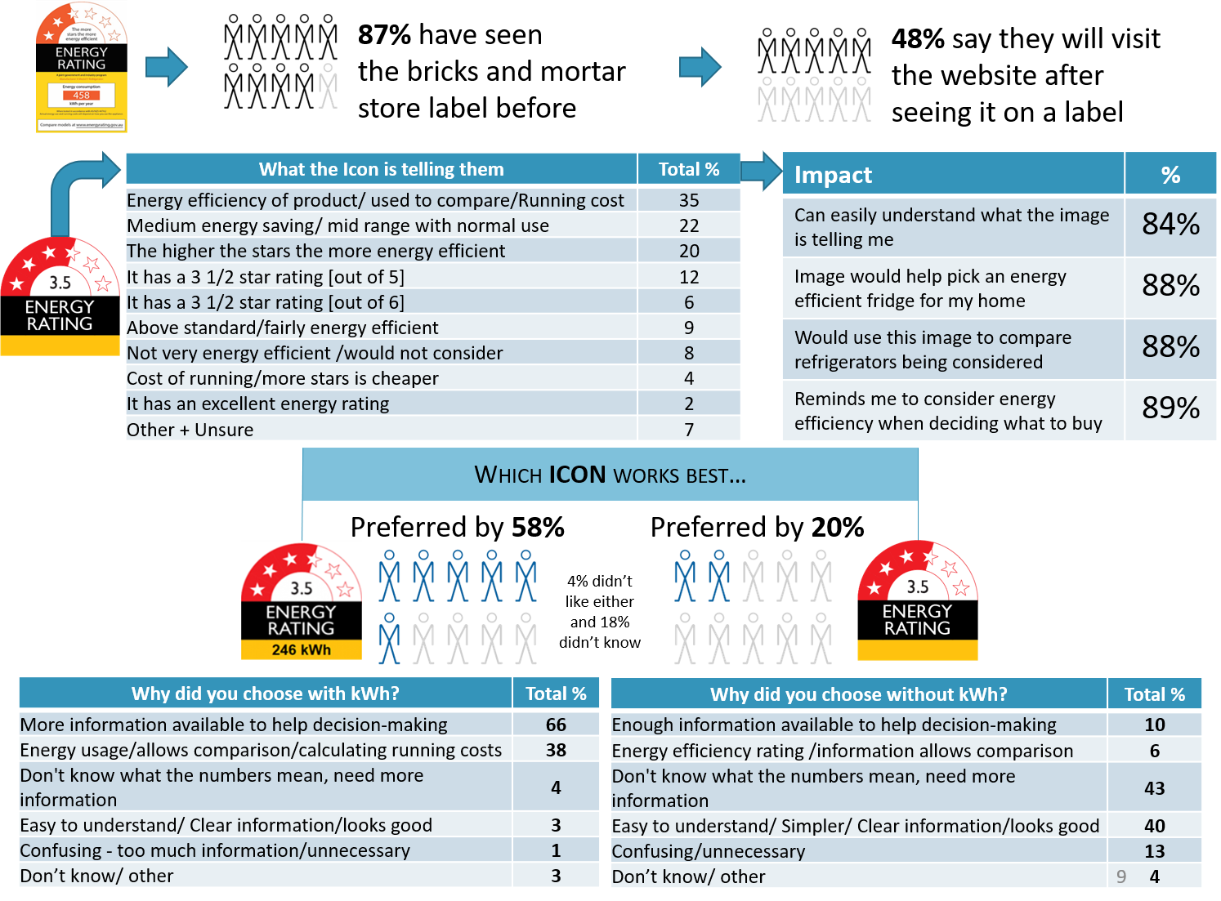

**Other research findings can be seen in the full research report.**