A consumer guide to buying quality LEDs

This guide will assist you in selecting a quality LED light bulb to meet your lighting needs.

Light-emitting diode light bulbs and lighting fixtures are known as LEDs. LEDs can have varied designs with a range of looks for many different uses. From the outside, many look like old-fashioned light bulbs and are available to replace a wide range of inefficient halogen and incandescent lighting.

Quality LEDs are now in most cases the ‘best buy’ in terms of electricity costs to run, frequency of replacement and overall lifetime costs.

LEDs are quickly gaining popularity as they become more available at lower prices, however, evaluation of LED products currently available in the marketplace indicates a wide variation in quality and efficiency. This guide provides some practical tips to purchasing a quality LED product.

Not all LEDs are the same

Unlike Compact Fluorescent Lamps (CFLs), LEDs are currently not regulated for energy efficiency – or characteristics such as colour. This means you may experience greater variation in their performance.

If you are unsatisfied with the performance of the LED product, we recommend you seek a replacement or refund from the place of purchase. If you are unsatisfied with the response, you can contact the [Australian Competition and Consumer Commission](https://www.accc.gov.au/) to understand your consumer rights and options to resolve the problem.

Quality LEDs – cheaper in the long run

Quality LED light bulbs last 5 to 10 times longer than halogen light bulbs and consume a quarter of the energy to produce the same light output.

• LED bulbs last between 15,000 to 50,000 hrs

• Halogen bulbs last between 1,000 to 4,000 hours

• CFLs last approximately 6,000 hours.

LED light bulbs can be as low as $10. Whilst more expensive upfront in comparison to halogen ($3) or CFL ($6), LED comes out on top when considering ongoing electricity and replacement costs.

The table below shows the total lifetime cost over 10 years for an 800 lumen LED bulb, compared with CFL and halogen alternatives.

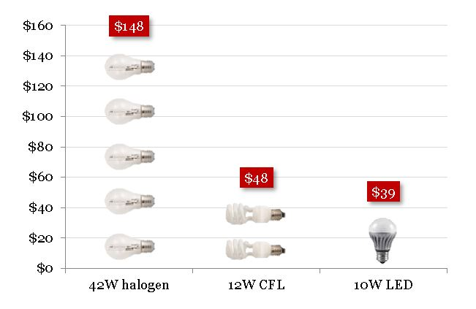

Figure 1 A 10W LED bulb would cost $39 in total to buy and run over 10 years. Over this time, five 42W halogen bulbs would need to be used at a total cost of $148, or two 12W CFL bulbs would be used, at a total cost of $48. These figures are based on lifetimes of 6000 hours for CFL and 2000 hours for halogen; an LED price of $10, CFL price of $6, and halogen price of $3. The electricity rate is 28.55¢ per kilowatt-hour (kWh).

What to look for when buying an LED bulb

Compatibility

To make sure your replacement LED fits when you get home, check what fitting you need (Bayonet or Edison screw base), size, shape and voltage. Taking your old lamp in to compare against can help.

Light output (Lumens)

The best way to identify a suitable LED lamp replacement for an existing lamp is to look for the amount of light the lamp produces (measured in lumens or lm). Package information that says that the light output was actually tested for this performance is a good sign of a quality product.

We used to purchase incandescent bulbs by the amount of power (or watts) they used. LED bulbs produce the same amount of light using far less power, meaning it no longer makes sense to shop for watts. Using ‘lumens’ is now the way to choose the light you need.

The table below shows the number of lumens (and watts) you should look for in an LED as a replacement for a range of halogen light bulbs. Lumen values are approximate and do vary between manufacturers.

| Incandescent bulb (in Watts) | Light output in lumens (220/240 Volts) (LED) |
| --- | --- |
| 25 W | 250 lm (3-4 W) |
| 40 W | 500 lm (5-8 W) |
| 60 W | 800 lm (8 -12W) |
| 75 W | 1100 lm (11-17W) |
| 100 W | 1500 lm (15-23W) |

Unfortunately the information on the LED packaging is not always accurate. Sometimes the information stated on the package is about the light source within the bulb (the electronic LED chip), not the light produced by the whole LED bulb. Light sources tested under laboratory conditions will always have a higher light output than the LED bulb used in normal conditions. If you have questions about the specification you should ask the retailer or contact the manufacturer.

Best of all, if it is possible, ask the retailer to show you one of the lamps in operation. If this is possible, do not look at how ‘bright’ the LED appears, look at how well the LED illuminates surfaces compared with other lamps on offer.

Safety rating

All bulbs must be safe to operate. At a minimum this means they have passed mandatory safety requirements and earned their safety marks. The Regulatory Compliance Mark (RCM) demonstrates that the product meets the Australian electrical safety and electro-magnetic compatibility requirements and should be visible on the package. In addition, the brand must be registered on the [Australian Government National Equipment Registration System](http://www.erac.gov.au/index.).

The safety rating mark is a traiangle with a circuled tick mark in the centre.

Marking requirements are currently in transition and suppliers have until 1 March 2018 for products to be marked with the RCM. Unregistered brands and suppliers may be supplying equipment that does not meet Australian standards and regulations.

How long it lasts

There are many factors that determine the lifetime of a LED bulb. Look for manufacturers that can back up their lifetime claims, either with testing or certification indicated on the product packaging.

For quality LED products the expected lifetime is somewhere in the range of 15,000 to 30,000 hours, however some products claim up to 50,000.

Product guarantee

Look for a warranty of at least 2 years for a product claiming a 15,000 lifetime or a minimum of 3 years or longer for lamps claiming a lifetime over 15,000 hours.

A good approximation for information on lifetime testing is the guarantee that a manufacturer is willing to provide. Any warranty offered with a product is in addition to other rights you as a consumer have under consumer law.

Bulb efficiency

Not all LED bulbs are equally efficient. Look for an energy efficiency rating in lumens per Watt (lm/W) on the bulb and compare with other products. The higher the number, the more efficient the product.

If this efficiency is not marked on the package you can simply divide the number of lumens (light output in lm) by the number of Watts. LED bulbs for most residential uses should be at least 60 lm/W, while LED luminaires intended to replace linear fluorescent lamps can achieve 85 lm/W or more.

Colour temperature

Colour Temperature is measured in Kelvin (K). LEDs can produce white light in a number of “shades” or “colour temperatures”– from warm-white (similar to regular incandescent and halogen bulbs, 2700 to 3,300 Kelvin) to neutral or cool-white (3,00-5,300 Kelvin) or cool daylight (5,300 to 6,500 Kelvin). The lower the number, the warmer the light appears.

Just like the amount or brightness of light, different rooms can suit different colour temperatures. Warm white light is considered good for relaxing, whereas cool white can be better for concentrating. If you’re replacing a light in a series of downlights or tract lighting, it’s good to know what colour the rest of the lights are, so the colour of the new light bulb visually matches with the colour of the rest.

Some LED bulbs and fittings are colour adjustable. This allows the colour – or colour temperature – to be changed to suit your needs.

Colour rendering

The Colour Rendering Index (CRI) is an indicator of how accurately colours can be distinguished under a light source. The higher the CRI value the better. Better still, if possible, purchase one LED and try it to see if it makes colours of objects appear appropriate before buying more.

Look for bulbs that have a CRI of 80 or above for normal tasks, while a CRI of 90+ is recommended for task lighting where colour is important.

Light Bulb Saver App

The Light Bulb Saver App has been created to help you choose a suitable efficient light bulb to replace inefficient incandescent and halogen bulbs, giving you guidance on whether LED and CFL replacement bulbs are available, what light output (lumens) you will need to look for ­– and also provides you with tips on lighting design for various rooms in your home.

Download the free app now on the [Apple App Store](https://itunes.apple.com/au/app/light-bulb-saver/id1095939669?mt=8) or [Google Play](https://play.google.com/store/apps/details?id=au.gov.energyrating.lampguide).