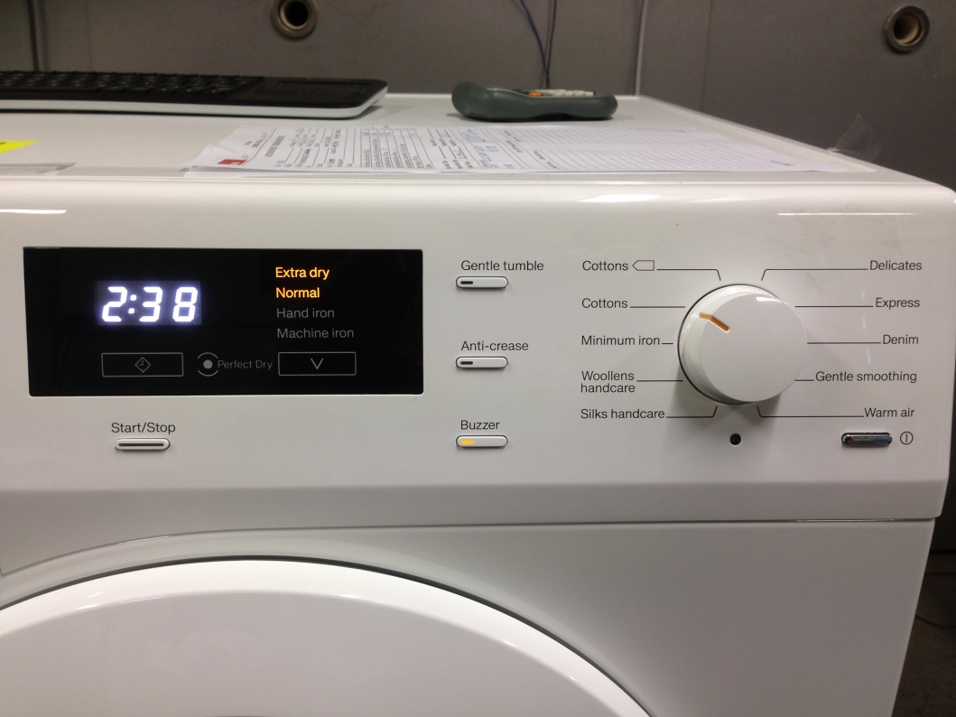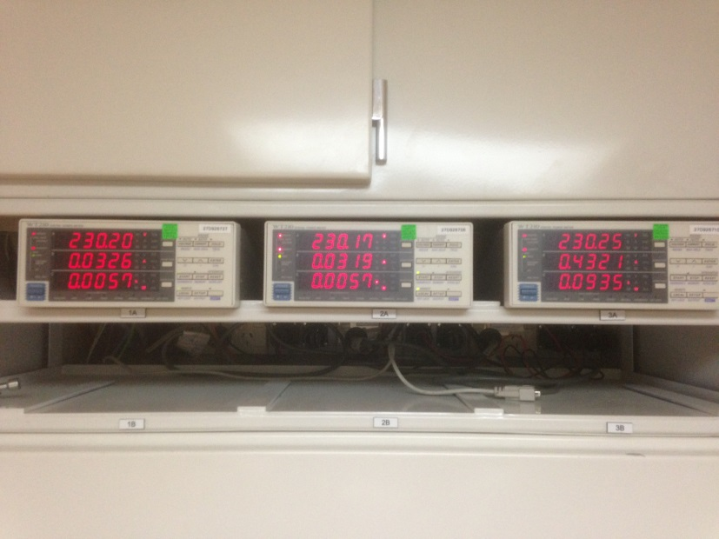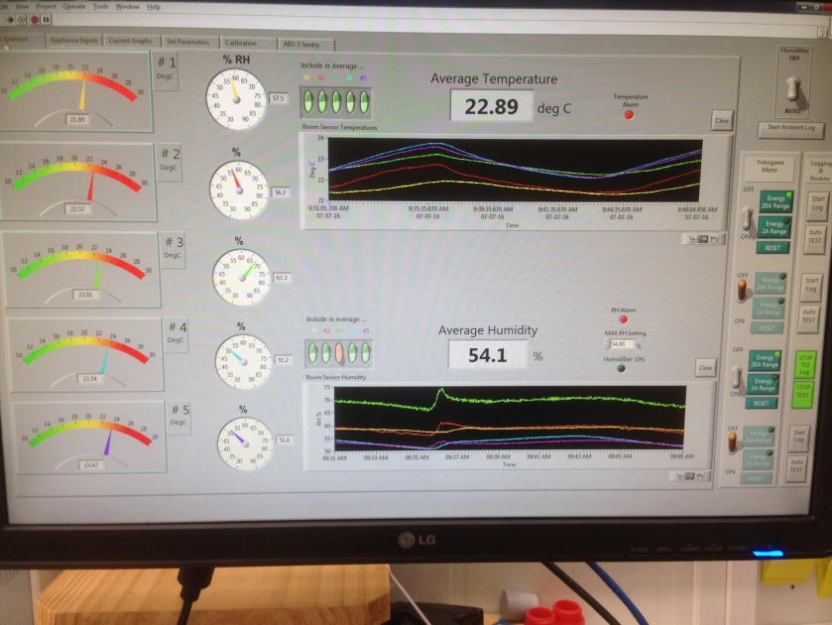Picture of a dryer test lab showing 2 dryers and various measuring equipment used in the round robin

|  |
| --- |
| AUSTRALIAN CLOTHES DRYER ROUND ROBIN TESTING TO THE IEC61121 STANDARD |
| Results of a round robin of four independent Australian test laboratories testing two clothes dryers to the IEC61121 Edition 4 standard in 2016 |
| Prepared by Energy Efficient Strategies for the Australian Government Department of the Environment and Energy and the E3 Committee |

AUSTRALIAN CLOTHES DRYER ROUND ROBIN TESTING TO THE IEC61121 STANDARD

Results of a round robin of four independent Australian test laboratories testing two clothes dryers to the IEC61121 Edition 4 standard in 2016

Report prepared for:

Department of the Environment and Energy, Australian Government

and the Equipment Energy Efficiency (E3) Committee

Energy Efficient Strategies company logo

Report Authors:

Lloyd Harrington, Energy Efficient Strategies

Robert Foster, Energy Efficient Strategies

November 2016

Disclaimer: The views, conclusions and recommendations expressed in this report are those of Energy Efficient Strategies. While reasonable efforts have been made to ensure that the contents of this publication are factually correct, Energy Efficient Strategies gives no warranty regarding its accuracy, completeness, currency or suitability for any particular purpose and to the extent permitted by law, does not accept any liability for loss or damages incurred as a result of reliance placed upon the content of this publication. This publication is provided on the basis that all persons accessing it undertake responsibility for assessing the relevance and accuracy of its content.

Contents

Introduction 6

Background 6

Test Results 7

Regulatory Context 7

Clothes Dryers Tested in the Round Robin 8

Participating Test Laboratories 8

Testing Specification and Test Method 9

Differences between IEC and AS/NZS 9

Variations to IEC61121 Edition 4 13

Testing Specification for the Round Robin 14

Overview of the Results 15

Laboratory naming convention for this report 15

Overall energy results 15

Analysis by final moisture content 17

In depth analysis and correction of data 17

Laboratory comparison with corrected data 27

Examination of load mass during the round robin 31

Changes in the mass of load items during the aging process 31

Variations in bone by mass by laboratory 32

Bone dry mass versus conditioned mass 33

Bone dry preparation of load items 34

Observations regarding test laboratories 36

Feedback to IEC 37

Ambient air temperature 37

Ambient humidity 38

Overall energy correction 38

Half load 39

Soft water definition 40

Guidance on placement of ambient sensors 40

Guidance on loading 40

Instrument uncertainty 41

Allowable variations in parameters 41

Dryer specification for preparing bone dry mass 42

Clause 8.2.2 and requirements of Table 6 42

Data recording 43

Test series 43

Average age of load items 43

Conclusions 44

Appendix A: Clothes Dryer Round Robin Testing Specification: IEC61121 Edition 4 46

Test standards 46

Test to be undertaken 46

Test specification 47

Test report format and data to be reported 51

Appendix B: Laboratory Power Profiles 53

**Index of Tables**

Table 1: Summary of differences between IEC61121 (Ed 4) and AS/NZS2442.1 10

Table 2: Comparison of bone dry moisture content and RMC moisture content systems 11

Table 3: Uncorrected raw test results averaged by laboratory, test machine and load 16

Table 4: Summary of key efficiency parameters for tested dryers 21

Table 5: Estimated energy correction values for a range of initial and final moisture contents 25

Table 6: Round robin data comparing raw values with corrected values 27

Table 7: Comparison of Bone Dry Masses by Laboratory 33

Table 8: Ratio of conditioned Mass to Bone Dry Mass by Laboratory 34

Table 9: Calculated bone dry factor for various inlet air temperatures 36

Table 10: Comparison of headline results for a new, average and old load in the Miele dryer 44

**Index of Figures**

Figure 1: All valid runs showing final moisture content versus energy consumption 17

Figure 2: Plot of RMC and energy for the Miele dryer with an 8kg load 19

Figure 3: Efficiency of operation through the drying cycle as a function of moisture in the load 20

Figure 4: Efficiency of the dryers as a function of RMC of the load 21

Figure 5: Generalised model of relative dryer efficiency as a function of RMC 22

Figure 6: Dryer energy efficiency curves showing proposed generalised model 22

Figure 7: Generalised dryer curves based on generic efficiency profiles 23

Figure 8: Model estimates of relative dryer efficiency for different initial and final moisture content values 24

Figure 9: Raw data for all labs and runs showing proposed correction curve 26

Figure 10: Comparison of IEC and proposed energy correction for various final RMC values 29

Figure 11: Comparison of IEC and proposed energy correction for a wider range of initial RMC values 30

Figure 12: Loss in Bone Dry Mass by Number of Runs (Sheets, Pillowcases and Towels) 32

Figure 13: Power profile Miele full and half load - Lab A 53

Figure 14: Power profile Electrolux full and half load - Lab A 53

Figure 15: Power profile Miele full and half load - Lab B 54

Figure 16: Power profile Electrolux full and half load - Lab B 54

Figure 17: Power profile Miele full and half load - Lab C 55

Figure 18: Power profile Electrolux full and half load - Lab C 55

Figure 19: Power profile Miele full and half load - Lab D 56

Figure 20: Power profile Electrolux full and half load - Lab D 56

# Introduction

## Background

It is proposed that, where appropriate, Australia and New Zealand will harmonise their test standards for whitegoods appliances with international standards. Presently, suppliers are required to demonstrate that their clothes dryers comply with the *Greenhouse and Energy Minimum Standards (Rotary Clothes Dryers) Determination 2015* legislative instrument (and the relevant New Zealand regulation) through test procedures specified by AS/NZS 2442.1.[1] To build capacity in Australian test facilities, a round robin testing of the International Electrotechnical Commission (IEC) 61121 *Tumble dryers for household use - Methods for measuring the performance* (Edition 4) standard was undertaken in 2016. The round robin also aimed to provide confidence in any potential future compliance and enforcement activities following harmonisation with international standards.

This report summarises the data and results from the Australian round robin of clothes dryers tested to IEC61121 Edition 4 published by the IEC in October 2012. The round robin was initiated and funded by the Department of Industry, Innovation and Science (now the Department of the Environment and Energy) and the Equipment Energy Efficiency (E3) Committee, with four independent, NATA accredited test laboratories participating. One dryer was kindly provided on loan by Miele Australia (heat pump) while the other dryer, a conventional electric resistance unit with autosensing, was purchased from Electrolux Home Appliances.

The round robin was fully funded by E3 and was contracted through the Department of the Environment and Energy. Energy Efficient Strategies was engaged as the project manager.

The round robin had many goals including to:

* Provide experience for those facilities charged with undertaking verification testing to Australian and New Zealand laws to gain practical testing experience with the relevant IEC test procedure for clothes dryers, which is the proposed testing basis for energy labelling in the future;
* Build testing capacity within local test laboratories;
* Assess the reproducibility and repeatability of the IEC test method and provide expert opinions as to its technical suitability as a basis for future regulation in Australia and New Zealand;
* Generate data and conduct analysis in order to provide technical feedback to the IEC with respect to any specific weaknesses or issues in the IEC test method prior to its adoption in Australia and New Zealand; and
* Give stakeholders confidence that the new test procedure gives sound results suitable for regulatory enforcement.

The Australian and New Zealand governments have long standing policies of adopting IEC and ISO test methods wherever possible. Australia and New Zealand energy efficiency agencies are likely to propose adopting the new IEC test method for energy consumption and performance of household clothes dryers (IEC61121) in the future.

In order to “road test” the IEC standard, the round robin used the published version of IEC61121 Edition 4 as the basis for testing, with only minor modifications (mostly relating to the specification of local values for voltage, frequency and water hardness relevant to Australian and New Zealand conditions). The participating test laboratories were able to examine the IEC test procedure very closely and highlighted any practical issues surrounding testing for the international committee. These issues have been compiled in this report and are to be submitted to the IEC SC59D committee (Performance of household and similar electrical laundry appliances) for consideration.

## Test Results

The round robin yielded substantial information regarding the IEC test method. The data collected also allowed some limited benchmarking back to the Australian and New Zealand test method currently used for local regulation.

The results were encouraging in the context of the possible policy goal of using the IEC test method for regulatory purposes in the future. The overall spread of energy results across test laboratories was 3% at full load and 3.5% at half load (following application of specially developed correction factors), which is in line with expectations for this type of appliance. However, investigation in this report found the current IEC correction factor is likely to be flawed. A later section in this report contains recommendations concerning this and other identified issues that the IEC is encouraged to consider.

The round robin results provide confidence to regulators and industry stakeholders that the IEC test method provides a sound basis for re-regulation of household clothes dryers and generated a good detail of data that can be used to commence the transition process to adopt IEC61121 for dryers in our region.

## Regulatory Context

IEC committee SC59D (household laundry appliances) published IEC61121 Edition 4 on 16 February 2012. Edition 4 included a number of minor improvements over Edition 3 (2002), including a more logical structure and closer links to the clothes washer standard IEC60456 (Edition 5). This dryer standard has now been adopted in Europe (with some significant modifications).

Australia and New Zealand have used AS/NZS2442.1 (and its predecessor) as the test method for clothes dryers ever since energy labelling commenced (in 1989 for Australia). When AS2442 was first published in 1981, an IEC standard for dryer performance did not exist, so Standards Australia used an approach based on the US test method at the time, AHAM A197.6. AS/NZS2442.1:1996 was modified to change the initial moisture content from 100% of bone dry mass to 90% of bone dry mass in order to reflect improvements in spin performance of clothes washers over time. Clothes dryer star ratings were re-graded in 2000 along with all other labelled appliances. A new label design was also introduced in 2000. No changes to the labelling requirements for dryers have occurred since 2000.

Australia and New Zealand have long held policies to adopt international test methods where this is feasible and practical. Given that clothes dryer energy testing is likely to move to the IEC test method in the medium term, a round robin provided a good opportunity to closely examine the IEC test method and to identify any issues in its adoption for use in energy labelling. Australian and New Zealand government agencies funded this round robin using IEC61121 as the test method.

## Clothes Dryers Tested in the Round Robin

Two models of clothes dryer were chosen to be included in the round robin. The products were selected with industry support as they were known to be reliable in their operation. Both models were said by their manufacturers to have stable operating characteristics. The models were:

* Electrolux model EDV6051 (6kg rated capacity, vented, autosensing control, resistive heating element);
* Miele model TKB350WB (8kg rated capacity, condensing, autosensing control, heat pump heating system).

The test units were supplied from available stock by the relevant manufacturers. The Electrolux model was broadly representative of the vented-autosensing market, which currently accounts for about 60% of the current dryer market in Australia. The Miele unit is representative of the relatively small heat pump market for dryers. This market segment is growing rapidly.

The Electrolux unit uses standard exhaust air temperature sensors to determine a shut off point for the program. The Miele unit uses a mixture of technologies which include exhaust temperature monitoring as well as conductivity of the remaining load (as the water mass decreases through the program the load itself becomes less conductive – the conductivity is measured through plates on the wall of the dryer). The behaviour of the Miele unit, in terms of termination moisture content, was to some extent expected to be affected by water quality variations across laboratories.

The Department of the Environment and Energy purchased the Electrolux unit while the Miele unit was kindly loaned by Miele Australia for the round robin. The cooperation and support offered by Miele for the round robin is gratefully acknowledged.

## Participating Test Laboratories

The laboratories which participated in the round robin included:

* VIPAC, Melbourne;
* SGS, Melbourne;
* Australian Gas Association, Melbourne;
* Choice (Test Research), Sydney.

All of the test laboratories that participated in the round robin have considerable experience in testing to AS/NZS2442.1 and all were equipped to deal with the requirements of that specific standard. The four independent test laboratories were all accredited to test in accordance with AS/NZS2442.1 by the National Association of Testing Authorities (NATA). In general terms, the technical requirements within IEC61121 are generally similar to AS/NZS2442.1, so laboratories generally had no problems meeting the requirements of the test specification and the IEC standard. If the IEC becomes the mandated test method in Australasia, the local test laboratories should have no difficulty in configuring their labs and equipment to fully comply with the requirements.

The test labs were able to access expert advice from EES when conducting their respective testing. This allowed issues to be handled consistently across facilities and provided a transparent process during the round robin. All testing requirements were set out in a detailed specification.

All of the participating test laboratories were paid a fee to undertake the necessary tests and to participate in a workshop where they could share their experience of testing to the IEC standard with other laboratories. Participating test laboratories generally found the IEC standard to be usable and generally consistent and clear. Participating laboratories were asked to provide written feedback on their experiences with the IEC test method. In particular, they were asked to identify any text in the IEC standard that was incorrect, unclear or ambiguous. Suggestions and changes have been compiled and these are included in a separate section later in this report. This will be submitted to IEC SC59D for further consideration.

# Testing Specification and Test Method

## Differences between IEC and AS/NZS

In terms of the physical testing requirements, the differences between IEC and AS/NZS are relatively minor. Essentially a dryer is operated in a room with controlled conditions with a specified load with a defined initial mass of moisture and dried until it reaches the termination of the program. There are of course many small details that differ between IEC and AS/NZS so the results for each test method are not directly comparable. However, many of these differences are somewhat arbitrary and the absolute values selected are not terribly important. What is critical is that the test method provides sufficient and accurate data to provide insight into how consumers may use their appliances in the home. The method also needs to be robust and accurate to provide regulators with a sound basis for the local mandatory energy labelling scheme.

There are a significant number of differences between the existing AS/NZS method and the IEC test method for clothes dryers. Some of these are listed below. Most of these are not expected to have a substantive impact on the measured energy consumption. Those differences that are expected to have a significant impact are highlighted in yellow below.

Table : Summary of differences between IEC61121 (Ed 4) and AS/NZS2442.1

| IEC clause | Parameter | IEC requirement | AS/NZS requirement | Energy impact | Notes |
| --- | --- | --- | --- | --- | --- |
| 4 | Capacity | Rated + other | Rated | None | Part load testing is important and there will be substantial energy differences under these conditions – see discussion |
| 5.2.1 | Voltage | Rated ± 2% | 230 V± 2V | None | Local requirements need to be specified, AS/NZS still allows 240V only machines at 240V, may be removed |
| 5.2.1 | Frequency | Rated ± 1% | 50 Hz ± 1% | None |  |
| 5.2.2.2 | Water temp | 15°C ± 2K | 20°C ± 2K | Small | <0.5% energy impact (calculated) |
| 5.2.2.3 | Water press | 240 kPa ± 50 | 320 kPa ± 20 | None | Only washer-dryers use water for drying |
| 5.2.2.4 | Hardness | Soft or hard | Not specified | V small | Likely to only impact conductivity dryers |
| 5.2.3.1 | Air temp | 23°C ± 2K | 20°C ± 2K | V small | Test condition. See note 1. |
| 5.2.3.1 | Humidity | 55% ± 5% | 60% ± 5% | V small | Test condition |
| 5.2.3.2 | Air temp | 20°C ± 2K | Not specified | None | Conditioning clothes. See note 2 |
| 5.2.3.2 | Humidity | 65% ± 5% | Not specified | None | Conditioning clothes |
| 5.3.2 | Test load | 3 items | Mixed load | Small | IEC = sheet, pillow case and towel |
| 5.3.3 | Detergent | IEC A* | IEC B | V small |  |
| 6.5.3.2 | Age of load | 30 – 50 cycles | Not specified | Not clear |  |
| 6.5.7 | Moisture | RMC | Bone dry | None | Different approach to defining load |
| 6.5.7 | Initial mass | 70%/60% RMC | 90% BD | Significant | Can calculate impact – see note 3 |
| 8.2.2 | Final mass | 0% RMC | 6% BD | Same/none | IEC series < +1.5% RMC |
| 8.2.6 | Test series | 5 runs | Not specified | Small | Large lab cost |
| 9.3 | Correction | Linear | Final slope | Significant | See note 4 |
| 8.2.4 | Termination | End of program | Start cool down | Small | Main impact is time, small energy diff |

Note 1: AS2442 originally had an ambient air temperature of 23°C. This was amended in 1999 to be 20°C to more closely align with IEC at the time and to align all wet products to a common ambient temperature. IEC61121 Edition 3 (2002) was amended in 2005 to change the ambient temperature to 23°C. All IEC wet product standards now specify and ambient of 23°C (these were all 20°C until the late 2000s). This small change in ambient temperature and associated humidity is unlikely to have any appreciable energy impact when dryers are tested.

Note 2: AS/NZS mandates the bone dry method for determining the correct mass of dry clothes. IEC61121 permits the bone dry method and also “conditioning” in a known ambient environment. These have been found to be equivalent.

Note 3: Changing the initial moisture content will have a significant impact on overall energy consumption. But the expected impact can be accurately estimated from the energy data. The preferred method in IEC61121 is specified in Annex F, in which two (or more) different initial moisture contents are tested in order to allow the calculation of the energy impact of changes in initial moisture content (e.g. resulting from different spin performance of different washing machines). The 60%/70% residual moisture content (RMC) values in Table 5 of IEC61121 are only recommended where a single initial moisture content in a single market is required.

Note 4: IEC61121 specifies a correction or adjustment of energy consumption and program time to calculate the value at the target initial moisture content of 60% RMC (or the nominal values used) and a final moisture content of 0% RMC. The correction is an overall linear correction does not take into account the typical drying performance curve – this is discussed in more detail later in the report. Also IEC and EN correct energy for autosensing dryers, while AS/NZS has not in the past. This is more of a regulatory application issue as it is an issue related to how post testing data is processed.

Some discussion in each of the key parameters is provided below.

**Initial Moisture Content**: IEC (and also EN) specify a much lower initial moisture content for the load at 60% RMC for Condition B, which is used for energy labelling in Europe. This is equivalent to 69.6% bone dry mass as shown in Table 2. Bone dry and RMC are just different ways of specifying the same parameter.

Table : Comparison of bone dry moisture content and RMC moisture content systems

| Bone Dry Mass % | RMC % | Comment |
| --- | --- | --- |
| 0% | -5.7% | Bone dry |
| 1% | -4.7% |  |
| 2% | -3.8% |  |
| 2.8% | -3.0% | IEC lower limit valid test run |
| 3% | -2.8% |  |
| 4% | -1.9% |  |
| 5% | -0.9% |  |
| 6% | 0.0% | AS/NZS and IEC target final |
| 6.5% | 0.5% |  |
| 7% | 0.9% |  |
| 7.1% | 1.0% | IEC upper limit valid series |
| 8% | 1.9% |  |
| 9% | 2.8% |  |
| 9.2% | 3.0% | IEC upper limit valid test run |
| 10% | 3.8% |  |
| 60% | 50.9% | AU market average new clothes washer |
| 69.6% | 60.0% | IEC initial cotton “B” (round robin) |
| 80% | 69.8% |  |
| 80.2% | 70.0% | IEC initial cotton “A” (not used) |
| 90% | 79.2% | AS/NZS2442.1:1996 initial moisture |
| 100% | 88.7% | AS2442:1981 initial moisture |
| 110% | 98.1% | AS/NZS2040.1 spin limit |

Notes: Assumes ratio of conditioned mass to bone dry mass of 1.060. All limits are for dry cotton.

Recent market analysis has shown that new clothes washers achieve a sales weighted spin performance of around 60% bone dry mass in 2014 (based on the water extraction index in AS/NZS2040.1 – see Whitegoods Efficiency Trends 2016[2]), which is equivalent to RMC 50.2%. This is 10% dryer than the initial moisture content in IEC61121 Cotton B. However, the stock spin performance of all clothes washers is likely to be close to the IEC61121 Cotton B initial moisture content. The change to the IEC initial moisture content will be quite significant, but this impact can be estimated with some accuracy.

**Final Moisture Content**: The IEC target moisture content at the end of drying is 0% RMC and this is the same as the requirement of 6% bone dry mass, so there should be no energy impact. This is regarded as a reasonable definition of “dry clothes” by most regions.

**Water temperature to wet the load**: While this would appear to be a significant difference, the energy impact is likely to be small. For an 8kg dryer, the water temperature difference of 5K for a total mass of moisture of 5kg in the wet load represents and energy difference of about 30Wh in terms of the thermal mass of the load. At a COP of about 1 for a resistive element, this represents about 0.5% of the total dryer energy, so can be considered negligible.

**Ambient air conditions**: There are some small differences between IEC and AS/NZS but the energy impacts will be small. Internal dryer temperatures are generally over 100°C so a few degrees or % difference in initial temperature and relative humidity will have only a very small impact on performance.

**Linear correction**: IEC undertake a linear correction between the initial and final moisture content. This is discussed in more detail in a later section.

**Load composition**: AS/NZS has a mixed cotton load while IEC has a simplified load of sheets, pillowcases and towels. As all items are cotton, the performance impact from the change in load composition is likely to be measurable but small. To some extent, any specified load is somewhat arbitrary, and if the performance differences are small, then consistency of supply is a more important consideration.

**Average load age**: AS/NZS does not specify average age requirements for load items, but an age limit is defined for individual items. IEC require that the mass-weighted average age of all items remain between 30 and 50 runs during each test run. The impact of age on dryer performance was not specifically investigated in the round robin, so the impact of meeting age requirements (or not) has not been quantified at this stage. Meeting this requirement is a significant administrative and management burden for test labs.

**Loading**: Currently AS/NZS only specifies loading at rated capacity for dryers. This is the only value used for energy labelling at this stage. IEC specifies load at rated capacity and also allows any other rating to be used (defined in 0.5kg increments). European labelling specifies tests at rated capacity and 50% rated capacity, which are then combined into a weighted average. This has necessitated a European variation to the IEC standard to define loads that are 50% rated for rated capacities that are at 0.5 kg increments. The EN standard splits the load into two halves, which may not be equal, and tests each part load two times. For example, a rated capacity of 7.5kg has a 50% load of 3.75kg and this capacity is not defined in the IEC standard. For the round robin, dryers were selected that were rated at a whole number of kg so this issue was avoided. However, if part load testing is to be adopted when adapting the IEC standard for use in energy labelling in Australia and New Zealand, this issue will need to be resolved. Recent analysis by Sustainability Victoria showed that average loads actually placed in dryers by users were very small – less than 2kg on average. This suggests that even 50% of rated capacity may be too large to reflect typical household use. However, that is an energy labelling issue rather than a test method issue as it is about how the test method is applied in the most relevant manner in the local and regional context.

**Termination of testing**: AS/NZS2442.1 requires that testing be terminated at the start of the cool down. In old style products, this is usually a fairly straight forward process for the laboratory to determine. However, for more complex products with electronic controls, which are now very common, the power may be gradually adjusted towards the end of the program and the heating function may start to cycle, so identification of formal cool-down period can be quite uncertain. This also creates a problem where the test time does not include the cool-down period and so does not match the total program time. IEC61121 operates the appliance until the program is terminated by the appliance itself. This is a more pragmatic and simpler requirement for the test laboratory. Detailed analysis shows that there is usually little energy consumed during cool-down and the final moisture content of the load also changes little during this part of the cycle. It also means that the program time can also be accurately assessed during the lab test. Inclusion of the cool-down period is generally considered to be a better representation of normal use.

**Test room and instrumentation**: There are no significantly more stringent requirements in the IEC standard with respect to test room conditions or instrumentation. The most important parameters are energy measurement and mass measurement. The IEC standard specifies only accuracy rather than uncertainty of measurement. No resolution is specified for energy measurements (but a class 1 meter in IEC 62053-21 is specified). Metering requirements for standby power (left on mode and off mode) are referenced to IEC62301 (noting that AS/NZS does not specify standby for dryers at this stage, but IEC requirements are compatible with AS/NZS washer and dishwasher standards, which can be met by all local laboratories).

**Test series**: AS/NZS defines a single test on a single unit. Multiple tests on the same unit and/or on different samples can be specified as required. IEC require a minimum of 5 runs in a test series in order to obtain a valid result for a dryer. If there is little variability then the results of each approach will be comparable. This IEC requirement is considered quite onerous in terms of test burden for laboratories. This issue is discussed in more detail later in this report.

## Variations to IEC61121 Edition 4

The round robin used the IEC61121 Edition 4 as the test method. Participating test laboratories examined the IEC test procedure closely and highlighted any practical issues in relation to their understanding of the methodology or equipment specification and use. The following items are noted as variations or specified options with respect to the Australian clothes dryer round robin:

* Each unit was tested at rated capacity and 50% rated capacity (to mirror EU requirements) but this did not require any deviation from IEC61121 as the rated capacity of each unit was a whole number of kg.
* Electricity supply was fixed at 230V and 50Hz irrespective of the rated values of the test machines (the rated voltage of each machine included these values)
* IEC61121 soft water option in Clause 5.2.2.4 was selected for all labs. Some labs had to harden the water slightly and this was not done in strict accordance with IEC60734 even though one of the dryers was known to use conductivity for termination control (this appeared to have some impact on the final moisture content, but this did not detract from the veracity of the results).
* Most laboratories were not able to measure and report alkalinity or conductivity as specified in the standard (this is a reporting requirement only) as this is not a standard requirement for other appliances and test methods.
* All laboratories elected to use the bone dry method for load preparation, but some comparison with the conditioned mass approach was also undertaken. This issue was of low importance as dedicated full and half loads were pre-prepared for each dryer and these were shipped with the dryers between laboratories, thus eliminating most load related issues.
* Initial moisture content option of Cotton B (60% RMC) was selected.
* Between 2 and 5 test runs were conducted in each lab for each test machine and each load size, so the requirement for a test series of 5 runs was not met. However, load age and conditioning after 10 to 12 runs was undertaken as per the standard.
* Only raw data was provided by lab laboratories – no post-test corrections specified in the IEC were applied. A range of post-test corrections have been included in this report.
* The target validity range was modified for the tests to be +1.5% RMC and -3% RMC. However, after initial investigation, all labs were asked to use the same program settings for rated and half load for consistency. There was little fine control on the dryers to adjust the final moisture content up or down once the program had been selected. Most runs complied with these target requirements but the Electrolux unit at half load consistently returned results just below the target of -3% RMC. This has little impact on the overall results.

## Testing Specification for the Round Robin

A testing specification document clarifying the IEC test was provided to the test labs prior to the start of testing. In addition, briefings and witnessing of tests were conducted for each lab to walk test personnel through the testing process and answer any staff questions. During or after the actual tests, the testing witness visited all facilities to document lab instrumentation, procedures and to answer any further questions generated by the testing. The key elements included were:

* Products to be tested
* Test specification and any deviations
* Detailed description of the minimum number of test runs required
* Supply and ambient conditions for testing
* Install the draining option for the Miele condensing dryer and measurement of drained water for each test run
* Detailed guidance and instructions on load preparation
* Detailed description of the program to select on each test machine
* Provision of data recording sheets
* Laboratories to provide raw data for independent analysis (generally 5 sec intervals)
* Condensation efficiency and evenness of drying measurements were not required.

New loads were purchased from WfK in Germany. The reference test laboratory subjected the load items to initial normalisations runs as per the standard and then parts of the load were washed and dried as if they were undergoing tests so that eventually there was a spread of ages for all load items. At the start of the round robin, dedicated loads for each dryer and capacity were made up and these were circulated with the dryers and tested by all laboratories. The dedicated loads started with a weighted average age of just over 30 runs and the loads stayed within the required age range of 30 to 50 runs throughout the round robin without the need to add or remove any items.

The laboratories were given common testing specification advice and all the parties were encouraged to share views and experiences so that the round robin testing represented a fair assessment of the IEC methodology. A copy of the testing specification is included as **Appendix A** of this report.

# Overview of the Results

## Laboratory naming convention for this report

A total of four independent, accredited Australian laboratories participated in this round robin. While there were few anomalies in the results and all labs showed equivalent results, the identity of each laboratory in this report has been concealed. Laboratories are identified as A, B, C and D. Laboratories have been informed of their individual identifiers. Trial runs that used different program settings or that may not have been compliant in some other way can still provide useful data and these have been retained in the results data set but have been marked with the identifier “T”. These trial results are from several laboratories.

## Overall energy results

A total of 56 test runs were undertaken on the 2 test machines used in the round robin. The overall energy results are given for each test machine, load capacity and laboratory in Table 3. It should be noted that these are uncorrected values for initial comparison only. In the left hand column of the table below the various machine/load combinations are identified as follows:

* M8 = Miele machine with a full load (8 kg)
* M4 = Miele machine with a half load (4 kg)
* E6 = Electrolux machine with a full load (6 kg)
* E3 = Electrolux machine with a half load (3 kg)

Following each machine/load identifier in the left hand column is the laboratory identifier (A, B, C or D).

Table : Uncorrected raw test results averaged by laboratory, test machine and load

| Unit/Lab | Final RMC | Energy kWh | Time min | Final RMC diff | Energy diff mean | Time  diff mean |
| --- | --- | --- | --- | --- | --- | --- |
| M8A | -1.6% | 2.542 | 192.5 | -0.6% | -1.0% | 1.7% |
| M8B | -1.7% | 2.675 | 192.3 | -0.7% | 4.1% | 1.6% |
| M8C | -1.0% | 2.713 | 198.6 | 0.0% | 5.6% | 4.9% |
| M8D | 0.4% | 2.345 | 173.6 | 1.4% | -8.7% | -8.3% |
| **M8 mean** | **-1.0%** | **2.569** | **189.2** |  |  |  |
| M4A | -2.2% | 1.466 | 115.0 | 0.4% | -3.0% | -1.8% |
| M4B | -3.6% | 1.510 | 114.0 | -1.0% | -0.1% | -2.7% |
| M4C | -2.4% | 1.532 | 119.8 | 0.2% | 1.4% | 2.3% |
| M4D | -2.2% | 1.538 | 119.6 | 0.4% | 1.8% | 2.2% |
| **M4 mean** | **-2.6%** | **1.511** | **117.1** |  |  |  |
| E6A | -2.1% | 4.036 | 134.5 | -0.2% | -2.0% | -1.3% |
| E6B | -2.7% | 4.246 | 139.7 | -0.8% | 3.1% | 2.4% |
| E6C | -1.6% | 4.071 | 135.3 | 0.3% | -1.1% | -0.7% |
| E6D | -1.3% | 4.118 | 135.8 | 0.6% | 0.0% | -0.4% |
| **E6 mean** | **-1.9%** | **4.118** | **136.3** |  |  |  |
| E3A | -3.9% | 2.244 | 79.5 | -0.3% | -1.2% | -1.2% |
| E3B | -3.3% | 2.316 | 81.8 | 0.4% | 2.0% | 1.7% |
| E3C | -3.6% | 2.238 | 79.9 | 0.1% | -1.4% | -0.7% |
| E3D | -3.8% | 2.283 | 80.6 | -0.2% | 0.6% | 0.2% |
| **E3 mean** | **-3.6%** | **2.270** | **80.4** |  |  |  |

Note: M8 is Miele test machine with 8kg load, M4 is Miele test machine with 4kg load, E6 is Electrolux test machine with 6kg load, E3 is Electrolux test machine with 3kg load, A/B/C/D are lab identifiers and represent average of all valid runs.

Generally, all laboratories gave consistent results in terms of energy and time and in most cases, laboratory results were within 3% of the mean values for all labs. When the final moisture content of the load is taken into account, the results are even more consistent. This is examined in more detail in the next section. Both dryers tended to terminate at a lower RMC when operated at half load.

While most test series were quite consistent, there was some significant variation in the results for the Miele machine at 8kg capacity. Closer investigation revealed that Lab D energy and program time was shorter than average mainly because the termination moisture content was consistently wetter than other laboratories. It is unclear why this would occur, but it may be related to water preparation and water conductivity. The manufacturer also advised that this machine has some fuzzy logic controls and it may take some runs to settle into stable operation. Lab C undertook 5 runs on the Miele at 8kg and the first two runs were substantially higher energy and longer time that the other 3 runs. A range of checks were undertaken and it appears that the average power for these runs was slightly higher and the program time about 10% longer, resulting in an energy consumption that was 15% higher for these two runs. The initial and final moisture content for these runs are comparable to other runs based on recorded parameters. Careful investigation has failed to reveal a definitive cause for these two anomalous runs but there may have been an issue with the taring of the balance as the condensed moisture content was lower and the dry mass was lower in one case before wetting. The remaining three runs at this lab were fully consistent with other lab results and only these results have been included. Selected power profiles for each lab are shown in Appendix B.

## Analysis by final moisture content

A more useful way to examine the results by laboratory is to plot the energy consumption as a function of the final moisture content. All valid data is illustrated in Figure 1.

Figure : All valid runs showing final moisture content versus energy consumption

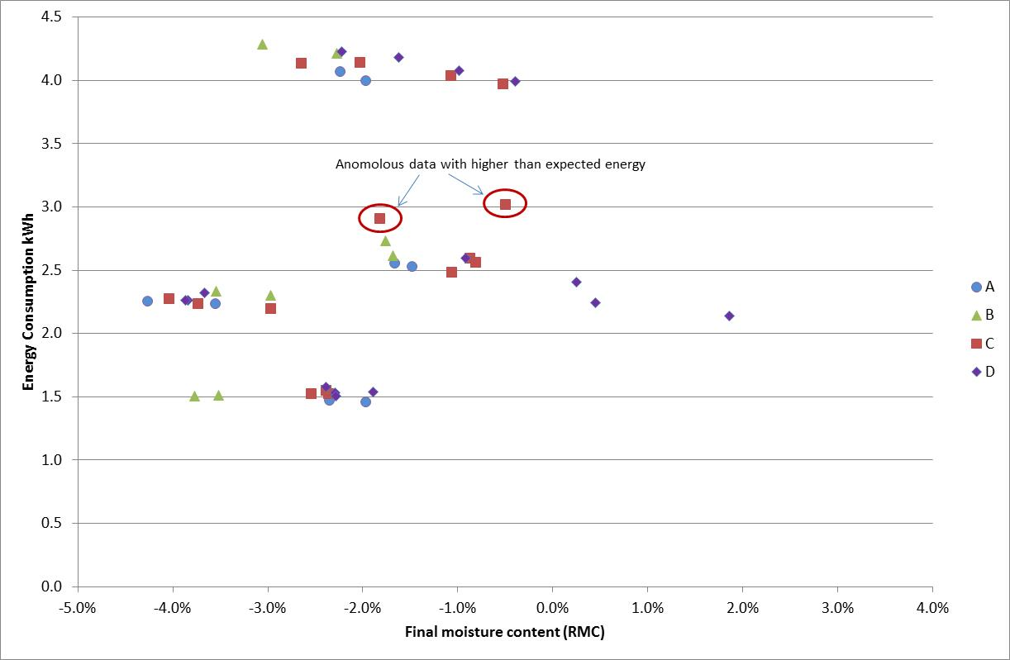

If the two anomalous data points are rejected from Lab C (shown in Figure 1), then it is clear that energy consumption and final moisture content are closely related. The drier the termination moisture content, the higher the energy consumption, as expected. For both dryers, the termination moisture content tended to be somewhat dryer at part load than at full load, despite using the same program and settings for both load sizes. Note that there was some variation in initial moisture content for each run, as the impacts of that are not shown in Figure 1.

## In depth analysis and correction of data

Clause 9.3 of IEC61121 sets out a calculation for correction of the measured energy consumption of the dryer. The corrected energy consumption for a test run Ej is given by the following equation:



Where:

Emj is the measured electric energy for test run j;

μi0 is the nominal initial moisture content (RMC);

μf0 is the target final moisture content (RMC);

W is the rated capacity of the tumble dryer for the type of load tested (this should be nominal test load mass rather than the rated capacity);

Wi is the mass of the test load after wetting;

Wf is the mass of the test load after drying.

For these tests the nominal or target initial moisture content (RMC) is 60% (Table 5, Cotton B) and the nominal or target final moisture content (RMC) is 0% (Table 6, Dry Cotton). The numerator is effectively the mass of moisture that should have been removed if the test started at nominal moisture content and finished at nominal moisture content while the denominator is the mass of moisture that was actually removed during the test. The intent is to correct the measured energy consumption back to a value that might be expected if the moisture removed was equal to the nominal values for initial and final moisture content.

Given that the initial moisture content is quite tightly specified (59% to 61%) there is not a large permitted variation in this component. In fact most labs on many runs were able to achieve exactly RMC 60% initial moisture by use of a fine spray. However, more variation is permitted in the final moisture content in the IEC standard (-3% RMC to +3% RMC for any individual test run for a timer dryer and just less than +3% RMC for an automatic dryer). All valid runs have been included in the data set. A similar IEC correction is applied to water consumption and program time.

The underlying assumption for this correction is that the energy consumed by a dryer is completely linear throughout its operating cycle. So an increase or decrease in the moisture removed will have a directly proportional impact on the energy consumed. In fact it is much easier for the dryer to remove a unit of moisture from the clothes when the load is wet compared to the load when it is almost dry.

As part of the detailed investigations undertaken during this round robin, additional measurements were taken on each dryer to assess the relationship between the energy consumed and the final moisture content. Two main approaches were examined: the first was to interrupt the dryer at regular intervals throughout the test and to record the mass of the load at each point to track the remaining moisture content (and the mass of moisture removed). This of course leads to an invalid test run as the dryer has to restart each time and it takes some time for the sensing control to settle back into stable operation. For interrupted runs, the program time was found to be longer (the added time being equal roughly to the time that the unit was stopped for weighing) and the energy consumption was increased by a few percent (possibly through heat loss from door openings), but the final moisture content was not unduly influenced.

The second approach was to record the total mass of the dryer on a balance as it operates through its normal program. The balance was tared at the start before adding the wet load and the total mass was recorded throughout the test. There are also some issues with this approach. The Miele unit is very heavy (around 100kg) and getting an accurate balance for that mass is problematical (nevertheless, the tests undertaken on a balance generated quite good results). Also, dryers naturally move and vibrate during operation, so individual spot readings can provide inaccurate results. The ideal approach is to undertake high speed data sampling from the balance and to smooth the data over the test period. Another issue was that the Miele unit collected condensate during its operation and this was not continuously pumped out from an internal intermediate reservoir (even though the unit was configured to drain condensed moisture), so the total mass on the balance varied depending on the state of pumping. However, the final load mass at the end of the test is directly measured using external scales, so this provides an accurate “calibration” for the balance measurements at the end. The balance has the advantage of obtaining additional data on the moisture removal profile without affecting the validity of the test. The Electrolux unit also presented some difficulties for the balance data because of the ducting, which was difficult to isolate from the dryer mass on the scales.

Figure 2 shows the data measurements on the Miele dryer with an 8kg load at 60% RMC.

Figure : Plot of RMC and energy for the Miele dryer with an 8kg load

Figure showing time on the X axis and moisture content on the Y axis left and cumulative energy consumption on the Y axis right. Energy data is quite linear. RMC is initially slow to change, is then linear for some time and the rate of change slows as the load becomes drier. Data is shown below

Time Energy RMC
 [kWh] 
0:00:00 0.00 60.3%
0:10:00 0.09 60.0%
0:20:00 0.20 59.6%
0:30:00 0.33 56.8%
0:45:00 0.52 49.8%
1:00:00 0.76 41.9%
1:20:00 1.04 31.0%
1:30:00 1.20 27.1%
1:45:00 1.40 21.4%
1:50:00 1.48 19.1%
1:55:00 1.56 15.1%
2:00:00 1.64 15.0%
2:05:00 1.68 11.3%
2:10:00 1.76 11.0%
2:15:00 1.84 8.5%
2:20:00 1.92 7.2%
2:25:00 1.99 5.5%
2:30:00 2.07 4.4%
2:35:00 2.12 3.2%
2:40:00 2.19 1.9%
2:45:00 2.27 1.0%
2:47:00 2.30 0.9%
2:49:00 2.33 0.8%
2:51:00 2.36 0.6%
2:53:00 2.39 -0.4%
2:55:00 2.42 -0.3%
2:57:00 2.45 -0.6%
2:59:00 2.48 0.0%
3:00:00 2.49 -0.9%
3:01:00 2.50 -0.6%
3:02:00 2.52 -1.9%
3:03:00 2.53 -0.8%
3:11:23 2.56 -1.7%


The main features of this chart are as follows:

* The initial moisture removal (blue line) is slow as it takes some time for the dryer and load to heat up and for evaporation to start – this dryer also has a lower initial power during the first 20 min (note that this is a heat pump dryer);
* Once the drying process is established, the moisture removal appears fairly linear down to about 25% RMC (or even less);
* As the RMC approaches 0%, the rate of moisture removal slows down and the energy input remains high, so the apparent efficiency is decreasing significantly.

Even though this unit is a heat pump and is substantially more efficient than a conventional dryer, the overall characteristic and shape of the energy and moisture removal curves are quite typical of many dryers. It is important to note that where there is a higher initial moisture content in the load, then the initial flat part of the moisture removal curve is just shifted up to a higher RMC and the linear part of the curve is extended. This data suggests that using a single average correction curve to take into account differences in final moisture content may give inaccurate results, especially where the results are further from the nominal final moisture content.

Another way of representing this data is to examine the marginal efficiency of the dryer at different points in the operating cycle. The marginal operating efficiency in this case is defined as the kg of moisture removed for each part of the cycle compared to the kWh of energy consumed during the same part of the cycle.

Figure : Efficiency of operation through the drying cycle as a function of moisture in the load

Figure showing comparative data for the four dryers with moisture remaining in the load kg on the X axis and efficiency in kWh/kg moisture removed on the Y axis. Data is below.

Miele 8kg
Moist remain kg kg/kWh
5.277 
4.682 1.920
3.740 2.349
3.397 2.541
3.053 2.448
2.719 2.479
2.391 2.442
2.069 2.447
1.762 2.310
1.464 2.229
1.189 2.037
0.936 1.851
0.740 1.511
0.731 
0.563 1.320
0.559 
0.429 1.061
0.426 

Miele 4kg
Moist remain kg kg/kWh
1.657 1.739
0.879 2.119
0.587 2.132
0.254 1.161
0.169 0.633

Electrolux 6kg
Moist remain kg kg/kWh
3.943 
3.094 0.890
2.036 1.041
1.700 1.002
1.365 0.993
1.047 0.907
0.747 0.816
0.495 0.739
0.305 0.518
0.194 0.370
0.128 0.235
0.108 0.103
0.148 

Electrolux 3kg
Moist remain kg kg/kWh
1.953 
1.787 0.672
1.474 0.939
1.154 0.952
0.832 0.965
0.518 0.923
0.247 0.788
0.078 0.512
0.037 0.215
0.057 


Notes: M8 is the Miele machine at rated capacity (8kg initial RMC 60%), M4 is the Miele machine at half rated capacity (4kg initial RMC 60%), E6 is the Electrolux dryer at rated capacity (6kg initial RMC 60%) and E3 is the Electrolux dryer at half rated capacity (3kg initial RMC 60%). M4 data is from the balance so there are some issues with the load shape due to irregular pump out events of condensed water.

The key characteristics of these curves are:

* The initial efficiency of all dryers is a bit lower than steady state as energy is used to heat up the dryer and load up to its operating temperature;
* Efficiency reaches a peak value during the linear part of the curve;
* Efficiency starts to drop once the remaining moisture content falls well below 20% RMC;
* Efficiency tends towards zero as the remaining moisture content approaches zero (this is the bone dry state or an RMC of about -5.7%);
* Peak efficiency at part load is a little bit lower than full load, but the efficiency does not fall as quickly when the load is dry, possibly due to the load being loose in the dryer and drying more effectively (note that this is mass of moisture remaining rather than RMC).

The same data can be plotted as RMC on the X axis (instead of mass of moisture remaining) versus energy efficiency. This is illustrated in Figure 4. When using RMC on the X axis, the full and half load values appear to align more closely as the efficiency falls in the dryer part of the operating cycle.

Figure : Efficiency of the dryers as a function of RMC of the load

Figure showing comparative data for the four dryers with RMC (moisture %) remaining in the load on the X axis and efficiency in kWh/kg moisture removed on the Y axis. Data is below.

Miele 8kg
RMC kg/kWh
60.0% 
52.5% 1.920
40.7% 2.349
36.4% 2.541
32.1% 2.448
28.0% 2.479
23.8% 2.442
19.8% 2.447
16.0% 2.310
12.2% 2.229
8.8% 2.037
5.6% 1.851
3.2% 1.511
3.1% 
1.0% 1.320
0.9% 
-0.7% 1.061
-0.8% 

Miele 4kg
RMC kg/kWh
36.1% 1.739
16.3% 2.119
8.8% 2.132
0.4% 1.161
-1.8% 0.633

Electrolux 6kg
RMC kg/kWh
60.1% 
45.8% 0.890
28.1% 1.041
22.4% 1.002
16.8% 0.993
11.5% 0.907
6.4% 0.816
2.2% 0.739
-1.0% 0.518
-2.9% 0.370
-4.0% 0.235
-4.3% 0.103
-3.6% 

Electrolux 3kg
RMC kg/kWh
60.0% 
54.4% 0.672
43.8% 0.939
33.0% 0.952
22.1% 0.965
11.4% 0.923
2.3% 0.788
-3.5% 0.512
-4.8% 0.215
-4.2% 


Notes: The RMC on the X axis is the relative moisture content for the initial load mass placed in the dryer (not an RMC value based on rated capacity). M4 data is from the balance so there are some issues with the load shape due to pump out events of condensed water.

The efficiency in Figure 3 and Figure 4 can be likened to a coefficient of performance of the dryer – the higher the number the more efficient it is (less energy is used) for a particular task (to remove a kg of moisture). It is useful to extract from the data the key parameters which are of interest in terms of correcting data for specific conditions. These are set out in Table 4. The efficiency values are effectively the slope of the energy versus moisture content curve.

Table : Summary of key efficiency parameters for tested dryers

|  |  |  |  |  |  |
| --- | --- | --- | --- | --- | --- |
| Dryer/ load | Overall eff kg/kWh | Marginal eff wet kg/kWh | Marginal  eff dry kg/kWh | Ratio wet eff/overall efficiency | Ratio dry eff/overall efficiency |
| E6 | 0.89 | 1.03 | 0.48 | 1.15 | 0.54 |
| E3 | 0.85 | 0.95 | 0.65 | 1.11 | 0.76 |
| M8 | 2.09 | 2.48 | 1.06 | 1.18 | 0.51 |
| M4 | 1.70 | 2.11 | 0.9 | 1.24 | 0.53 |

Notes: Overall efficiency is the average kg of moisture removed per kWh of energy consumed over the whole operating cycle. Marginal efficiency wet is the peak or plateau value shown in Figure 3 (down to about 20% RMC). Marginal efficiency dry is the measured marginal efficiency at around 0% RMC moisture content.

This data suggests that the marginal wet load efficiency should be about 1.15 times the overall efficiency and the marginal dry load efficiency is about half the overall efficiency (at around 0% RMC). This latter relationship may not hold so well for small part loads. However, using these to undertake corrections should provide much better results compared to the current IEC approach. A simplified plot of this type of model is shown in Figure 5. Figure 6 then shows the proposed simplified model as compared to the actual data for each dryer.

Figure : Generalised model of relative dryer efficiency as a function of RMC

Chart showing the proposed model to characterise moisture removal for dryers with RMC on the X axis and relative efficiency on the Y axis. Data is below.

RMC Efficiency
60% 1.15
10% 1.15
-10% 0
with straight lines between these points


Notes: The relative efficiency for each part of the dryer cycle is the ratio of instantaneous efficiency compared to the measured value for overall efficiency from an initial 60% RMC to a nominal final moisture content of 0% RMC. This curve ignores the initial lower efficiency that most dryers appear to show as the load and dryer are heated up. This function may not be valid for different initial moisture contents. The end points have been manually adjusted to more closely fit the test data for the round robin machines with efficiency starting to decline from 10% RMC reaching 0% at -10% RMC. In practical terms and RMC of lower than -7% is not possible, but this improves the overall fit.

Figure : Dryer energy efficiency curves showing proposed generalised model

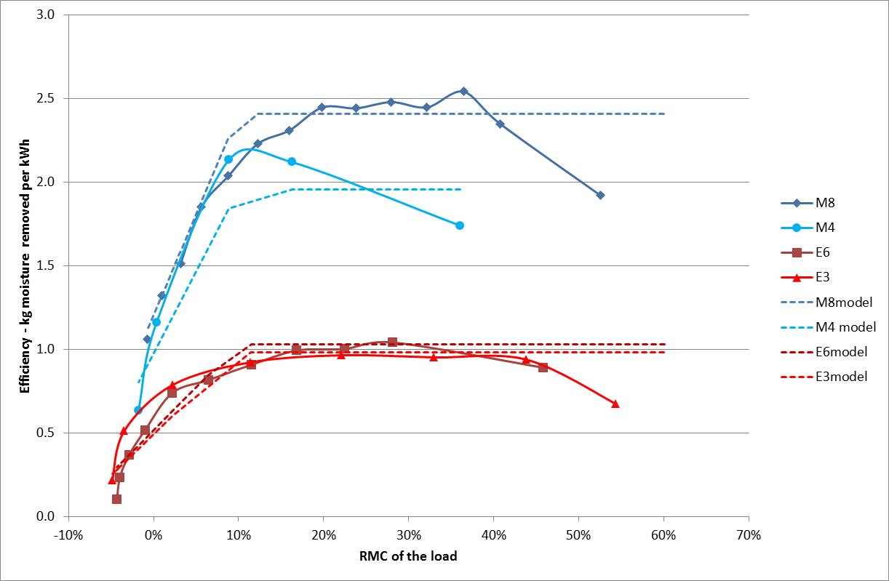

Notes: M4 data has some issues due to the measurement approach so the fit appears less robust.

Using this generalised efficiency curve, it is then possible to generate a generic energy consumption curve for each dryer, based on the measured parameters during the round robin, the initial load (RMC 60%) and the final moisture content. This is illustrated in Figure 7. This can then be used to generate correction algorithms for energy consumption. These curves assume a constant initial moisture content of 60% RMC.

Figure : Generalised dryer curves based on generic efficiency profiles

Figure showing a generalised energy consumption curve for a range of different final moisture content values with final moisture content RMC on the X axis and energy consumption on the Y axis. Data assumes initial moisture content of 60% RMC. Data is below.

Final RMC M8-curve M4-curve E6-curve E3-curve
2% 2.19 1.18 3.36 1.64
1% 2.28 1.22 3.49 1.71
0% 2.39 1.28 3.67 1.79
-1% 2.53 1.36 3.89 1.90
-2% 2.70 1.45 4.14 2.02
-3% 2.90 1.55 4.44 2.17
-4% 3.11 1.67 4.78 2.33
-5% 3.36 1.80 5.15 2.52


The expected change in overall efficiency of the dryer can be plotted as a function of final moisture content and initial moisture content as shown in Figure 8.

Figure : Model estimates of relative dryer efficiency for different initial and final moisture content values

Figure showing the relative energy efficiency (Y axis) for a range of final moisture contents (X axis) for 4 different initial moisture content values. Data is below.

Overall Relative Efficiency
Final  Initial Initial Initial Initial
RMC 50% 60% 70% 80%
10% 1.111 1.118 1.124 1.127
9% 1.101 1.110 1.117 1.121
8% 1.090 1.101 1.109 1.115
7% 1.078 1.091 1.101 1.107
6% 1.066 1.081 1.092 1.099
5% 1.053 1.070 1.082 1.091
4% 1.039 1.058 1.072 1.082
3% 1.024 1.046 1.061 1.073
2% 1.009 1.033 1.050 1.063
1% 0.994 1.020 1.038 1.052
0% 0.977 1.006 1.026 1.041
-1% 0.961 0.991 1.013 1.030
-2% 0.944 0.977 1.000 1.018
-3% 0.926 0.961 0.987 1.006
-4% 0.908 0.946 0.973 0.994
-5% 0.890 0.930 0.959 0.981
-6% 0.872 0.913 0.944 0.968


Note: All values are referenced to a value of 1.0 for an initial moisture content of 60% RMC and a final moisture content of 0% RMC. Note these are efficiency values (kg/kWh) and not energy values.

The proposed approach to correct for initial and final moisture content variations from target can be summarised as follows:

* Utilize the generalised load shape
* Make corrections for deviations in initial moisture content
* Make correction for deviations in final moisture content.

Because both of these elements are non-linear, it is necessary to undertake both corrections at the same time. In order to do this, generalised efficiency curves were generated for a range of initial and final moisture content as shown in Figure 8. These were converted to relative energy curves by multiplying by the relative moisture content (initial RMC minus final RMC) and dividing by the relative efficiency. The relative energy correction is then given as the inverse of the relative energy consumption value. Note that the energy correction factor in Table 5 provides an estimate of the relative energy consumption of the appliance at an initial moisture content of 60% RMC and a final moisture content of 0% RMC for any given initial and final moisture content measured in a test. For products that terminate wetter than 0% RMC, the energy consumption has to be adjusted higher (and vice versa). For products that start with an initial moisture content that is lower that 60% RMC the energy has to be adjusted higher (and vice versa). This should provide a solid basis for undertaking corrections for both initial and final moisture content. The proposed corrections are listed in tabular form in Table 5.

Table : Estimated energy correction values for a range of initial and final moisture contents

|  |  |  |  |
| --- | --- | --- | --- |
| **Final RMC** | **Initial RMC 50%** | **Initial RMC 60%** | **Initial RMC 70%** |
| 3% | 1.300 | 1.095 | 0.945 |
| 2% | 1.254 | 1.063 | 0.921 |
| 1% | 1.210 | 1.031 | 0.898 |
| 0% | 1.166 | 1.000 | 0.874 |
| -1% | 1.124 | 0.970 | 0.852 |
| -2% | 1.083 | 0.940 | 0.829 |
| -3% | 1.043 | 0.910 | 0.806 |
| -4% | 1.004 | 0.881 | 0.784 |
| -5% | 0.966 | 0.853 | 0.762 |

Note: The correction value provided, when multiplied by the measured energy for the given initial and final moisture content, should give an estimate of the energy consumption at initial 60% RMC and final 0% RMC. Values in this table are derived from the relative efficiency data in Figure 8.

This appears to provide good correction values, but such a table does not provide a simple to use format that could be easily incorporated into a standard. A multivariate regression was developed instead to derive an equation to fit the data as follows:

Energy correction = A0 + A1×(initial) + A2×(initial)2 + A3×(final) + A4×(final)2 + A5×(initial × final)

Where:

A0 = 2.556

A1 = -3.711

A2 = 1.867

A3 = 8.915

A4 = 3.186

A5 = -9.488

This has an R2 of 0.9996. Note that initial and final are entered as decimal values (e.g. 0.63 and -0.02).

It is useful to examine the uncorrected laboratory data to assess the proposed correction approach. This is illustrated in Figure 9. Note that these curves assume that the initial moisture content was exactly 60% RMC for every run. In fact there is some variation in initial moisture content, so this in part explains some of the residual scatter above and below the proposed correction lines. The most important influence in energy consumption is the final moisture content.

Figure : Raw data for all labs and runs showing proposed correction curve

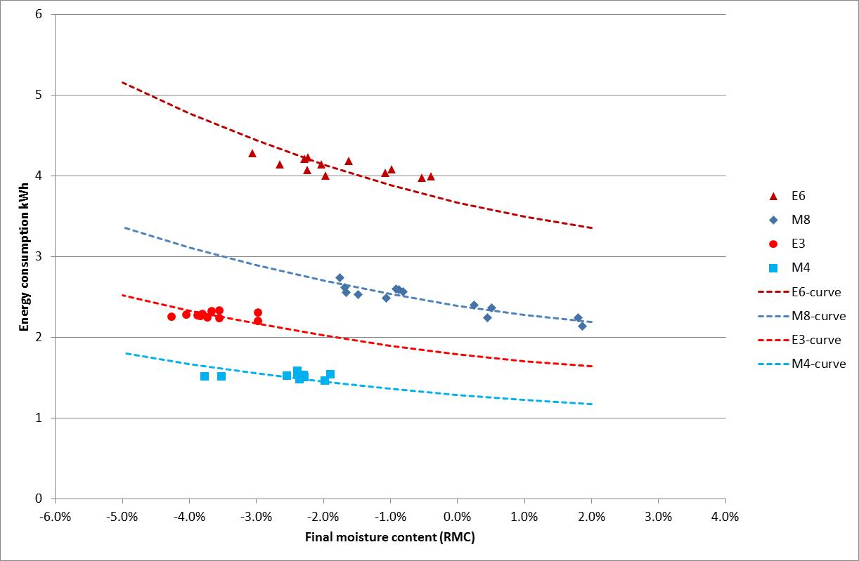

Note: This figure does not correct test points for variations in initial moisture content, so the data fit is approximate.

### Laboratory comparison with corrected data

In order to compare the current IEC correction with the proposed correction outlined in the previous section, raw data for each laboratory was subjected to the relevant corrections with the results set out in Table 6. This data corresponds to the raw data summary presented previously in Table 3.

Table : Round robin data comparing raw values with corrected values

|  |  |  |  |  |  |  |
| --- | --- | --- | --- | --- | --- | --- |
| Unit/Lab | Energy raw | IEC correction kWh | Proposed correction kWh | Spread raw energy | Spread IEC correction | Spread proposed correction |
| kWh |
| M8A | 2.542 | 2.485 | 2.411 | 0.6% | -0.4% | -1.5% |
| M8B | 2.675 | 2.617 | 2.530 | 5.8% | 4.8% | 3.4% |
| M8C | 2.546 | 2.519 | 2.475 | 0.8% | 0.9% | 1.1% |
| M8D | 2.345 | 2.365 | 2.375 | -7.2% | -5.3% | -3.0% |
| **M8 mean** | **2.527** | **2.496** | **2.448** |  |  |  |
| M4A | 1.466 | 1.444 | 1.368 | -3.0% | -2.1% | -1.6% |
| M4B | 1.510 | 1.454 | 1.337 | -0.1% | -1.4% | -3.8% |
| M4C | 1.532 | 1.503 | 1.417 | 1.4% | 1.9% | 1.9% |
| M4D | 1.538 | 1.498 | 1.439 | 1.8% | 1.6% | 3.5% |
| **M4 mean** | **1.511** | **1.475** | **1.390** |  |  |  |
| E6A | 4.036 | 3.933 | 3.772 | -2.0% | -2.1% | -2.5% |
| E6B | 4.246 | 4.103 | 3.890 | 3.1% | 2.1% | 0.6% |
| E6C | 4.071 | 3.999 | 3.874 | -1.1% | -0.5% | 0.2% |
| E6D | 4.118 | 4.038 | 3.933 | 0.0% | 0.5% | 1.7% |
| **E6 mean** | **4.118** | **4.018** | **3.867** |  |  |  |
| E3A | 2.244 | 2.143 | 1.971 | -1.2% | -1.6% | -2.2% |
| E3B | 2.316 | 2.241 | 2.079 | 2.0% | 2.9% | 3.2% |
| E3C | 2.238 | 2.149 | 1.991 | -1.4% | -1.4% | -1.2% |
| E3D | 2.283 | 2.180 | 2.017 | 0.6% | 0.1% | 0.1% |
| **E3 mean** | **2.270** | **2.178** | **2.015** |  |  |  |

There are a range of interesting observations that can be gleaned from this data.

* The proposed correction provides a better fit to the data for the Miele machine at rated capacity, in that the spread of data across labs is lower – note that this unit had a wider range of final moisture content values than other machines and loadings, so it a good test of the veracity of the proposed correction.
* The proposed correction shows a wider spread of the data for the Miele machine at half capacity in terms of the spread of data across labs when compared to the IEC correction. However the spread for the proposed correction is consistent with the spread for the full load tests. The expected variability for half load should be slightly greater than full load as small changes in operation have a larger impact on the smaller total energy consumption. One lab showed the same energy consumption for a 2% lower RMC value – the proposed correction identifies this as a low value while the IEC correction suggests that this is expected.
* The IEC correction and the proposed correction give a similar spread for full load and half load for the Electrolux dryer – both show a spread of about 3%, with a slightly higher spread at half load, as expected.
* The IEC correction appears to give a significant over-estimate of energy at full load for all machines, varying from 2% to 8%. This difference (or overestimate) is highly dependent on the termination moisture content, with the IEC correction giving a larger error when the termination moisture content is lower.
* The proposed correction gives a spread of data of about 3.5% or better for both test machines and both load levels, which is considered to be quite reasonable for this type of measurement considering the uncertainties involved.
* The IEC correction suggests a spread of over 5% for the Miele dryer at rated capacity and a comparable spread to the proposed correction for other machines and load levels. The apparent good fit of the IEC correction in terms of spread for these other settings is because the final moisture content was in a fairly tight range. The IEC correction seems to significantly overestimate the energy consumption when compared to the expected performance curve because the final moisture content was generally well below 0% RMC.

To demonstrate the veracity of the proposed correction, it is worth considering the results for a trial test point in one of the laboratories. Due to a miscalculation, two tests were conducted on the Electrolux machine at full load at a higher initial moisture content (at around 70% RMC) (machine E6 laboratory B). Naturally, these results were not included in Table 6 as they were not in line with the testing specification. The measured energy consumption for these two runs was around 4.8 kWh and 4.7 kWh while the final moisture content was -2.4%. When subjected to the proposed correction, the estimated energy for these two runs for an initial and final moisture content of 60% RMC and 0% RMC was estimated to be 3.86 and 3.92 kWh respectively for these two runs, which was completely in line with the other runs on that machine undertaken using the correct initial moisture content (average of valid runs was 3.89 kWh).

To illustrate the IEC correction and the proposed correction (shown as “Corr4”) for a range of initial and final moisture contents, both are illustrated in Figure 9.

Figure : Comparison of IEC and proposed energy correction for various final RMC values

Figure showing final moisture content on the X axis and energy correction on the Y axis for 3 different initial moisture contens (59%, 60% and 61% RMC). The proposed correction is much steeper than the current IEC correction. Data is below.

Current IEC correction   
 Initial Initial Initial
Final 61% 60% 59%
3% 1.034 1.053 1.071
2% 1.017 1.034 1.053
1% 1.000 1.017 1.034
0% 0.984 1.000 1.017
-1% 0.968 0.984 1.000
-2% 0.952 0.968 0.984
-3% 0.938 0.952 0.968
-4% 0.923 0.938 0.952
-5% 0.909 0.923 0.938

Proposed correction   
 Initial Initial Initial
Final 61% 60% 59%
3% 1.083 1.101 1.118
2% 1.050 1.067 1.084
1% 1.018 1.034 1.050
0% 0.987 1.001 1.016
-1% 0.956 0.969 0.983
-2% 0.925 0.938 0.951
-3% 0.896 0.907 0.919
-4% 0.867 0.877 0.888
-5% 0.838 0.848 0.858



Note: The proposed correction is labelled as Corr4 in the legend.

The standard only permits a ±1% variation in initial RMC (which is fairly tight). However the proposed correction (labelled as Corr4 in the figure) has the dotted lines closer together as variations in the initial moisture content have a smaller impact than assumed in the IEC correction, while the slope of the proposed correction is significantly steeper than the IEC correction, as the energy impact of changes in final moisture content are much larger (because the marginal efficiency is much lower than the overall average at the dryer end of the cycle). The IEC correction underestimates the energy correction by 5% at a final RMC of +3% and overestimates the energy correction by over 7% at a final RMC of -5%.

For larger variations in initial moisture content (which are not strictly permitted at this stage), the IEC correction understandably gives very poor estimates of the overall energy at standard conditions, as illustrated in Figure 11.

Figure : Comparison of IEC and proposed energy correction for a wider range of initial RMC values

Figure showing final moisture content on the X axis and energy correction on the Y axis for 3 different initial moisture contens (50%, 60% and 70% RMC). The proposed correction is much steeper than the current IEC correction. Data is below.

Current IEC correction   
 Initial Initial Initial
Final 70% 60% 50%
3% 0.896 1.053 1.277
2% 0.882 1.034 1.250
1% 0.870 1.017 1.224
0% 0.857 1.000 1.200
-1% 0.845 0.984 1.176
-2% 0.833 0.968 1.154
-3% 0.822 0.952 1.132
-4% 0.811 0.938 1.111
-5% 0.800 0.923 1.091

Proposed correction   
 Initial Initial Initial
Final 70% 60% 50%
3% 0.944 1.101 1.295
2% 0.919 1.067 1.252
1% 0.896 1.034 1.209
0% 0.873 1.001 1.167
-1% 0.850 0.969 1.126
-2% 0.829 0.938 1.085
-3% 0.807 0.907 1.045
-4% 0.787 0.877 1.005
-5% 0.767 0.848 0.966


The IEC correction appears to provide a fairly poor basis for correcting energy data when attempting to estimate the energy consumption for standardised initial and final moisture contents. The correction understandably gets worse where dryers terminate further from a final 0% RMC. For the tests undertaken for this round robin, the estimated energy using the IEC correction when compared to the proposed correction was between 2% and 8% higher - this is highly dependent on the final moisture content of the test runs and this over-estimate occurs as most runs terminated at well below the target final moisture content of 0% RMC.

The current IEC correction formula has a notional error in that it should say the “tested capacity” rather than the rated capacity for W. In fact the formula should have the actual conditioned mass tested rather than the nominal load mass.

There are several issues to debate if the IEC standard is applied in Australia and New Zealand. The first is whether the IEC correction should be applied or another correction. Initial analysis (above) suggests that the IEC correction is likely to give poor results in some circumstances and will be of low value for verification tests. However, this does not have any material impact on the test method as it is a post-test adjustment and any correction can be made to the measured test data. A specific local correction selected for use will have no bearing on the adoption and use of the IEC standard locally.

The other issue is whether energy values should be corrected for automatic (autosensing) dryers. Currently local labelling requirements in Australia and New Zealand do not correct measured energy values for automatic dryers. These dryers must be operated on a program that achieves a bone dry mass of 6% (which is equivalent to 0% RMC). These issues can be discussed in the labelling implementation phase.

The proposed correction proposed in this report, while somewhat more complex, appears to provide a better explanation of changes in energy consumption with changes in initial and final moisture content. The proposed correction equation can easily be expanded to cover a wide range of initial moisture content values and final moisture content values. This may be useful as an advisory tool to consumers or as a research tool to help understand field data for dryers. An equation that is fitted to a wider range of data (from 20% initial RMC to 80% initial RMC) is given by:

Relative energy = A0 + A1×(initial) + A2×(initial)2 + A3×(final) + A4×(final)2 + A5×(initial × final)

Where:

A0 0.2856

A1 0.9386

A2 0.3755

A3 -5.0616

A4 10.8340

A5 2.8486

Note that is equation gives relative energy, whereas the previous equation was an energy correction (inverse of relative energy). This version of the equation is perhaps slightly less accurate around the tight initial and final moisture content values defined in the standard, but does provide a useful map of changes in energy consumption under a wider range of operating conditions. For example, a recent study of end use monitoring data in some Victorian homes found that average dryer load sizes ranged from 0.5kg to 1.5kg, with loads rarely exceeding 2kg. The above tool is useful for better understanding field data of this type. These types of field measurements do raise questions about the depiction of dryer energy consumption in Australian and New Zealand energy rating labels and how that could be made more relevant to normal use.

## Examination of load mass during the round robin

### Changes in the mass of load items during the aging process

All load items were subject to initial pre-treatment runs as specified in Clause 6.5.2. A selection of load items were then subjected to dummy test runs in order to increase their age. This was necessary in order to meet the average load age requirements specified in Clause 6.5.3.2. The number of treatments ranged from zero to 60 in order to get a mix of ages that would comply with the IEC age requirements throughout the round robin process.

After each batch of treatments of 10 runs, the bone dry mass of each load item was determined. Laboratories also determined the bone dry mass again on completion of their tests. This data allowed the mass to be tracked over the life of each load item. The general trends are depicted in the following figures. The data points appear to be quite scattered (see Figure 12). This is because the mass of individual load items can vary by a few grams (depending on balance uncertainty) and the mass can vary slightly due to small variations in bone dry processes and the relatively small mass of individual load items. The mass loss over the whole test period for items that were subjected to a large number of runs was found to be very small: around 1% mass loss over 60 runs for sheets and pillowcases and about 2% mass loss for towels. This equates to a very small mass loss per test run.

Figure : Loss in Bone Dry Mass by Number of Runs (Sheets, Pillowcases and Towels)

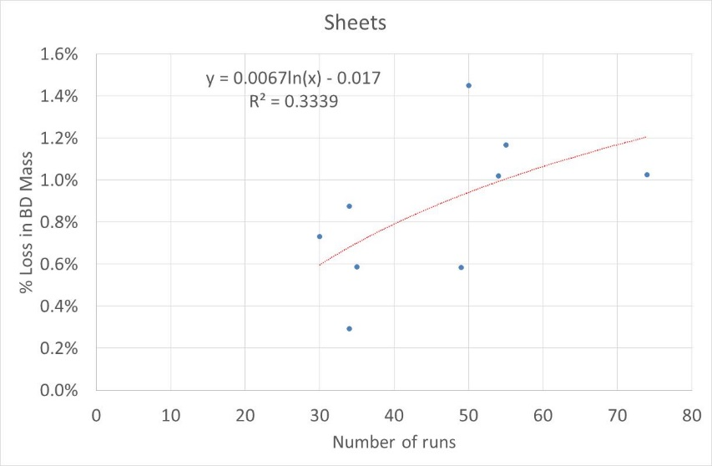

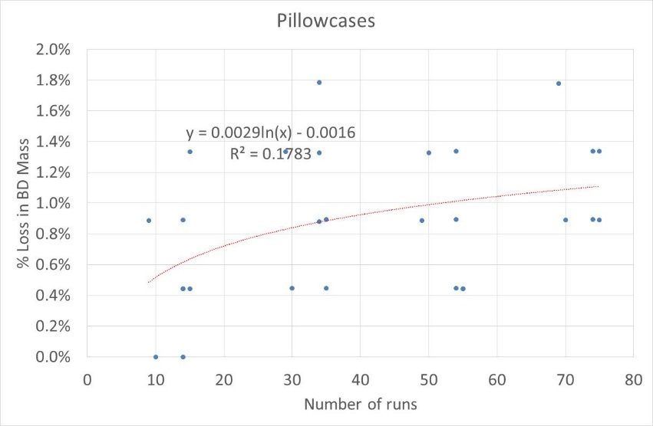

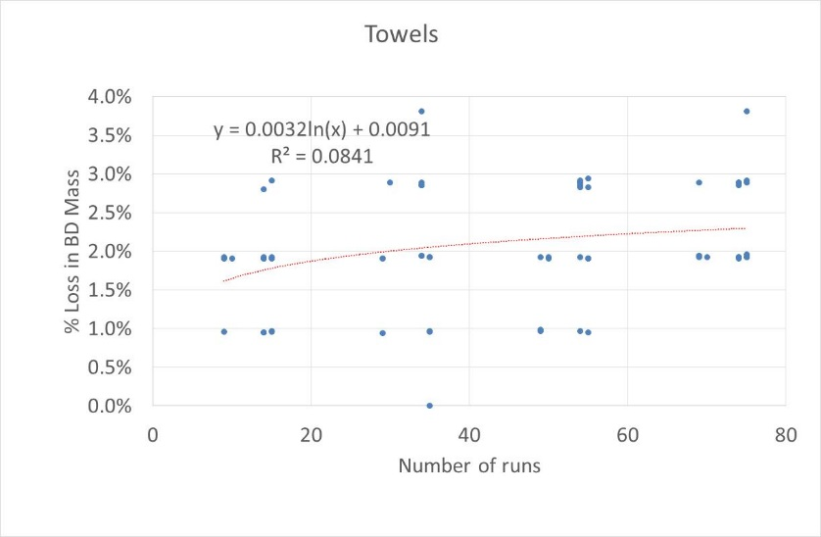

### Variations in bone by mass by laboratory

The round robin used dedicated loads for each dryer and load size – no items were removed or added during the round robin. The only exception was that two towels were lost in one lab during testing. These were never found and were replaced with similar aged load items that were spare.

A common load for all tests allows the bone dry mass to be compared by laboratory (see Table 7). As can be seen from the results in this table the variation in measured bone dry mass between laboratories was relatively small (approximately 0.5%). It is notable that the variations in measured bone dry mass do not follow a trend in accordance with the age of the load (as might be expected, all other things being equal). This suggests that the variations between laboratories in the bone drying and weighing processes are greater than the variations in mass as the load ages. Neither factor however is particularly significant, nevertheless these variations have prompted the suggested revisions to the bone dry process and adjustment factors set out in the following sections.

Table : Comparison of Bone Dry Masses by Laboratory

|  |  |  |  |  |  |  |
| --- | --- | --- | --- | --- | --- | --- |
| **Load** | **Laboratory** | | | | **Max. variation (g)** | **Max. variation (%)** |
| A | B | C | D |
| M8 | 7463 | 7456 | 7492 | 7457 | 36 | 0.48% |
| E6 | 5585 | 5572 | 5599 | 5574 | 27 | 0.48% |
| M4 | 3681 | 3663 | 3688 | 3664 | 25 | 0.68% |
| E3 | 2763 | 2755 | 2773 | 2760 | 18 | 0.65% |

Laboratory B consistently had the lowest test mass for all loads (noting that laboratory labels are not the order of testing). This lab ensured that the loads were run for long periods and that the maximum load subject to bone dry conditioning was around 50% of the rated capacity of the conditioning dryer. This does suggest that these differences could be reduced further with some attention to dryer specifications and operation.

### Bone dry mass versus conditioned mass

Three of the laboratories were able to operate their test rooms at the controlled ambient temperature and humidity required to condition the load according to 5.2.3.2. In each case the loads were already dried and were laid out so that they were fully exposed to ambient conditions for at least 60 hours (from Friday afternoon until Monday morning). One of the labs (Lab B) mistakenly operated the test room at the dryer test conditions of 23°C and 55% humidity for this process, so understandably the conditioned mass for this lab was slightly lower than expected, as the conditioned mass is likely to be dictated primarily by relative humidity.

The results are shown in Table 8. Here it can be seen that the ratio of conditioned load mass across all load types and laboratories sits within a relatively tight band between 1.055 and 1.060, with the lowest values mostly occurring in the lab with the incorrect ambient conditions. The averages across all loads for each laboratory sit in the range 1.057 to 1.059 noting that two laboratories averaged 1.059 and the lower value of 1.057 applies to laboratory B where the ambient conditions were incorrectly set to 23°C and 55% humidity, which would explain the difference between this laboratory and the other two.

Table : Ratio of conditioned Mass to Bone Dry Mass by Laboratory

|  |  |  |  |
| --- | --- | --- | --- |
| Load | **Laboratory** | | |
| A | B | C |
| M8 | 1.059 | 1.057 | 1.059 |
| E6 | 1.059 | 1.055 | 1.060 |
| M4 | 1.060 | 1.060 | 1.059 |
| E3 | 1.059 |  | 1.058 |
| Average | 1.059 | 1.057 | 1.059 |

Note: The conditioned mass of load E3 at Laboratory B was not measured.

More discussion on this issue is included the following section.

### Bone dry preparation of load items

All Australian labs tend to use the bone dry mass approach as they are familiar with this method and none of the labs currently have a dedicated room for conditioning loads at the appropriate ambient conditions. They also find the bone dry approach is faster. A number of issues did arise during tests with respect to the preparation of bone dry masses. These issues are as applicable to AS/NZS2442.1 as they are to IEC61121.

Firstly, where the bone mass of individual load items needs to be determined (such as for evenness of drying assessments), it is important that the full load reaches the bone dry state in the dryer first. In order to determine the mass of individual items, the dryer should continue to operate with the heating element on while just a few items at a time are removed to have their mass measured. Guidance on this issue needs to be included in the standard. One lab compared the difference between these two approaches (viz. pulling items out individually and weighing one by one versus removing the whole load and weighing items over a period of about 10 min) and found that where all the items were removed from the dryer, the mass increased by 30g by the time all of the load items were weighed and recorded. While this is a fairly small discrepancy, it does represent an unnecessary error of 0.5% that can occur if there is poor attention to detail.

The second issue was that there was some variation in the bone dry mass values achieved in each laboratory. Again, these variations were only small, but to some extent they appear to be dictated by the dryer used to bone dry the mass and the amount of load that is conditioned. Currently Annex G of IEC60456 Edition 5 states:

*The nominal bone-dry mass of the items being dried as a single load shall be not more than 1 kg for each 20 l of measured rated drum volume and, when expressed in kg, shall be less than 3,3 times the heating element rating of the tumble dryer (expressed in kW).*

This requirement would permit a standard 2.4kW dryer to condition nearly 8kg of load, which is likely to be close to its rated capacity for a conventional dryer. For all dryers used to condition load in the round robin laboratories (large commercial dryers), the power input times 3.3 was typically well in excess of the rated capacity of these units (commercial dryers tended to have a rated capacity of about 2.3kg per kW input). Large dryers are typically rated at about 20 litres per kg of rated capacity. So this specification provides little limitation on the type of dryer used or how it should be used to get the best result. It should be noted that the current requirements in IEC were derived from AS/NZS2442.1 on the basis of advice provided from Australia, so this is not intended as a criticism of the IEC.

However, in light of data from the round robin, the following suggestions should improve the approach to bone drying on the IEC standard:

* Dryers must be controlled by timer (autosensing dryers are not permitted)
* The maximum load that can be treated should not exceed 1.5kg per kW of input rating for an electric resistance heater or 1.0kg per kW of input rating for a gas dryer, or the load conditioned should not exceed 50% of its rated capacity.
* The drum volume should exceed 30 litres per kg of load treated.

These are initial recommendations based on observed data in the round robin. It would be useful to review these in the light of more data from test labs where possible.

The last issue regarding bone drying of loads is that IEC60456 Edition 5 has a requirement to measure the inlet air temperature into the dryer drum (inside the dryer) as follows:

*An electric tumble dryer used shall be equipped with a temperature sensor able to read the temperature of the inlet air. The average temperature reading during the last step is recorded as Tinletair. The temperature of the inlet air is determined by measurement of the inlet air temperature at the plane directly where the air enters the drum. The measurement shall be made by attachable surface temperature sensors attached at the drum as near as possible to the entrance of the hot air. Electric dryers used to bring a load to the bone dry condition shall have an average temperature of the inlet air during the final 20 min of operation of not less than 75 °C.*

Practical experience suggests that placing a temperature sensor in a position that can determine the air temperature after the heating system and at the drum inlet (as specified in the standard) is impractical for most labs where commercial dryers are used. Access to this part of the dryer is difficult and rotation of the drum also makes sensor placement impossible in many cases. Equation G.1 in IEC60456 Edition 5 specifies the calculation of the bone dryer factor based on the inlet temperature into the dryer drum as follows:

Bone dry factor = 

The bone dry factor can then be calculated for a range of *Tinletair* values as shown in Table 9.

Table : Calculated bone dry factor for various inlet air temperatures

| **Tinletair °C** | **Bone dry factor** |
| --- | --- |
| 70 | 1.059 |
| 75 | 1.061 |
| 80 | 1.062 |
| 85 | 1.063 |
| 90 | 1.064 |
| 95 | 1.065 |
| 100 | 1.066 |
| 105 | 1.067 |
| 110 | 1.067 |
| 115 | 1.068 |
| 120 | 1.068 |
| 125 | 1.069 |
| 130 | 1.069 |
| 135 | 1.070 |
| 140 | 1.070 |

Practical experience suggests that the resulting bone dry factor is too high. Most laboratory dryers operate in the range of 90°C to 110°C, which suggests a bone dry factor of 1.067. The practical tests undertaken in Australia (bone dry versus conditioned mass as set out in the previous section) found that the bone dry factor in two of the labs was about 1.06 while the other lab was slightly lower (due the ambient conditions being incorrect). This suggests that the current IEC calculation gives a bone dry factor that is slightly too high. While this difference is fairly small and will have only a minimal impact on overall results, using a bone dry factor that is too high will lead to a slightly larger estimate of the total conditioned mass which may lead to a slightly smaller total load mass for a given target load size. The amount of water added to the load should be unaffected. It is therefore suggested that a flat factor of 1.06 be used for all cases (provided that the recommended dryer specifications are met) and that the specifications of the dryer used to condition the load be revised as set out above.

## Observations regarding test laboratories

This section sets out some broad observations regarding the test laboratories that participated in the round robin.

All laboratories have the ability to actively control and maintain ambient conditions and meet IEC requirements. One laboratory did not have active humidity control in the test room, but this is unlikely to have any measurable impact on the results. All local laboratories are using high quality energy instruments and follow accreditation procedures for calibration and traceable references, so this is unlikely to be an area of concern.

All laboratories used high quality, calibrated and traceable temperature measurement systems that meet current accreditation requirements and comfortably meet IEC requirements.

Measurement of relative humidity is undertaken using a range of instruments and the overall uncertainty was generally 2% to 4%. Accreditation bodies in Australia like NATA now tend to take instrument uncertainty into account when assessing compliance with conditions. Given that the permitted relative humidity is 55% ±5%, accreditation requirements may require conditions to be held with the range 54% to 56% if there is an uncertainty of 4%. Depending on the interpretation of the standard, most laboratories would find this very difficult to achieve. Changes in relative humidity in the test room are likely to have some impact on the tested result, although this impact becomes very small once the dryer operating temperature exceeds 90°C. This issue is discussed more in the recommendations section of this report.

Mass measurement is a critical issue for the dryer test, and all laboratories appeared to have adequate and accurate instruments for this purpose. Instrument resolution and uncertainty is critical when the mass of individual load items is being measured.

Some laboratories were able to exhaust the dryer air for the vented dryer outside of the conditioned test room space, while others were not able to do this. Where the test room is small, the dryer exhaust could have some impact on the ambient conditions and the ability of the lab to maintain specified conditions during the test. This was not a significant issue but is worthy of some consideration in some cases.

Most of the test laboratories used one recording system to monitor energy and voltage and a separate system for recording ambient conditions. Sometimes these were recorded at different time intervals. This was generally not an issue as long as the ambient data records were available for merging with the energy and voltage records. Different formats also made data merging less straight forward in some cases. Difficulty in access to data sometime makes verification of test conditions more time consuming and awkward.

One laboratory did not use a regulated power supply but was able to comfortably meet the voltage requirements. This obviously depends on the local supply and supply system variations. Other labs used either a voltage regulator (that passed through mains frequency to the test appliance) or a UPS type system that could run independently any voltage and frequency. Some laboratories had limited ability to fine tune the supply voltage at the appliance once the set point on the regulator was selected (e.g. 230V). The ability to fine tune the voltage supply at the point of connection with the appliance (e.g. through use of individual variacs) is an area where some laboratories could enhance the operation of their laboratory in accordance with all standards.

# Feedback to IEC

This section sets out a range of issues that came to light during Australian dryer round robin testing and where individual test labs, the project managers and the Australian national committee are making recommendations for consideration by IEC SC59D (home laundry appliances). Some of these may result in amendments to IEC61121 (dryers) and IEC60456 (clothes washers), the latter standard defining the process for bone drying.

### Ambient air temperature

All test personnel found that the room temperature of 23°C is verging on uncomfortable when actively undertaking normal tasks in the test laboratory. Research in Australia shows the average temperature of living areas in Australian homes to be 21°C (population weighted Australian average) while for non-conditioned spaces such as laundries, the average temperature is 20.3°C (population weighted Australian average). Average temperatures in New Zealand homes are a few degrees cooler. Impact of 3K difference in ambient temperature will be negligible in terms of dryer performance as long as the relative humidity is adjusted accordingly. Having different ambient conditions for testing dryers and conditioning the load introduces unnecessary complexity in that test laboratories have to maintain different conditions in different parts of the laboratory. While it is accepted that common temperature conditions for all wet products is essential (clothes dryers, dishwashers and clothes washers), the actual temperature is not all that critical in terms of the measured value. The ambient temperature appears to be somewhat arbitrary, so it should be comfortable for laboratory personnel and be more relevant to room temperatures found in homes.

**Recommendation 1**: IEC could consider changing the test conditions as follows:

1. Change ambient test temperature back to 20°C (as was the case for all wet appliances until recently) in a coordinated fashion for all wet appliances; and
2. Add an additional requirement to make mean and permitted variability clearer.

### Ambient humidity

Humidity requirements for testing are currently quite tight (55% ±5%). Most humidity measurement sensors tend to have an uncertainty of 2% to 5%. This provides little leeway for laboratories to meet normal accreditation requirements, which are to remain inside the permitted range after taking instrument uncertainty into account. This could be ameliorated to some extent by changing the requirements to make the permitted variability in the measured data clearer.

The other consideration is that small variations in ambient humidity will have a small impact on the measured test result. Relative humidity has some impact on internal dryer relative humidity (around 1% per 5% change in RH) at lower dryer operating temperatures (around 70°C to 80°C) but these differences become very small once internal dryer temperatures exceed 90°C (0.3% per 5% change in RH at 100°C). The humidity ratio of the test room (a measure of absolute humidity in g per kg of dry air) is the factor that has a direct impact on the relative humidity in the dryer during the dryer operation, which will impact on its performance. Changes in test room temperature have some impact on the air enthalpy (the energy needed to heat the air from the room to operating temperatures) at about 1% per degree K. However, the relative humidity has only a very small impact on the air enthalpy (energy change) when heating air in the dryer. The standards committee could consider revising the test room specification to put more emphasis on the control of humidity ratio (absolute humidity) rather than the current control of temperature and relative humidity and allow a more realistic range of conditions during testing.

**Recommendation 2**: Ambient humidity requirements are currently tight and can be difficult to meet. IEC could consider alternative approaches regarding control of humidity ratio in the test room. This could include examining:

1. Whether more flexible ambient conditions for humidity can be defined in the standard while maintaining accuracy; and
2. Add an additional requirement to make mean and permitted variability clearer.

### Overall energy correction

The current overall IEC energy correction appears to be too simplistic. The current IEC methodology assumes a constant energy slope and efficiency throughout the dryer operation, which is known to be incorrect. This has been raised at IEC for about 20 years and there has been no action or research on this topic. This has not previously concerned Australia and New Zealand directly as we have not used this standard or the associated correction. However, this will become a significant issue if this test method is to be applied in Australia and New Zealand.

As set out in this report, a new approach for a correction in variations of initial and final moisture content has been developed to reflect typical performance curves for dryers based on limited data available in the Australian round robin. This would be best applied as a combined overall correction based on initial and final moisture content as set out in the previous section. IEC could further develop and refine this approach for inclusion in a future amendment of the standard to provide a more robust correction factor in the standard. In the absence of any change to the current IEC correction factor, Australia and New Zealand are likely to consider applying their own correction factor to local test data. Australia and New Zealand have robust compliance programs that rely on reproducibility of test results as the basis for enforcement actions. Therefore, their governments will carefully consider an appropriate correction factor should they decide to adopt the IEC test method as the basis for the regulation of for clothes dryers in this region.

The other issue is that automatic dryers currently do not have any correction factor applied to the measured values for energy labelling in Australia and New Zealand. In addition, all appliances must have a program setting that can achieve ≤ 0% RMC. Australia and New Zealand will likely maintain this program option when applying IEC61121 locally. It would be useful if the standard could make it clear that applying a correction (or not) is the prerogative of local regulatory authorities for different dryer types (e.g. automatic versus timer).

IEC61121 allows any value to be corrected whereas EN61121 requires the measured value to be within a defined range before correction is permitted. This shows that application of corrections is already varied at a regional level.

The IEC energy correction in 9.3 states that *W* is the *rated capacity of the tumble dryer for the type of load tested*. However, for this correction to work as intended, *W* should be *W0*, which is the *mass of the conditioned test load*. Note that this is the actual conditioned mass and not the nominal or rated capacity for the test.

**Recommendation 3**: IEC could examine and consider:

1. Undertaking further research and development along the lines of the analysis in this report with a view to developing a more robust energy correction for inclusion in a future revision or amendment to IEC61121, noting that the proposed correction in this report is based on a limited number of tests and dryers;
2. Assessing whether such a correction factor could also be applied to program time; and
3. Adjusting the text in the standard to make it clear that the application of a correction (or not) is a matter for regional authorities and may vary by dryer type and performance level.

The issue of correction of water consumption has not been investigated (as this is generally only applicable to combination washer-dryers) so no recommendation is made at this time.

### Half load

Field data shows that average load sizes for many driers in Australia are very small (most are less than 2kg of dry load mass). This suggests that tests at lower capacities will be important for consumer relevance in Australia.

European energy labelling sets out requirements for testing at rated capacity and half load. EN61121 has common modifications to define half load compositions where the rated capacity is a 0.5 kg value. For example, currently a dryer that is rated at 6.5kg would have a half load value of 3.75 kg which is not permitted as in IEC61121 as only loads in 0.5 kg increments are defined. Such half loads are however defined in EN. The EN half load definition is quite elaborate and somewhat arbitrary as the load is split into two halves that may be different masses. The EN half load mass is also intricately tied up with the 5 runs in a test series (see later comments), so this approach is not supported as it does not allow a single run on a single machine to be undertaken in accordance with the standard.

**Recommendation 4**: In general terms inclusion of a half load specification in IEC to match EN61121 is not supported as this necessitates both half loads being tested. Regions can easily adopt a suitable part load value that lies within the existing 0.5kg increments. A note on this issue could be included in IEC for guidance.

### Soft water definition

The current range for soft water is 0.5 ± 0.2 mmol/litre. This is quite narrow and any adjustment of water hardness by labs automatically triggers a range of complex requirements with respect to conductivity and alkalinity in IEC60734. Many dryers operate in soft water and suppliers should be able to make their products perform correctly in natural soft water. Active controlling of hardness, conductivity and alkalinity creates a range of potential problems in terms of product performance, repeatability and reproducibility.

**Recommendation 5**: Consider broadening and aligning the soft water hardness definition for dryers with that of IEC60436 for dishwashers; that is to be ≤0.85 mmol/litre.

### Guidance on placement of ambient sensors

Currently there is no specific guidance on the placement of ambient temperature and humidity sensors in the test room. It is important that sensors be placed in a representative position but away from any direct influence from any heat sources or sinks such as test appliances and conditioning equipment. The standard could also include some limits on air movement, which are not currently specified. It would be preferable that temperature sensors also have a low thermal mass in order to pick up short-term changes in ambient conditions.

**Recommendation 6**: Consider including in the standard specific guidance on the placement of ambient temperature and humidity sensors in the test room. Suggested requirements are:

* Placement should be in a position that will measure a representative value of the test room.
* Sensors shall be in a position that is not directly influenced by any appliances under test.
* Temperature sensors shall be shielded from any heat sources or sinks that are more than 5K different to the ambient conditions and that are closer than 5 m.
* Air movement at a position close to the appliance test position shall be ≤0.75m/s under normal test room configuration and operating conditions.
* All air temperature sensors shall have a time constant in air of less than 30 sec (tentative suggested value).

### Guidance on loading

When a test load is wetted and spun, it is possible for load items to become tangled and in some cases twisted “ropes” of wet load items can be formed. It would be useful to include in the standard guidance on the placement of load items in the dryer prior to testing.

**Recommendation 7:** Consider including text in the standard regarding placement of load items:

* After wetting the load and measurement of the wet mass, load items shall be added individually to the test dryer.
* Single items shall be loosely laid initially in layers to avoid tangling or twisting of items after removal from the spinning device.

### Instrument uncertainty

Currently instrument requirements are set out in IEC61121 Table 2. Specification of accuracy, as opposed to uncertainty, is imprecise and is of lower value for accreditation bodies.

**Recommendation 8**: IEC could consider defining instrument requirements in terms of as expanded uncertainty (k = 2) rather than accuracy, as this is now used routinely by accreditation bodies. For a normal distribution the coverage factor k corresponds to a 95 % confidence level, which is the recommended level for most parameters and instruments. The required uncertainty for energy instruments could be directly defined rather than externally referenced in IEC62053-21.

### Allowable variations in parameters

All parameters in the standard are defined in terms of a target parameter and an allowance tolerance. Clause 5.1 states:

*The tolerances specified for parameters within this International Standard, using the symbol ‘±’, indicate the allowable limits of variation from the specified parameter outside which the test or results shall be invalid. The statement of tolerance does not permit the deliberate variation of these specified parameters.*

This suggests that laboratories are required to aim for the nominal test condition and maintain this within the permitted range. As noted before, where accreditation bodies contract the allowable range by the overall uncertainty of measurement, this can make the requirements very tight for some parameters.

Another issue is variability of the ambient conditions. If a dryer operates for 2 hours and the requirement is for voltage to be held at 230V ±2%, this means that voltage must remain in the range 225.4V to 234.6V throughout the test. If there is a small perturbation in the supply for say 1 second out of 7200 readings that exceeds this fixed range, then under the current interpretation, this test result would be invalid. Clearly, such a minor excursion will have negligible impact on the result. One way to overcome this issue is to specify a tolerance for both the mean conditions and the variability of the conditions. For temperature, for example, this could be defined as:

* The mean temperature recorded during the appliance operation shall be in the range 23°C ± 2K.
* Two times the standard deviation of temperature recorded during the appliance operation shall be less than 1.0K.

This type of definition will require labs to target 23°C but the resulting average temperature must be within 21°C to 25°C. The variability of the measurement will also have to be fairly low at 1K, but small, short term excursions outside of the permitted range would be permitted. This is an illustrative example and the permitted range for the mean temperature and the permitted standard deviation can be independently varied in order to precisely define the permitted values for the relevant test parameter.

A further debate then required as to whether the permitted range 23°C ± 2K (for example) should exclude the uncertainty of measurement of temperature sensors (typically 0.5K), meaning that accreditation bodies may require mean ambient temperatures to be controlled in the range 21.5°C to 24.5°C during accredited tests. This is perfectly achievable for temperature, but it may present significant issues for humidity given the allowable range 55% ± 5% and the permitted instrument “accuracy” of 3%. The question is whether ambient humidity needs to be so tightly controlled or whether a new specification can be developed to control humidity ratio as set out previously. We offer no view on this without some exploratory tests and further calculations, other than the note that the spirit of the standard can be difficult to meet when being assessed by accreditation bodies.

**Recommendation 9:** IEC consider defining permitted variations in temperature, humidity and voltage as the permitted range for measured mean and a separate definition of permitted variability, which is generally 2 times the standard deviation of the measured values. Suitable values for both permitted range and permitted variation would need to be developed for each parameter.

### Dryer specification for preparing bone dry mass

A previous section set out a number of issues regarding bone dry mass preparation. While most of these issues are relatively minor, if taken on board, they will improve the overall repeatability and reproducibility of the standard. Based on measurements at three labs, the bone dry correction factor in IEC60456 appears to be too high (1.065) when compared to the recommended value recommended in this report (1.06).

**Recommendation 10:** The following changes are recommended with respect to bone drying of load items:

1. Dryers for preparing loads to the bone dryer condition must be controlled by timer (autosensing dryers are not permitted, electronic temperature controls are not recommended).
2. The maximum load that can be treated should not exceed 1.5kg per kW of input rating for an electric resistance heater or 1.0kg per kW of input rating for a gas dryer – an alternative would be to ensure that the dry mass of load conditioned is less than 0.5 of the rated capacity of the dryer.
3. The drum volume should exceed 30 litres per kg of load treated.
4. Consideration should be given to elimination of the drum inlet temperature measurement, or at least making this optional if it cannot be undertaken.
5. A default fixed bone dry factor of 1.06 be applied for the above dryer type and operation.

### Clause 8.2.2 and requirements of Table 6

Table 6 sets out requirements for individual test runs and for a test series. The text prior to Table 6 also states requirement as follows:

*For automatic tumble dryers those programmes are selected which aim to achieve target final moisture content values that are close as possible to but no greater than the values given in Table 6.*

*For non-automatic tumble dryers the dryer is operated for as long as required to achieve the target final moisture content values given in Table 6. The period of time required for this is determined by monitoring the drying process.*

This text is somewhat confusing as it is unclear whether the range of values applies to an automatic dryer or not (and why would there be a lower limit for an automatic dryer in any case).

**Recommendation 11:** IEC to consider reorganising Table 6 and the associated text in 8.2.2 so that the requirements for automatic dryers and non-automatic dryers are more clearly specified.

### Data recording

Currently IEC61121 does not make any statements about the recording of data during the test. Given that parameters such as supply voltage, ambient temperature and humidity all have target requirements and a permitted range, it is implied that these parameters need to be recorded on a regular basis throughout the test. It is also good practice to record instantaneous power and energy throughout the test at regular intervals. The participating Australian test laboratories all use high quality digital power analysers to record electrical parameters and a range of other systems to record ambient and other conditions.

**Recommendation 12**: It is recommended that the standard require that parameters such as voltage, energy, temperature and relative humidity be recorded at equal intervals of 1 min or less throughout the test (not necessarily on the same system or at the same interval for different parameters). This will provide a high level of traceability of data and will allow an accurate quantitative assessment of the standard requirements to be undertaken. It will also facilitate the application of the new variability requirements proposed.

### Test series

Currently IEC61121 and IEC60456 specify a test series of 5 test runs in order to obtain a valid result. Mandating 5 test runs is very onerous and provides little additional information. The test method should be generic and it should define a type test; that is, a single run on a single machine. This can be applied in the most appropriate way in different regions to achieve a desired certainty of result. Depending on the application and the desired certainty of the result, it is then possible to define how many runs on a specific machine are required and how many different machines may need to be tested to meet these requirements. Mandating 5 runs in a test series already conflicts with local regulatory requirements in a number of regions and encourages regions to move away from alignment with IEC standards. Because the conditioning and normalisation of the load is currently so intertwined with the IEC specification, these local variations are likely to be significant and random by region, which is not in the interests of international alignment.

**Recommendation 13**: IEC could consider altering both the clothes washer and clothes dryer standards to specify a single test on a single machine, with additional guidance on multiple test runs and sampling as a separate advisory annex.

### Average age of load items

Some laboratories expressed concern that the preparation of load items in accordance with the standard average age requirements is quite onerous (noting that loads were manually aged prior to testing in this round robin, which would not normally be the case if IEC loads and aging processes were routinely used). It appears that load items lose very little mass throughout the tests.

At the end of the round robin, one laboratory was able to undertake additional tests on the Miele 8kg dryer at rated capacity. From existing load items, a very new load was made up and a very old load. Two additional runs were undertaken on the very new load (average weighted age of load items 20 runs) and two additional runs of the very old load (average weighted age of load items 65.6 runs). The results are shown in Table 10. These data suggest that the age of the load does not have a significant impact on the headline dryer results. The average load run (complying with the standard requirements of 30 to 50 cycles) was conducted at a different time to the other runs and the slightly longer program time, higher energy and lower final moisture content are all internally consistent. This suggests that load age may not have a significant impact on dryer performance.

Table : Comparison of headline results for a new, average and old load in the Miele dryer

|  |  |  |  |
| --- | --- | --- | --- |
| Parameter | New Load | Average load | Old load |
| Final RMC | -1.3% | -1.6% | -0.9% |
| Energy kWh | 2.38 | 2.54 | 2.39 |
| Time min | 179 | 193 | 180 |

Unfortunately the Australian round robin did not have the resources to undertake more detailed investigations into the impact of load item age on dryer performance. However, this initial data suggests that the impact of load age may be small, so a relaxation of the load age requirements could be investigated.

**Recommendation 14:** IEC could share data or undertake further investigations on the impact of load item age on dryer performance with a view to simplifying the average age requirements in the standard if this is found to have a small or negligible impact on performance.

# Conclusions

The round robin of Australian independent accredited test laboratories showed that the underlying test method in IEC61121 is sufficiently accurate and can be applied readily in the Australian and New Zealand contexts. Careful review of the test procedure by laboratories, the project managers and the government has generated a range of issues to be considered and hopefully redressed by IEC SC59D regarding the test procedure. Many of these are minor in nature, but some are quite significant. This report and these issues should be communicated directly to IEC SC59D once this report is released.

The most important issue to be resolved is the overall correction of data in order to obtain an estimate of energy and program time at the nominal initial and final moisture content. The current IEC correction is based on an assumption of linear operation throughout the cycle, which is known to be incorrect. A new correction approach has been developed in this report, based on typical dryer performance curves and analysis of data obtained during the round robin. This new approach appears to give more robust and reliable results and the IEC is encouraged to further develop and refine this method for inclusion in IEC61121. In the absence of an improved correction in the IEC standard, Australia and New Zealand are likely to apply their own correction formula at a regional level, in cases where a correction is required. Regional discussions are yet to be held with respect to the types of dryers may have a correction applied. This does not unduly detract from the application of the key components of the IEC test method in Australia and New Zealand, but it would be a variation nonetheless.

The other significant issue is the requirement for a test series of 5 runs. The requirements of IEC61121 currently conflict with the current local regulatory approach (which specifies tests across multiple samples of the same model). In the absence of any change in IEC61121, it is likely that Australia and New Zealand may modify this requirement for local application of the test procedure, as this places undue burden on suppliers. This modification will be a significant variation from the published IEC standard, which undermines the value of regional alignment.

A range of other recommendations have been made to the IEC regarding refinements and improvements in the standard. It would be ideal for these to be considered and resolved within the IEC so that Australia and New Zealand can adopt the IEC test procedure without significant local variations.

The overall results from the round robin showed that the spread of results was within the band of ±3% at rated capacity and ±3.5% at half load, which is a good result for an electro-mechanical device such as a dryer. The spread of results includes product variability (which appeared to be fairly small), instrument and measurement uncertainty and variations in conditions between test laboratories. This is considered to be an acceptable variability for a regulatory standard in Australia and New Zealand.

While test laboratories were generally found to have good instrumentation and procedures for calibration, some areas could be improved in terms of recording ambient conditions and verifying compliance with the requirements specified in the standard. New, clearer requirements with respect to mean conditions and permitted short term excursions have been suggested for consideration by IEC.

The round robin has given regulators confidence that Australia can adopt IEC61121 for clothes dryer testing as a replacement for AS/NZS2442.1. However, depending on future amendments to IEC61121 developed by IEC SC59D, a range of local variations may need to be applied in order to use this test method for energy labelling in Australia and New Zealand. Some of the issues to be considered in the application of the new test method for energy labelling have been raised in this report, but more detailed discussions with local stakeholders need to be held to identify all relevant issues prior to a transition to IEC61121 for energy labelling. The timetable for such a transition will be dictated by governments in consultation with key stakeholders.

The results of the round robin have given all parties confidence in the IEC test methodology for clothes dryers and have flagged a range of issues that need to be discussed and resolved locally and considered within the IEC. The round robin has provided a solid foundation for commencing the transition process in Australia and New Zealand.

# Appendix A: Clothes Dryer Round Robin Testing Specification: IEC61121 Edition 4

*This specification was handed to participating laboratories prior to the start of testing. A modified and abbreviated version is included in this report in this Appendix. Material that is repeated elsewhere in this report has been deleted.*

## Test standards

Each laboratory was supplied with a licenced copy of IS EN61121. The structure of the standard is as follows:

* Numbered Page 4 to 45 (PDF pages 7 to 48) contain European Common Modifications (note that page numbering in the two sections starts from 1)
* Numbered Page 2 to 50 (PDF pages 50 to 98) contains the base EN61121 standard, which is identical to IEC61121.

Testing specifications will generally be in line with IEC61121 (EN61121) requirements, but specific requirements for each element of the specification are set out below. Requirements that are specified in IEC61121 will be referenced by IEC clause number. Requirements from the European Common Modifications will be specified as ECM.X.X where X.X is the relevant clause number of the European Common Modifications in the first section of the supplied test standards.

## Test to be undertaken

Each test laboratory was being commissioned to undertake the following tests:

* 2 runs at rated capacity in accordance with IEC61121 and EU energy labelling requirements
* 2 runs at half load capacity in accordance with IEC61121 and EU energy labelling requirements.

Note that the tests were to be broadly in accordance with IEC61121 but as modified as set out in the detailed list of requirements below.

Unlike the EN standard, a dedicated full load and a dedicated half load for each dryer was prepared for this round robin (namely 8kg and 4kg for the Miele and 6kg and 3kg for the Electrolux). Each load was been aged and the average age of the load will meet the age requirements for IEC61121 throughout the round robin. Labs should not have to recondition or treat the load during the round robin. The load items in each dedicated load shall remain the same for each load throughout the round robin.

Summary of test runs are:

* 2 runs of the Miele TKB350WB using dedicated 8kg load
* 2 runs of the Miele TKB350WB using dedicated 4kg load
* 2 runs on the Electrolux EDV 6051 using dedicated 6kg load
* 2 runs on the Electrolux EDV 6051 using dedicated 3kg load.

## Test specification

Specific requirements in IEC61121 that apply (or that do not apply) are specified in this section. Clause numbers in the relevant standard are noted (in brackets).

Definitions in IEC61121 Section 3 generally apply.

The rated capacity of each machine is as stated in the specification above. (4.2)

Dimensions do not have to be determined as part of the round robin. (4.3)

Voltage and frequency for the test shall be as specified in the European Common Modifications, namely (ECM.5.2.1 page 8), which is:

* Supply voltage shall be 230V ± 1%
* Supply frequency shall be 50 Hz ± 1%

Water conditions for wetting the load shall be as set out in (5.2.2) as follows:

* Water temperature 15°C ± 2K (5.2.2.2)
* As water is not supplied to the test dryers during the drying process, water pressure requirements are not applicable to this round robin. (5.2.2.3)
* Water hardness shall be soft 0.5 ± 0.2 mmol/litre. (5.2.2.4) (this is equivalent to 50 ppm ± 20 ppm CaCO3 equivalent).
* The alkalinity and conductivity of the water shall be measured and reported (5.2.2.5) where equipment to do this is available.

Ambient conditions for testing shall be as per IEC61121 as follows:

* Ambient air temperature shall be 23°C ± 2K (5.2.3.1)
* Relative humidity shall be 55% ± 5% (5.2.3.1).

Test loads – dedicated loads for each load capacity for each dryer are supplied. These have been aged and should NOT require normalisation during the round robin. Runs on each load were tracked throughout the round robin. (5.3.2)

Detergent should not be required during the round robin. (5.3.3)

Normalization of the test load should not be required during the round robin, except as directed by the project manager. (5.4.1)

Equipment to condition the test load is not required. (5.4.2)

Equipment to wet the test load shall be a washing machine with a rated capacity of 8kg or greater. It is preferable that a top loading machine that fully immerses the load during a rinse be used. (5.4.3) Labs may need to undertake some trial runs in order to select a spin setting that gives an RMC value that is in the required range or just below the required range. The spin setting may vary with load size, depending on the machine.

Where a laboratory does not have a water supply that meets the temperature and hardness requirements of Clause 5.2.2.2, the load may be manually fully immersed in a tub of water that is within the temperature and hardness specification and just spin the load in the washing machine or spin extractor. Garbage bins of water at the right hardness that are allowed to cool may be a suitable option. An alternative option may be to add CaCl2 to mains water that is at the correct temperature to increase the hardness to the correct range (Melbourne labs will generally need to increase the hardness slightly in order to reach the lower hardness limit of 0.3 mmol/litre, Choice should not need to adjust the hardness).

Other equipment is required as set out in the standard. (5.4.4)

Instrument accuracy should comply with the requirements of IEC61121 (5.5, Table 2). Laboratory staff should contact EES immediately if any of their equipment does not meet any of the specifications in Table 2.

Dryer installation shall be as follows:

* Miele TKB350WB shall be installed in the test room.
* The condensing tank shall be configured to drain away from the appliance. Water drained from the appliance shall be in a dedicated container. The container shall be empty at the start of each run and the mass of condensed water shall be recorded for each run.
* Electrolux EDV 6051 shall be installed in the test room with a duct as per Annex B Figure B.2 – 100mm plastic PVC pipe is provided.
* Where possible, the dryers should be placed on a balance during the test with mass recorded by data logger to track overall mass of the dryer and load during the drying process. Note that the mass of the Miele dryer is about 100kg.

The dryer shall be at ambient temperature before each test run. (6.4) Where the dryer has not been operated for >18 hours, no measurement is required. Where the time between runs is shorter than 18 hours, then Clause 6.4 must be followed.

Load items are already pre-treated so laboratories do not have to undertake any actions. (6.5.2)

Load items are pre-aged and meet the age requirements of the standard for all dedicated load packages so laboratories do not have to undertake any actions. (6.5.3)

Load items are pre-normalised in accordance with the standard for all dedicated load packages so laboratories do not have to undertake any actions. (6.5.4)

Load items have had their bone dry mass determined by the reference lab and these values will be supplied to each lab. All load items are numbered. Laboratories do not have to undertake any actions. (6.5.5) However, it is strongly recommended that each load be brought to the bone dry condition prior to any runs and the mass of each load item determined and checked against the supplied schedule. To do this, once the mass as a whole has met bone dry requirements (mass change of less than 1% in 20 min), remove a few items at a time to weigh them individually while keeping the rest of the load in the operating dryer. Repeat until all items are individually weighed.

Loads have been made up to suit each test run so laboratories should use only the dedicated test loads supplied. (6.5.6) Loads are not to be mixed or split.

As a formal conditioning process or bone dry process is not undertaken prior to each test, it is critical that the load be allowed to reach equilibrium moisture content in the lab after drying and between runs. The dry mass of the load at the start of the test prior to wetting shall be recorded. This is a quasi-conditioned mass (this is a nominal mass only and is NOT the conditioned mass). This is an important check to ensure that the load is essentially dry and at equilibrium conditions before the test procedure commences, to ensure that the correct load is being used and to check that no load items are missing from the load. Suggested allowable initial load masses for each load are:

* Miele 8kg load: 7.9kg to 8.1kg
* Miele 4kg load: 3.95kg to 4.05kg
* Electrolux 6kg load: 5.9kg to 6.1kg
* Electrolux 3kg load: 2.95kg to 3.05kg.

The load shall be wetted as specified in IEC61121. (6.5.7) The bone dry mass of the load items in each of the dedicated loads supplied times 1.065[3] shall be taken as the conditioned mass (W0 = RMC 0%). The initial moisture content of the wetted load shall be as per Table 5 Column B for a cotton load (RMC of 60%). The allowable range for initial moisture content shall be as per Table 5 Column B for a cotton load (RMC range of 59% to 61%) (i.e. W0 × 1.59 to W0 × 1.61). As set out in the standard, the RMC of the spun load should be in the range or just under the allowable range. Additional moisture can be added by means of a fine spray as set out in the standard. As far as possible, please aim to hit the initial mass of 1.60 W0 where possible.

Note that all calculations in IEC61121 are based on the conditioned mass (W0). This assumes that cotton has an equilibrium moisture content of around 7% to 8% and this is an RMC of 0%. It means that the dry mass at the end of a dryer run may have an RMC value that is negative (i.e. below the conditioned mass). This is different to AS/NZS2442.1 which calculates all masses on the basis of bone dry mass. A constant conversion factor of 1.065 to convert from bone dry mass to conditioned mass is assumed on the basis that the bone dry process is unable to remove all moisture from the clothes load under normal test conditions.

All normal parameters during testing shall be recorded except for condensation efficiency and evenness of drying. (7)

The Miele program to be selected is as follows:

* Miele: Cottons, Extra Dry, Buzzer ON, anti-crease off, gentle tumble off

The expected drying time for a rated capacity load is approximately 2:45 for 8kg and 2:00 for 4kg. The time remaining on the display may vary through the program (it has been noted to increase towards the end as the dryer reassesses the remaining moisture). Near the end of the program the remaining time disappears and is replaced with a dash that tracks around the edge of the time display rectangle. The Miele makes a short series of beeps at the end of the program. This should be recorded as the termination time for data logging. Miele facia with the correct settings is shown below.

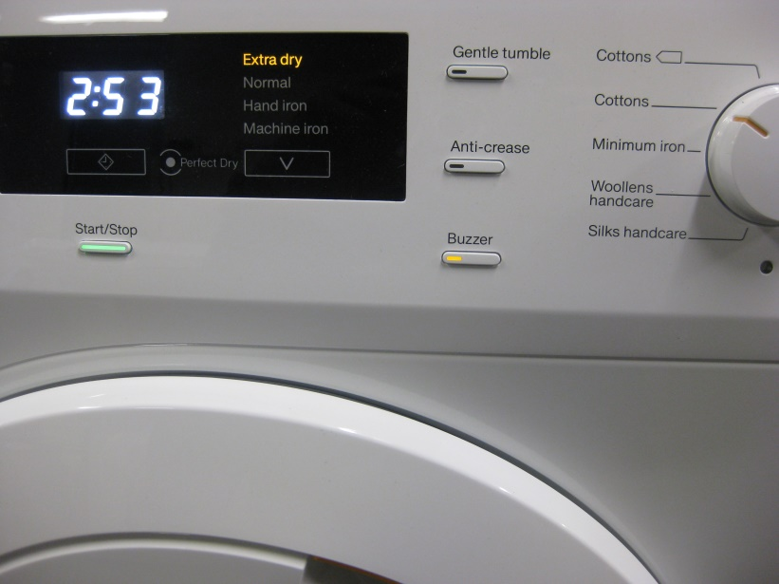

The Electrolux program to be selected is as follows:

* Electrolux Iron Dry Program, Normal Temperature, crease free off, no delay start

The dryer periodically reverses direction and the power dips to near zero. The expected drying time for a rated capacity load is approximately 2:15 for 6kg and about 1:30 for 3kg. The Electrolux dryer has a “Cooling” light that comes on when the dryer is near to completion. The Electrolux dryer makes a short beep at the end of the program. This should be recorded as the termination time for data logging. Electrolux facia with the correct settings is shown below.

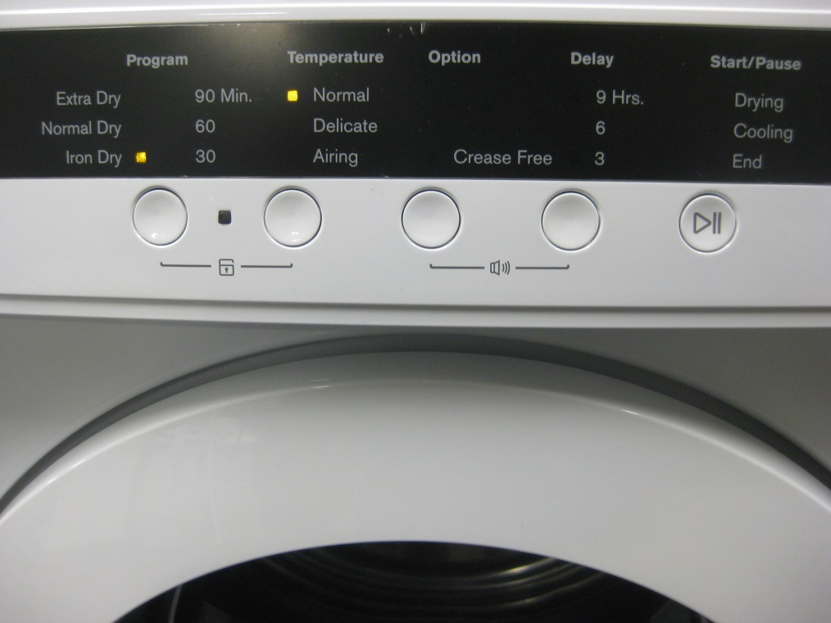

The final moisture content of the load at the completion of the program for each test run should be in the range RMC -3% to +1.5% - this is slightly different to the requirements set out in Table 6 for a Dry Cotton setting. (8.2.2). For the programs selected, the Electrolux unit will probably over-dry slightly for the 3kg load. The Miele will be at the upper end of the range at 8kg and the lower end of the range at 4kg. This is acceptable - just make sure that all the test parameters are recorded for each run.

The test procedure set out in IEC61121 shall be followed. (8.2.4)

The validity for a test run is set out in IEC61121. (8.2.5) Noting however that the valid moisture content range for each run conducted is to be +1.5% to – 3% and not as specified in table 6 of IEC61121

A test series as defined in IEC61121 is not being undertaken. (8.2.6)

Measurements of energy consumption are specified in IEC61121. (8.3) Measurement of water consumption during drying is not applicable to these tests. Measurement of off mode and left on mode is not required for these tests. Laboratories are required to record the following parameters at equal intervals of 1 min or less throughout the test:

* Voltage
* Power
* Energy (0.1 Wh or better)
* Room temperature
* Room relative humidity
* Mass of dryer and load (if possible)

Measurements of condensation efficiency are not required for these tests. (8.4)

Measurements of evenness of drying are not required for these tests. (8.5)

Pressure measurements at the exhaust duct exit during the test (Electrolux unit only) can be used to estimate the volume of exhaust air. (8.6) A hole for a pressure sensor is included in the duct near the dryer exit. The expected pressure at this point is approximately 50 Pa when the specified duct provided is fitted. A small hole for a transducer has been provided at the back of the dryer. The pipe fits well, but it needs to be secured when the dryer is in situ to make sure there is no air leakage.

Evaluations as per Section 9 of IEC61121 are not required. However, raw and summary data for each test run shall be provided to EES. A reporting spreadsheet for the results will be provided.

In lieu of formal conditioning prior to each run, at the completion of testing, the load items shall be hung out loosely in the test laboratory for a minimum of 12 hours to allow the load items to reach equilibrium moisture content in the laboratory conditions. After this time the load items can be retested or stored in a permeable bag or container. It is critical that items from other loads do not get mixed in. Items should be kept clean. Please make sure you count items each time the load is put away.

## Test report format and data to be reported

Machine to be tested, nominal load, test officer

Time date and details of the test run

Mass prior to wetting (dry, but not bone dry)

Nominal mass of the conditioned load (bone dry * 1.065)

Mass of the load after wetting and spinning

Description of process to adjust the mass of the load after spinning

Mass and RMC of the wet load (%) at the start of the test

Program selected and details

Time, energy to be recorded at 1 min intervals throughout the test

Total energy, time at the end of cool down, total mass at the end of cool down, RMC of dry load (%)

An excel sheet to record the above data. All labs provided raw test data for independent analysis.

END OF SPECIFICATION

# Appendix B: Laboratory Power Profiles

Power profiles for selected runs in each laboratory are shown in the following figures.

Figure : Power profile Miele full and half load - Lab A

Load profile for Miele dryer in Lab A
Interval 60 seconds
Initial power is 500W and this increases to 900W after about 60 minutes.
After reaching a peak power of 900W the power declines slightly to about 850W after 120 minutes.
4kg load terminates rapidly after about 100 minutes
8kg load terminates rapidly after about 180 minutes

Figure : Power profile Electrolux full and half load - Lab A

Load profile for Electrolux dryer in Lab A
Interval 120 seconds
Power is constant at 2000W with some brief oscillations and power reductions just prior to termination.
3kg load terminates rapidly after about 70 minutes
6kg load terminates rapidly after about 140 minutes

Figure : Power profile Miele full and half load - Lab B

Load profile for Miele dryer in Lab B
Interval 60 seconds
Initial power is 500W and this increases to 900W after about 60 minutes.
After reaching a peak power of 900W the power declines slightly to about 850W after 120 minutes.
4kg load terminates rapidly after about 100 minutes
8kg load terminates rapidly after about 180 minutes

Figure : Power profile Electrolux full and half load - Lab B

Load profile for Electrolux dryer in Lab B
Interval 60 seconds
Power is constant at 2000W with some brief oscillations and power reductions just prior to termination.
3kg load terminates rapidly after about 70 minutes
6kg load terminates rapidly after about 140 minutes

Figure : Power profile Miele full and half load - Lab C

Load profile for Miele dryer in Lab C
Interval 180 seconds
Initial power is 500W and this increases to 900W after about 60 minutes.
After reaching a peak power of 900W the power declines slightly to about 850W after 120 minutes.
4kg load terminates rapidly after about 100 minutes
8kg load terminates rapidly after about 180 minutes

Figure : Power profile Electrolux full and half load - Lab C

Load profile for Electrolux dryer in Lab C
Interval 180 seconds
Power is constant at 2000W with some brief oscillations and power reductions just prior to termination.
3kg load terminates rapidly after about 70 minutes
6kg load terminates rapidly after about 140 minutes

Figure : Power profile Miele full and half load - Lab D

Load profile for Miele dryer in Lab D
Interval 60 seconds
Initial power is 500W and this increases to 900W after about 60 minutes.
After reaching a peak power of 900W the power declines slightly to about 850W after 120 minutes.
4kg load terminates rapidly after about 100 minutes
8kg load terminates rapidly after about 180 minutes

Figure : Power profile Electrolux full and half load - Lab D

**Load profile for Electrolux dryer in Lab D
Interval 60 seconds
Power is constant at 2000W with some brief oscillations and power reductions just prior to termination.
3kg load terminates rapidly after about 70 minutes
6kg load terminates rapidly after about 140 minutes**

1. Standards Australia (1996) *AS/NZS 2442.1:1996 Performance of household electrical appliances—Rotary clothes dryers Part 1: Energy consumption and performance* including all amendments up to and including AS/NZS 2442.1:1996/Amdt 4
2. Energy Efficient Strategies (2016) *Whitegoods Efficiency Trends: A report into the energy efficiency trends of whitegoods in Australia 1993 – 2014* [online] <http://www.energyrating.gov.au/news/whitegoods-efficiency-trends-1993-2014>
3. This was found to be 1.06 on analysis after the completion of the round robin.