Decision Regulation Impact Statement – Household Refrigerators and Freezers

Regulatory reform opportunities and improving energy efficiency outcomes

November 2017

|  |
| --- |
| This work is licensed under the Creative Commons Attribution 3.0 Australia Licence.  To view a copy of this license, visit <http://creativecommons.org/licences/by/3.0/au>  The Department of the Environment and Energy on behalf of the Equipment Energy Efficiency (E3) Program asserts the right to be recognised as author of the original material in the following manner:  Creative Commons Attribution logo  © Commonwealth of Australia (Department of the Environment and Energy) 2017.  The material in this publication is provided for general information only, and on the understanding that the Australian Government is not providing professional advice. Before any action or decision is taken on the basis of this material the reader should obtain appropriate independent professional advice.  This document is available at [www.energyrating.gov.au](http://www.energyrating.gov.au)  While reasonable efforts have been made to ensure that the contents of this publication are factually correct, the E3 Program does not accept responsibility for the accuracy or completeness of the content, and shall not be liable for any loss or damage that may be occasioned directly or indirectly through the use of, or reliance on, the contents of this publication. |

Contents

Executive Summary vi

1. Introduction 9

1.1 Background 9

1.2 Regulatory Environment 9

1.3 The Market 14

2. The Problem 21

2.1 MEPS 21

2.2 Test standard 23

3. Objective 24

4. Options 25

4.1 Option A: BAU 25

4.2 Option B: Adopt MEPS3 25

4.3 Option C: Adopt MEPS3 and IEC test standard 26

5. Impacts 30

5.1 Option A: BAU 30

5.2 Option B: Adopt MEPS3 30

5.3 Option C: Adopt MEPS3 and IEC test standard 34

6. Conclusion 37

6.1 Recommended option 37

7. Implementation and review 38

7.1 Implementation 38

7.2 Energy Rating Label design 38

7.3 Review 41

8. Consultation 42

8.1 Past Consultations 42

Attachment A – Trends 44

A.1 Sales Trends 44

A.2 Stock Trends 45

A.3 Price Trends 46

Attachment B – Modelling 51

B.1 Cost benefit analysis key parameters and inputs 51

B.2 Sensitivity analysis 54

B.3 Charts 56

Attachment C – Electricity prices and GHG emissions factors 61

Attachment D – Consultations 63

Attachment E – Consultation RIS Submissions 71

Attachment F – MEPS3 Levels 75

Attachment G – Performance and Test Parameters 76

References 81

LIST OF FIGURES

Figure 1: Improvements to refrigerator and freezer efficiency – Australia (1993-2017) 13

Figure 2: Improvements to refrigerator and freezer efficiency – New Zealand (2002-2016) 13

Figure 3: Refrigerator sales by star rating – Australia (2005-2017) 16

Figure 4: Freezer sales by star rating – Australia (2005-2017) 16

Figure 5: Refrigerator and freezer sales by star rating – New Zealand (2011-2016) 17

Figure 6: Refrigerator energy and real price trends – Australia (1993-2017) 19

Figure 7: Freezer energy and real price trends – Australia (1993-2017) 20

Figure 8: Nations with MEPS and/or ERLs 22

Figure 9: Refrigerator ownership trends and projections – Australia and New Zealand 36

Figure 10: Freezer ownership trends and projections – Australia and New Zealand 36

Figure 11: ERL designs 39

Figure 12: Annual sales of refrigerators and freezers – Australia and New Zealand 44

Figure 13: Refrigerator stock – Australia and New Zealand 45

Figure 14: Freezer stock – Australia and New Zealand 45

Figure 15: Average group 1 prices – Australia 46

Figure 16: Average group 2 prices – Australia 46

Figure 17: Average group 3 prices – Australia 47

Figure 18: Average group 4 prices – Australia 47

Figure 19: Average group 5B prices – Australia 48

Figure 20: Average group 5S prices – Australia 48

Figure 21: Average group 5T prices – Australia 49

Figure 22: Average group 6C prices – Australia 49

Figure 23: Average group 6U prices – Australia 50

Figure 24: Average group 7 prices – Australia 50

Figure 25: Refrigerator sales trend by group – Australia 56

Figure 26: Freezer sales trend by group – Australia 56

Figure 27: Refrigerator sales trend by group – New Zealand 57

Figure 28: Freezer sales trend by group – New Zealand 57

Figure 29: Energy consumption by group for Option A (BAU) – Australia 58

Figure 30: Energy consumption by group for Option C (MEPS3 + IEC) – Australia 58

Figure 31: Energy consumption by group for Option A (BAU) – New Zealand 59

Figure 32: Energy consumption by group for Option C (MEPS3 + IEC) – New Zealand 59

Figure 33: Refrigerator lifetime 60

Figure 34: Freezer lifetime 60

List of Tables

Table 1: Cost/benefit estimates – Australia (appliances installed from 2015-2030) vii

Table 2: Cost/benefit estimates – New Zealand (appliances installed from 2015-2030) vii

Table 3: Household refrigerating appliance classes/groups 11

Table 4: Typical refrigerator and freezer characteristics – Australia (2017) 14

Table 5: Refrigerator sales – Australia (2017) 15

Table 6: Freezer sales – Australia (2017) 15

Table 7: Refrigerator sales – New Zealand (2016) 15

Table 8: Freezer sales – New Zealand (2016) 15

Table 9: Average prices – Australia ($2017) 17

Table 10: Group 2 star/price comparison – Australia (2016-2017) 18

Table 11: Group 5B star/price comparison – Australia (2016-2017) 18

Table 12: Group 5T star/price comparison – Australia (2016-2017) 18

Table 13: Group 6C star/price comparison – Australia (2016-2017) 19

Table 14: Group 6U star/price comparison – Australia (2016-2017) 19

Table 15: Estimated converted (standardised) MEPS levels (kWh/annum) 21

Table 16: Proposed ERL algorithm parameters 28

Table 17: International adoption of IEC test parameters 29

Table 18: Expected energy reduction by group, 2014 to 2021 – Option B (sales weighted) 31

Table 19: Average retail price increase and energy savings for Option B in 2021 – Australia 32

Table 20: Average retail price increase and energy savings for Option B in 2021 – New Zealand 32

Table 21: Evaluation of impacts – Option B (MEPS3) 33

Table 22: Evaluation of impacts – Option C (MEPS3 + IEC test standard) 35

Table 23: Indicative implementation timeline 39

Table 24: Modelling assumptions and parameters 51

Table 25: Energy-price coefficients – Australia 53

Table 26: Discount rate sensitivity analysis – Australia 54

Table 27: Discount rate sensitivity analysis – New Zealand 54

Table 28: GHG sensitivity analysis – Australia – A$11.82/tonne CO2-e 55

Table 29: GHG sensitivity analysis – Australia – A$35.00/tonne CO2-e 55

Table 30: GHG sensitivity analysis – New Zealand – NZ$25.00/tonne CO2-e 55

Table 31: Residential electricity tariffs – Australia (real Au 2017 cents/kWh) 61

Table 32: Long-run marginal electricity cost – New Zealand (real NZ 2017 cents/kWh) 61

Table 33: GHG emission factors for electricity – Australia and New Zealand (kg CO2-e/kWh) 62

Table 34: Summary of Stakeholder Submissions 72

Table 35: MEPS cut-off level factors 75

Table 36: Generally agreed performance parameters (Option B) 76

Table 37: Generally agreed performance parameters (Option C) 77

Table 38: Generally agreed test parameters (Option C) 78

Table 39: Test parameters that are proposed to not be included 80

# Executive Summary

**Background**

This decision Regulation Impact Statement (RIS) proposes changes to energy efficiency regulations applicable to household refrigerators and freezers.

In 2016, around 1,050,000 refrigerators and freezers were sold in Australia, with an estimated refrigerator stock of 12.5 million units and a freezer stock of 3.3 million. In 2016, New Zealand refrigerator and freezer sales totalled approximately 212,800[1] and stock levels were estimated to be approximately 2.3 million and 1.1 million resepectively.[2]

Regulations in both countries require that household refrigerators and freezers supplied to consumers meet minimum energy performance standards (MEPS) and also display the Energy Rating Label (ERL). MEPS specify the minimum level of energy performance that products/appliances must meet or exceed before they can be offered for sale. The ERL provides consumers with a product’s energy performance information at point-of-sale that enables them to compare similar products using their star ratings and estimated annual energy consumptions.

MEPS requirements were first introduced in 1999 in Australia (2002 in New Zealand) and were upgraded in 2005 in both countries. The ERL was introduced nationally in Australia in the early 1990s (2002 in New Zealand) and was re‑graded in Australia in 2000 and in both countries in 2010. These policy actions have been taken to reduce energy use, lower greenhouse gas (GHG) emissions and provide consumers with improved purchasing information.

**Problem**

Although the current regulations have largely achieved their objective of promoting the development and use of more energy efficient refrigerators and freezers than would have been the case under business as usual (BAU), regulatory failures exists because:

* Current MEPS levels are set too low for Australia’s and New Zealand’s markets. In an environment where we now have access to a wider variety of cheaper and more efficient appliances, increased electricity costs mean that it is cost effective to mandate tighter MEPS levels. This will reduce consumers’ net costs of refrigeration ownership and also reduce the negative externality of GHG emissions.
* Requiring suppliers to test their appliances to the Australian and New Zealand regionally-specific test standard for refrigerators and freezers makes appliance testing more complex than necessary, resulting in an unnecessarily high regulatory burden.

Consequently, there is scope to align Australia’s and New Zealand’s MEPS levels with those adopted by the United States (US) in 2014, referred to as MEPS3. Further, referencing the International Electrotechnical Committee (IEC) test standard (IEC 62552:2015 parts 1-3), rather than the regionally-specific Australian and New Zealand test standard, will simplify product testing and lead to an efficiency improvement.

**Objective**

The objective of the proposed government actions is to resolve issues with the regulations that impede the supply and purchase of energy efficient or effective household refrigerators and freezers. Without government action, these market distortions and unnecessary costs would continue. Resolving the issues would also contribute to government objectives to improve energy productivity and reduce GHG emissions.

**Policy options**

In this RIS, a number of policy options (Options A, B and C) have been identified:

* Option A: No changes to the existing regulatory requirements - BAU
* Option B: Adopt MEPS3
* Option C: Adopt MEPS3 and the IEC test standard and provide better information on the ERL.

Specific details concerning each option are provided in the Options section.

**Cost benefit analysis**

The estimated impacts of the proposals are shown in **Table 1** and **Table 2**.

Table 1: Cost/benefit estimates – Australia (appliances installed from 2015-2030)

|  |  |  |  |  |  |  |
| --- | --- | --- | --- | --- | --- | --- |
| **Option** | **Energy Saved (cumulative to 2030) GWh** | **GHG Emission Reduction (cumulative to 2030) Mt** | **Total Benefits (NPV, A$M)** | **Total Costs**  **(NPV, A$M)** | **Net Benefit (NPV, A$M)** | **Benefit Cost Ratio** |
| Option B | 4,098 | 3.5 | $1,180.6 | $300.6 | $879.9 | 3.9 |
| Option C | 5,605 | 4.7 | $1,655.9 | $401.7 | $1,254.3 | 4.1 |

*Notes: Discount rate = seven per cent real; AU$ 2017*

Table 2: Cost/benefit estimates – New Zealand (appliances installed from 2015-2030)[3]

|  |  |  |  |  |  |  |
| --- | --- | --- | --- | --- | --- | --- |
| **Option** | **Energy Saved (cumulative to 2030) GWh** | **GHG Emission Reduction (cumulative to 2030) Mt** | **Total Benefits (NPV, NZ$M)** | **Total Costs**  **(NPV, NZ$M)** | **Net Benefit (NPV, NZ$M)** | **Benefit Cost Ratio** |
| Option B | 995 | 0.104 | $82.1 | $39.1 | $43.0 | 2.1 |
| Option C | 1,120 | 0.116 | $93.7 | $45.0 | $48.7 | 2.1 |

*Notes: Discount rate = six per cent real; NZ$ 2017*

Consumers will receive the overwhelming majority of the benefits quantified in Options B and C through reduced consumers’ energy consumption and ongoing electricity cost savings. For example, if Australia and New Zealand were to adopt MEPS3 levels, consumers could expect to save approximately A$145 in reduced energy costs over the life of an average refrigerator.[4]

Option C provides an opportunity to use parts of the IEC test method to enhance the information provided on the ERL concerning energy consumption during normal use in Australian and New Zealand homes. This will provide consumers with better information on the appliances’ likely energy consumption and also encourage manufacturers to optimise appliances’ efficiency under these conditions.

In addition, because Option C would only require that industry use the IEC 62552 test standard, rather than the unique Australia/New Zealand test standard, it would simplify product testing and lead to an efficiency improvement.

Option C remains effective if the discount rate is increased to 10 per cent in the Australian case (benefit cost ratio of 3.46:1) or increased to eight per cent in the New Zealand case (benefit cost ratio of 1.77:1).

**Recommendation**

The Energy Efficiency Advisory Team, which manages the Equipment Energy Efficiency (E3) Program, recommends adopting policy Option C because it would:

* deliver the greatest net benefit to the Australian and New Zealand economies - A$1,254.3 million and NZ$48.7 million respectively
* provide the best benefit cost ratios – 4.1:1 and 2.1:1 respectively
* significantly reduce Australia’s and New Zealand’s cumulative greenhouse gas (GHG) emissions to 2030 – 4.7 Mt and 116 kt respectively.[5]

Option C has also received general support from industry and other stakeholders.

The cost-benefit analysis in this RIS has also shown that there will be significant additional costs on consumers if the current MEPS levels for refrigerators and freezers remain unchanged.

**Implementation and Review**

The main implementation risk from the proposed policy option is that suppliers may not have sufficient time to adjust to the proposed new regulations. This could affect the availability of products, market competition or compliance with the new regulations. This risk has been largely addressed by lengthening the proposed implementation time from one year to two years.

Further, this risk would be also mitigated by introducing a procedure whereby the Regulator would assess whether products with existing registrations be deemed to be compliant with MEPS3 levels and can continue to be sold for the remainder of their registration periods without being required to re-test to the IEC test standard. This approach would significantly reduce both regulatory and administrative burdens during the transition period. It would also help to ensure that there would be an adequate breadth of product offerings and that consumers would continue to have access to a competitive market.

If the Council of Australian Governments (COAG) Energy Council approves to change the regulations, the Australian legal instrument, the *Greenhouse and Energy Minimum Standards (Household Refrigerating Appliances) Determination 2012* (the Determination) would be revised for approval by the Commonwealth Minister for the Environment and Energy. In New Zealand, a policy option needs to be approved by Cabinet before being adopted under the *Energy Efficiency (Energy Using Products) Regulations 2002.* If approved, the updated regulations would be subject to compliance monitoring and review in both countries.

To help consumers understand changes that will occur to the ERL once the Determination becomes effective, E3 will continue to engage with retailers and consumer groups via established processes so that they, and ultimately consumers, can understand what the labelling changes mean and how to best select more efficient appliances. Relevant information will also be provided on the E3 website.

For Australia, a regulatory offset has not been identified to accompany Option C. However, the Commonwealth Department of the Environment and Energy is seeking to pursue net reductions in compliance costs and will work with affected stakeholders and across Government to identify regulatory burden reductions where appropriate.

**Consultation**

Extensive consultation processes have been undertaken between 2011 and 2017, including numerous stakeholder forums and bilateral meetings. During 2017, stakeholder feedback was sought on the policy options presented in a consultation RIS that was released on 13 April 2017. Submissions were invited over a six and a half week period and six public and one confidential submissions were received. Over this period, E3 officials also held public briefing sessions in Sydney, Melbourne and Auckland where policy and modelling briefings were given and stakeholders were encouraged to provide feedback on the regulatory options presented. In August 2017, a stakeholder meeting was held to discuss issues that had been raised by stakeholders. The policy positions in this decision RIS are based on an understanding and consideration of the full range of stakeholders’ views that have been presented.

# Introduction

### 1.1 Background

This decision Regulation Impact Statement (RIS) examines options designed to encourage improvements in the energy efficiency of household refrigeration appliances sold in Australia and New Zealand. Household refrigerators and freezers are also used in commercial settings such as offices and factories for domestic-type purposes. It is estimated that up to 10 per cent of the stock of household refrigerating appliances may be used in commercial settings. However, these units are not considered within the modelling scope of this RIS because there is no accurate estimation of their stock numbers. Therefore, future energy savings and reductions in greenhouse gas emissions from these units that could be realised from instituting options in this RIS would be additional, non‑quantified benefits of the regulatory proposals herein.

A refrigerator is a cooling appliance used for keeping food fresh by the process of refrigeration. A freezer is either a stand-alone appliance or a compartment of the refrigerator used to store food or other perishable items at temperatures below zero degrees Celsius (°C). Refrigerators and freezers have an insulated cabinet with a refrigeration circuit that uses the vapour compression cycle[6] to extract heat from the internal compartments and rejects this to the surrounding room. Internal temperatures are maintained within narrow ranges that are suitable for the specified compartment type.

A refrigerator/freezer can be a significant energy consumer in many households as nearly all households contain at least one refrigerator that is operating 24 hours a day, seven days a week. They are seen as an important long-term household investment. Refrigerators and freezers contribute on average to approximately 10 per cent of households’ electricity demand in Australia and New Zealand.[7] [8]

### 1.2 Regulatory Environment

***Australia***

In 2012, the *Greenhouse and Energy Minimum Standards Act 2012* (GEMS Act)[9] came into effect, creating a national framework for product energy efficiency in Australia. The GEMS Regulator replaced the previous state regulators, and is the sole party responsible for administering the legislation in Australia. The specific requirements for each product regulated under the GEMS Act are set out in legislative instruments called GEMS determinations that are specific to relevant product types. Refrigerators and freezers are covered by the *Greenhouse and Energy Minimum Standards (Household Refrigerating Appliances) Determination 2012* (the Determination) and they must meet certain [regulatory requirements](http://www.energyrating.gov.au/suppliers/registration/regulated-products) before they can be supplied or sold in Australia. The Determination references the standard AS/NZS 4474.2 for many of the technical requirements.

**New Zealand**

Since 2002, New Zealand has regulated the energy performance of products through the *Energy Efficiency (Energy Using Products) Regulations 2002*, which are administered by the Ministry of Business, Innovation and Employment (MBIE). MBIE incorporates changes to MEPS based on advice from the Energy Efficiency and Conservation Authority (EECA), developed with Australian regulators under the joint trans-Tasman E3 Program. The New Zealand Regulations reference the standard AS/NZS 4474.2 for many of the technical requirements. The Regulations generally mirror the requirements of the Determination.

In Australia and New Zealand, energy efficiency regulations have been introduced to address market failures associated with household refrigerators and freezers; namely:

* The Energy Rating Label (ERL) was introduced nationally in 1992 in Australia[10] (and in 2002 for New Zealand) to address an information failure because it was agreed that consumers had inadequate information concerning the relative energy efficiency and energy consumption of appliances when making purchasing decisions.
* Minimum energy performance standards (MEPS) were introduced in 1999 in Australia for a number of reasons including limiting negative externalities[11] due to greenhouse gas (GHG) emissions generated from the operation of appliances and to reduce energy use. New Zealand adopted MEPS in 2002 to raise the energy efficiency of products sold in New Zealand in order to reduce energy consumption and related emissions and deliver a net national benefit. MEPS have also proven to be an effective tool to reduce the energy consumption of consumer market segments that are unresponsive to labelling.

#### 1.2.1 Energy Rating Labelling

The ERL provides consumers with energy performance information at point-of-sale on a range of products (including refrigerators and freezers) that are regulated under GEMS and the New Zealand Regulations. Consumers can use the ERL to compare the star ratings and estimated annual energy consumptions of similar product models and therefore have the information choose the most efficient products that meet their needs.

Energy labelling formulae (known as algorithms) are used in conjunction with test methods prescribed in the relevant determinations/regulations to calculate appliances’ energy star ratings. This ensures that the lowest performing products are allocated low star ratings and better performing products are awarded more stars.

The ERL star ratings for all appliances are reviewed from time to time and the star rating algorithms changed to ensure there are appropriate incentives for manufacturers to continually improve appliance efficiency. In 2005 when refrigerator and freezer MEPS were raised it was also noted that the majority of products had star ratings clustered around the range of 3.5 to 5.0 stars. In 2010, the refrigerator and freezer algorithm used to generate star ratings was revised in order for the ERL to continue to be an effective tool. At that time, all refrigerators and freezers ERL star ratings were decreased by approximately 2.0 stars to encourage the supply of more efficient appliances.

#### 1.2.2 Minimum energy performance standards

MEPS specify a minimum level of energy performance that appliances, such as refrigerators and freezers, must meet or exceed before they can be supplied to consumers. MEPS are mandatory for household refrigerators and freezers in Australia and New Zealand and it has been agreed that they are an appropriate and effective policy option to increase the energy efficiency of products. The use of MEPS means that inefficient products are prevented from entering the market and manufacturers are given appropriate signals to increase product efficiency. For consumers, MEPS mean that all products available in the market meet minimum energy performance targets and have lower running costs over their lifetime. Importantly, MEPS deliver very significant energy savings and emissions reductions that culminate in national benefits regardless of whether or not consumers factor energy performance into their purchase decisions.

The Australian and New Zealand governments work together and consult with industry to determine the appropriate MEPS levels for products. In 2005, household refrigeration MEPS levels were reviewed and tightened (to MEPS2) resulting in products that were less efficient being removed from the market, which helped ensure that manufacturers continued to develop and supply improved energy efficient products.

#### 1.2.3 Scope of the Determination and Regulations

The Determination/Regulations cover the sale of new household refrigerating appliances irrespective of the context in which they are used.[12] **Table 3** shows the product groups that are covered by the Determination/Regulations. Refrigerators and freezers are classified into groups according to the configuration and type of compartments and the defrosting technologies used.

Table 3: Household refrigerating appliance classes/groups

|  |  |
| --- | --- |
| **Group** | **Configuration** |
| 1 | Refrigerator without a low temperature compartment[13], automatic defrost |
| 2 | Refrigerator with or without an ice making compartment, manual defrost (bar refrigerators) |
| 3 | Refrigerator with or without an ice making compartment, includes a short-term frozen food compartment, manual defrost |
| 4 | Refrigerator-freezer, fresh food compartment is cyclic defrost, freezer is manual defrost |
| 5B | Refrigerator-freezer, both compartments automatic defrost, bottom mounted freezer |
| 5S | Refrigerator-freezer, both compartments automatic defrost, side by side |
| 5T | Refrigerator-freezer, both compartments automatic defrost, top mounted freezer |
| 6C | Chest freezer, all defrost types |
| 6U | Vertical freezer, manual defrost |
| 7 | Vertical freezer, automatic defrost |

Source: AS/NZS 4474.1:2007, Table 1.1

The following refrigerating products are excluded from the scope of the Determination/Regulations and therefore are not within the scope of this RIS:

1. products which have a total gross volume of less than 60 litres and that are designed exclusively for use in caravans and other vehicles including: mobile homes; campervans; rail cars; and boats;
2. portable products that have a gross volume of less than 30 litres;
3. products that have a gross volume of less than 30 litres where the refrigeration function is secondary, such as boiled and cooled water dispensers;
4. products that have no options for connection to a 230 volt or 400 volt mains electricity supply at 50 hertz;
5. products that cool using technologies other than the vapour compression cycle;
6. wine storage cabinets; or
7. stand alone ice-makers.[14]

#### 1.2.4 Standards and Testing

Standards are documents that set out specifications and testing procedures to ensure that products are safe, reliable and consistently perform the way suppliers claim. Standards also set out specifications to ensure products meet certain energy performance levels and other energy efficiency requirements. The Determination/Regulations refer to the following Australian and New Zealand performance and test standards:

* *AS/NZS 4474.1:2007 Performance of household electrical appliances – Refrigerating appliances – Part 1: Energy consumption and performance* including amendments 1 and 2 (also known as Part 1). This is the **test standard** and includes: all ambient test conditions; the test method, requirements for temperature performance; test materials and details the method for determining energy consumption.
* *AS/NZS 4474.2:2009/* *Amdt2:2014 Performance of household electrical appliances – Refrigerating appliances – Part 2: Energy labelling and minimum energy performance standard requirements* including amendments 1 and 2 (also known as Part 2)*.* This is the **performance standard** and includes: algorithms for the calculation of the energy efficiency rating; star rating and comparative energy consumption; performance requirements; details of the energy label; and application requirements. It also contains the MEPS for refrigerators and freezers.

In Australia, suppliers must have their appliances tested in accordance with the test standard and they are permitted to have tests performed in Australia or elsewhere. In Australia, the GEMS Regulator is responsible for monitoring and compliance under the GEMS Act. Product compliance testing must be undertaken at a National Association of Testing Authorities (NATA) accredited (or equivalent) laboratory.

In New Zealand, EECA is the regulator and manufacturers may test their models in their own laboratories which do not have to be International Accreditation New Zealand (IANZ) or NATA accredited. However, all check tests performed by the E3 Program are performed in a recognised and accredited laboratory.

AS/NZS 4474.1is a regionally unique test standard and suppliers must pay to access this standard so they can understand the testing requirements if they want to supply products into the Australian or New Zealand markets.

#### 1.2.5 Product Registration

In order to supply products regulated under the GEMS Act and the *Energy Efficiency (Energy Using Products) Regulations 2002*, suppliers must register their products online.[15] Registrations need to be accompanied by a test report that demonstrates that products meet MEPS. The results of the test report will also be used to determine the energy consumption that is provided on the product’s ERL.

Products registered in Australia are considered registered under the New Zealand Regulations and these products can be supplied in New Zealand. The Trans-Tasman Mutual Recognition Arrangement (TTMRA) provides that products registered in New Zealand may be sold in Australia without the need for an Australian registration, provided the product was imported into Australia from New Zealand.

#### 1.2.6 Effectiveness of existing measures

The introduction of refrigerator and freezer MEPS in Australia and New Zealand have in the past compelled market participants to supply appliances with improved energy efficiency, reducing: consumers’ energy costs; national energy demand; and related greenhouse gas emissions.[16] **Figure 1** and **Figure 2** show that the announcement and introduction of MEPS in Australia and New Zealand followed by the tightening of MEPS levels in 2005 (to MEPS2), aligning MEPS levels with world’s best practice, have reduced the energy consumption of refrigerators and freezers by approximately 50 per cent. ERL parameters have also been adjusted to help ensure that consumers have relevant information that accurately represents the relative energy efficiency of products on the market.

For refrigerators, in Australia, the introduction of MEPS2 in 2005 has resulted in financial savings in the range of AU$1.83 to AU$2.92 billion in 2014 terms from 2005 to 2014. For freezers, in Australia, MEPS2 achieved financial savings in the range of AU$246.5 million to AU$410.5 million in 2014 terms between 2005 and 2014.[17]

To meet more stringent MEPS levels, improvements by manufacturers have included better compressors, improved insulation, more efficient fans (both reducing the fan motor’s energy use and its heat transfer to the food compartment) and microchip control of the defrost cycle.

**Figure 1** to **Figure 3** show that since initial gains from the introduction of MEPS2 in 2005, there have been relatively modest improvements in the energy efficiency of refrigerators and freezers supplied to Australia and New Zealand. Efficiency improvements from 2013 can be attributed to a number of factors:

* The ERL regrade in 2010 encouraging the supply of more efficient models
* Announcement of MEPS3 in 2013
* The supply of more efficient appliances from overseas markets where governments have mandated tighter MEPS levels, such as the United States of America (US) and Europe.

Figure 1: Improvements to refrigerator and freezer efficiency – Australia (1993-2017)

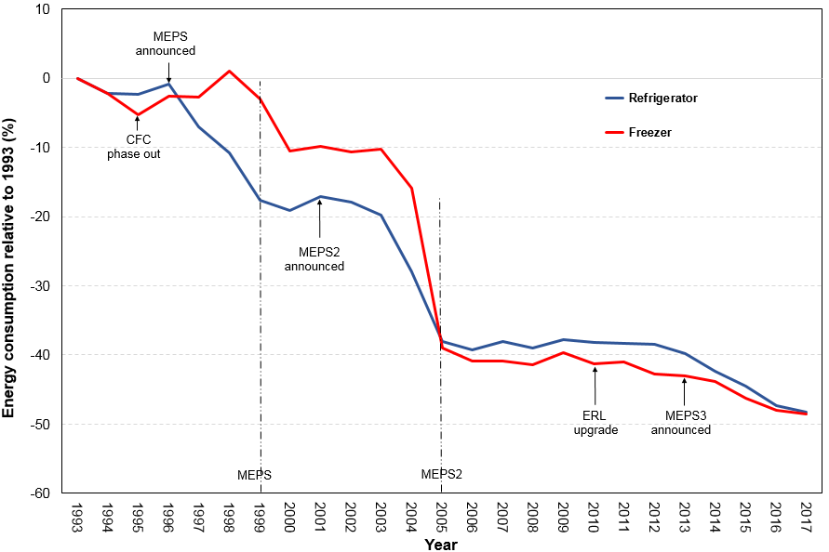

Source: Energy Efficient Strategies estimates (2017)

Figure 2: Improvements to refrigerator and freezer efficiency – New Zealand (2002-2016)

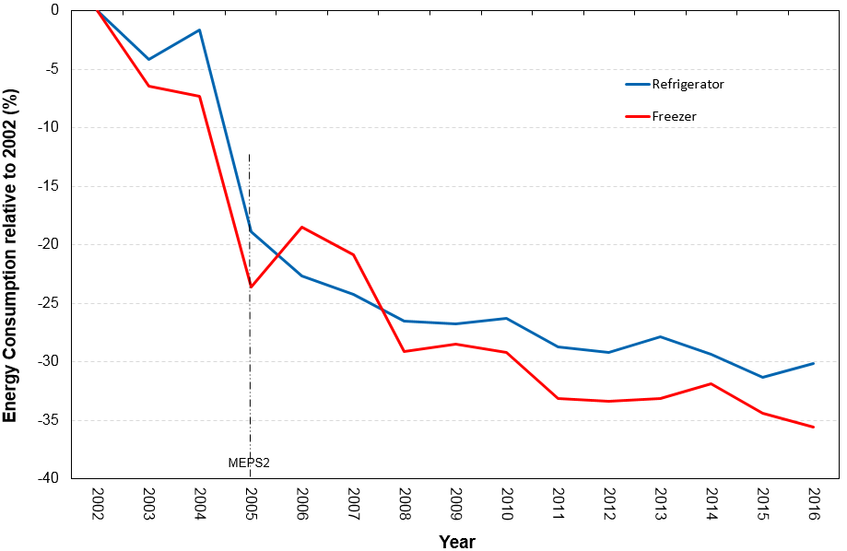

Source: Energy Efficiency and Conservation Authority (2016)

Notes: Data beginning from 2002 when these appliances were first regulated. Actual sales data is required to be collected by EECA on an annual basis

### 1.3 The Market

Australian manufacturing of whitegoods, including refrigerators and freezers, ceased in April 2016 and New Zealand also ceased whitegoods manufacturing in late 2016. Since then, all refrigerating appliances have been imported into Australia and New Zealand with refrigerators predominantly coming from China, Thailand, South Korea, the US, Germany, Brazil, Japan, Mexico and Taiwan. The majority of freezers are imported from China. Manufacturers and importers bring in appliances and supply them to retailers who sell to consumers.

#### 1.3.1 Characteristics of appliances

Approximately 120 brands of refrigerators and freezers are registered for supply in Australia and New Zealand. Major refrigerator brands include: Fisher and Paykel, Hisense, LG, Samsung and Westinghouse. Major freezer brands include: Changhong, Fisher and Paykel, Haier, Hisense and Westinghouse. There are approximately 1,200 models of refrigerators and 370 models of freezers registered for supply in Australia and New Zealand.[18]

The average storage volumes of these appliances have continued to increase slightly over the past 20 years. In 2017, the average total volume of a refrigerator (refrigerator/freezer configuration) purchased in Australia was 417 litres and average freezer volume was 214 litres, as shown in **Table 4**. In New Zealand, the typical average refrigerator volume tends to be slightly smaller than in Australia whereas the typical New Zealand freezer volume tends to be slightly larger.

Table 4: Typical refrigerator and freezer characteristics – Australia (2017)

|  |  |  |
| --- | --- | --- |
| **Characteristic** | **Refrigerator** | **Freezer** |
| Fresh food volume (litres) | 288 | - |
| Freezer volume (litres) | 122 | 214 |
| Other volume (litres) | 7 | - |
| **Average total volume (litres)** | **417** | **214** |
| Label energy usage (kWh/year) | 399 | 319 |
| Average star rating (rounded) | 3.0 | 2.5 |
| Price (AU$2017) | $1,063 | $566 |

Source: Energy Efficient Strategies (2016) *Whitegoods Efficiency Trends*, pages 30 and 40, updated with 2017 GfK data

#### 1.3.2 Stock

In 2016, the estimated Australian stock of household refrigerators was approximately 12.5 million units and freezer stock was 3.3 million. New Zealand stock levels are estimated to be 2.3 million and 1.1 million respectively.[19] Stock estimates have been derived using Australian Bureau of Statistics and Statistics New Zealand data and estimates of household refrigerator and freezer ownership levels. Stock levels are a function of sales adding to existing stock and old appliances being retired. Industry estimates that the average refrigerator life is approximately 15-17 years while freezers have a life expectancy of approximately 21-25 years.

#### 1.3.3 Sales

In 2017, the five major refrigerator brands accounted for approximately 79 per cent of Australian sales and the five major freezer brands accounted for approximately 93 per cent of sales.[20] According to 2016 sales data, approximately 900,000 refrigerators and 150,000 freezers were sold in Australia valued at approximately $1.11 billion.[21] As shown in **Table 5**, groups 5T and 5B dominate Australia’s refrigerator market with approximately 77 per cent of sales, with group 2 (small bar refrigerators) capturing approximately 10 per cent and group 5S holding about eight per cent.[22]

Table 5: Refrigerator sales – Australia (2017)

|  |  |
| --- | --- |
| **Refrigerator Group** | **Percentage of Sales** |
| 1 | 4.0% |
| 2 | 10.4% |
| 3 | 0.6% |
| 4 | 0.2% |
| 5B | 38.9% |
| 5S | 7.6% |
| 5T | 38.2% |

Source: GfK sales data

As shown in **Table 6**, group 6C (chest freezers) accounts for about 52 per cent of Australia’s freezer sales and group 7 (frost free vertical) holds about 29 per cent of sales.

Table 6: Freezer sales – Australia (2017)

|  |  |
| --- | --- |
| **Freezer Group** | **Percentage of Sales** |
| 6C | 51.5% |
| 6U | 19.8% |
| 7 | 28.7% |

Source: GfK sales data

In 2016, approximately 212,800 refrigerators and freezers were sold in New Zealand.[23] As shown in **Table 7**, groups 5T and 5B lead the New Zealand refrigerator market with approximately 66 per cent of sales, group 2 captures approximately 15 per cent and group 5S holds 8 per cent.[24]

Table 7: Refrigerator sales – New Zealand (2016)

|  |  |
| --- | --- |
| **Refrigerator Group** | **Percentage of Sales** |
| 1 | 3.8% |
| 2 | 15.4% |
| 3 | 0.8% |
| 4 | 5.7% |
| 5B | 47.3% |
| 5S | 8.0% |
| 5T | 19.1% |

Source: Energy Efficiency and Conservation Authority

As shown in **Table 8**, group 6C accounts for about 62 per cent of New Zealand’s freezer sales and group 6U holds about 21 per cent of sales.

Table 8: Freezer sales – New Zealand (2016)

|  |  |
| --- | --- |
| **Freezer Group** | **Percentage of Sales** |
| 6C | 61.6% |
| 6U | 21.3% |
| 7 | 17.1% |

Source: Energy Efficiency and Conservation Authority

**Figure 3** and **Figure 4** show Australian refrigerator and freezer sales by star rating from 2005 when MEPS2 was introduced. Consumers have gradually shifted purchasing preferences to more efficient products. In 2017, approximately 60 per cent of refrigerators sold carried three or more stars and about 65 per cent of freezers carried three or more stars.

Figure 3: Refrigerator sales by star rating – Australia (2005-2017)

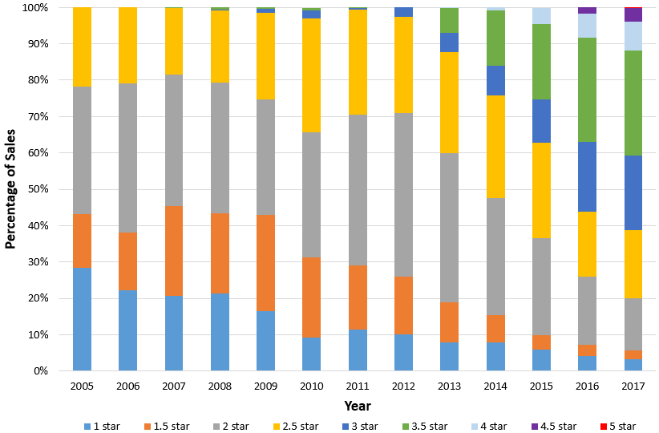

Source: GfK sales data. 2017 sales are based on six months of data that has been scaled up

Figure 4: Freezer sales by star rating – Australia (2005-2017)

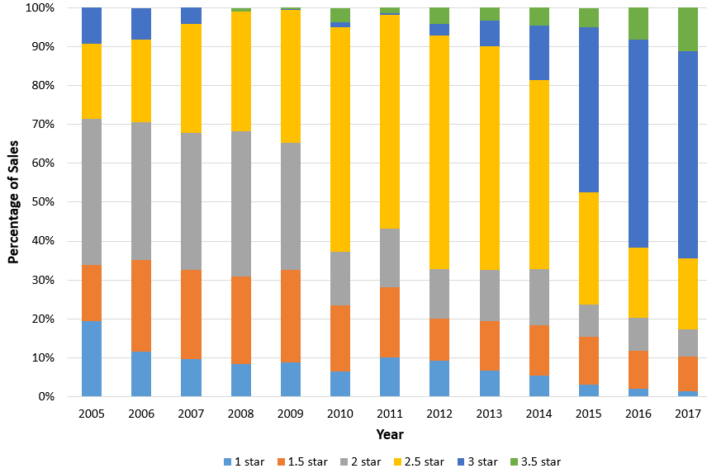

Source: GfK sales data. 2017 sales are based on six months of data that has been scaled up

**Figure 5** shows that New Zealand consumers have been shifting their purchasing decisions towards more efficient appliances. In 2016, approximately 45 per cent of appliances sold carried 2.5 or more stars.

Figure 5: Refrigerator and freezer sales by star rating – New Zealand (2011-2016)

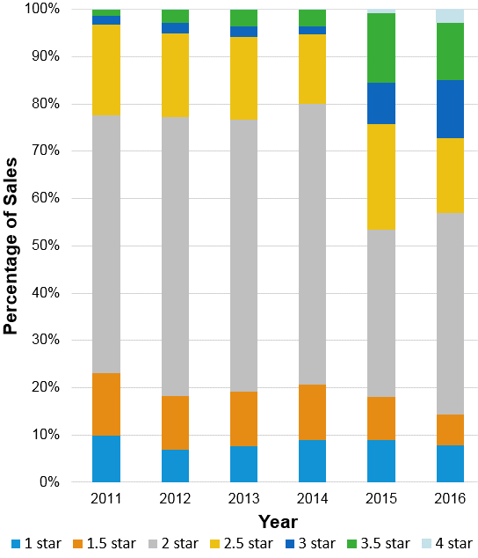

Source: Energy Efficiency and Conservation Authority

#### 1.3.4 Prices

The real average prices of household refrigerating appliances in all product groups have trended down over time. **Table 9** provides the average price in Australia for the typical refrigeration appliance in each group (detailed time‑series price data is at Attachment A). It is understood that these trends have also been occurring in New Zealand because the majority of products sold in both markets are identical and the levels of retail competition in Australia and New Zealand are likely to be similar. There are no trade barriers between Australia and New Zealand under the TTMRA and all major refrigerator suppliers compete in both markets.

Table 9: Average prices – Australia ($2017)

|  |  |
| --- | --- |
| **Group** | **Average price** |
| 1 | $893 |
| 2 | $288 |
| 3 | $374 |
| 4 | $484 |
| 5B | $1,563 |
| 5S | $1,452 |
| 5T | $753 |
| 6C | $404 |
| 6U | $330 |
| 7 | $1,026 |

Source: Energy Efficient Strategies (2016) *Whitegoods Efficiency Trends*,

Detailed Output Tables updated with 2017 GfK data

Australian sales data indicates that improved energy efficiency does not necessarily carry a retail price premium. In some instances refrigerators and freezers with greater efficiencies retail for lower prices. **Table 10** shows that while there is a price premium (per litre) for 2.5 star group 2 refrigerators, 3.0 star appliances generally retailed cheaper than other star ratings. Similarly, **Table 11** and **Table** **12** showthatenergy efficient group 5B and 5T refrigerators do not necessarily carry a price premium, and in some groups, more efficient refrigerators retail cheaper (e.g. on a per litre basis, a 4.5 star 5B refrigerator is generally sold cheaper than a 2.0 to 3.5 star refrigerator and a 4.0 star 5T refrigerator is generally sold cheaper than a 3.5 star). These tables need to be carefully interpreted because some table cells have have few models and, in these cases, characteristics may not be representative of the group.

Table 10: Group 2 star/price comparison – Australia (2016-2017)

|  |  |  |  |  |  |
| --- | --- | --- | --- | --- | --- |
| **Star Rating** | **1.0** | **1.5** | **2.0** | **2.5** | **3.0** |
| **Number of Models** | 23 | 12 | 19 | 11 | 13 |
| **Average Volume (litres)** | 84.5 | 88.8 | 129.1 | 181.0 | 170.0 |
| **Average Price (2013$)** | $216 | $210 | $278 | $477 | $362 |
| **Energy** | 268.3 | 242.1 | 225.5 | 216.7 | 189.7 |
| **$/litre** | $2.56 | $2.36 | $2.16 | $2.63 | $2.13 |

Source: Energy Efficient Strategies (2016) *Whitegoods Efficiency Trends*, page 95 - updated with 2017 GfK data

Table 11: Group 5B star/price comparison – Australia (2016-2017)

|  |  |  |  |  |  |  |  |
| --- | --- | --- | --- | --- | --- | --- | --- |
| **Star Rating** | **1.5** | **2.0** | **2.5** | **3.0** | **3.5** | **4.0** | **4.5** |
| **Number of Models** | 7 | 46 | 67 | 77 | 65 | 19 | 10 |
| **Average Volume (litres)** | 416.7 | 532.4 | 621.3 | 514.3 | 474.5 | 441.5 | 468.3 |
| **Average Price (2013$)** | $1,193 | $1,734 | $2,222 | $1,589 | $1,466 | $1,048 | $1,337 |
| **Energy** | 555.2 | 610.7 | 589.9 | 460.8 | 394.3 | 327.2 | 304.3 |
| $/litre | $2.86 | $3.26 | $3.58 | $3.09 | $3.09 | $2.37 | $2.86 |

Source: Energy Efficient Strategies (2016) *Whitegoods Efficiency Trends*, page 99 - updated with 2017 GfK data

Table 12: Group 5T star/price comparison – Australia (2016-2017)

|  |  |  |  |  |  |  |  |  |
| --- | --- | --- | --- | --- | --- | --- | --- | --- |
| **Star Rating** | **1.5** | **2.0** | **2.5** | **3.0** | **3.5** | **4.0** | **4.5** | **5.0** |
| **Number of Models** | 1 | 30 | 55 | 27 | 80 | 9 | 1 | 3 |
| **Average Volume (litres)** | 158.6 | 244.5 | 305.3 | 419.5 | 416.0 | 419.5 | 620.9 | 494.8 |
| **Average Price (2013$)** | $404 | $453 | $550 | $743 | $903 | $887 | $1,291 | $1,507 |
| **Energy** | 370.7 | 406.2 | 392.7 | 414.9 | 354.0 | 322.6 | 329.3 | 269.9 |
| **$/litre** | $2.55 | $1.85 | $1.80 | $1.77 | $2.17 | $2.11 | $2.08 | $3.05 |

Source: Energy Efficient Strategies (2016) *Whitegoods Efficiency Trends*, page 98- updated with 2017 GfK data

There are similar observations for certain groups of freezers as shown in **Table 13** and **Table 14** with 3.0 star and 3.5 star group 6C freezers sold cheaper than 2.0 star freezers and 3.0 and 3.5 star group 6U freezers sold cheaper than 1.5 or 2.5 star freezers, on a price per litre basis.

Table 13: Group 6C star/price comparison – Australia (2016-2017)

|  |  |  |  |  |  |  |
| --- | --- | --- | --- | --- | --- | --- |
| **Star Rating** | **1.0** | **1.5** | **2.0** | **2.5** | **3.0** | **3.5** |
| **Number of Models** | - | - | 10 | 18 | 21 | 11 |
| **Average Volume (litres)** | - | - | 401.2 | 402.9 | 183.8 | 169.9 |
| **Average Price (2013$)** | - | - | $898 | $679 | $358 | $306 |
| **Energy** | - | - | 495.0 | 468.5 | 274.6 | 237.2 |
| **$/litre** | - | - | $2.24 | $1.68 | $1.95 | $1.80 |

Source: Energy Efficient Strategies (2016) *Whitegoods Efficiency Trends*, page 101 - updated with 2017 GfK data

Table 14: Group 6U star/price comparison – Australia (2016-2017)

|  |  |  |  |  |  |  |
| --- | --- | --- | --- | --- | --- | --- |
| **Star Rating** | **1.0** | **1.5** | **2.0** | **2.5** | **3.0** | **3.5** |
| **Number of Models** | - | 6 | 7 | 4 | 8 | 6 |
| **Average Volume (litres)** | - | 81.2 | 139.8 | 86.1 | 133.8 | 154.5 |
| **Average Price (2013$)** | - | $238 | $340 | $401 | $391 | $423 |
| **Energy** | - | 288.3 | 320.5 | 230.3 | 240.8 | 222.8 |
| **$/litre** | - | $2.93 | $2.43 | $4.66 | $2.92 | $2.74 |

Source: Energy Efficient Strategies (2016) *Whitegoods Efficiency Trends*, page 102 - updated with 2017 GfK data

As shown in **Figure 6** and **Figure 7**, regulatory measures have contributed to appliances consuming considerably less energy while real costs have continued to trend downwards. For example, in 1993 the average price (in $2017) of an average‑sized refrigerator sold in Australia was approximately $1,650 and in 2017, the average price has fallen to approximately $1,050. Similarly, the average price (in $2017) of an average-sized freezer sold in Australia has fallen from approximately $1,050 in 1993 to about $550 in 2017.[25]

Figure 6: Refrigerator energy and real price trends – Australia (1993-2017)

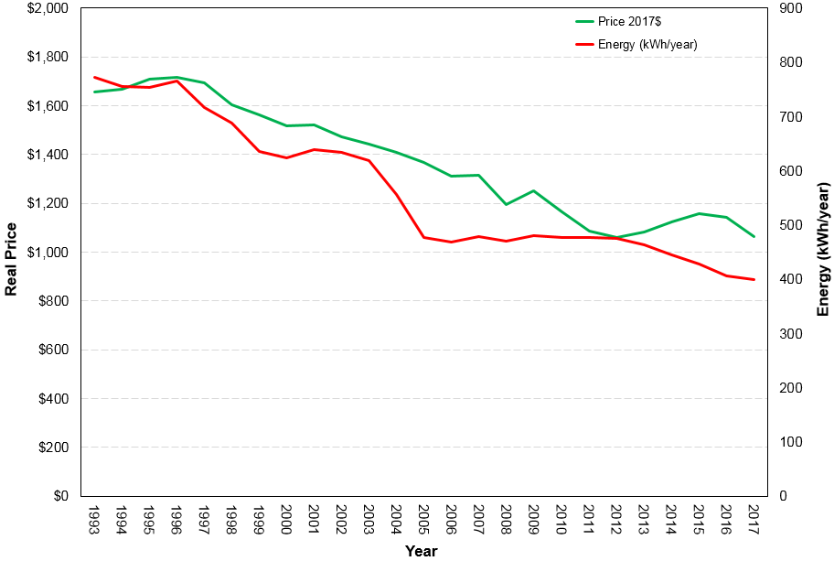

Source : Energy Efficient Strategies (2016) *Whitegoods Efficiency Trends*, page 5 - updated with 2017 GfK data

Figure 7: Freezer energy and real price trends – Australia (1993-2017)

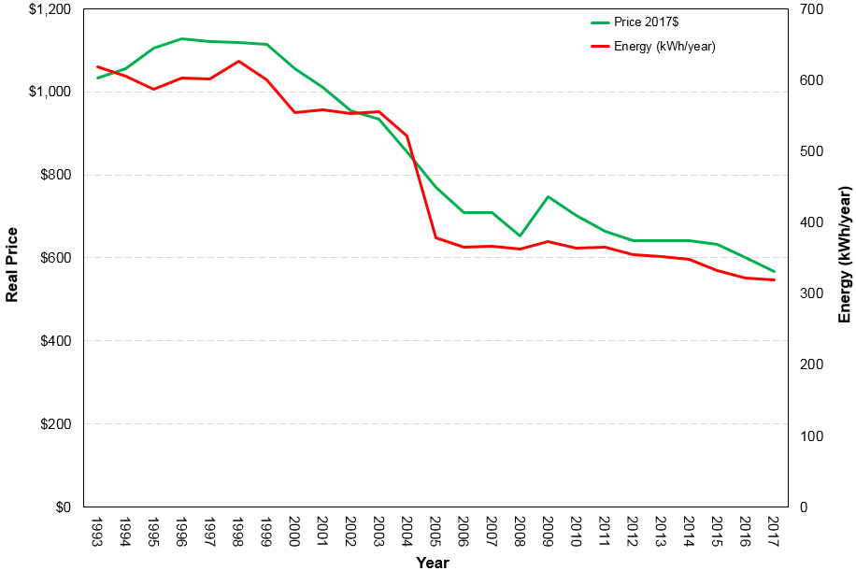

Source: Energy Efficient Strategies (2016) *Whitegoods Efficiency Trends*, page 6 - updated with 2017 GfK data

It is assumed that similar pricing characteristics as those shown in **Table 10** to **Table 14** and trends shown in **Figure 6** and **Figure** **7** are also present in the New Zealand market.

These trends are not unique to Australia and New Zealand and similar effects have been reported in other countries.[26] Observed real price reductions are understood to be driven by a combination of factors:

* Competition between manufacturers
* Improvements in manufacturing efficiencies
* Some suppliers have moved their manufacturing operations to countries where labour and administrative costs are lower
* Reductions in materials costs.

While real retail prices have trended down over time, it is important to note that retail price is not always an accurate reflection of the cost of manufacturing an appliance. Further, while **Table 10** to **Table** **14** show that there is not necessarily a direct correlation between higher efficiency appliances and higher retail prices, it is acknowledged that, all else being equal, manufacturing costs of more energy efficient refrigerators and freezers are generally higher. Relatively lower retail prices charged for relatively high star appliances may be a reflection of some suppliers squeezing their margins in pursuit of sales volumes.

# The Problem

The current regulatory requirements applicable to household refrigerators and freezers have contributed to the development and supply of more energy efficient appliances in Australia and New Zealand than would have been the case under a business as usual (BAU) scenario. However, there is scope to make significant simplification and harmonisation changes to the regulations that can address adverse consequences and improve energy efficiency. In this section, these regulatory issues are discussed.

In Australia and New Zealand, energy efficiency regulations in the form of the ERL and MEPS have been introduced to address market failures (information failure and negative externalities as discussed in Section 1.2) associated with household refrigerators and freezers. However, there have only been relatively modest improvements in the energy efficiency of refrigerators and freezers supplied in Australia and New Zealand beyond the regulatory levels set in 2005, compared to what is technically achievable. It is likely that in the absence of more stringent MEPS levels, further efficiency gains in these markets will be relatively slow to materialise.

### 2.1 MEPS

Since 2005, the US and European Union (EU) have both tightened their MEPS levels, stimulating product energy efficiency improvements, reducing emissions and reducing consumers’ energy costs. Consequently, Australia’s and New Zealand’s MEPS levels have again lagged behind those adopted by other countries as shown in **Table 15**.

Table 15: Estimated converted (standardised) MEPS levels (kWh/annum)

|  |  |  |  |  |
| --- | --- | --- | --- | --- |
|  | **Appliance** | | | |
| **Country/Region** | Small refrigerator | Small refrigerator‑freezer | Medium refrigerator‑freezer | Chest freezer |
| EU | 183 | 258 | 370 | 211 |
| US | 224 | 294 | 360 | 329 |
| Mexico | 298 | 408 | 499 | 346 |
| Australia/New Zealand | 315 | 448 | 540 | 384 |
| China | 332 | 394 | 575 | 404 |
| India | - | 522 | 628 | - |

Source: CLASP (2014) *Improving Global Comparability of Appliance Energy Efficiency Standards and Labels*

Notes: The standardised MEPS values in this table specify the maximum allowable power consumptions per annum that broad categories of refrigerators and freezers must not exceed for them to be allowed to be offered for supply in indicated markets. The lower the number, the less energy used by the appliance.

CLASP notes the above converted levels, taking into account differences in test methods, are based on estimates and that actual figures are likely to be within 25 per cent of the indicated values.

Efficiency improvements in the US and EU have been achieved by incorporating mature technologies such as vacuum insulation panels and more efficient compressors. While some very efficient models sold in Australia and New Zealand already incorporate these technologies, other less-efficient models could also relatively easily be upgraded and would deliver considerable emissions abatements and energy cost savings to consumers.

When MEPS2 levels were agreed for Australia and New Zealand, a cost benefit analysis was undertaken to determine the optimum mandated efficiency levels, weighing up the costs associated with more efficient appliances with potential energy savings. This level was assessed as appropriate for the market conditions prevailing at the time. However, since 2005 when MEPS2 levels were decided:

* Large markets in the EU and US have tightened MEPS levels and are now supplied with more energy efficient refrigeration appliances using mature technologies that were not available in 2005. Therefore, a wide variety of more energy efficient appliances are also available for Australian and New Zealand consumers
* Australia’s electricity prices have increased significantly over the past five to 10 years
* Real appliance prices have continued to fall, making higher levels of efficiency even more cost effective.

**Figure 3** and **Figure 4** show that approximately 30 per cent of refrigerators and about 25 per cent of freezers are relatively inefficient. In other markets these models have been removed when MEPS levels were increased. Manufacturers already supply many energy efficient models to other international markets, but relatively few of such models are supplied to our markets. For example, there are only seven models (of approximately 1,540 models registered) that have attained 5.0 stars of a possible 10 stars provided for by the ERL.

***For the reasons above, a regulatory failure exists because current MEPS levels are set too low for Australia’s and New Zealand’s markets. In an environment where we now have access to a wider variety of cheaper and more efficient appliances, increased electricity costs mean that it is cost‑effective to mandate tighter MEPS levels. This will reduce consumers’ net costs of refrigeration ownership and also reduce the negative externality of GHG emissions.***

Recognising the value of further work to stimulate demand for the purchase of more energy efficient refrigerating appliances, the E3 Program is pursuing avenues to achieve continued appliance energy efficiency gains. These initiatives include behavioural insights work underway that is examining consumer behaviour to better understand and influence consumers’ purchasing decisions toward more energy efficient appliances.

However, such work streams are newly commenced and it will take several years to effect any possible changes. Currently, the energy efficiency of products in the global market is primarily driven by MEPS regulations and, as a small market of approximately two per cent of global sales, Australia and New Zealand need to use the existing MEPS policies to address the existing market failure.

The international application of appliance energy efficiency standards via MEPS and energy efficiency labelling programs were introduced in the 1970s and are now applied in more than 80 countries as indicted in **Figure 8.** While the design and coverage of these measures vary according to nations’ individual policies and circumstances, they provide central components of most national energy efficiency and climate change mitigation programs.[27]

Figure 8: Nations with MEPS and/or ERLs

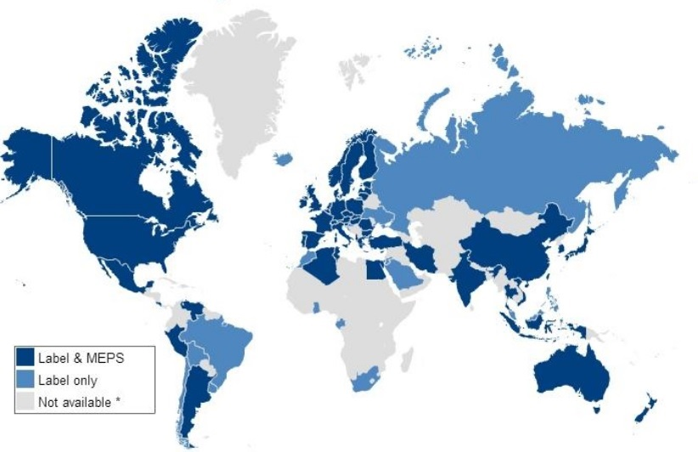

Source: IEA (2014) *Energy Efficiency Standards and Labeling*

There is now an opportunity to align Australia’s and New Zealand’s MEPS with international best practice and realise significant energy savings for consumers and reduce GHG emissions.

### 2.2 Test standard

Another problem with the current regulatory framework is that Australia and New Zealand use a unique regional standard when testing the energy efficiency of household refrigerating appliances to assess whether appliances meet MEPS. However, because several countries, who are major household refrigerating appliances suppliers to the Australian and New Zealand markets (notably China, Japan and Thailand), have already adopted test methods similar to the International Electrotechnical Committee test method *62552-3:2015*, *Household Refrigerating Appliances - Characteristics and Test Methods - Part 3: Energy Consumption and Volume* (the IEC test method[28]) the requirement to also test to our regional standard imposes an unnecessary regulatory burden on suppliers. In addition, the Australian and New Zealand standard measures energy consumption at an ambient temperature of 32°C whereas the average household temperature is approximately 21°C and therefore the energy consumption figure on the ERL is a poor reflection of in-home energy use. In comparison, the IEC standard measures energy consumption at both 16°C and 32°C. Testing at two different temperatures can provide improved information on the likely field performance of appliances and provides an opportunity to recalibrate the ERL to better reflect the expected energy consumption during normal use in Australian and New Zealand households.

***For the reasons above, a second regulatory failure exists because Australia and New Zealand require product suppliers to use a unique test method when testing appliances for MEPS and labelling requirements, rather than using an internationally recognised and employed test method, and therefore businesses face unnecessary regulatory costs.***

# Objective

**Why is government action needed?**

The proposed government actions to exclude the least energy efficient household refrigeration products from the Australian and New Zealand markets, adopt an internationally recognised test procedure and provide better information on the ERL have the following objectives for Australia and New Zealand:

* Result in the increased supply of more energy efficient household refrigerators and freezers to the national stock
* Reduce greenhouse gas emissions and assist both countries to meet climate change related commitments
* Mitigate the growth in energy demand thereby defer the need to invest in new energy supply infrastructure
* Reduce consumers’ energy costs
* Deliver national benefits
* Encourage manufacturers to optimise their product performance under conditions of normal use
* Reduce product suppliers compliance costs by removing the need to test to a unique regional standard
* Ensure that regulation remains relevant and effective over time.

Without government action the regulatory failures identified in this decision RIS will persist.

For Australia, the objectives of this RIS are consistent with Principle 6 of the COAG RIS Guidelines. This principle seeks the review of regulation “…with a view to encouraging competition and efficiency, streamlining the regulatory environment, and reducing the regulatory burden on business arising from the stock of regulation”. The proposals in this consultation RIS are also aligned with the *Australian Government Industry Innovation and Competitiveness Agenda (2014)* principle to reduce regulatory burden by removing inefficient regulation and simplify compliance.[29]

It is considered that the COAG RIS guidelines are broadly in line with the requirements of the New Zealand Government for Regulatory Impact Analysis.

# Options

The following policy options are considered to address the problems identified in this RIS:

* Option A: No changes to the existing requirements - BAU
* Option B: Adopt MEPS3
* Option C: Adopt MEPS3 and the IEC test standard and provide better information on the ERL

### 4.1 Option A: BAU

This option would see no changes to the current regulatory requirements. MEPS would remain unchanged and therefore the energy efficiency benefits of the existing requirements would continue to accrue as the existing stock of household refrigerators and freezers is turned over and replaced by products that meet current MEPS levels. It can be expected that there will likely be some improvements in the energy efficiency of appliances supplied to the Australian and New Zealand markets due to manufacturers’ abilities to produce more energy efficient appliances to comply with the energy efficiency policies instituted in countries that have tighter MEPS. However, as previously discussed, efficiency improvements are likely to be slower to materialise in the absence of tighter MEPS.

This option also involves the continued use of AS/NZS 4474.1 as the test standard in Australia and New Zealand.

### 4.2 Option B: Adopt MEPS3

This option would require Australia and New Zealand to adopt MEPS3 levels, equivalent to those adopted in the US as at 15 September 2014. US MEPS levels are complicated due to the use of 42 different product groups, known as product classes. In the past, the classes defined by the US have been rationalised and condensed when adapted for Australia and New Zealand by the use of allowances for features such as through the door (TTD) icemakers. Many of the US product categories (such as built-in products that account for 11 categories) are rare in Australia and New Zealand and therefore no specific group has been created for them in the Australian and New Zealand contexts, but an equivalent energy allowance has been provided.

As detailed in the Consultation section of this RIS, there have been several years of extensive consultations with stakeholders about how to best apply US MEPS levels in the Australian/New Zealand contexts. While there is general consensus concerning many of the details involved with adopting US MEPS levels, some details remain unresolved and these issues are discussed below.

**4.2.1 Product coverage**

Option B maintains the status quo regarding the products that are in scope of the Determination/Regulations and there is no proposal to expand the coverage of the Determination/Regulations to include products such as wine cabinets or other beverage coolers.

E3 notes the US has recently applied new MEPS regulations[30] (that come into force in 2019) to wine cabinets and other types of miscellaneous refrigerating appliances.[31] In the future, Australia and New Zealand may also consider expanding the scope of the Determination/Regulations to cover these types of products.

**4.2.2 MEPS Levels**

The introduction of MEPS3 would significantly lower the maximum allowable energy consumption of refrigerators and freezers and would result in substantial energy reductions. In broad terms, the impact would be comparable to the initial introduction of MEPS levels in Australia and New Zealand and would result in the majority of 1.0 to 2.0 star appliances being removed from the market. To some extent, the star rating of products eliminated by MEPS3 will depend on the product size and group.

**4.2.3 Performance parameters**

E3 has led past work with stakeholders to draft a revised AS/NZS 4474.2 to reflect MEPS3 levels and other technical parameters, including performance parameters. There has been general agreement with stakeholders on Option B parameters. Any outstanding issues would be agreed in consultation with stakeholders via the established Standards Australia *EL-060 Household Refrigerating Appliances* Committee and, if required, a proposed Technical Working Group. Attachment G provides details concerning proposed Option B performance parameters.

### 4.3 Option C: Adopt MEPS3 and IEC test standard

In addition to adopting MEPS3 as discussed in Option B, Option C would involve replacing the regionally specific AS/NZS 4474.1 test standard with the IEC test standard, IEC 62552 parts 1 to 3, published February 2015 and providing improved information on the ERL that would more accurately reflect energy consumption during normal use.

This proposed change would mean that product suppliers would no longer need to purchase, interpret and comply with the Australian/New Zealand test standard. Further, suppliers would no longer need to test appliances in accordance with AS/NZS 4474.1 and test reports that have been generated using the IEC test methodology could be used to register products for sale in Australia and New Zealand. For some suppliers, test reports based on the IEC test standard are already being produced for products that are sold in other markets. If those products are designed to operate at the same voltage as used in Australia and New Zealand and the cabinets are identical then then many elements of the relevant current IEC test reports will be able to be used when registering those appliances in Australia and New Zealand. However, it is recognised that models designed for other markets may incorporate different features to those required in Australia and New Zealand and that not all products produced for other markets will be suitable or available for Australia or New Zealand.

The Implementation section details how product registrations will be handled during the transition period between when the new Determination/Regulations receive Ministerial approval and when they come into effect and how suppliers’ inventories will be effected after the Determination/Regulations come into effect.

Australia was actively involved with the development of the IEC standard and recommendations made by Australia (and other stakeholders) to improve the standard have been accepted by the IEC.

There are several arguments that support adopting the IEC test method for energy testing. These include:

* In cases where industry already tests their appliances against IEC test method, requiring them to also test according to our unique regional standard imposes an unnecessary regulatory burden and associated costs may be passed on to consumers.
* Industry broadly supports Australia and New Zealand aligning their appliance test procedures with the IEC standards.
* The Australian and New Zealand Governments’ policies are to, where appropriate, generally harmonise electrical product test standards with the best-practice standards applied by our major trading partners.
* When the US introduced MEPS3 it made changes to their test method that substantially aligned it with the IEC’s and therefore the allowances that will need to be made to adopt MEPS3 will be smaller and provide higher confidence concerning alignment.
* China, Japan and Thailand have adopted test methods similar to the IEC’s and the EU has a process underway that is likely to see it substantially adopt the IEC test method.
* IEC test method allows measurement of energy consumption at ambient temperatures of 32°C (the current Australia and New Zealand ambient temperature) and 16°C as well as providing a load processing efficiency test which will enable products to be tested for energy consumption in a manner closer to their normal use.
* Adopting the IEC test method would provide more options for Australia and New Zealand to provide more relevant energy consumption information on the ERL.

**4.3.1 Product coverage**

Option C maintains the status quo regarding the products that are currently in scope of the Determination and there is no proposal to expand the coverage of the Determination to include additional products.

The Determination/Regulations define a household refrigerating appliance as an appliance ‘…intended for preservation of foodstuffs, frozen or unfrozen’. While the Determination does not provide a definition for foodstuffs, they are defined in subclause 1.3.11 of AS/NZS 4474.1 as ‘…food, ingredients, beverages… that require refrigeration at specified temperature conditions’. However, should Australia and New Zealand adopt the IEC test standard, the definition of foodstuff in the IEC standard is ‘…food and beverages intended for consumption’. Consequently, the IEC definition may result in beverage coolers (drink coolers/beverage display cabinets) to be classified as refrigerators, which is at odds to how beverage coolers are currently treated in Australia and New Zealand (i.e. they are not covered). Therefore, E3 proposes to explicitly exclude beverage coolers from regulation (wine storage cabinets are already excluded) to ensure there can be no misunderstanding in this area.

E3 notes the US has applied MEPS regulation to other types of miscellaneous refrigerating appliances and in the future, Australia and New Zealand may also consider expanding the scope of the regulation to cover these types of products in the future.

**4.3.2 IEC test standard**

The current approach to measuring the annual energy consumption of refrigerators and freezers is to allow the appliance to establish a steady state at an ambient temperature of 32°C and then measure its energy consumption over a period of time.

In comparison, the IEC test method can be considered as a suite of test types that implementing countries are free to choose from when regulating products that will be supplied to their markets. The IEC approach quantifies the energy consumption of selected test elements that can then be aggregated in different ways to better reflect regional differences in annual energy consumption. Implementing countries are also free to decide on specific parameters for certain test elements.

The advantage of the IEC test methodology is that it enables regulators to select tests and parameters that can enable energy consumption measurements to be more representative of the appliances’ actual consumption in the field and better reflect typical energy use in households.

**4.3.3 IEC test parameters**

Option C would involve Australia and New Zealand adopting the following IEC test components:

* 16°C ambient energy consumption
* 32°C ambient energy consumption
* Load processing test: This test is designed as a proxy for the typical energy consumption required to extract heat loads during normal use. These loads are due to user interactions that can occur in households (e.g. door openings and adding warm foodstuffs)

Adopting these three elements will enable the provision of more accurate and representative labelling data and allow users to better compare the relative energy performance of appliances.

Numerous consultation processes (see Consultation section) have been undertaken to compare the parameters and requirements of the: IEC test standard; US test standard (that is largely based on IEC 62552-3), and Australia/New Zealand test standard. There has been general agreement that there would not be any insurmountable problems should we adopt the IEC test method. On 24 August 2017, after submissions against the consultation RIS had been reviewed, a stakeholder workshop was held to discuss technical issues with the proposed implementation of the IEC test standard. These issues are outlined at Attachment G.

While there has been general agreement with stakeholders concerning Option C parameters, any outstanding issues would need to be agreed in consultation with stakeholders via an established Standards Australia *EL-060 Household Refrigerating Appliances* Committee process and, if required, a proposed Technical Working Group.

Some of the proposed changes relate to the number of units required to be tested for registration and changes to the ERL algorithm discussed below.

**4.3.4 Number of test units**

E3 notes that adopting the proposed IEC test suite will mean that additional days of test laboratory time per test unit will be required when compared with the current requirements. Assuming that a default value is used for the load processing test, testing time per unit under IEC could approximately double.[32] To reduce the regulatory impact on suppliers of the proposed adoption of the IEC test suite, E3 propose to reduce the number of test units required for registration from three to one. This change will not weaken the effectiveness of the registration or compliance regimes because suppliers will continue to be responsible for ensuring that supplied products meet MEPS levels and the check testing regime will not change. Suppliers will continue to be provided with an option to submit results for up to three test units if they choose.

**4.3.5 ERL algorithm parameters**

The last ERL algorithm re-grade occurred in 2010 and was designed to be relevant for at least 10 years from the time of introduction. However, the adoption of the IEC test method would have a significant impact on the star ratings of appliances, if the algorithm is not modified. Further, past consultations with stakeholders have made it clear that a new algorithm should not be a typical re-grading of the star ratings, but the new algorithm should move the label energy closer to a value that more closely represents typical or normal product use. This will encourage suppliers to optimise energy consumption and performance under normal use conditions, which is likely to stimulate additional energy savings in practice. E3 also want to, as far as practical, ensure that currently registered products that will also meet MEPS3 will have comparable ERL ratings when registered using the IEC test standard and will not receive a penalty following adoption of a new algorithm. This approach will maintain some comparability between products currently registered against AS/NZS 4474.1 and new products registered against the IEC test standard.

In June 2015, E3 officials released the options paper, *Household Refrigeration Appliances: New Star Rating Algorithm Proposal for the IEC Test Method*, to whitegoods stakeholders outlining four potential algorithms that could use the IEC test method when determining ratings for the ERL. In August 2015, E3 officials met with stakeholders to discuss options outlined in the paper. There was general stakeholder consensus to adopt Option 4 for a new algorithm using the parameters as contained in **Table 16**. These factors will be reviewed and confirmed with stakeholders.

Table 16: Proposed ERL algorithm parameters

|  |  |  |  |
| --- | --- | --- | --- |
|  | **Groups** | | |
| **Parameter** | **1, 2, 3** | **4, 5B, 5S, 5T** | **6C, 6U, 7** |
| Fixed allowance factor (Cf)kWh/a | 130 | 200 | 150 |
| Variable allowance factor (Cv) kWh/a | 2.3 | 5.8 | 5.5 |
| Energy reduction factor (ERF) | 0.18 | 0.18 | 0.18 |

Where:

* Cf and Cv are used to determine the base energy consumption (BEC), the energy consumption of a product with a star rating index (SRI) of 1.0.
* ERF represents the reduction in the comparative energy consumption (CEC), the energy consumption figure that appears on the ERL, to gain each additional star. It effectively represents the percentage energy reduction need to gain an extra star.

These proposed changes are expected to have the following impacts on models that will meet MEPS3:

* Products that are close to the MEPS3 cut-off line may have their ratings adjusted lower
* Products at mid-range star ratings are not likely to have their ratings effected
* Products at higher star ratings may have their ratings adjusted higher.

These impacts are not universal across all products in each current star group. The proposed changes will reward better performing products (e.g. more efficient products equipped with inverters) and also tend to spread products out across the star ratings bins. The intention is to better utilise the lower ratings bins that would be largely emptied due to the introduction of MEPS3 and also better differentiate better performing products without the requirement to go through a star re-grading process.

A full discussion of how these parameters are used to determine a product’s SRI can be found in the document *Household Refrigeration Appliances: New Star Rating Algorithm Proposal for the IEC Test Method*.

**4.3.6 International comparison of IEC adoption**

**Table 17** shows the countries that have adopted various IEC test components. All listed countries have adopted 32°C energy test. Option C proposed test components are most closely aligned with IEC adoption proposed for the EU.

Table 17: International adoption of IEC test parameters

|  |  |  |  |  |  |  |
| --- | --- | --- | --- | --- | --- | --- |
|  | **16°C Energy Test** | **32°C Energy Test** | **43°C Pulldown** | **Freezing Capacity** | **Operating Temperature Performance** | **Load Processing** |
| Current Au/NZ | - | Y | Y | - | Y | - |
| Proposed Au/NZ | Y | Y | Y | - | Y | Y |
| USA | - | Y | - | - | - | - |
| China | - | Y | - | - | Y | Optional |
| Thailand | - | Y | - | - | - | - |
| Japan | Y | Y | - | Optional | - | Y |
| EU (proposed) | Y | Y | Optional | Y | Y | Optional |

Source: Electrolux submission

# Impacts

This section identifies the groups of stakeholders likely to be affected by each option and outlines the associated costs and benefits as well as their distribution.

### 5.1 Option A: BAU

Under Option A, there is no change to the current regulatory requirements for refrigerators and freezers. This means the energy efficiency benefits arising from the existing requirements continue to accrue. The service life of appliances means that older, less energy efficient products are replaced over time with newer products that meet the current energy efficiency requirements. Product development driven by competition among suppliers and consumer demand will likely result in some energy efficiency improvements, albeit at likely a relatively slow rate as experienced since the introduction of MEPS2, as shown in **Figure 1** to **Figure 3**.

It is worth noting that this option, when compared to the other options below, would see Australian consumers experiencing annual lost savings and also a lost opportunity to reduce GHG emissions.

### 5.2 Option B: Adopt MEPS3

Option B would require Australia and New Zealand to increase their MEPS levels to MEPS3 and would result in the impacts outlined below.

**5.2.1 Suppliers**

Increasing MEPS levels to MEPS3 will either have:

* No or minimal impact on suppliers whose current products would already meet MEPS3
* Greater impacts if existing products require modification/s to meet MEPS3
* Greatest impacts if new products needed to be developed to meet MEPS3.

In cases where existing products need to be modified or new products need to be developed, the following categories of costs may be incurred:

* Product design and development work
* Compressor and other components evaluation activities
* Capital costs associated with required plant upgrades.

E3 understands that some manufacturers have already made investment decisions in advance of higher MEPS levels and therefore modelling of the costs and benefits incurred in some earlier years are included in the analysis. It is recognised that the costs to upgrade existing, non-compliant refrigerators to meet MEPS3 will be different for each manufacturer and model.

**5.2.2 Consumers**

For consumers, increasing MEPS levels will result in less efficient appliances being removed from the market and therefore consumers will only be able to purchase more energy efficient products. The consumer impacts differ depending on what products they will purchase.

Regarding product price impacts, for consumers that would purchase:

* Existing products that would already meet MEPS3 levels, there are not expected to be any impacts.
* Existing products that would require relatively minor upgrades to meet MEPS3, impacts may vary from none to relatively modest product price increases, depending on the extent of the modifications and the extent to whether:

1. product design and manufacturing improvements that result in cost reductions (discussed in the Background section) that offset efficiency improvement costs; and
2. competitive forces resulting in suppliers absorbing relatively modest costs increases.

* New MEPS3 compliant products, the impacts would be the greatest and these products may be priced higher than comparable MEPS2 compliant products that are the same/similar brand and/or size having the same/similar features.

E3 notes that as suppliers offer more efficient products that have higher production costs, average retail prices are expected to rise. Further, as new features such as vacuum panels and inverters become necessary to meet customer expectations, related price increases will not be solely driven by tightened energy efficiency regulations.

Regarding consumers’ energy costs, in cases where the introduction of MEPS3 will reduce consumers’ energy consumption, they will pay lower energy costs. For the average product in each product group, the net effect on consumers that are expected to pay higher average product prices for more efficient products, will differ depending on the product type (e.g. product group). Regardless of product type, all consumers who purchase more expensive energy efficient products, due to the change in MEPS, will be more than compensated over time due to lower running costs for those appliances. **Table 18** shows the expected reduction in sales weighted energy usage by group in response to the introduction of MEPS3 in Australia and New Zealand.

Table 18: Expected energy reduction by group, 2014 to 2021 – Option B (sales weighted)

|  |  |  |
| --- | --- | --- |
| **Group** | **Australia** | **New Zealand** |
| 1 | 4.8% | 4.8% |
| 2 | 9.7% | 16.8% |
| 3 | 8.8% | 12.4% |
| 4 | 0.5% | 0.7% |
| 5B | 7.7% | 9.4% |
| 5S | 21.3% | 28.8% |
| 5T | 13.5% | 19.3% |
| 6C | 9.2% | 15.2% |
| 6U | 13.5% | 15.2% |
| 7 | 10.3% | 18.4% |

Source: Energy Efficient Strategies estimates (2016)

**Table 19** and **Table 20** show the estimated price impacts to upgrade appliances on ‘average’ and associated energy savings for current products that do not meet MEPS3. The prices are based on the general price difference between efficient and less-efficient appliances based on a full market analysis of Australian products up to 2016-17 then projected to 2030 (see Energy Efficient Strategies 2016, updated with 2016-17 data).

As noted in **Table 5** and **Table 7**, group 2, 5B and 5T dominate refrigerator sales and the typical simple payback periods for these groups are range between approximately six months (group 2) and two years and 10 months (group 5B) for both Australia and New Zealand. The simple payback period for group 1 refrigerators is about two to two and a half years, although sales of these refrigerators are relatively small, accounting for only 1.5 per cent of New Zealand sales and about five per cent of Australian sales. Simple payback periods for group 4 refrigerators are the longest but sales of this group are negligible. As noted in **Table 6** and **Table 8**, freezer sales are dominated by group 6C freezers and the typical simple payback period for this group is about two years.

Table 19: Average retail price increase and energy savings for Option B in 2021 – Australia

|  |  |  |  |
| --- | --- | --- | --- |
| Group | Average price increase | Average annual saving | Typical payback period (years) |
| 1 | $9.20 | $3.70 | 2.5 |
| 2 | $3.50 | $7.00 | 0.5 |
| 3 | $4.80 | $6.80 | 0.7 |
| 4 | $1.90 | $0.30 | 5.6 |
| 5B | $30.70 | $10.90 | 2.8 |
| 5S | $55.50 | $37.20 | 1.5 |
| 5T | $31.20 | $14.30 | 2.2 |
| 6C | $17.70 | $8.10 | 2.2 |
| 6U | $34.70 | $10.40 | 3.4 |
| 7 | $18.90 | $11.90 | 1.6 |

Sources: Energy Efficient Strategies estimates (2017), historical price trends to 2021; projected price increases as a result of MEPS3; and an electricity tariff of AU$0.28/kWh

Table 20: Average retail price increase and energy savings for Option B in 2021 – New Zealand

|  |  |  |  |
| --- | --- | --- | --- |
| **Group** | Average price increase | Average annual saving | Typical payback period (years) |
| 1 | $9.70 | $4.30 | 2.1 |
| 2 | $6.50 | $11.70 | 0.5 |
| 3 | $7.20 | $10.10 | 0.7 |
| 4 | $3.10 | $0.70 | 3.9 |
| 5B | $40.00 | $13.50 | 2.8 |
| 5S | $80.30 | $52.10 | 1.4 |
| 5T | $47.70 | $22.50 | 2.0 |
| 6C | $31.20 | $15.40 | 1.9 |
| 6U | $41.90 | $13.20 | 3.0 |
| 7 | $36.10 | $26.30 | 1.3 |

Sources: Energy Efficient Strategies estimates (2017), historical price trends to 2021; projected price increases as a result of MEPS3; and an electricity tariff of NZ$0.30/kWh

**CONSUMER BENEFITS OF MORE EFFICIENT APPLIANCES**

Tighter MEPS levels will mean that less efficient appliances will no longer be sold in Australia and New Zealand. While this may mean that consumers may generally pay slightly more for particular refrigerating products, potential product price increases will be quickly offset by the money they will save from future energy savings.

For example, Australian consumers may pay an average $30 extra for a 5B refrigerator but could expect to save about $11 per year in reduced electricity costs. For this product group, consumers could expect a simple payback period of about two years and 10 months, and over the life of the product (approximately 16 years), consumers could save about $145 in reduced energy costs (based on an electricity tariff of 28 cents/kWh.

However, it is unclear to what extent manufacturers will pass through potential product price increases to consumers given competitive pressures and the historic falls in real product prices.

**5.2.3 Competition impacts**

Consultations with suppliers that have significant market shares of refrigerator and freezer sales in Australia and New Zealand indicate that the introduction of MEPS3 is not expected to impact on the breadth of their product offerings once transition to MEPS3 is complete. However, some small volume, speciality products may not meet MEPS3 levels and the suppliers of these products will need to source compliant products. Given that proposed new MEPS levels are expected to largely remove appliances rated at 2 stars or less (unless these products are upgraded to meet the new requirements), there may be a transition period when fewer models are available. Given that all refrigerators and freezers are made overseas and the EU and US already have MEPS levels at least as stringent as those proposed for MEPS3, it should be relatively easy for suppliers to source compliant products.

E3 expect that given past experience of the tightening of MEPS levels in the Australian and New Zealand contexts, no material effect on competition is expected. For example, the past adoption of more stringent MEPS levels have precluded less efficient products from sale but not prevented sustained reductions in the prices of other MEPS‑compliant products nor prevented suppliers from sourcing alternative MEPS‑compliant products or improving the quality or other features of their products. When MEPS2 levels were announced in 2001, no products on the market met the new MEPS levels. By 2005, more products were registered for energy labelling and MEPS2 than were on the market in 2001.

From an international perspective, few countries have mandated appliance energy efficiency product registration regimes that also publically provide details of registered products. However, the Canadian Government does publish appliance energy efficiency details.[33] This data shows there are approximately 3,800 refrigerators and freezers that meet Canada’s MEPS thresholds and are registered for sale in Canada. It is likely that at least this many refrigerating appliances would also be compliant and available in the US market. In the US, the Department of Energy maintains an online database of refrigerators and freezers that are certified for sale in the US. This data shows that as at 30 June 2017, 4,113 appliances were registered for supply in the US.[34]

Association of Home Appliance Manufacturers (AHAM) has an industry-certified list of refrigerators and freezers and this totals around 1,950 models[35] and many more models that are not certified are also supplied to the US market.

This demonstrates that manufacturers are capable of producing a wide array of MEPS3 compliant products and it can be reasonably assumed that Australia and New Zealand would continue to be supplied with a diverse range of products if MEPS3 levels were adopted.

**Table 21** shows the modelled impacts of Option B and indicates that the net benefits of adopting MEPS3 to Australia are approximately AU$880 million and NZ$43 million to New Zealand and the benefit cost ratios are 3.93:1 and 2.10:1 respectively. Further details of the modelling and assumptions are at Attachment B.

Table 21: Evaluation of impacts – Option B (MEPS3)

|  |  |  |
| --- | --- | --- |
| **Indicator** | **Appliances installed 2015 to 2030** | |
|  | **Australia** | **New Zealand** |
| Energy savings (cumulative) | 4,098 GWh | 995 GWh |
| Emissions savings (CO2-e cumulative) | 3.5 Mt | 104 kt |
| Benefits | A$1,180.6 m | NZ$82.1 m |
| Costs | A$300.6 m | NZ$39.1 m |
| Net present value | A$879.9 m | NZ$43.0 m |
| Benefit cost ratio | 3.93 : 1 | 2.10 : 1 |

Notes: Cumulative energy and emissions savings are modelled out to 2030 whereas the benefits of appliances installed up to 2030 are modelled to 2050. New Zealand modelling results are based on partial economic modelling whereas the Australian results are based on financial modelling of consumer impacts.

### 5.3 Option C: Adopt MEPS3 and IEC test standard

Option C would require Australia and New Zealand to adopt MEPS3 levels and the IEC test standard. In addition to the impacts discussed above relating to the introduction of MEPS3, there would be other impacts outlined below.

**5.3.1 Suppliers**

Suppliers would no longer need to access, interpret and comply with the regionally-specific Australian/New Zealand test standard and no longer need to:

* Purchase the Australian/New Zealand test standard
* Have appliances tested against Australian/New Zealand standard
* Incur administrative costs associated with interpreting and complying with the unique Australian/New Zealand-specific test standard.

Suppliers would instead need to test appliances against the IEC standard. If they already produce appliances for markets that have adopted the IEC test standard, they will already have purchased the IEC test standard and be familiar with IEC test procedures.

As noted above, adopting the proposed IEC test suite will result in longer testing time per unit. This will increase suppliers’ laboratory testing time in cases where appliances have been exclusively produced for the Australian and New Zealand markets.

Adopting the IEC test standard will provide manufacturers with an incentive to improve efficiency and this will come at a cost over and above costs estimated for Option B. These costs relate to manufacturers optimising and re‑designing products to take advantage of the both the 16°C energy and load processing test results that will give better performing appliances better star ratings. These changes are likely to result in greater ongoing reductions in the energy consumption of these appliances during normal use.

**5.3.2 Test laboratories**

There are several independent test laboratories Australia and New Zealand that are capable of testing household refrigerating appliances. In 2013-14, a round robin testing process was undertaken in Australia and New Zealand that involved testing two refrigerators to the IEC standard. This testing indicated that the four participating independent laboratories (three in Australia and one in New Zealand) should have little difficulty in configuring their laboratories and equipment to fully comply with the requirements if IEC 62552 becomes the mandated test method.[36] Choice’s RIS submission notes there will be costs involved to setup test laboratories for a new regime but their submission has not quantified the costs.

Given that suppliers will have the option to test between one and three units for registration purposes and that the proposed IEC test suite will require more hours of laboratory time it is unclear what the impacts will be on laboratories.

**5.3.3 Consumers**

Under this option, consumers are expected to experience very similar impacts as described in Option B in the short term because MEPS3 impacts are substantially higher than those that would occur from adopting of the IEC test standard.

In addition to the modelled energy reductions from MEPS3, the new ERL based on the range of available IEC test components will enable the ERL to better reflect normal energy use in Australian and New Zealand homes. This will encourage manufacturers to further improve the efficiency of their products under normal use as they will be rewarded with a higher star rating for such improvements, which is expected to lead to further significant energy savings in the medium term. Savings during normal use are not quantified in the current test method and manufacturers get no reward from the current energy labelling or MEPS system if their product saves more energy in homes where the temperature is generally closer to 16°C than 32°C. Some of these effects are modelled under Option C for existing configurations, but it is expected that additional product design changes, such as the elimination of low ambient compensation heaters and the wider introduction of inverter driven compressors, will result in significant additional non-quantified benefits from Option C.

**Table 22** shows the modelled impacts of Option C and indicates net benefits to Australia are approximately AU$1,254 million and NZ$49 million to New Zealand and the benefit cost ratios are 4.12:1 and 2.08:1 respectively. Further details of the modelling and assumptions are at Attachment B.

Table 22: Evaluation of impacts – Option C (MEPS3 + IEC test standard)

|  |  |  |
| --- | --- | --- |
| **Indicator** | **Appliances installed 2015 to 2030** | |
|  | **Australia** | **New Zealand** |
| Energy savings (cumulative) | 5,605 GWh | 1,120 GWh |
| Emissions savings (CO2-e cumulative) | 4.7 Mt | 116 kt |
| Benefits | A$1,655.9 m | NZ$93.7 m |
| Costs | A$401.7 M | NZ$45.0 m |
| Net present value | A$1,254.3 m | NZ$48.7 m |
| Benefit cost ratio | 4.12 : 1 | 2.08 : 1 |

Notes: Cumulative energy and emissions savings are modelled out to 2030 whereas the benefits of appliances installed up to 2030 are modelled to 2050. New Zealand modelling results are based on partial economic modelling whereas the Australian results are based on financial modelling of consumer impacts.

**5.3.4 Distributional impacts**

Distributional impacts of either Option B or Option C are expected to vary according to region. For Australian refrigerator owners, the impacts (that are positive due to generally modest appliance price increases that are soon offset by reduced energy costs) are expected to be greatest on households in the Northern Territory because ownership rates are highest in that region (approximately 1.6 refrigerators per household) and lowest in Tasmania (approximately 1.3 refrigerators per household), as indicated in **Figure 9**. The higher average house temperatures in the Northern Territory also means that the energy savings per refrigerator will also be higher in this jurisdiction.

The impact will overwhelmingly affect households’ main refrigerators, which form the vast bulk of new purchases. Most secondary refrigerators in households are either retained after the purchase of a new product or are acquired second hand, so the impacts of MEPS3 on secondary refrigerators is very indirect and will be spread over the next 10 to 20 years. From this perspective, the distribution of impacts for refrigerators is expected to be fairly uniform across states.

Figure 9: Refrigerator ownership trends and projections – Australia and New Zealand

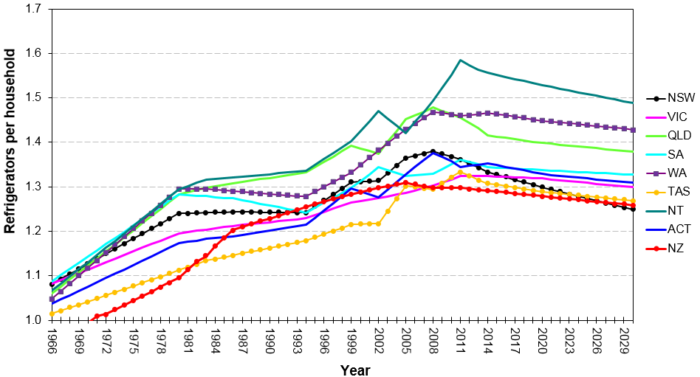

Source: Energy Efficient Strategies estimates (2016) based on ABS4602 historical data to 2014

For Australian freezer owners, the impacts are expected to be greatest on households in Tasmania because ownership rates are highest in that state (approximately 0.6 freezers per household) and lowest in the Australian Capital Territory (approximately 0.3 freezers per household), as indicated in **Figure 10**. However, despite the variations in regional impacts, low and declining ownership rates result in very low replacement rates for freezers. This is reflected in the total sales of freezers, which are less than 15 per cent of sales of refrigerators despite an ownership of about half. This is also a reflection of the longer lifetime of freezers.

Figure 10: Freezer ownership trends and projections – Australia and New Zealand

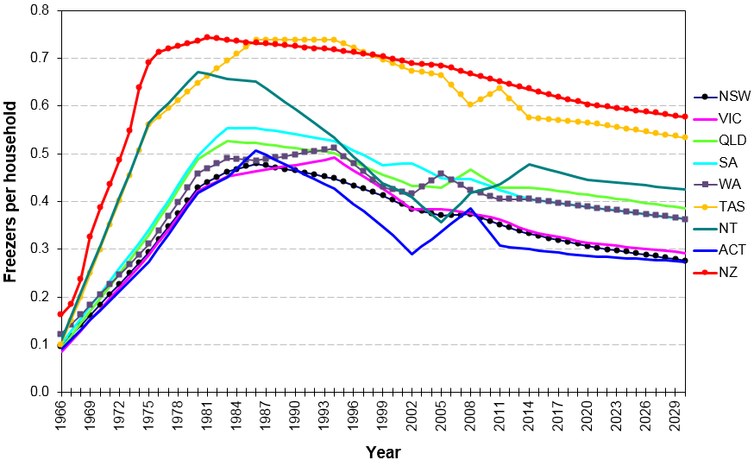

Source: Energy Efficient Strategies estimates (2016) based on ABS4602 historical data to 2014

Detailed cost/benefit results, energy savings and emissions reductions by state/region, product category and sensitivity scenarios are at Attachment B.

# Conclusion

### 6.1 Recommended option

Based on the current analysis, Option C is the recommended policy option because it would:

* Deliver the greatest net benefit to the Australian and New Zealand economies - A$1,254.3 million and NZ$48.7 million respectively
* Provide the best benefit cost ratios – 4.12:1 and 2.08:1 respectively
* Significantly reduce Australia’s and New Zealand’s cumulative GHG emissions out to 2030 – 4.7 Mt and 116 kt respectively.

This policy option remains effective if the discount rate is increased to 10 per cent in the Australian case (cost benefit ratio of 3.46:1) or increased to eight per cent in the New Zealand case (cost benefit ratio of 1.77:1).

This option would also reduce the regulatory burden for industry because it would:

* Reduce the number of units required to be tested from three to one
* Only require that industry use the IEC 62552 Parts 1 to 3 test standard rather than the regionally-specific Australia/New Zealand standard.

The cost-benefit analysis in this RIS has also shown that if the current MEPS levels for refrigerators and freezers remain unchanged under Option A, there will be significant additional costs on consumers, primarily through higher energy costs.

For Australia, a regulatory offset has not been identified to accompany Option C. However, the Commonwealth Department of the Environment and Energy is seeking to pursue net reductions in compliance costs and will work with affected stakeholders and across Government to identify regulatory burden reductions where appropriate.

# Implementation and review

### 7.1 Implementation

If COAG Energy Ministers agree to regulatory change, the relevant regulatory requirements will be reviewed and formulated. A Standards Australia processes that is currently underway (via the EL-060 Household Refrigerating Appliances Committee) will need to be finalised and the necessary technical changes to the standard completed by early 2018. If technical issues cannot be resolved by the EL-060 Committee, E3 will establish a Technical Working Group (consisting of industry and other stakeholders and Government officials and their advisors) to consider what actions will be necessary to introduce the regulatory changes. The Australian Determination will also need to be revised through a consultative process. New Zealand will implement the agreed requirements into the *Energy Efficiency (Energy Using Products) Regulations 2002*.

The expected implementation date (the commencement date) when MEPS3 levels would become mandatory is proposed to be approximately two years after a new Determination receives Ministerial approval (expected to be by 1 December 2018) making the expected implementation date 1 January 2021. The New Zealand implementation date is expected to align with this date, subject to Cabinet processes.

It is recognised that the eventual timing will depend on how long it will take to run processes to resolve any issues associated with implementing the agreed option. This could include adopting the IEC test method and changing the Determination, standard and Regulations to reflect new MEPS levels and the adoption of the IEC test method.

### 7.2 Energy Rating Label design

To encourage suppliers to bring MEPS3 compliant products to the market ahead of the mandated MEPS3 commencement date, it is proposed that suppliers will have the option to voluntarily register new or existing MEPS3‑compliant products using the IEC test method and the new algorithm to generate a new ERL, prior to mandated MEPS3 levels coming into effect.

In Australia, the labelling component of Determination would become effective when the Determination is signed. MEPS3 levels would become effective approximately two years later. In this transition period, suppliers could register products using either the:

* IEC test method to generate an ERL that could be recognised as different to the existing ERL; or
* AS/NZS test method to generate an existing ERL compliant with the current regime.

In New Zealand, suppliers wishing to use the new test method before it is mandatory can voluntarily register their models tested with the IEC test method, and label accordingly. Both the requirements for labelling and IEC test method, will become mandatory in New Zealand in 2021.

Any check-testing undertaken before the law is mandatory will use the test methods and MEPS levels that these models are registered to.

To help consumers understand changes that will occur to the ERL once the Determination becomes effective, E3 will continue to engage with retailers and consumer groups via established processes, including via the E3 Review Committee, so that they and ultimately consumers can understand what the labelling changes mean and how to best select more efficient appliances. Relevant information will also be provided on the E3 website. In New Zealand, EECA will additionally engage with consumers through their energywise programme.

To differentiate products registered under the existing regulatory requirements and proposed MEPS3 requirements, a variant of the current label will need to be used. The proposed new ERL would contain three points of difference as shown in **Figure 11**. The new ERL would:

* Have a new requirement, an IEC volume measurement that will allow consumers to easily compare similar appliances and make meaningful comparisons of appliances’ efficiencies
* Display that the appliance had been tested to the IEC standard, rather than the AS/NZS
* Not have a white box at the bottom
* Aid manufacturers and compliance officers to differentiate between old and new stock.

Figure 11: ERL designs

|  |  |
| --- | --- |
| The figure shows the current ERL design.  **Current ERL** | The figure shows the proposed new ERL design has three points of difference: a volume field has been added; there is statement that the appliance has been tested to IEC; and the white box at the bottom of the ERL has been removed.  **Proposed New ERL** |

**Table 23** provides an indicative timeline of the milestones involved to complete the proposed process.

Table 23: Indicative implementation timeline

|  |  |
| --- | --- |
| **Date** | **Item** |
| December 2017-November 2018 | E3 will work with EL-060 to draft revised standard and with stakeholders to draft new Determination |
| December 2018 | Determination/Regulations to receive Ministerial approval |
| Mid 2019 | New Zealand Cabinet approval for final regulations received (approximate) |
| December 2018-December 2020 | MEPS3 labelling elements of the Determination/Regulations commence and suppliers have the option to register MEPS3 appliances using IEC test method and new algorithm |
| January 2021 | Mandated MEPS levels commence and suppliers must register using IEC test method and all appliances imported must meet MEPS3 |

Given the E3 Program’s experience with implementing or revising energy efficiency requirements, the risks associated with implementation are considered low. Any transitional arrangements will be developed in close consultation with industry.

**Australia**

In Australia:

* From the date the Determination receives Ministerial approval, and prior to the Determination coming into effect, suppliers will have the option to register new or existing MEPS3 compliant products using the IEC test method using the new algorithm to generate a star rating and pay the appropriate fee.
* If a product that was registered prior to the Determination’s coming into effect would meet MEPS3, it can continue to be imported/supplied for the remaining period of its existing registration. The current ERL can continue to be used and the product imported until the registration has expired. It will not need to be re‑registered. The following process will be undertaken to validate products as MEPS3-compliant:
* An agreed methodology to estimate MEPS3 cut-off levels using MEPS2 data and IEC volumes would be established in consultation with stakeholders
* The Regulator will apply a conversion factor to the registered AS/NZS 4474.1 appliance volumes to estimate IEC volumes
* The Regulator would use existing registration data (under AS/NZS 4474.1) and the estimated IEC volumes to calculate an estimated MEPS3 comparative energy consumption (CEC) under IEC62552-3
* Appliances with existing registrations would be deemed to comply if the estimated CEC shows that the model is likely to meet MEPS3 levels once an ‘uncertainty’ factor had been applied
* A fee would not be required for this process
* If appliances fail to meet MEPS3 levels using the above methodology, the Regulator would notify suppliers that appliances had been assessed as not being compliant with MEPS3 levels
* If suppliers believe that estimated volumes/CEC are not representative of models’ capacities/performance, suppliers could provide the Regulator the IEC volume data for each compartment of appliances and/or submit a new IEC test report demonstrating compliance
  + If IEC volumes are provided and existing AS/NZS 4474.1 data is used then no fee would be required
  + If IEC volumes and an IEC test report were provided that demonstrated that the appliance meets MEPS3, the supplier could either:
    - vary the registration and pay the appropriate fee; or
    - re-register for a five-year period and pay the appropriate fee
* For deemed to comply existing registrations, check testing would be undertaken using the AS/NZS test method
* Renewal after 1 January 2021 would require an IEC test report demonstrating that the appliance met MEPS3 levels
* If a product was registered prior to the Determination’s commencement date but it does not meet MEPS3, no more of that product can be imported after the new Determination comes into effect, but the products in the country at that time can be distributed/sold/retailed until its stock is depleted.

**New Zealand**

In New Zealand:

* Any policy proposals will need to be approved by Cabinet before they can be adopted under the *Energy Efficiency (Energy Using Products) Regulations 2002.*
* At least six months’ notice will be given to industry before they can come into force. The date that regulations come into force in New Zealand is expected to be aligned with Australia. EECA will advise of any variation to this.
* Once the changes come into force:
* Registered products imported or manufactured prior to the law change that do not meet the new requirements may only be sold until stock is depleted. New import of these products is not permitted.
* Registered products imported or manufactured prior to the law change that already meet the new requirements, may continue to be supplied. Their registrations will be re-validated and updated.
* Suppliers wishing to import models that are not already registered, but meet the new requirements, will need to complete a registration application and lodge it with EECA, the New Zealand Regulator. There is no fee for this registration application.
  + The New Zealand regulator accepts valid Australian registrations.
* Unregistered products that fall within the scope of the law are not permitted to be supplied.

### 7.3 Review

**7.3.1 Compliance monitoring**

Australian and New Zealand regulators undertake compliance activities, involving education, surveys, store inspections and checking claims in the media. They also purchase products using a risk-based approach, for the purpose of laboratory check testing, to assess whether efficiency claims made in registrations are accurate. Regulators also check that in-store and supplied products appropriately display ERLs. In Australia, compliance activities are undertaken by the GEMS Regulator while in New Zealand, these activities are undertaken by EECA.

**7.3.2 Evaluation**

The E3 Program uses various sources of information to evaluate both the effectiveness of the program and product category requirements. This includes retrospective reviews to compare the effect of policies versus what was projected in RIS analysis; analysing sales data to understand consumer awareness and usage of energy efficiency labelling; tracking hits on the Energy Rating website ([www.energyrating.gov.au](http://www.energyrating.gov.au)); and utilising Australian Bureau of Statistics data and other survey results of consumer intent and consideration of energy efficiency in purchase decisions.

In New Zealand, after a year of trading under new laws, product suppliers are requested to supply sales data on how many products they sold and various energy efficiencies, so that energy savings can be tracked over time.

# Consultation

### 8.1 Past Consultations

Between October 2011 and August 2017, numerous consultations relating to this RIS process were held between stakeholders and the Commonwealth. A summary of actions includes:

* **October 2011** – E3 Committee released information and technical papers for public comment announcing that Australia and New Zealand intended to align MEPS levels for refrigerators and freezers to US 2014 MEPS
* **August 2012** – E3 Committee released a further three discussion papers outlining details of the proposal and E3’s position
* **September 2012** – Technical aspects of five industry submissions were reviewed by consultant. A total of 16 recommendations were made
* General industry support for proposal was found. Concerns surrounding the testing method and timing/transition were outlined. Other concerns were of a technical nature
* **February 2013** – E3 released:
* Three papers for stakeholder review
* Revised draft GEMS Determination for Household Refrigerators
* Draft comparison of AS/NZ standards with IEC standards
* **March 2013** – Whitegoods Forum workshop of refrigerator and freezer MEPS.
* Industry consensus was gained to link to the US energy standards in the future
* A commitment from the Commonwealth was sought by industry to provide not less than 12 months’ notice for labelling and other mandatory changes
* A commitment of three years from the Commonwealth was sought by industry to develop products to meet new performance standard
* **April 2013** – Three stakeholder submissions received
* Generally, stakeholders not opposed to adoption of the IEC test standard
* Four technical issues were raised
* E3 agreed to devote resources to support labelling transition
* **May 2013** –Voting on IEC refrigerator test method opened
* Australia submitted positive votes plus 74 written comments
* **July 2013** – Stakeholder workshop with six discussion papers circulated
* Consensus obtained on most points outlined in draft of AS/NZS 4474.2:2015 *Performance of household electrical appliances—Refrigerating appliances, Part 2*
* There were outstanding issues over algorithm and load processing
* **August – November 2013** – Round Robin testing of refrigerators
* Testing at six test laboratories undertaken between August 2013 and January 2014.
* Workshop held with round robin participating test laboratories
* Workshop was held with industry, consumer groups, test laboratories, efficiency advocates and government officials from Australia and New Zealand in October 2013
* Presentations were given by national and international experts. Updates on progression of IEC test method, round robin and regulatory proposals were provided
* Round robin report submitted to IEC with a list of key recommendations for change
* **December 2013 – IEC SC59M Committee meeting in Auckland, New Zealand.**
* IEC accepted Australasian and other national committees’ recommendations concerning improvements to the IEC test standard
* **October 2014** – Final draft international standard (FDIS) of IEC62552-1, IEC62552-2 and IEC62552-3 released for voting by national committees
* **February 2015** – IEC62552-1, IEC62552-2 and IEC62552-3 published
* **June – November 2015** – ERL algorithm development
* Options paper released outlining algorithms for Energy Rating Label that could be instigated.
* Commonwealth met with industry stakeholders to discuss options
* General stakeholder consensus on the preferred Option 4 be included in this RIS
* **November 2016** – Industry interviews
* The Commonwealth met with representatives of manufacturers who accounted for approximately 75‑85 per cent of household refrigeration sales
* Capital costs and appliance costs required to meet MEPS3 were discussed
* Anticipated model availability and regulatory costs were also discussed
* **April/May 2017** – Consultation RIS released with public meetings
* Consultation RIS released in April 2017
* Commonwealth delivered RIS overview and modelling results presentations to stakeholders in Sydney, Melbourne and Auckland in May 2017
* Question and answer sessions
* **August 2017** – Consultation RIS issues meeting
* Stakeholder consultation RIS submissions issues were discussed
* E3 proposed to extend implementation time from one year to two years
* Technical issues and parameters were discussed

Attachment D provides more details of each stakeholder event, including issues raised and subsequent actions. Implementation of any policy changes will be informed by the results of feedback from ongoing consultations. E3 is committed to continual engagement with a range of stakeholders.

**Consumer Electronics Suppliers Association (CESA)**

E3 representatives regularly meet with industry during CESA meetings that are held at least annually. These meetings provide an opportunity for industry members to receive regular updates on E3 activities, to discuss issues and make submissions to E3.

**E3 Review Committee**

E3 representatives meet with key stakeholder groups (industry and consumer bodies) through the E3 Review Committee. The E3 Review Committee is a forum for key stakeholder groups to provide advice to government across the entire E3 Program and meets twice per year.

# Attachment A – Trends

### A.1 Sales Trends

The sales of refrigerators and freezers are a function of economic growth and consumer/business product preferences. **Figure 12** shows actual sales data from published and unpublished sources and forecast sales are estimated based on current trends.

Figure 12: Annual sales of refrigerators and freezers – Australia and New Zealand

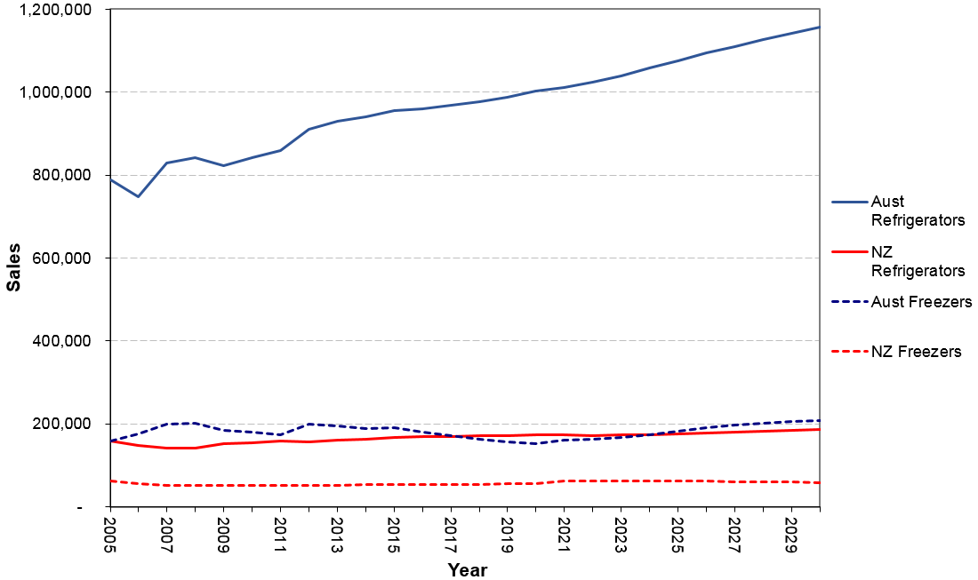

Source: Energy Efficient Strategies estimates (2017)

### A.2 Stock Trends

The estimated stocks of refrigerators and freezers for Australia and New Zealand over the period 1985 to 2030 are shown in **Figure 13** and **Figure 14**.

Figure 13: Refrigerator stock – Australia and New Zealand

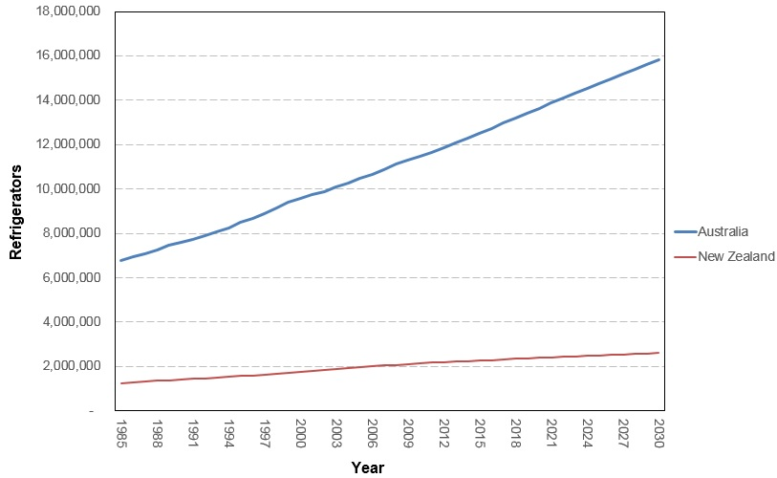

Sources: ABS 3236-2015 Series III; Statistics New Zealand Dwelling and Household Estimates; and unpublished data

Figure 14: Freezer stock – Australia and New Zealand

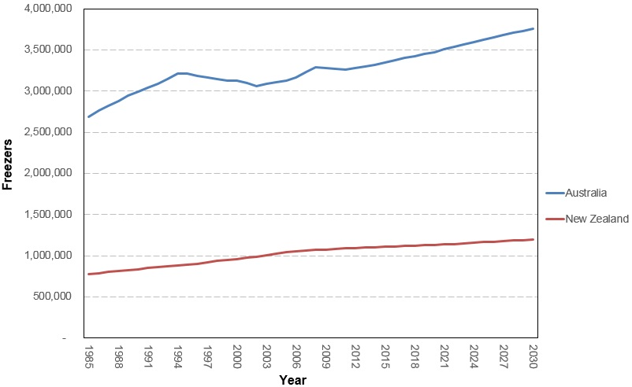

Sources: ABS 3236-2015 Series III; Statistics New Zealand Dwelling and Household Estimates; and unpublished data

### A.3 Price Trends

Australian retail price trends for all refrigerator and freezer groups over the period 1993-2017 are shown below.

Figure 15: Average group 1 prices – Australia

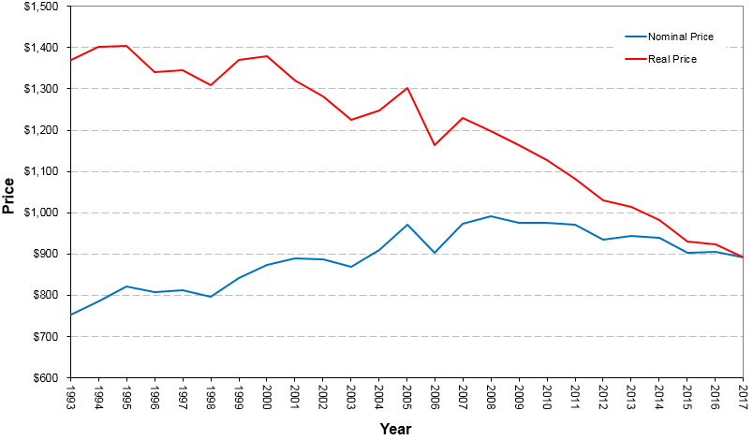

Source: Energy Efficient Strategies estimates (2017) based on 2017 GfK sales data

Figure 16: Average group 2 prices – Australia

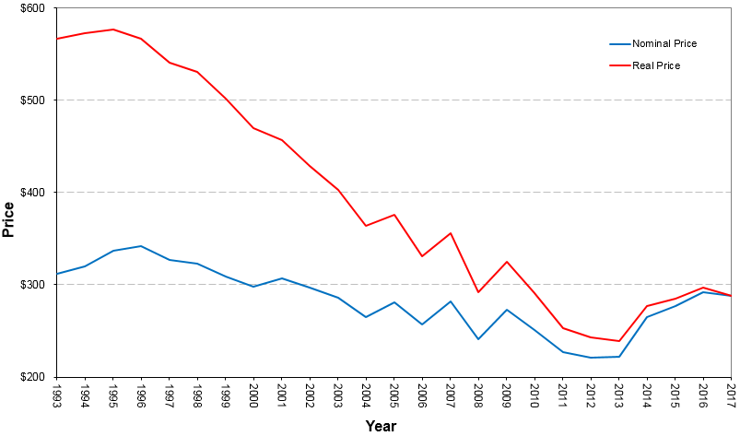

Source: Energy Efficient Strategies estimates (2017) based on 2017 GfK sales data

Figure 17: Average group 3 prices – Australia

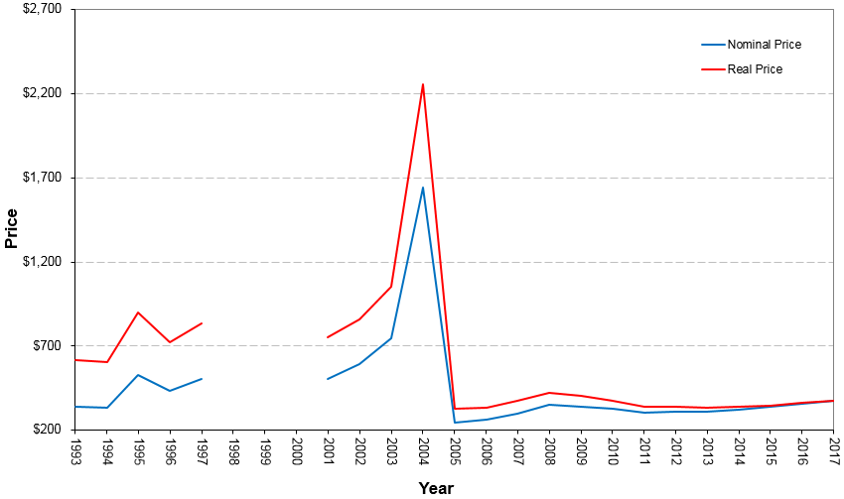

Source: Energy Efficient Strategies estimates (2017) based on 2017 GfK sales data

Note: The discontinuities in prices for this group are artefacts of the data set provided by GfK which was for a small collection of models

Figure 18: Average group 4 prices – Australia

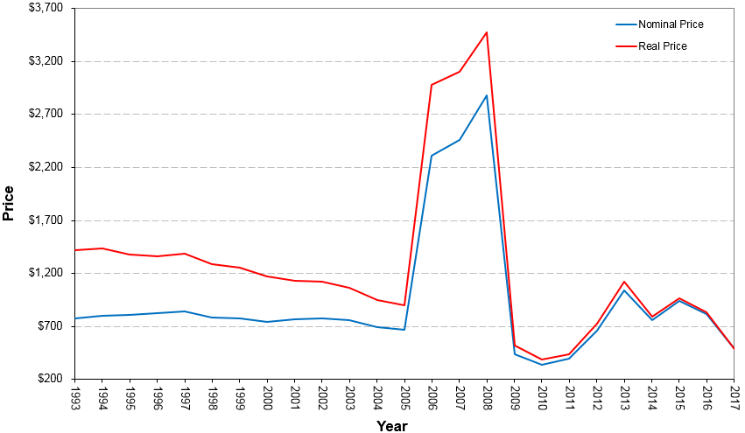

Source: Energy Efficient Strategies estimates (2017) based on 2017 GfK sales data

Note: The discontinuities in prices for this group are artefacts of the data set provided by GfK which was for a small collection of models

Figure 19: Average group 5B prices – Australia

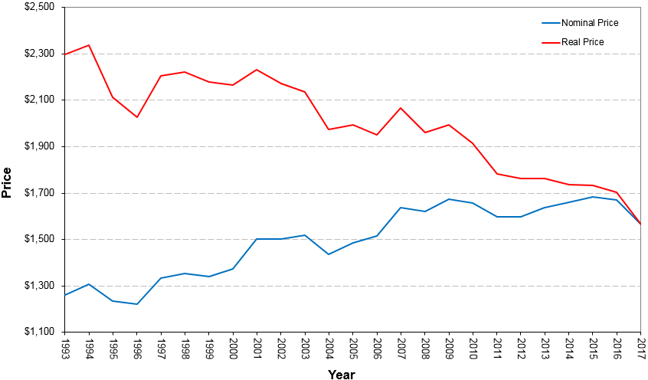

Source: Energy Efficient Strategies estimates (2017) based on 2017 GfK sales data

Figure 20: Average group 5S prices – Australia

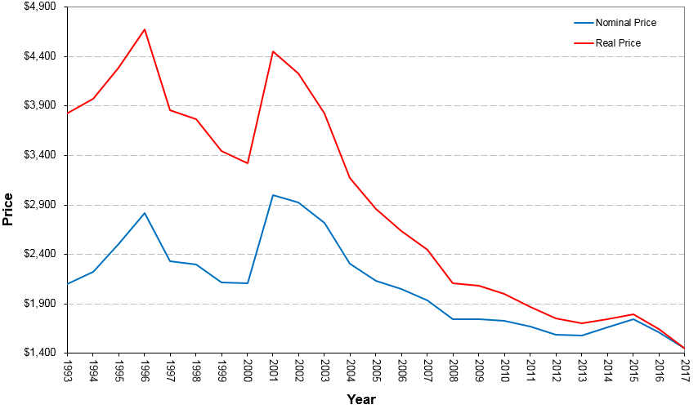

Source: Energy Efficient Strategies estimates (2017) based on 2017 GfK sales data

Note: The discontinuity in prices from 2000 to 2001 for this group is an artefact of the data set provided by GfK which was for a small collection of models to 2000 and all models from 2001. See Energy Efficient Stategies (2016) for more details.

Figure 21: Average group 5T prices – Australia

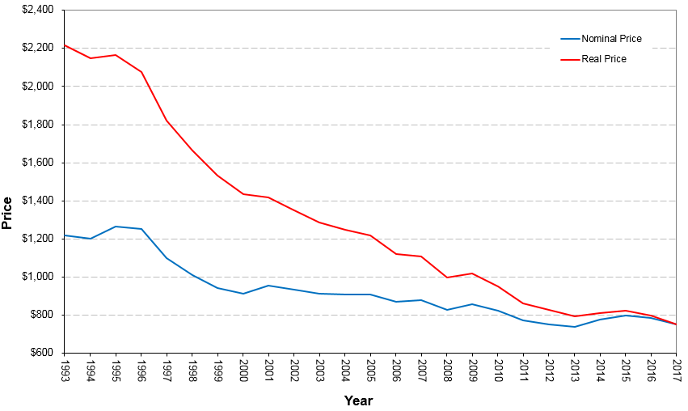

Source: Energy Efficient Strategies estimates (2017) based on 2017 GfK sales data

Figure 22: Average group 6C prices – Australia

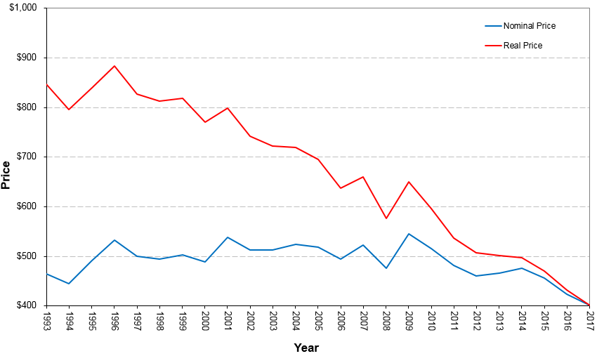

Source: Energy Efficient Strategies estimates (2017) based on 2017 GfK sales data

Figure 23: Average group 6U prices – Australia

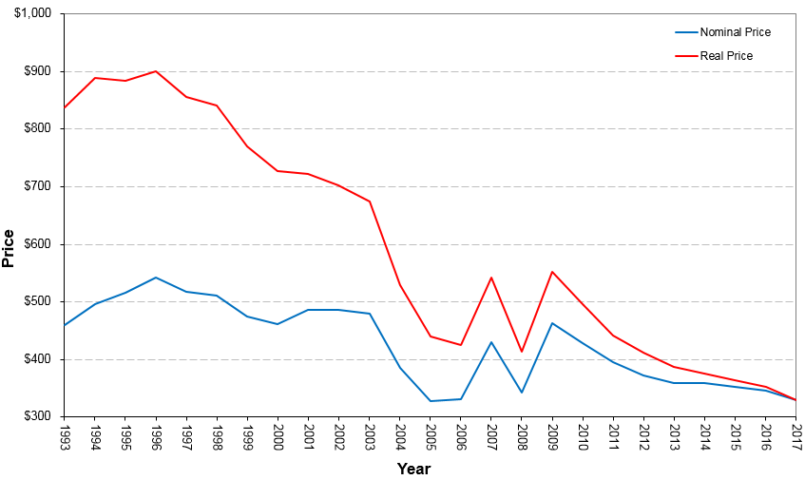

Source: Energy Efficient Strategies estimates (2017) based on 2017 GfK sales data

Note: There was a signifciant decline in average product size across this period

Figure 24: Average group 7 prices – Australia

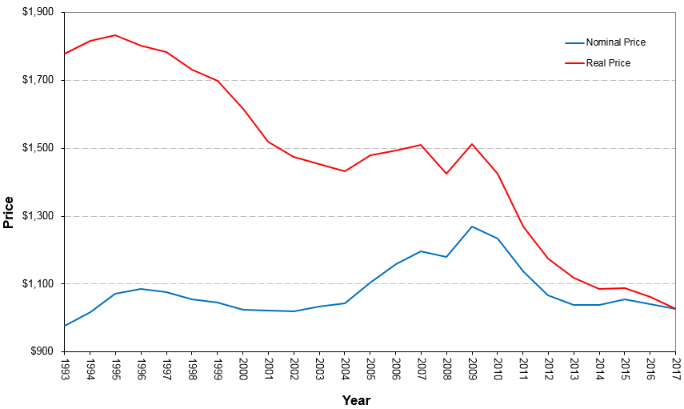

Source: Energy Efficient Strategies estimates (2017) based on 2017 GfK sales data

# Attachment B – Modelling

This attachment provides supporting technical and modelling assumptions and outputs to assist with the consideration of this decision RIS affecting household refrigerators and freezers. It presents the methods used for the cost benefit analysis for the policy options proposed and documents the data sources used. A financial analysis model has been built to review the overall costs and benefits related to each proposal being considered. Proposals are compared to BAU where there is no policy intervention to the refrigerator and freezer market. Both costs and benefits are evaluated relating to appliances installed from 2015 (the likely year that some manufacturers started to spend money to eventually become compliant with MEPS3) to 2030. They include the following:

**Benefits**

* Energy saving for consumers/the economy due to improved efficiency of refrigerators and freezers as well as the resulting reduced electricity costs
* Reduced emissions as a result of energy savings from policy (quantified but only monetised for sensitivity analysis)
* Additional energy savings from the adoption of a new ERL that better estimates energy consumption during normal use in homes under Option C, which will increase the label’s effectiveness (some elements not quantified or monetised)[37]
* The energy savings of household refrigerators and freezers used in commercial settings are not within the scope of this RIS (not quantified or monetised)
* Benefits from appliances installed up to 2030 are modelled to 2050
* Energy and emissions savings are modelled to 2030

**Costs**

* Increase in the purchase price of energy efficient refrigerators and freezers when regulation restricts sales of products that are unable to meet MEPS3 requirements
* Regulatory cost for the industry (including changes to: administrative resources; test costs; and registration costs) as a result of new policy proposals
* Costs are modelled to 2030

### B.1 Cost benefit analysis key parameters and inputs

Table 24: Modelling assumptions and parameters

| **Assumptions** | **Parameters** |
| --- | --- |
| Scenarios | * Option A: BAU * Option B: increase MEPS levels to MEPS3 * Option C: increase MEPS levels to MEPS3, adopt IEC test standard and improve ERL |
| Sales  Sales | * Australian historical sales data based on GfK sales data from 1993 to June 2017 * New Zealand historical sales data based on most recent EECA data * Forecast sales based on projected trends |
| Stock | Australian and New Zealand refrigerator and freezer stock levels have been estimated by Energy Efficient Strategies using:   * Australian household projections: Australian Bureau of Statistics (2015) * New Zealand household projections: Statistics New Zealand (2015 and 2016) * Refrigerator/freezer ownership rate over time and projected trends   Stock model: Ownership data and household numbers, together with an estimated product life, generates a notional sales stream over the period 1990 to 2017.  Based on known long-term sales data into the residential sector, an estimated mean lifetime of 15 years (with a standard deviation of three years) for refrigerators and mean lifetime of 21 years for freezers (with a standard deviation of four years) has been used in the stock model. It was found to most closely align the sales data sets over the modelling period. The survival and retirement rates of refrigerators and freezers are assumed to follow a normal distribution.  Modelling assumes that on average, consumers must immediately replace refrigerators and freezers with new appliances when they reach their mean life times (i.e. appliances are old and they break down). |
| Projection period | Impacts have been modelled from appliances installed over the period 2015-2030 |
| Industry costs | All incremental capital/development costs are assumed to be passed on to consumers |
| Product prices | Australia: Retail product prices using GfK data  New Zealand: Wholesale product prices have been derived from retail prices (i.e. they are a proportion of retail prices) and have been estimated in consultation with industry.  Price impacts of increased MEPS levels on the price of refrigerators and freezers are modelled according to assumed price to efficiency ratios (price coefficients) see **Table 25**.   * A price-efficiency regression was undertaken using sales data up to and including June 2017. * For some groups, no correlation between price and energy was found. For some other groups, a positive correlation was found, implying that more efficient appliances were cheaper. For these groups, price coefficients were set with default values of -0.20. * For other groups that had statistically significant negative correlations, the observed market price coefficients were used in the modelling. |
| Registration administration costs and compliance costs | Government administration costs are made up of salary, program administration, check testing, consumer information/education and miscellaneous (market research, etc.). As all product categories are already regulated for MEPS and labelling, there no increases in government costs.  Testing costs per unit are expected to approximately double assuming the number of test days increases from 13 days under AS/NZS 4474.1 to 25 days under IEC 62552 (Source: Electrolux submission). This assumes a default value is used for the load processing test.  AS4474.1 costs $273 and IEC 62552 costs A$1,410. This cost may be reduced if the IEC standards are republished as identical AS/NZS.  The incremental administration costs for Australia and New Zealand are assumed to be marginal over the modelling period if Option C is adopted and therefore have not included. |
| Energy consumption | Historic and future trends in energy efficiency for all refrigerator and freezer groups are based on sales weighted trends of sales data mentioned above, taking into account previous program implementation dates and impacts.  The stock model used contains information on the numbers, capacity, efficiency and energy consumption of refrigerators and freezers. Energy consumption estimates for the BAU baseline established, and then the energy consumption under different policy options are calculated and compared to the BAU consumption.  Products are retired from the stock according to a survival function which includes some early breakdowns, most refrigerators retiring around the average and some refrigerators having an extended life. |
| Energy tariffs | Australia  Derived from electricity market forecasts modelled by Frontier Economics in 2015 that were commissioned and published by the Australian Energy Market Operator (AEMO). Detailed modelling was used to derive wholesale market and green/LRET cost combined with estimates for future distribution, transmission and retail costs (see Attachment C).  New Zealand  Based on long-run marginal electricity cost: Interactive Electricity Generation Cost Model 2016 (see Attachment C). |
| GHG emissions | Accounted as carbon dioxide equivalent units (CO2-e)  Australia  Projected GHG emission factors are Scope 2 emission factors from Department of the Environment and Energy (2016) *National Greenhouse Accounts Factors*  New Zealand  Ministry of Business, Innovation and Employment, New Zealand’s Electricity Demand and Supply Generation Scenarios 2016 (see Attachment C) |
| Sensitivity analysis | Australia  NPV: Seven per cent real discount rate, with sensitivity tests at zero per cent, three per cent and 10 per cent  GHG: A$11.82/tonne CO2-e and A$35.00/tonne CO2-e  New Zealand  NPV: Six per cent real discount rate, with sensitivity tests at zero per cent, three per cent and eight per cent  GHG: NZ$25.00/tonne CO2-e |
| Other assumptions | * Reduction in energy use is due to new policy options described above. * Although GHG abatements have been estimated, the financial/economic benefits of lower levels of greenhouse gas emissions have not been quantified in the primary analysis but is included in the sensitivity analysis. |

Price coefficients estimates for refrigerator and freezer groups sold in Australia are provided in **Table 25**. For example, -0.25 is used for group 5B products which means that a 10 per cent decrease in energy consumption from the introduction of MEPS3 is assumed to result in a 2.5 per cent price increase at an individual model level.

Table 25: Energy-price coefficients – Australia

|  |  |  |  |
| --- | --- | --- | --- |
| Group | Coefficient (2008 RIS) | Coefficient (Consultation RIS) | Coefficient (Decision RIS) |
| 1 | -0.10 | -0.91 | -0.20b |
| 2 | -0.10 | -0.29 | -0.20b |
| 3 | -0.10 | -0.20 a | -0.20a |
| 4 | -0.10 | -0.20 a | -0.90 |
| 5B | -0.40 | -0.20 b | -0.25 |
| 5S | -0.15 | -0.20 b | -0.20b |
| 5T | -0.60 | -0.22 | -0.41 |
| 6C | -0.20 | -0.20 b | -0.46 |
| 6U | -0.30 | -1.62 | -0.86 |
| 7 | -0.90 | -0.35 | -0.20b |

Source: Energy Efficient Strategies estimates (2017) based on analysis on FY data July 2016 to June 2017

Notes: a - few models so default value used

b - Indicates negative slope or slope less than -0.2 in regression so default value used

Boutique products with a normalised price of more than three times the market average eliminated from the analysis

These coefficients have been used to estimate the corresponding retail price impact from the mandatory reduction of energy by group for MEPS3 in 2021. For New Zealand modelling, price coefficients have been adjusted accounting for the differentials between retail prices (used in the Australian modelling case) and wholesale prices (used in the New Zealand modelling case). This approach is consistent with other assumptions used in the modelling to account for the economic modelling basis used for the New Zealand case and the financial modelling of consumer costs used for the Australian case.

### B.2 Sensitivity analysis

Sensitivity analyses were undertaken to examine the impacts on the modelling outcomes.

**Discount Rate**

The discount rate sensitivity analysis shows that all proposals considered for Australia and New Zealand will have substantial positive net benefits, regardless of the discount rates selected aa shown in **Table 26** and **Table 27**. For example, the net benefit for Option C in Australia is projected to be between A$3,569.2 million (zero per cent discount rate) and A$$849.2 million (10 per cent discount rate), with benefit cost ratios between 6.85:1 and 3.46:1 respectively. This means that the benefits from projected energy use reduction and related reduction in running costs for consumers are expected to exceed the costs of implementing the proposal by at least 3.46 times under the most conservative discount rate scenario.

Table 26: Discount rate sensitivity analysis – Australia

|  |  |  |  |  |
| --- | --- | --- | --- | --- |
|  | **Discount rate (real)** | | | |
|  | 0 per cent | 3 per cent | 7 per cent | 10 per cent |
| **Option B** | | | | |
| Total Benefits (NPV, $M) | $2,929.5 | $1,923.9 | $1,180.6 | $858.4 |
| Total Costs (NPV, $M) | $457.0 | $377.4 | $300.6 | $258.3 |
| Net Benefits (NPV, $M) | $2,472.5 | $1,546.4 | $879.9 | $600.1 |
| Benefit Cost Ratio | 6.41 : 1 | 5.10 : 1 | 3.93 : 1 | 3.32 : 1 |
| **Option C** | | | | |
| Total Benefits (NPV, $M) | $4,179.2 | $2,725.9 | $1,655.9 | $1,194.7 |
| Total Costs (NPV, $M) | $610.0 | $503.8 | $401.7 | $345.6 |
| Net Benefits (NPV, $M) | $3,569.2 | $2,222.1 | $1,254.3 | $849.2 |
| Benefit Cost Ratio | 6.85 : 1 | 5.41 : 1 | 4.12 : 1 | 3.46 : 1 |

Note: seven per cent is the base case

For New Zealand, Option C is projected to be between NZ$161.8 million (zero per cent discount rate) and NZ$29.8 million (eight per cent discount rate), with benefit cost ratios between 3.41 and 1.77. This means the benefits to the New Zealand economy from implementing Option C are expected to exceed the costs of implementing the proposal by at least 1.77 times under the most conservative discount rate scenario.

Table 27: Discount rate sensitivity analysis – New Zealand

|  |  |  |  |  |
| --- | --- | --- | --- | --- |
|  | **Discount rate (real)** | | | |
|  | 0 per cent | 3 per cent | 6 per cent | 8 per cent |
| **Option B** | | | | |
| Total Benefits (NPV, $M) | $198.4 | $131.5 | $82.1 | $60.7 |
| Total Costs (NPV, $M) | $58.0 | $48.4 | $39.1 | $34.0 |
| Net Benefits (NPV, $M) | $140.4 | $83.1 | $43.0 | $26.7 |
| Benefit Cost Ratio | 3.42 : 1 | 2.72 : 1 | 2.10 : 1 | 1.78 : 1 |
| **Option C** | | | | |
| Total Benefits (NPV, $M) | $228.8 | $151.0 | $93.7 | $68.9 |
| Total Costs (NPV, $M) | $67.0 | $55.8 | $45.0 | $39.0 |
| Net Benefits (NPV, $M) | $161.8 | $95.2 | $48.7 | $29.8 |
| Benefit Cost Ratio | 3.41 : 1 | 2.71 : 1 | 2.08 : 1 | 1.77 : 1 |

Note: six per cent is the base case

**GHG emissions**

The impact on the cost benefit estimates of monetising the benefit from reduced GHG emissions for Australia is shown in **Table 28** and **Table 29**. Estimates for New Zealand are provided in **Table 30**.

Table 28: GHG sensitivity analysis – Australia – A$11.82/tonne CO2-e

|  |  |  |  |  |  |  |
| --- | --- | --- | --- | --- | --- | --- |
| **Option** | **Energy Saved (cumulative GWh to 2030)** | **GHG Emission Reduction (cumulative) Mt** | **Total Benefit (A$M)** | **Total Cost (A$M)** | **Net Benefit (A$M)** | **BCR** |
| B | 4,098 | 3.5 | 1,217.4 | 300.6 | 916.7 | 4.0 |
| C | 5,605 | 4.7 | 1,707.4 | 401.7 | 1,305.8 | 4.3 |

Note: Discount rate of 7%. $11.82/tonne CO2-e was the market price in the April 2017 Emissions Reduction Fund auction

Table 29: GHG sensitivity analysis – Australia – A$35.00/tonne CO2-e

|  |  |  |  |  |  |  |
| --- | --- | --- | --- | --- | --- | --- |
| **Option** | **Energy Saved (cumulative GWh to 2030)** | **GHG Emission Reduction (cumulative) Mt** | **Total Benefit (A$M)** | **Total Cost (A$M)** | **Net Benefit (A$M)** | **BCR** |
| B | 4,098 | 3.5 | 1,289.6 | 300.6 | 988.9 | 4.3 |
| C | 5,605 | 4.7 | 1,808.5 | 401.7 | 1,406.9 | 4.5 |

Note: Discount rate of 7%. $A35/tonne CO2-e has been used by the US Environmental Protection Agency in assessing the costs and benefits of new policies

Table 30: GHG sensitivity analysis – New Zealand – NZ$25.00/tonne CO2-e

|  |  |  |  |  |  |  |
| --- | --- | --- | --- | --- | --- | --- |
| **Option** | **Energy Saved (cumulative GWh to 2030)** | **GHG Emission Reduction (cumulative) Mt** | **Total Benefit (NZ$M)** | **Total Cost (NZ$M)** | **Net Benefit (NZ$M)** | **BCR** |
| B | 995 | 0.104 | 84.6 | 39.1 | 45.5 | 2.16 |
| C | 1,120 | 0.116 | 96.5 | 45.0 | 51.5 | 2.15 |

Note: Discount rate of 6%

### B.3 Charts

The figures belowshow refrigerator and freezer sales trends for Australia and New Zealand over the period 1966‑2030.

Figure 25: Refrigerator sales trend by group – Australia

The figure shows Australian refrigerator sales trends over the period 1966 to 2017 and projections for the period 2018 to 2030. 
Group 1 sales have fallen from approximately 12% of sales in 1966 to 4.0% in 2017 and are assumed to remain relatively flat over the projection period. 
Group 2 sales have fallen from approximately 29% of sales in 1966 to 12% in 2017 and are assumed to remain relatively flat over the projection period. 
Group 3 sales have fallen from approximately 29% of sales in 1966 to 1.0% in 2017 and are assumed to gradually decline further over the projection period. 
Group 4 sales have fallen from approximately 29% of sales in 1966 to 0.1% in 2017 and are assumed to decline further over the projection period. 
Group 5T sales have grown from approximately 0.5% of sales in 1982 to 41% in 2017 and are assumed to gradually decline to 34% over the projection period.
Group 5B sales have fallen from approximately 0.1% of sales in 1982 to 31% in 2017 and are assumed to gradually increase to 42% over the projection period.
Group 5S sales have fallen from approximately 0.1% of sales in 1966 to 10% in 2017 and are assumed to gradually decline to 7% over the projection period.

Sources: GfK sales data and Energy Efficient Strategies estimates

Figure 26: Freezer sales trend by group – Australia

The figure shows Australian freezer sales trends over the period 1966 to 2017 and projections for the period 2018 to 2030.
Group 6U sales have fallen from approximately 43% of sales in 1966 to 24% in 2017 and are assumed to gradually decline to 20% over the projection period.
Group 6C sales have fallen from approximately 57% of sales in 1966 to 43% in 2017 and are assumed to remain relatively flat over the projection period.
Group 7 sales have risen from approximately 0.7% of sales in 1982 to 33% in 2017 and are assumed to gradually increase to 37% over the projection period.

Sources: GfK sales data and Energy Efficient Strategies estimates

Figure 27: Refrigerator sales trend by group – New Zealand

The figure shows New Zealand refrigerator sales trends over the period 1966 to 2016 and projections for the period 2017 to 2030. 
Group 1 sales have fallen from approximately 12% of sales in 1966 to 3.6% in 2016 and are assumed to remain relatively flat over the projection period. 
Group 2 sales have fallen from approximately 29% of sales in 1966 to 17% in 2016 and are assumed to remain relatively flat over the projection period. 
Group 3 sales have fallen from approximately 29% of sales in 1966 to 0.3% in 2016 and are assumed to phase out over the projection period.
Group 4 sales have fallen from approximately 29% of sales in 1966 to 1.2% in 2016 and are assumed to gradually decline over the projection period.
Group 5T sales have grown from approximately 0.6% of sales in 1976 to 17% in 2016 and are assumed to gradually decline to 14% over the projection period.
Group 5B sales have fallen from approximately 1% of sales in 1971 to 52% in 2016 and are assumed to gradually increase to 60% over the projection period.
Group 5S sales have fallen from approximately 0.1% of sales in 1982 to 8.0% in 2016 and are assumed to gradually decline to 5% over the projection period.

Sources: EECA sales data and Energy Efficient Strategies estimates

Figure 28: Freezer sales trend by group – New Zealand

The figure shows New Zealand freezer sales trends over the period 1966 to 2016 and projections for the period 2017 to 2030.
Group 6U sales have grown from approximately 0.1% of sales in 1982 to 18.0% in 2016 and are assumed to gradually decline to 15% over the projection period.
Group 6C sales have fallen from approximately 100% of sales in 1966 to 68% in 2016 and are assumed to remain relatively flat over the projection period.
Group 7 sales have risen from approximately 0.5% of sales in 1971 to 14% in 2016 and are assumed to gradually increase to 17% over the projection period.

Sources: EECA sales data and Energy Efficient Strategies estimates

The figures belowshow the average energy consumption over time of each group, given the policy scenario. These trends demonstrate the projected energy savings from cost benefit analysis. Current observed trends in energy efficiency projected for all refrigerators and freezers based on sales weighted trends up to 2017. Projections for 2017 and beyond are estimated based on the policy scenario.

Figure 29: Energy consumption by group for Option A (BAU) – Australia

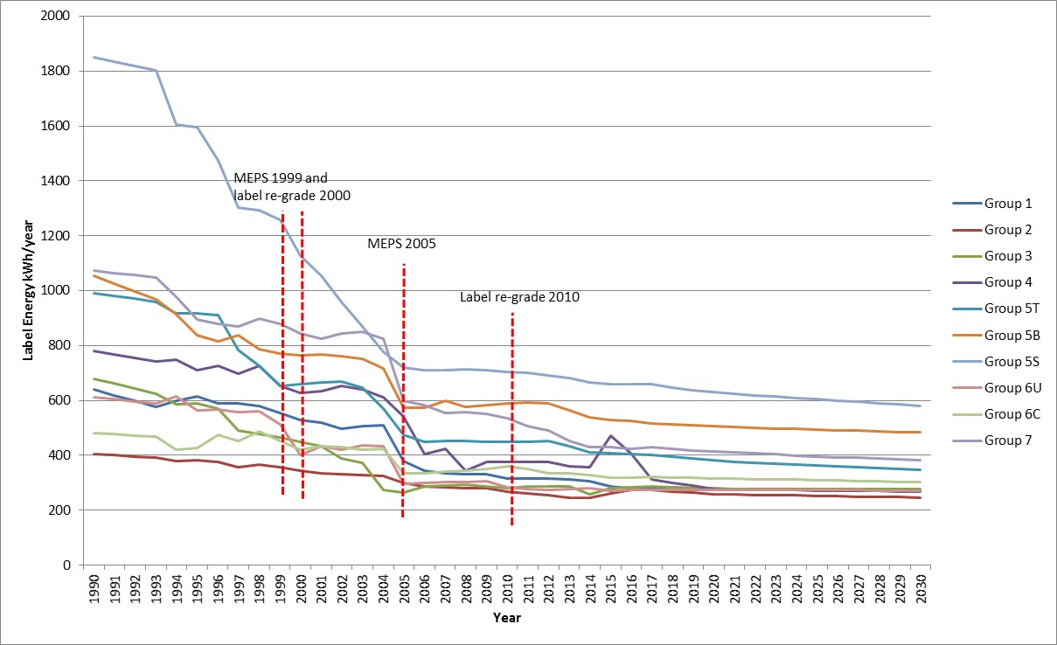

Source: Energy Efficient Strategies modelling results

Figure 30: Energy consumption by group for Option C (MEPS3 + IEC) – Australia

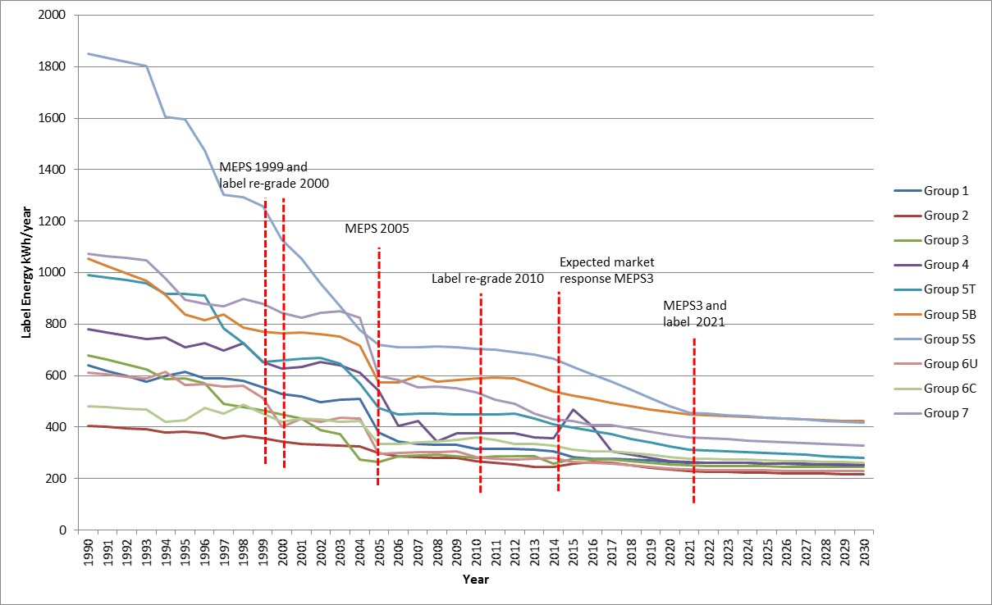

Source: Energy Efficient Strategies modelling results

Figure 31: Energy consumption by group for Option A (BAU) – New Zealand

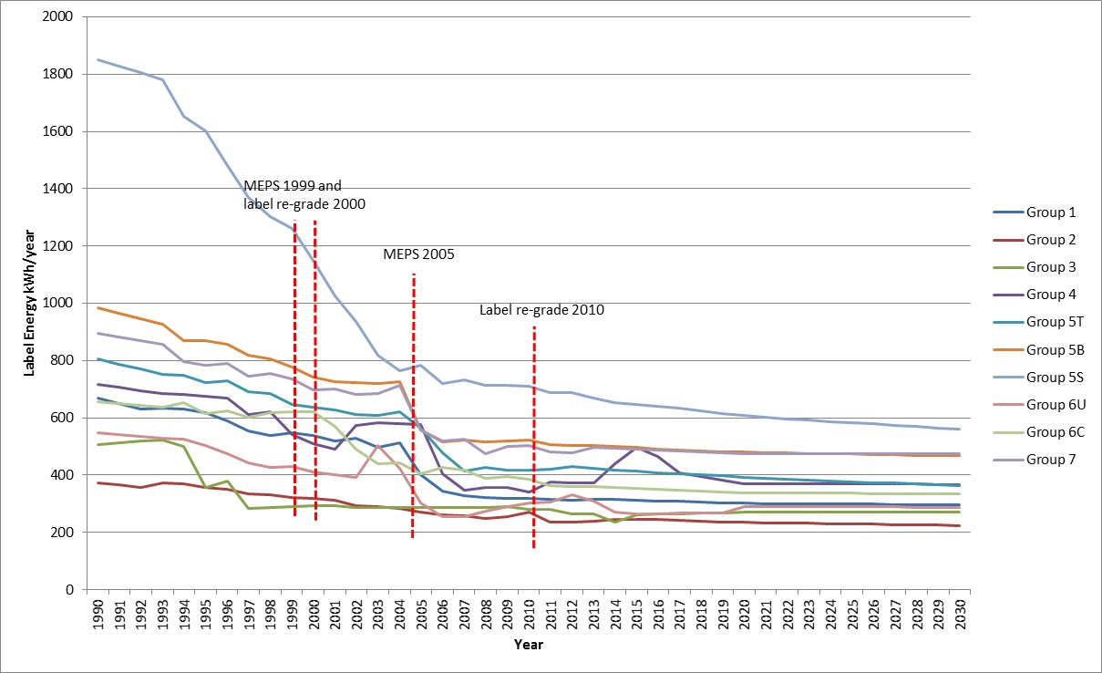

Source: Energy Efficient Strategies modelling results

Figure 32: Energy consumption by group for Option C (MEPS3 + IEC) – New Zealand

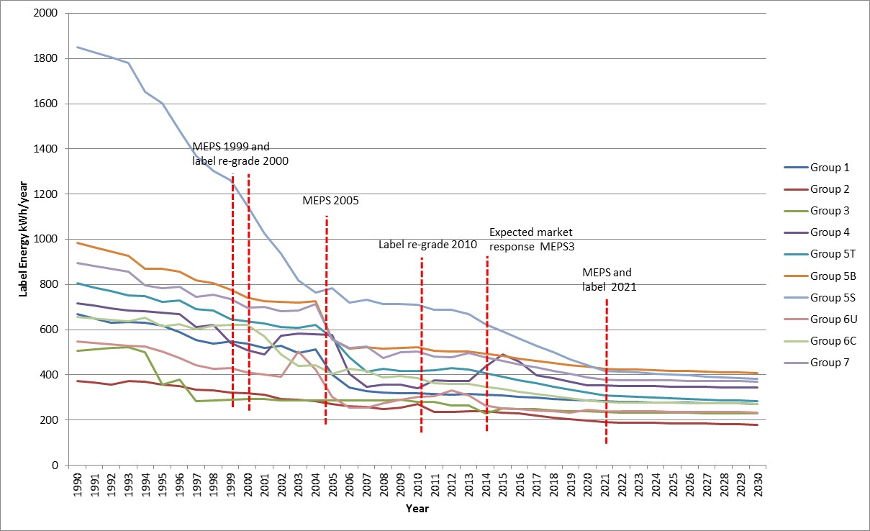

Source: Energy Efficient Strategies modelling results

The figures below show the lifetime assumptions for refrigerators and freezers used in the modelling.

Figure 33: Refrigerator lifetime

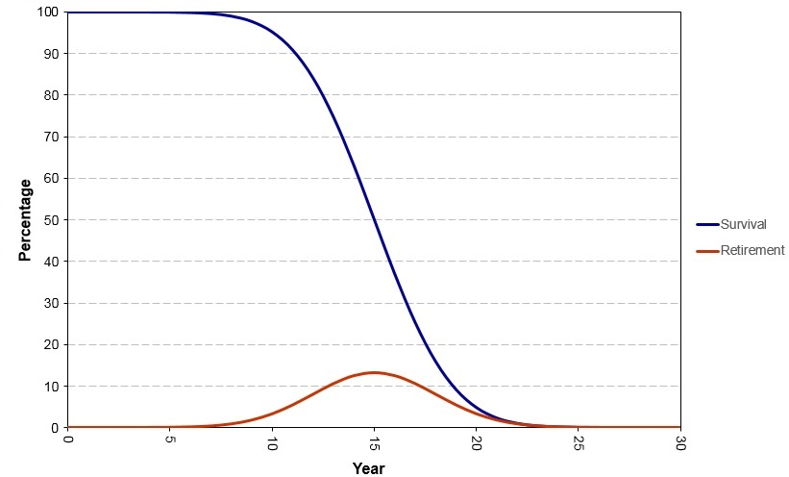

Source: Energy Efficient Strategies modelling results

Figure 34: Freezer lifetime

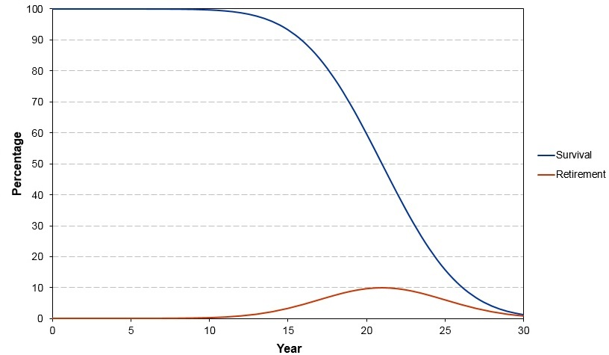

Source: Energy Efficient Strategies modelling results

# Attachment C – Electricity prices and GHG emissions factors

Table 31: Residential electricity tariffs – Australia (real Au 2017 cents/kWh)

|  |  |  |  |  |  |  |  |  |  |  |  |  |  |  |  |  |
| --- | --- | --- | --- | --- | --- | --- | --- | --- | --- | --- | --- | --- | --- | --- | --- | --- |
|  | **2015** | **2016** | **2017** | **2018** | **2019** | **2020** | **2021** | **2022** | **2023** | **2024** | **2025** | **2026** | **2027** | **2028** | **2029** | **2030** |
| **NSW** | 26.39 | 26.63 | 26.88 | 27.33 | 27.80 | 28.33 | 28.78 | 30.42 | 30.72 | 30.97 | 31.25 | 31.52 | 31.77 | 31.94 | 32.20 | 32.46 |
| **VIC** | 27.54 | 27.70 | 27.93 | 28.39 | 28.88 | 29.40 | 29.84 | 31.13 | 31.35 | 31.46 | 31.73 | 32.09 | 32.36 | 32.53 | 32.73 | 33.02 |
| **QLD** | 28.88 | 32.52 | 32.41 | 30.01 | 30.54 | 31.18 | 29.94 | 31.56 | 31.94 | 32.28 | 32.71 | 33.15 | 33.49 | 33.79 | 34.10 | 34.47 |
| **SA** | 29.74 | 29.96 | 30.16 | 30.60 | 31.11 | 31.66 | 32.14 | 33.26 | 33.48 | 33.57 | 33.82 | 34.14 | 34.39 | 34.55 | 34.77 | 35.14 |
| **WA** | 25.69 | 27.02 | 27.01 | 26.88 | 25.87 | 25.38 | 26.07 | 25.97 | 25.84 | 25.46 | 25.37 | 25.33 | 25.32 | 25.33 | 25.33 | 24.91 |
| **TAS** | 23.78 | 24.06 | 24.28 | 24.72 | 25.20 | 25.70 | 26.12 | 27.33 | 27.56 | 27.69 | 27.97 | 28.31 | 28.60 | 28.78 | 28.99 | 29.28 |
| **NT** | 25.07 | 26.36 | 26.36 | 26.22 | 25.25 | 24.77 | 25.44 | 25.34 | 25.21 | 24.85 | 24.75 | 24.71 | 24.70 | 24.71 | 24.71 | 24.31 |
| **ACT** | 16.90 | 17.05 | 17.21 | 17.50 | 17.80 | 18.14 | 18.43 | 19.48 | 19.67 | 19.83 | 20.01 | 20.18 | 20.34 | 20.45 | 20.62 | 20.78 |

Source: E3 estimates based on Frontier Economics (2015) projections

Table 32: Long-run marginal electricity cost – New Zealand (real NZ 2017 cents/kWh)

|  |  |  |  |  |  |  |  |  |  |  |  |  |  |  |  |  |
| --- | --- | --- | --- | --- | --- | --- | --- | --- | --- | --- | --- | --- | --- | --- | --- | --- |
|  | **2015** | **2016** | **2017** | **2018** | **2019** | **2020** | **2021** | **2022** | **2023** | **2024** | **2025** | **2026** | **2027** | **2028** | **2029** | **2030** |
| NZ | 9.07 | 9.07 | 9.07 | 9.07 | 9.07 | 9.07 | 9.07 | 9.07 | 9.07 | 9.07 | 9.07 | 9.07 | 9.07 | 9.07 | 9.07 | 9.07 |

Source: Ministry of Business, Innovation and Employment (2017)

Table 33: GHG emission factors for electricity – Australia and New Zealand (kg CO2-e/kWh)

|  |  |  |  |  |  |  |  |  |  |  |  |  |  |  |  |  |
| --- | --- | --- | --- | --- | --- | --- | --- | --- | --- | --- | --- | --- | --- | --- | --- | --- |
|  | **2015** | **2016** | **2017** | **2018** | **2019** | **2020** | **2021** | **2022** | **2023** | **2024** | **2025** | **2026** | **2027** | **2028** | **2029** | **2030** |
| NSW | 0.840 | 0.840 | 0.840 | 0.840 | 0.840 | 0.840 | 0.840 | 0.840 | 0.840 | 0.840 | 0.840 | 0.840 | 0.840 | 0.840 | 0.840 | 0.840 |
| VIC | 1.120 | 1.120 | 1.120 | 1.120 | 1.120 | 1.120 | 1.120 | 1.120 | 1.120 | 1.120 | 1.120 | 1.120 | 1.120 | 1.120 | 1.120 | 1.120 |
| QLD | 0.790 | 0.790 | 0.790 | 0.790 | 0.790 | 0.790 | 0.790 | 0.790 | 0.790 | 0.790 | 0.790 | 0.790 | 0.790 | 0.790 | 0.790 | 0.790 |
| SA | 0.560 | 0.560 | 0.560 | 0.560 | 0.560 | 0.560 | 0.560 | 0.560 | 0.560 | 0.560 | 0.560 | 0.560 | 0.560 | 0.560 | 0.560 | 0.560 |
| WA | 0.760 | 0.760 | 0.760 | 0.760 | 0.760 | 0.760 | 0.760 | 0.760 | 0.760 | 0.760 | 0.760 | 0.760 | 0.760 | 0.760 | 0.760 | 0.760 |
| TAS | 0.120 | 0.120 | 0.120 | 0.120 | 0.120 | 0.120 | 0.120 | 0.120 | 0.120 | 0.120 | 0.120 | 0.120 | 0.120 | 0.120 | 0.120 | 0.120 |
| NT | 0.670 | 0.670 | 0.670 | 0.670 | 0.670 | 0.670 | 0.670 | 0.670 | 0.670 | 0.670 | 0.670 | 0.670 | 0.670 | 0.670 | 0.670 | 0.670 |
| ACT | 0.840 | 0.840 | 0.840 | 0.840 | 0.840 | 0.840 | 0.840 | 0.840 | 0.840 | 0.840 | 0.840 | 0.840 | 0.840 | 0.840 | 0.840 | 0.840 |
| NZ | 0.130 | 0.140 | 0.143 | 0.150 | 0.151 | 0.134 | 0.135 | 0.129 | 0.105 | 0.100 | 0.100 | 0.096 | 0.093 | 0.092 | 0.092 | 0.091 |

Sources: Department of the Environment and Energy(2017) and Ministry of Business, Innovation and Employment (2017)

# Attachment D – Consultations

Over the past six years, E3 has liaised extensively with stakeholders regarding alignment to existing international energy efficiency and product testing standards. This work has focused on potentially aligning MEPS for refrigerators and freezers, currently at MEPS2, with those implemented by the US in September 2014, known as MEPS3. This work also includes potentially adopting the IEC test method for domestic refrigerators and freezers. Details concerning consultations relating to proposed changes outlined in this document are detailed below.

| **Date** | **Item** | **Details** | **Issues Raised** | **Actions** |
| --- | --- | --- | --- | --- |
| October 2011 | Whitegoods Forum Melbourne  Issues papers released | * E3 officials announced that Australia and New Zealand intended to align with US 2014 MEPS levels for refrigerators and freezers. * Release of papers that set out technical aspects of the US regulatory requirements and the MEPS proposal. * *Paper 1 - MEPS for Household Refrigeration: Summary of new MEPS levels in the USA, October* 2011 * *Paper 2* - *MEPS for Household Refrigeration: Roadmap for MEPS 3 in Australia and New Zealand*, October 2011 |  |  |
| August 2012 | Issues and discussion papers released | * Release of papers setting out more details of the proposal and E3 position paper. * *Paper 3 - Household Refrigeration: MEPS3 in Australia and New Zealand – Preliminary Impact Assessment of New MEPS Levels in 2015,* August 2012 * *Paper 4 - Household Refrigeration: Technical Support Document on MEPS and Labelling for 2015 for Energy-using Refrigeration Equipment,* August 2012 * *Regulatory Discussion Document – Government agency proposed pathway to regulate refrigeration equipment sold to consumers in Australia and New Zealand from about April 2015,* October 2012 |  |  |
| September 2012 | Stakeholder submissions received | * Five industry stakeholder submissions received from: * Consumer Electronics Suppliers’ Association (CESA) * Electrolux Australia * Fisher and Paykel Appliances * Mitsubishi Electric Australia Pty Ltd * Black Diamond Technologies (New Zealand agents for Mitsubishi) * Technical aspects of industry submissions were reviewed by Energy Efficient Strategies and 16 recommendations were made. | * General support for the proposal * Concerns about implementation timing and transition arrangements * Some general concerns regarding IEC test method * Costs, research and development, beverage cooler labels issues * Technical issues raised were: * capacity * humidity * proposals for compact products * range of other minor issues | * Energy Efficient Strategies considered submissions and made decisions on each of the substantive matters in November 2012 * These decisions were included into documents released in early 2013 |
| February 2013 | Whitegoods Forum papers released | * Documents released for discussion were: * Information Paper - AS4474*.2-2013 (V0.4) - Performance of Household Electrical Appliances – Refrigerating Appliances,* February 2013 * Information Paper *- Domestic Refrigeration – Proposed Regulatory Changes Explanatory Guide to the proposed AS/NZS 4474, Part 2,* February 2013 * Information Paper - *Household Refrigerators – Energy Labelling Algorithm in Draft AS/NZS 4*474*.2-2013*, February 2013 * Draft - *Revised 2015 GEMS Determination for household refrigerators,* February 2013 – (*AS/NZS 4474.2:2015 Performance of household electrical appliances – Refrigerating appliances, Part 2*) * *Comparison of AS/NZ standards and regulatory requirements with EN and IEC standards for refrigerating appliances in draft*, February 2013 |  | * Issues to be discussed during Whitegoods Forum |
| March 2013  March 2013 (cont.) | Whitegoods Forum  Whitegoods Forum | * Stakeholders given formal opportunity to raise issues with government officials arising from the previously circulated documents. * Officials sought stakeholder views on linking future MEPS for refrigerators and freezers to future MEPS changes within the US. | * Industry seeking three years to develop products to meet new MEPS * Industry sought a commitment to not less than 12 months’ notice of labelling changes, administrative arrangements and other mandatory requirements in Determinations * Industry agreed that officials present E3 a consensus that refrigeration products regulation should be linked to US developments in the future * Stakeholders sought more opportunities to input to future RIS processes * Participants sought commitment from officials to have Australian representation at IEC refrigerator committee meetings by experts from our region * Various technical issues were discussed | * A milestone approach would be adopted rather than fixed dates driving future regulation commencement * Agreed by all parties to have both government and industry representation |
| April 2013 | Invitation for formal stakeholder submissions | * Submissions requested to support verbal positions from Whitegoods Forum. * Three industry stakeholder submissions received: * Electrolux Home Appliances Australia * Fisher and Paykel Appliances * Australian Industry Group (AIG) | * Submissions requested sufficient formal notice regarding regulatory changes – project milestones and project planning considered important so that industry can securely make large investments required to meet new MEPS levels * Government requested to provide adequate resources to support proposed labelling transition – including adequate communication and marketing * Cautious but not opposed to adoption of testing standard IEC62552 * Supportive of a more realistic energy value on label * Technical input received * Technical Issues raised * humidity * testing analysis * labelling algorithm |  |
| May 2013 | IEC released draft refrigerator test method for voting | * Draft voting open for three months * Comments and votes closed on 16 August 2013 | * Australia submitted positive votes plus 74 written comments |  |
| July 2013 | Stakeholder Workshop | * Six papers circulated: * *Paper 1 -* *Refrigerator and Freezer MEPS3 and IEC Migration Documentation (recap of documents to date)* * *Paper 2 - IEC Migration Position Differences – CESA and AIG* * *Paper 3 - AS/NZS 4474.2 (V0.5) – incorporating whitegoods forum discussions and industry submission from April 2013* * *Paper 3a - Summary of the edits undertaken on AS/NZS 4474.2 (V0.5)* * *Paper 4 -* *Refrigerator Round Robin Testing – First Concept Draft* * *Paper 5* - *How does the energy efficiency of Australian whitegoods compare internationally?* * *Paper 6 - Guide to undertaking tests to IEC SC59M/24/NP – Energy Consumption of Household Refrigerators* * Key task was to review part 2 Version 0.5 | * Review of draft of *AS/NZS 4474.2:2015 Performance of household electrical appliances – Refrigerating appliances, Part 2* * Consensus on most points * Some issues on algorithms and load processing need further work * Technical advisory group to consider * Stakeholders agreed on value of round robin testing * Supported by officials |  |
| August 2013  August 2013 (cont.) | Round robin of test laboratories commences  Round robin of test laboratories commences | * Government sponsored laboratory testing of two specified model refrigerators to the IEC test standard * Checked that requirements of the standards (both IEC and AS/NZS 4474 draft) were clear, unambiguous and not onerous * Purpose of testing is to support adoption of IEC test method IEC62552 in Australia and New Zealand as well as preparing testing facilities to adapt to testing to support the new regulatory requirements in 2017 through the requirements of AS/NZS 4474.2 * Six test laboratories contracted including two manufacturers’ laboratories (one in Australia and one in New Zealand) and four independent accredited laboratories in Australia * Testing was conducted over the period August 2013 to January 2014 * Results were compared for consistency and issues identified * Participant workshop held on October 2013 | * E3 prepared detailed technical comments about specific issues identified with the IEC standard aimed at making the test method more practical and workable |  |
| October 2013 | International Whitegoods Workshop - Melbourne | * Two day workshop with over 60 stakeholders including industry, consumer groups, test laboratories, efficiency advocates and government officials from Australia and New Zealand. * Updates on IEC test method, round robin results presented and the regulatory proposal were discussed * Several experts in energy efficiency matters presented: * *Bilateral comparisons of Historical Trends in US and Australian Refrigerators* (Robert Van Buskirk, PhD) * *IEC Refrigerator Round Robin : Concept and Objectives* (Lloyd Harrington, Ian Forte and Lindsey Roke) * *Refrigerator testing: IEC 62552 Ed 2 Development and Australian/New Zealand Round Robin Testing* (Martien Janssen) * *US DOE Misc. Refrigeration Products Coverage* (Robert Van Buskirk, PhD) * *Australian Efforts at Copying US Refrigerator MEPS* (Lloyd Harrington) |  |  |
| November 2013 | Finalise round robin testing to IEC standard in Australasia finalised | * Participating laboratories reviewed draft round robin test report * A range of proposals to make testing easier and more efficient were included * Final report was submitted to the IEC |  |  |
| December 2013 | IEC SC59M Committee meeting – Auckland | * IEC SC59M Committee reviewed and resolved comments made by Australasian and other national committees concerning the IEC test standard | * SC59M committee accepted all recommendations | * IEC prepared FDIS over the period December 2013 – February 2014 |
| June 2015 | Options paper released to whitegoods stakeholders | * Options paper outlining four potential algorithms that could use the IEC 62552 test standard when determining rating for ERL was circulated for consideration |  |  |
| October 2014 | FDIS released | * FDIS standards of IEC62552-1, IEC62552-2 and IEC62552‑3 were released for vote | * None |  |
| February 2015 | IEC standard published | * IEC62552-1, IEC62552-2 and IEC62552-3 published | * Unanimous ‘Yes’ vote from National Committees |  |
| August 2015 | Whitegoods stakeholder meeting | * Discussion of algorithm options outlined in June 2015 * General stakeholder consensus on the preferred algorithm option that has been included in this RIS |  |  |
| November 2016 | Stakeholder Meetings | * Discussions on capital and other costs and assumptions used in modelling |  |  |
| April 2017 | Consultation RIS released | * Six week public consultation period | * Issues summarised in Attachment E |  |
| May-June 2017 | Public consultation meetings | * RIS overview presented * RIS modelling assumptions presented * Question and answer session |  |  |
| August 2017  August 2017 (Cont.)  August 2017 (Cont.) | RIS Issues Meeting  RIS Issues Meeting  RIS Issues Meeting | * RIS Issues Discussion Paper circulated to stakeholders * Discussed issues raised by stakeholders in consultation RIS submissions | * Suppliers unanimously supported adoption of IEC62552 * Suppliers unanimously supported adoption of MEPS3 levels * E3 proposed to increase implementation period from one years to two years   + Stakeholders agreed this would greatly assist with orderly transition to MEPS3   + Some stakeholders maintained that three years was needed * E3 proposed to develop a methodology that would enable the recognition of currently registered appliances as MEPS3 compliant without requiring testing to IEC standard. This would dramatically reduce regulatory burden on industry   + Stakeholders provided in principle support * Number of test units required for registration   + Some stakeholders maintained that test results for three units continue be required for registration   + E3 will continue to provide an option to submit results for three test units. However, suppliers only required to submit test results for one unit * E3 maintained policy to adopt load processing test recognising the value of test in determining consumers’ annual energy consumption   + Stakeholders agreed in principle that test is useful and generally support further work to how to determine an appropriate default value   + Suppliers will be able to voluntarily submit 32°C and/or 16°C load processing test results for registration * Stakeholders agreed to adopt existing volume tolerances specified in AS/NZS * E3 proposed that individual tolerances be applied to the results of each test because each test result carries a different uncertainty of measurement * Regulator proposed to accept tests conducted at 220V until 1 January 2021 as part of the transition process * In response to strong stakeholder support of existing defrost excursion requirements, E3 agreed to re-examine the benefits of maintaining the existing requirements * New ERL design   + E3 agreed that new ERL be clearly distinguishable from old ERL * Addition registration data   + Stakeholders supported facility to voluntarily provide refrigerant type at registration time because it would assist with reducing regulatory burden | * E3 confirmed it would continue to work with stakeholders to resolve issues via: * An established Standards Australia EL-060 Committee to revise AS/NZS 4474.2 * An E3 Technical Working Group as required |

# Attachment E – Consultation RIS Submissions

During the consultation RIS submission period (from 13 April 2017 to 28 May 2017) E3 received six public submissions and one confidential submission. Public submissions were received from:

* Ai Group
* Choice – The Australian Consumers Association (Choice)
* Consumer Electronics Suppliers Association (CESA)
* Electrolux Home Products Pty Ltd (Electrolux)
* Fisher & Paykel Appliances (F&P)
* Sharp Corporation of New Zealand (Sharp NZ)

Below is a list of questions posed in the consultation RIS:

1. Do stakeholders support no changes to energy efficiency regulations for household refrigerating appliances? If yes, then please provide supporting arguments.
2. What are the advantages/disadvantages of incorporating the contents of AS/NZS 4474.2 into the Determination/Regulations rather maintaining the status quo and leaving it as a standard?
3. Do stakeholders support incorporating the contents of AS/NZS 4474.2 into the Determination/Regulations and if not then why?
4. Do stakeholders support adopting Option B measures? If not, please provide arguments supporting your position accompanied with quantitative evidence as appropriate.
5. Do stakeholders support adopting Option C measures? If not, please provide arguments supporting your position accompanied with quantitative evidence as appropriate.
6. Do stakeholders support adopting the proposed performance, test and algorithm parameters? If not, then please outline issues you may have.
7. E3 understands that the actual consumer price impacts on each product group from introducing MEPS3 are likely to be different to those presented in this RIS. E3 seeks feedback from suppliers/manufacturers on the average price increases for each product group following the adoption of MEPS3 levels.
8. Increased MEPS levels will result in some less-efficient models being removed from the market and increased supply of new/updated more efficient models. E3 seeks feedback from suppliers/manufacturers on whether the adoption of MEPS3 levels would have a material impact on competition.
9. Adopting the IEC test standard will have impacts on suppliers that include changes to administrative and laboratory costs. E3 seeks a better understanding of these and related costs and requests that, where possible, suppliers provide estimates of cost differences that would be experienced if only required to test appliances to the IEC test standard, rather than to the Australian/New Zealand test standard.
10. Ahead of mandated MEPS3 levels commencing, do stakeholders support proposed provisions to allow the registration of MEPS3-compliant products using the IEC test method and the new algorithm.
11. Do stakeholders support proposed changes to the ERL design? If not then please outline what would be a preferable design.
12. Do stakeholders agree with the proposed timing for the introduction of MEPS3? If not, please advise of alternative timing with detailed, supporting rationale.

**Table 34** provides a summary of public submissions that are accessible online at [www.energyrating.gov.au/consultation/consultation-ris-household-refrigerators-and-freezers](http://www.energyrating.gov.au/consultation/consultation-ris-household-refrigerators-and-freezers).

Table 34: Summary of Stakeholder Submissions

|  | **Choice** | **CESA** | **F&P** | **Electrolux** | **Ai Group** | **Sharp NZ** |
| --- | --- | --- | --- | --- | --- | --- |
| 1. Support status quo? | N | N | N | N | - | - |
| 2. Pros and cons of incorporating contents of AS/NZS 4474.1 into Determination | Regulations updated less frequently than standards | 1. No advantage in change  2. Determination format not appropriate for technical content  3. Standards processes are consensus based that include public comment | 1. Determinations written in a very legalistic way making them very difficult to understand  2. A standard represents consensus on a wide range of issues and is written in a language that engineers and technicians understand  3. Determinations lead to a mismatch between Australian and New Zealand regulations | 1. Standards Australia have a proven, consensus based process for providing effective MEPS and energy efficiency labelling requirements  2. Standards process is an appropriate approach for drafting complex technical requirements in which expert opinion is required and is publically scrutinised | Need to maintain processes equivalent to those currently used in standards processes including a consensus based approach | 1. The standards or the Determination should be created as a stand‑alone document written in easily understood English  2. The Determination should not be accepted until it has been formally accepted at an industry meeting and/or emailed to interested stakeholders |
| 3. Support Determination or standards approach | Standards | Standards | Standards | Standards | Standards | - |
| 4. Support Option B? | Y | N | - | - | - | - |
| 5. Support Option C? | Qualified Y | Qualified Y | Qualified Y | Qualified Y | - | - |
| 6. Support Algorithm | Y | Qualified Y | Y | Y | - | - |
| 7. Price effect | - | - | - | - | - | - |
| 8. Competition effect | - | During transition period, fewer models expected to be available | - | - | - | - |
| 9. Laboratory costs | 1. Testing costs per unit will be higher due to two ambient tests  2. Other setup costs will be incurred | 1) No laboratory cost benefits from adopting IEC  2) Increased testing time for IEC vs AS/NZS | - | Testing time per unit will be longer | - | - |
| 10. Allow early registration to IEC | Y | Y | - | Y | - | - |
| 11. Support new ERL design | N - Need to better differentiate old and new labels | Qualified Y | Y - optional to include old CEC in green band | Y - Include old CEC in band. Include old CEC, gross volume and SRI on website | - | - |
| 12. Support implementation timing |  | N - 3 years minimum post signing of the Determination | N - 2 years minimum post signing the Determination, maybe longer depending on the details | N - 30 months post signing the Determination | - | Need to ensure that the time is maximised between the date of acceptance of the new requirements and date of enactment |
| Other Comments |  | 1) Streamline registration process to only require information that confirms compliance with GEMS requirements  2) Need to use up-to-date price coefficients and sales data for the decision RIS modelling  3) Need to provide basis for 15 year refrigerator lifetime assumption  4) Modelling has not included sensitivity analysis of electricity prices nor product lifetimes  5) Regulator should consider automatic recognition of registered products that meet MEPS3  6) Need to include 'other beverage coolers' in exclusions  7) Multiple tests are required to understand product variability  8) Support retaining pulldown test  9) Need to define defrost temperature excursions as in AS/NZS 4474.1 Clause 3.7.3  10) Define volume tolerances  11) Review check testing tolerances  12) Repeatability/accuracy of the load processing test questioned | 1) Load processing test is not sufficiently mature to be used: results variable; refrigerator defrost unpredictable; freezer results also variable; IEC does not cover how to deal with defrost during load processing; allowing different set points may provide gaming opportunity. Exclude load processing for ERL until issues resolved.  2) 16C test results are too variable. Suggest using a fixed ‘average’ figure as a placeholder  3) Consider defining adjustment factor for defrost at 230v cw 220v  4) Checktest tolerance needs to be reviewed  5) Support retaining pulldown test | 1) Do not support load processing test  2) Maintain requirement for test report for three appliances  3) Revise CBA for higher testing and development costs  4) Exclude beverage coolers  5) Define parameters enabling voluntary wine cabinet labelling  6) Use recent sales data in decision RIS  7) Revise RIS to reflect that retail prices do not correlate with energy efficiency but high efficiency products cost more to produce  8) Confirm MEPS levels during the development of the decision RIS  9) Support retaining pulldown test | - | 1) Regardless whether a standard or determination approach is adopted, the document should be stand alone and not reference other standards or documents and be written in easily understood English  2) The Determination should not be accepted until it has been formally accepted at an industry meeting and/or emailed to interested stakeholders  3) Stakeholders should have a timeline in which they can "Return for rewrite" until it is deemed accepted |

# Attachment F – MEPS3 Levels

Proposed MEPS3 levels for all refrigerating appliance groups are shown in **Table 35.**

Table 35: MEPS cut-off level factors

|  |  |  |
| --- | --- | --- |
| Appliance group | Fixed allowance factor  (*K*f) kWh/y | Variable allowance factor  (*K*v) kWh/y/L |
| 1 | 219.3 | 0.2717 |
| 2 | 181.4 | 0.2247 |
| 3 | 270.9 | 0.3397 |
| 4 | 247.3 | 0.3101 |
| 5T | 256.9 | 0.3133 |
| 5B | 348.1 | 0.3431 |
| 5S | 327.4 | 0.3304 |
| 6C | 182.2 | 0.4375 |
| 6U | 252.0 | 0.2559 |
| 7 | 296.9 | 0.3960 |

Where MEPS cut-off level = [Kf + (Kv × Vadj tot)]  + Awi + Abi (kWh/y)

For compact refrigerating appliances having a base area of less than 0.36m2

|  |
| --- |
| Compact MEPS cut-off level =  (kWh/y) |

Note: Group 6C are not eligible for the compact MEPS level, irrespective of the footprint area

Where:

*K*f = fixed allowance factor for its appliance group (kWh/year)

*K*v = variable allowance factor (kWh/y/L)

*V*adj tot = total adjusted volume (litres)

*A*wi = an allowance of 52 kWh/y which applies where an appliance has a ‘through-the-door ice dispenser’ or a dispenser that may also dispense chilled water. A chilled water dispenser alone is not eligible for this allowance

*A*bi = an allowance of 40 kWh/y for all Groups except Group 5S, which has an allowance of 100 kWh/year, that applies where an appliance complies with the definition of a built-in product

*W* = external width of the refrigerating appliance in metres

*D* = external depth of the refrigerating appliance in metres

# Attachment G – Performance and Test Parameters

AS/NZS 4474.2 contains performance parameters relating to MEPS levels and energy star rating calculations.

**Table 36** lists aspects of performance parameters (from draft AS/NZS 4474.2) that have been generally agreed during stakeholder consultations, should Australia and New Zealand adopt MEPS3 only (Option B).

Table 36: Generally agreed performance parameters (Option B)

|  |  |  |
| --- | --- | --- |
| **Parameter** | **Reference Clause of draft AS/NZS 4474.2** | **Notes** |
| Scope | Clause 1.1 | Inclusion of covered refrigeration products for labelling and MEPS |
| Exclusions | Clause 1.2 | Current exclusions remain, beverage coolers also excluded |
| Built in products | Clause 1.6.3 | Use US definition for a built in product modified with local industry suggestion - MEPS only |
| Compact products | Clause 1.6.6 | Use local industry definition for a compact product (i.e. small footprint) - MEPS only |
| Refrigerating Appliance Designation | Clause 1.6.16 | From AS/NZS 4474.1 |
| Refrigerating Appliance Group | Clause 1.6.17 | From AS/NZS 4474.1 |
| Humidity maps | Clause 2 | US humidity map for MEPS and AS/NZS humidity maps for energy labelling |
| Number of units to test | Clause 3.2.1 | Testing 3 units (no change) |
| Pull down requirement | Clause 4.3 | Pull down time of six hours as per current AS/NZS 4474.1 requirement at an ambient of 43°C |
| Storage test | Clause 4.4 | Temperature operation test as per AS/NZS 4474.1 |
| Adjusted volume | Clause 4.5 | Applied for MEPS and labelling as defined in AS/NZS 4474.2 |
| Projected MEPS energy consumption | Clause 4.6 | Endorsed |
| MEPS levels | Clause 4.7 | Including levels for standard products and compact products |

Source: Generally agreed during stakeholder consultations as detailed in the Consultation section of this document

Notes: Built in and compact type products are currently regulated in Australia and New Zealand and clauses 1.6.3, 1.6.6 and 4.7 will align the MEPS treatment of these products with that used in the US

**Pull down test**

The current regulatory requirements include that appliances must meet a pull down requirement whereby appliances are tested at an ambient temperature of 43°C and they must be capable of meeting defined target temperatures within six hours of being powered on. Numerous stakeholder submissions to the consultation RIS fully supported the continuation of this requirement because of its value in verifying that appliances are fit‑for‑purpose in local temperature extremes.

**Table 37** lists parameters (from draft AS/NZS 4474.2) that have been generally agreed during stakeholder consultations, should Australia and New Zealand adopt MEPS3 and the IEC test method (Option C).

Table 37: Generally agreed performance parameters (Option C)

| **Parameter** | **Reference Clause of draft AS/NZS 4474.2** | **Notes** |
| --- | --- | --- |
| Scope | Clause 1.1 | Inclusion of all covered refrigeration products for labelling and MEPS |
| Exclusions | Clause 1.2 | Current exclusions remain and beverage coolers also excluded to ensure clarity |
| Built in products | Clause 1.6.3 | Use US definition for a built in product modified with local industry suggestion - MEPS only |
| Compact products | Clause 1.6.6 | Use local industry definition for a compact product (i.e. small footprint) - MEPS only |
| Refrigerating Appliance Designation | Clause 1.6.16 | From AS/NZS 4474.1 |
| Refrigerating Appliance Group | Clause 1.6.17 | From AS/NZS 4474.1 |
| Humidity maps | Clause 2 | US humidity map for MEPS and AS/NZS humidity maps for energy labelling |
| Number of units to test | Clause 3.2.1 | Testing of a single product in lieu of addition testing load in IEC (flagged Oct 2013) |
| Star Rating Index | Clause 3.7 | Broad agreement to reduce ERF to 0.18 as set out in Option 4 of Energy Efficient Strategies (2015) |
| Volume | Clause 4.2 | IEC volume measurement in IEC62552-3 Annex H |
| Pull down requirement | Clause 4.3 | Pull down test as per IEC62552-2 Annex A at an ambient of 43°C with performance requirement of six hours to be specified in Part 2 or Determination |
| Storage test | Clause 4.4 | Temperature operation test IEC62552-2 Clause 4 |
| Adjusted volume | Clause 4.5 | Included in the Part 2 or Determination for IEC test conditions |
| Projected MEPS energy consumption | Clause 4.6 | Endorsed |
| MEPS levels | Clause 4.7 | Includes levels for standard products and compact products |

Source: Generally agreed during stakeholder consultations as detailed in the Consultations section of this document.

Notes: Built in and compact type products are currently regulated in Australia and New Zealand and clauses 1.6.3, 1.6.6 and 4.7 will align the MEPS treatment of these products with that used in the US.

**Table 38** lists aspects of the IEC test method that have been broadly agreed by stakeholders, should Australia and New Zealand adopt MEPS3 and the IEC test standard (Option C).

Table 38: Generally agreed test parameters (Option C)

| **Parameter** | **Reference Clause** | **Notes** |
| --- | --- | --- |
| Definitions | IEC62552-1 Clause 3 | Endorsed |
| Climate classification | IEC62552-1 Clause 4 | Storage test conducted at +10°C to +32°C. |
| Instrumentation | IEC62552-1 Annex A | Voltage and frequency specified in Part 2 or Determination |
| Setup, preparation | IEC62552-1 Annex B | Endorsed |
| Freezer test packs | IEC62552-1 Annex C | Only used for storage test |
| Sensor locations | IEC62552-1 Annex D | Air sensor positions |
| Storage test | IEC62552-2 Clause 4 | Only 500g test packages are permitted, equivalent to temperature operation test in AS/NZS 4474.1 |
| Pull down test | IEC62552-2 Annex A | Pull down time specified in Part 2 or Determination (no pull down time limit in IEC standard) at an ambient of 43°C |
| Energy target temps | IEC62552-3 Clause 5 | Note that these are different to AS/NZS |
| Daily energy | IEC62552-3 Clause 6 | Annual energy defined in Part 2 or Determination |
| Circumvention | IEC62552-3 Clause 7 | Principles same as AS/NZS |
| Set up for energy tests | IEC62552-3 Annex A | Ice storage bin left in place, see (1) below |
| Steady state power | IEC62552-3 Annex B | Endorsed |
| Defrost and recovery | IEC62552-3 Annex C | Endorsed |
| Defrost interval | IEC62552-3 Annex D | Endorsed |
| Interpolation | IEC62552-3 Annex E | Endorsed |
| Ambient controlled anti-condensation heaters | IEC62552-3 Annex F | Humidity map to be specified by region |
| Load processing test | IEC62552-3 Annex G | General recognition that load processing is a valuable parameter for energy labelling. The proposal is for suppliers the register load processing testing at 32°C only OR 32°C and 16°C OR a default value. Further work to be undertaken to decide on an appropriate default value. |
| Volume determination | IEC62552-3 Annex H | Endorsed |
| Analysis without steady state between defrosts | IEC62552-3 Annex K | Only where Annex B cannot be applied |

Note (1) Under IEC62552-3 A.2.5 the position of manually switched anti condensation heaters can be specified in regional requirements. Part 2 proposed that these shall be set in the ON position or in the maximum (highest energy) position where there is a variable control (this is a permitted variation with IEC) for both energy labelling and MEPS energy Determination.

Source: Generally agreed during stakeholder consultations as detailed in the Consultations section of this document.

**Load processing test**

The load processing efficiency test is a new component of the IEC test suite. An equivalent test is not a current requirement under Australian and New Zealand regulations. The application of the load processing approach is straightforward. The load processing efficiency is calculated as the heat energy in the processing load (which is proposed as a function of the compartment type and volume) divided by the measured additional energy to cool this load as set out in the IEC standard Part 3 Clause G.5.5.

However, this test is relatively new and has only been adopted in Japan, but is an optional test in China and is a proposed optional test for EU (see **Table 17**). On 24 August 2017, stakeholders recognised the value of this test in determining consumers’ annual energy consumption.[38] Stakeholders generally support further work to how to determine an appropriate default value for this test in the first instance. Suppliers will be able to submit 32°C only or 32°C and 16°C load processing test results for registration. Where no measured values are provided, a default value will be assigned.

**Adjusted volume**

Adjusted volume (and normalised volume) are critical elements used to determine the overall efficiency metric used to assess and compare similar products. The measured or rated volume, by compartment type (and operating temperature), is used to determine the relevant volume parameter, which in turn defines the energy intensity in kWh/adjusted litre (for MEPS) or kWh/normalised litre (for labelling). The energy intensity is a core part of MEPS and energy labelling as they are used to determine MEPS levels and star rating. The overall impact on adjusted volume of adopting IEC is generally expected to be less than a 10 per cent reduction in measured volumes when compared to the methodology prescribed in AS/NZS 4474.1. This issue has been discussed at length with stakeholders and it is well understood that the adjusted volumes of products within specific groups will all be subject to similar impacts so no product will be significantly disadvantaged when compared to other products within the same group.

**Volume tolerance**

The IEC standard does not specify a tolerance for the volume measurement of appliances. Stakeholders have agreed it appropriate to adopt existing volume tolerances specified in AS/NZS 4474.1.

**MEPS3 levels**

Proposed MEPS3 cut-off level factors for appliance groups and other associated details are at Attachment F.

**Test results at 220v**

Some suppliers have existing IEC test results conducted at 220 volts (220v) rather than at the Australian and New Zealand supply voltage of 230v. E3 note that the overall effect of the voltage difference on energy consumption is expected to be relatively small. It is proposed that the Regulator will accept tests conducted at 220V until 1 January 2021 as part of the transition process if the product tested is electrically equivalent to that supplied to the Australian and New Zealand markets.

**Defrost excursions**

Allowable defrost temperature excursions are specified in Clause 3.7.3 of AS/NZS 4474.1 but are not specified in the IEC test standard. To ensure that food is not subject to conditions that may cause food safety concerns, Clause 3.7.3(a) limits the time above 0°C for any temperature measurement point to a maximum of 20 minutes during defrost and recovery events.

E3 recognises that the IEC standard requires measurement of compartment temperatures over the whole temperature measurement period and this provides an incentive for designers to keep temperature excursions during the defrost and recovery period within reasonable limits.

However, stakeholders supported the retention of this performance requirement under Option C. E3 acknowledges that it would be beneficial to maintain the current defrost excursion requirements and will agree with stakeholders on appropriate parameters.

**Check test tolerances**

Currently, there is a 7.5 per cent tolerance applied to the energy consumption test result if a product is subject to a check test process.[39] This relates to the result of an energy test conducted at an ambient temperature of 32°C and the tolerance has been determined as a function of the uncertainty of measurement of the test.

Option C would involve adopting three separate tests to determine the total energy consumption displayed on the ERL. Because each test result carries a different uncertainty of measurement, individual tolerances should be applied to the results of each test. This approach is consistent with that adopted by E3 for air conditioning test tolerances. E3 will consult with stakeholders to consider appropriate values for the tolerances.

**Table 39** lists aspects that are proposed to not be included in the Australian or New Zealand requirements.

Table 39: Test parameters that are proposed to not be included

| **Parameter** | **Reference Clause** | **Notes** |
| --- | --- | --- |
| Compartment marking | IEC62552-1 Clause 4 | IEC symbols and markings for compartments are optional |
| Cooling capacity test | IEC62552-2 Clause 5 | Not included, only applies to fresh food, pull down test covers the requirements |
| Freezing capacity test | IEC62552-2 Clause 6 | Not included, only applies to freezers, pull down test covers the requirements |
| Automatic ice-making capacity test | IEC62552-2 Clause 7 | Not included in requirements |
| Temperature rise test | IEC62552-2 Annex C | Not required |
| Water vapour condensation test | IEC62552-2 Annex D | Not required |
| Ice making energy test for tank type icemakers | IEC62552-3 Annex F | No test yet for icemakers connected to mains water supply, covered by load processing test |
| Load processing test | IEC62552-3 Annex G | 16°C test is optional for labelling |

Source: Generally agreed during stakeholder consultations as detailed in the Consultations section of this document.

# References

Australian Bureau of Statistics (2015) *3236.0 - Household and Family Projections, Australia, 2011 to 2036* [online] <http://www.abs.gov.au/ausstats/abs@.nsf/mf/3236.0>, accessed 11 February 2017

Australian Bureau of Statistics (2016) *6401.0 - Consumer Price Index, Australia* [online] <http://www.abs.gov.au/ausstats/abs@.nsf/mf/6401.0>, accessed 11 February 2017

Australian Government (2012)1 *Greenhouse and Energy Minimum Standards Act 2012* [online] <https://www.legislation.gov.au/Details/C2012A00132>, accessed 11 February 2017

Australian Government (2012)2 *Greenhouse and Energy Minimum Standards (Household Refrigerating Appliances) Determination 2012* [online]<https://www.legislation.gov.au/Details/F2012L02126>, accessed 11 February 2017

Australian Government (2013) *Your Home - Appliances* [online] [www.yourhome.gov.au/energy/appliances](http://www.yourhome.gov.au/energy/appliances), accessed 28 September 2017

Australian Government (2014) *Industry Innovation and Competitiveness Agenda Report: An action plan for a stronger Australia* [online] <http://www.dpmc.gov.au/publications>, accessed 8 November 2016

BRANZ (2010) *Energy use in New Zealand households - final HEEP report* [online] <https://www.branz.co.nz/heep>, accessed 28 September 2017

CLASP (2014) *Improving Global Comparability of Appliance Energy Efficiency Standards and Labels*

Department of the Environment and Energy (2016) *National Greenhouse Accounts Factors* [online] <http://www.environment.gov.au/climate-change/climate-science-data/greenhouse-gas-measurement/publications/national-greenhouse-accounts-factors-aug-2016>, accessed 22 September 2017

Department of the Environment, Water, Heritage and the Arts (2008) *Energy Use in the Australian Residential Sector 1986-2020* [online] <http://www.energyrating.gov.au/document/report-energy-use-australian-residential-sector-1986-2020>, accessed 29 September 2017

Energy Consult (2015) *Data Tables: Residential Baseline Study for Australia 2000 – 2030* [online] <http://www.energyrating.gov.au/document/2015-data-tables-residential-baseline-study-australia-2000-%E2%80%93-2030>, accessed 29 September 2017

E3 (2016) *Refrigeration - Domestic* [online] <http://www.energyrating.gov.au/products/domestic-refrigeration>, accessed 27 January 2017

E3 (2011) *Household Refrigeration Paper 1 - MEPS for Household Refrigeration, Summary of new MEPS levels in the USA* [online] [www.energyrating.gov.au/document/discussion-paper-paper-1-summary-new-meps-levels-usa](http://www.energyrating.gov.au/document/discussion-paper-paper-1-summary-new-meps-levels-usa), accessed 11 February 2017

E3 (2011) *Household Refrigeration Paper 2 - MEPS for Household Refrigeration, Roadmap for MEPS 3 in Australia and New Zealand* [online] http://www.energyrating.gov.au/document/discussion-paper-paper-2-roadmap-meps-3-australia-and-new-zealand, accessed 11 February 2017

E3 (2012) *Household Refrigeration Paper 3 - MEPS3 in Australia and New Zealand – Preliminary Impact Assessment of New MEPS Levels in 2015* [online] <http://www.energyrating.gov.au/document/household-refrigeration-paper-3-meps3-australia-and-nz-preliminary-impact-assessment-new>, accessed 11 February 2017

E3 (2012) *Household Refrigeration Paper 4 - Technical Support Document on MEPS and Labelling for 2015 for Energy-using Refrigeration Equipment* [online] http://www.energyrating.gov.au/document/household-refrigeration-paper-4-technical-support-document-meps-and-labelling-2015-energy, accessed 11 February 2017

E3 (2012) *Regulatory Discussion Document - Government agency proposed pathway to regulate refrigeration equipment sold to consumers in Australia and New Zealand from about April 2015* [online] <http://www.energyrating.gov.au/document/discussion-document-government-agency-proposed-pathway-regulate-refrigeration-equipment>, accessed 11 February 2017

E3 (2015) *Household Refrigeration Appliances: New Star Rating Algorithm Proposal for the IEC Test Method* [online] [http://www.energyrating.gov.au/document/report-household-refrigeration-appliances-new star-rating-algorithm-proposal-iec-test](http://www.energyrating.gov.au/document/report-household-refrigeration-appliances-new-star-rating-algorithm-proposal-iec-test), accessed 11 February 2017

E3 (2015) *Australasian Refrigerator Round Robin to IEC62552-3* [online] <http://www.energyrating.gov.au/document/refrigerator-round-robin-report-april-2015>, accessed 29 August 2017

Energy Efficiency and Conservation Authority (2017) *Energy savings under E3* [online] <https://www.eeca.govt.nz/standards-ratings-and-labels/equipment-energy-efficiency-programme/energy-savings-achieved-under-e3>, accessed 30 January 2017

Energy Efficiency and Conservation Authority (2017) *Energy End Use Database* [online] <https://www.eeca.govt.nz/resources-and-tools/tools/energy-end-use-database>, accessed 22 September 2017

Energy Efficient Strategies (2015) *Household Refrigeration Appliances: New Star Rating Algorithm Proposal for the IEC Test Method* [online] [http://www.energyrating.gov.au/document/report-household-refrigeration-appliances-new star-rating-algorithm-proposal-iec-test](http://www.energyrating.gov.au/document/report-household-refrigeration-appliances-new-star-rating-algorithm-proposal-iec-test), accessed 11 February 2017

Energy Efficient Strategies (2016) *Whitegoods Efficiency Trends: A report into the energy efficiency trends of whitegoods in Australia 1993* – 2014 [online] <http://www.energyrating.gov.au/news/whitegoods-efficiency-trends-1993-2014>, accessed 12 May 2016

Frontier Economics Pty. Ltd., Australia (2015) *Electricity market forecasts: 2015, A Report Prepared for the Australian Energy Market Operator (AEMO): Final* [online] <https://www.aemo.com.au/-/media/Files/PDF/150420-AEMO-2015-Electricity-price-forecasts--Final-External-STC.pdf>, accessed 31 August 2017

International Electrotechnical Commission (2015) *IEC 62552-1:2015 Household refrigerating appliances - Characteristics and test methods - Part 1: General requirements* [online] <https://webstore.iec.ch/publication/21805>, accessed 11 February 2017

International Electrotechnical Commission (2015) *IEC 62552-2:2015* *Household refrigerating appliances - Characteristics and test methods - Part 2: Performance requirements* [online] <https://webstore.iec.ch/publication/21804>, accessed 11 February 2017

International Electrotechnical Commission (2015) *IEC 62552-3:2015 Household refrigerating appliances - Characteristics and test methods - Part 3: Energy consumption and volume* [online] <https://webstore.iec.ch/publication/21803>, accessed 11 February 2017

International Energy Agency (2014) *Energy Efficiency Standards and Labeling*

International Energy Agency (2015) *Energy Efficiency Market Report*

Ministry of Business, Innovation and Employment (2017) *Interactive Electricity Generation Cost Model 2016* [online] <http://www.mbie.govt.nz/info-services/sectors-industries/energy/energy-data-modelling/modelling/interactive-electricity-generation-cost-model>, accessed 22 September 2017

Standards Australia (2011) *AS/NZS 4474.1:2007 Performance of household electrical appliances - Refrigerating appliances - Energy consumption and performance* including Amdt1:2008 and Amdt2:2011, [online] <http://infostore.saiglobal.com/store/Details.aspx?ProductID=383878>, accessed 11 February 2017

Standards Australia (2014) *AS/NZS 4474.2:2009 Performance of household electrical appliances – Refrigerating appliances – Part 2: Energy labelling and minimum energy performance standard requirements* including Amdt1:2011 and Amdt2:2014, [online] <http://infostore.saiglobal.com/store/details.aspx?ProductID=1114739>, accessed 11 February 2017

Statistics New Zealand (2015) *National Family and Household Projections: 2013(base)–2038* [online] <http://www.stats.govt.nz/browse_for_stats/population/estimates_and_projections/NationalFamilyAndHouseholdProjections_HOTP2013base.aspx>, accessed 31 August 2017

Statistics New Zealand (2016) *National Population Projections: 2016(base)–2068* [online] <http://www.stats.govt.nz/browse_for_stats/population/estimates_and_projections/NationalPopulationProjections_HOTP2016.aspx>, accessed 11 February 2017

Sustainability Victoria (2017) *Refrigerator Retrofit Trial* [online] <http://www.sustainability.vic.gov.au/services-and-advice/households/energy-efficiency/toolbox/reports/technical-reports>, accessed 3 March 2017

United States Department of Energy (2011) *Using the Experience Curve Approach for Appliance Price Forecasting* [online] <https://www1.eere.energy.gov/buildings/appliance_standards/pdfs/experience_curve_appliance_price_forecasting_3-16-11.pdf>

Weiss, M.P.; Martin K.; Junginger, Martin; Blok, Kornelis (2010) *Energy Policy 38(2)* ‘Analyzing price and efficiency dynamics of large appliances with the experience curve approach’, pages 770-783

United States Government (2016) *Energy Conservation Program: Energy Conservation Standards for Miscellaneous Refrigeration Products*, Federal Register, 10CFR430, Vol. 81, No. 209 [online] <https://www.federalregister.gov/documents/2016/10/28/2016-24759/energy-conservation-program-energy-conservation-standards-for-miscellaneous-refrigeration-products>, accessed 11 February 2017

United States Government (2017) <https://www.regulations.doe.gov/certification-data/products.html>

**A joint initiative of Australian, State and Territory and New Zealand Governments**

**Consultation Regulation Impact Statement**

**Household Refrigerators and Freezers  
www.energyrating.gov.au**

1. Energy Efficiency and Conservation Authority (EECA) 2017
2. These stock levels exclude household products used in commercial settings for domestic purposes (e.g. offices), which could account for an additional 10 per cent of the stock.
3. New Zealand modelling results are based on partial economic modelling whereas the Australian results are based on financial modelling of consumer impacts. See Attachment B for further details.
4. Based on: the purchase price of an average 5B refrigerator (i.e. a refrigerator compartment on the top of the unit and freezer compartment on the bottom); a simple payback period of about two years and ten months; a product life of approximately 16 years; and an electricity tariff of 28 cents/kWh.
5. GHG emissions have been accounted for as carbon dioxide equivalent units (CO2-e).
6. It is recognised that are other refrigeration cycle types but this RIS does not consider appliances that do not utilise the vapour compression cycle because the Determination excludes them from regulation.
7. Department of the Environment, Water, Heritage and the Arts (2008) and Energy Consult (2015)
8. BRANZ (2010)
9. Australian Government (2012)1
10. Some Australian states regulated refrigerators and freezers for energy labelling as early as 1986.
11. A negative externality is a cost that is incurred by a third party as a result of an economic transaction. In the case of refrigerators and freezers, negative externalities relate to the costs incurred by third parties due to emissions associated with the production and supply of electricity to power refrigerators and freezers.
12. For example, the Determination applies to household refrigerators and freezers used in a commercial context.
13. A ‘compartment’ which means a storage area with a separate external door or an internal sub-compartment.
14. Australian Government (2012)
15. http://www.energyrating.gov.au/suppliers/registration
16. For example, Sustainable Victoria recently published its *Refrigerator Retrofit Trial* report that shows significant energy savings can be achieved when replacing older refrigerators (often pre-MEPS) with newer, more efficient appliances.
17. Unpublished Department of the Environment and Energy figures
18. The number of models refers to the number of registrations that include family of models registrations that rely on a single test report.
19. See Attachment A for time-series estimates of stock levels and Attachment B for stock assumptions.
20. GfK retail sales data which includes most products installed in offices and factories but does not cover direct wholesale purchases by large companies (e.g. developers or hotel chains). However, this data covers approximately 95 per cent of the market and is the best available source of sales data.
21. GfK sales data and Energy Efficient Strategies (2016) *Whitegoods Efficiency Trends*, Detailed Output Tables - updated with GfK data to mid 2017.
22. See Attachment B for Australian refrigeration and freezer time-series sales data
23. Energy Efficiency and Conservation Authority (2017)
24. See Attachment B for New Zealand refrigeration and freezer time-series sales data
25. In Australia, real prices have been calculated using the Cost Price Index for all capital cities as published by the Australian Bureau of Statistics (ABS 6401.0).
26. For example see: US Department of Energy (2011) *Using the Experience Curve Approach for Appliance Price Forecasting* and Weiss, M.P.; Martin K.; Junginger, Martin; Blok, Kornelis ‘Analyzing price and efficiency dynamics of large appliances with the experience curve approach’ Energy Policy (2010) 38(2), pages 770-783.
27. See IEA 2015, for example
28. The terms IEC test method, IEC test standard, IEC standard and IEC 62552 are used interchangeably in this RIS.
29. [www.dpmc.gov.au/publications](http://www.dpmc.gov.au/publications)
30. US Government (2016)
31. Referred to as miscellaneous refrigeration in the US
32. Based on information contained in Electrolux submission.
33. See <http://www.nrcan.gc.ca/energy/products/12509>
34. United States Government (2017)
35. See <http://rfdirectory.aham.org/AdvancedSearch.aspx>
36. E3 (2015) *Australasian Refrigerator Round Robin to IEC62552-3*
37. Because Option C includes adopting the IEC 16°C energy test, appliances that perform better at in-house temperatures will be rewarded and there will be an incentive to redesign appliances to take advantage of testing at a lower ambient temperature. Manufacturers could make improvements including equipping appliances with inverters and replacing low-ambient heaters with more intelligent technologies. However, the modelling does not include the costs or benefits of these additional impacts because it is unclear what particular changes manufactures will make to specific models in response to testing at 16°C.
38. See Attachment D
39. Check testing, also known as verification testing, refers to the activities undertaken to ensure that appliances meet the requirements, including MEPS levels, specified in the relevant GEMS determinations.