## GEMS Stakeholder Satisfaction Survey – 2017-18 Results

The third annual survey of users of GEMS registration and enquiry services was conducted at the beginning of May 2018. The overall satisfaction level remained high while all specific measures of improvement were up on 2016-17, continuing the trend of improvements since the first survey in May 2016.

### Response

A total of 872 invitations to participate were sent to registrants and contacts who had emailed the energy rating team over the year. Last year’s impressive 20 per cent response rate was maintained although, on this occasion, two reminders rather than one were needed to help achieve this rate. More than 50 per cent of respondents provided comments or suggestions in regards to registration and enquiry services.

More than half (60 per cent) of the respondent organisations were Australian, 20 per cent Chinese, with Taiwan, USA, New Zealand and a range of European countries also represented. Half of the respondents had lodged over 5 registrations in the preceding year.

### Results Overview

Overall satisfaction with GEMS registration and/or enquiries remained high at 82 per cent. When asked about product registration and/or the enquiry process however, respondents consistently recorded higher satisfaction scores than 2016-17 with 12 per cent more respondents agreeing the product registration process was improving over time and communication with the enquiry team was clear, accurate and relevant (up from 64 to 76 per cent and 76 to 87 per cent respectively). Ease of use of the registration system, enquiry resolution time and enquiry handling professionalism were all up nine per cent. A new question, agreement with the statement ‘The time it takes to complete a registration application is reasonable’, recorded a satisfaction level of 77 per cent.

Free text comments on GEMS service experience were sought. In this survey 63 per cent included positive feedback about the Energy Rating team compared to 72 per cent in the previous survey. Suggestions for improvement included provision of a telephone number for enquiries and simplification of registration system complexity.

An average of 64 per cent of respondents agreed with positive statements about compliance and monitoring activities, up from 58 per cent. There were improvements in all measures with the exception of levels of education and engagement being appropriate. The greatest improvement, 10 per cent, was recorded for compliance activities taking into consideration the operational needs of regulated businesses. It should be noted that average dissatisfaction for compliance monitoring and enforcement was low at nine per cent. Stakeholders may have had less interaction with compliance activities compared to registration, reflected in the higher number of neutral responses at around 27 per cent.

Two different views of the results for registrations and enquiries and also for compliance and monitoring are attached to this report.

***Analysing and using the results***

The survey results are analysed in-house to determine themes, trends and gaps in service performance. In 2018 four respondents (two per cent) suggested a need for a telephone hotline. This was down from five per cent in the previous survey and from 27 per cent in the first survey. This is a pleasing result and reflects continuous improvement in response times for both registration processing and enquiry handling. For example, average registration processing response times are now below two days.

### Reporting

The results will be outlined in the next edition of the Efficiency Standard and published on energyrating.gov.au.

### GEMS Service Delivery Team

GEMS Regulator

Department of Environment and Energy

30 May 2018

### GEMS Stakeholder Satisfaction Survey 2018

### GEMS registration and enquiry results

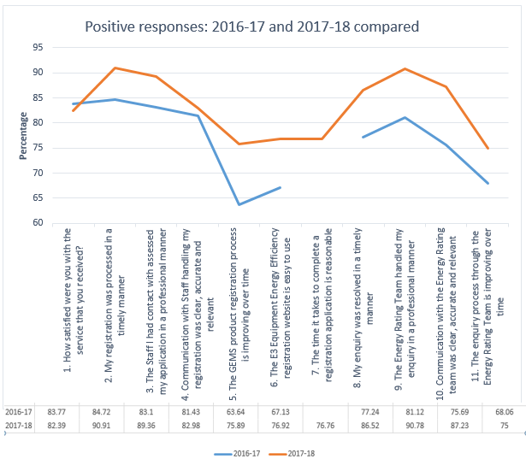

### GEMS compliance and monitoring results