RETAILER FACTSHEET:   
TVs and monitors

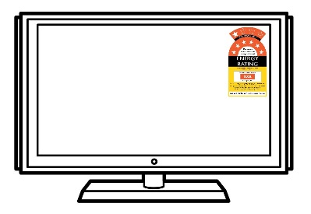Purchase price is only part of the picture…

Your customers are looking for a TV or computer monitor that suits their needs – at the right price. However, purchase price is only part of the picture.

The ongoing running costs can vary greatly between models, so choosing a less efficient model could cost your customer hundreds over the years they own it – it could end up being a purchase decision they regret.

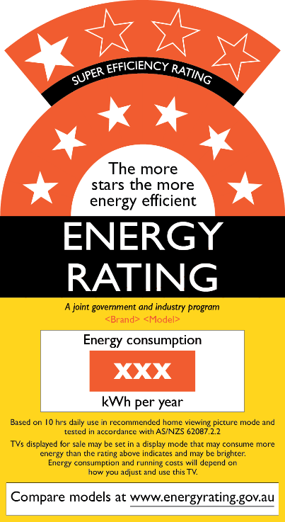You can help your customer make an informed choice. When you have the facts about energy efficiency, you’ll be able to confidently answer your customers’ questions about how to choose a TV or monitor that suits their needs – and saves them money in the long run.

The Energy Rating Label

The [Energy Rating Label](http://www.energyrating.gov.au/about/what-we-do/labelling) will be a familiar sight to most of your customers – it’s been displayed on some appliances for more than two decades. The label is required to be displayed on all TVs and certain monitors available in Australia.

Star Ratings

We all know that more stars means more energy efficient – so it’s cheaper to run. However, we have to compare apples-with-apples.

The star ratings can only be used to compare TVs and monitors of a *similar* size). That is, we *can’t* use the stars to compare a 50 inch TV with a 70 inch model.

As display technology improves, so does energy efficiency. Now, a label for *super-efficient* models is available, displaying 7 to 10 stars.

Energy consumption

Energy consumption is how much energy the TV or monitor uses each year, given in kilowatt hours (kWh). This is based on standardised testing, which is based on 10 hours use per day.

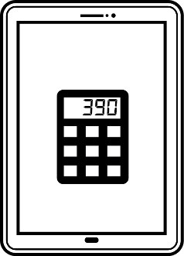This number is especially handy because you can use it to calculate the annual running cost, irrespective of the screen size. Simply multiply the kWh figure on the label by your local energy tariff, which you can find on your energy bill. Alternatively, you can use the average Australian tariff of 28.55c per kWh.

A quicker and easier way to calculate and compare annual – and total lifetime costs – is to use the [online calculator](http://www.energyrating.gov.au/calculator) or download the free app from [iTunes](https://itunes.apple.com/au/app/energy-rating-calculator/id458822857?mt=8) or [Google Play](https://play.google.com/store/apps/details?id=com.environment.energyratingcalc).

|  |  |
| --- | --- |
|  | **The Energy Rating Icon**  Many retailers are now using the Energy Rating Icon on their websites to help their customers compare products. Visit our website to learn more. |

|  |  |
| --- | --- |
| Quick facts | |
| $22 | The average 4.5 star, 55 inch TV uses 78 kWh more each year than a 5.5 star model – that’s $22. |
| $32 | Screen size affects energy bills.  In fact, the average 65 inch TV uses 112 kWh *more* than the average 55 inch model.  That’s $32 each year – either in your customer’s wallet or in energy bills |
| $66 | The average LCD TV made just 5 years ago uses 233 kWh *more* than the current equivalent.  This means keeping the old one could be costing $66 *more* each year in energy bills. |

*Visit our website for more information*

TVs, monitors and energy efficiency – what you need to know

Saving energy means saving money on electricity bills.

Below are some tips you can pass on to your customer to help them choose an energy efficient TV or monitor. Knowing what to look for *before* they buy allows them to compare products properly and make an informed choice – reducing the risk of regret.

* **Choose the appropriate size** first– because generally, the bigger the screen, the *more* energy it uses – which means higher energy bills for your customer.
* **Choose the higher star rating** because it’s more energy efficient compared to models of a similar size, and cheaper to run. Sometimes spending more upfront for a model with just one extra star can work out cheaper in the long-run.
* **The screen type makes a difference** because technology has advanced in recent years, both in terms of picture quality and energy efficiency. For example, when Plasma screens were introduced they were considered very efficient; however, nowadays they are behind the current technologies of OLED, LED and LCD.
* **Compare total lifetime costs** – not just purchase price. Use the online calculator or the apps to calculate and compare total lifetime costs.

Want more information?

For more information about energy efficiency or to use the online calculator, visit our website – or download the free Energy Rating Calculator app from iTunes or Google Play.

[www.energyrating.gov.au](http://www.energyrating.gov.au)