

February 2016

Report for the Equipment Energy Efficiency Program (E3)

**WHITEGOODS** **EFFICIENCY TRENDS 1993-2014**

A report into the energy efficiency trends of whitegoods in Australia from 1993 to 2014

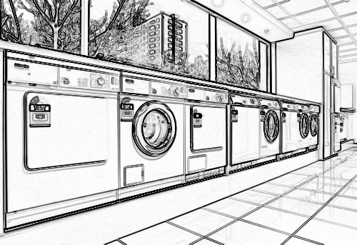

Prepared by Energy Efficient Strategies

TABLE OF CONTENTS

1. Executive Summary 1

1.1 Overview 1

1.2 Background 1

1.3 Coverage 2

1.4 Key Findings 3

General 3

Refrigerators 3

Freezers 5

Clothes Washers 7

Clothes Dryers 9

Dishwashers 11

2. Methodology 13

2.1 Overview 13

2.2 Data Interpretation Issues 13

2.3 Source Data 15

2.4 Analysis Methodology 19

2.5 Comparing label data to actual use in households 20

Refrigerators and Freezers – AS/NZS 4474 20

Clothes Washers – AS/NZS 2040 20

Clothes Dryers – AS/NZS 2442 22

Dishwashers – AS/NZS 2007 22

3. Results for Refrigerators 24

3.1 Market Trends – Main Findings 24

3.2 Energy Efficiency Trends – Main Findings 29

4. Results for Separate Freezers 36

4.1 Market Trends – Main Findings 36

4.2 Energy Efficiency Trends – Main Findings 39

5. Results for Clothes Washers 45

5.1 Market Trends – Main Findings 45

5.2 Energy Efficiency Trends – Main Findings 52

6. Results for Clothes Dryers 57

6.1 Market Trends – Main Findings 57

6.2 Energy Efficiency Trends – Main Findings 61

7. Results for Dishwashers 65

7.1 Market Trends – Main Findings 65

7.2 Energy Efficiency Trends – Main Findings 67

8. Price–Efficiency Relationship for Refrigerators & Freezers 71

8.1 Cross-sectional Analysis of Product Price and Energy Efficiency 71

8.2 Methodology 71

8.2.1 Step 1: Sales weighted volume versus energy and price 72

8.2.2 Step 2: Calculation of normalised energy and normalised price for each model 74

8.2.3 Step 3: Examine relationship between normalised energy and normalised price 74

8.3 Results of cross sectional analysis 75

8.3.1 Price-Efficiency Relationship 80

8.3.2 Real price trends 81

8.4 Cost as a function of star rating by Group 94

8.4.1 Group 1 94

8.4.2 Group 2 95

8.4.3 Group 3 96

8.4.4 Group 4 97

8.4.5 Group 5T 98

8.4.6 Group 5B 99

8.4.7 Group 5S 100

8.4.8 Group 6C 101

8.4.9 Group 6U 102

8.4.10 Group 7 103

9. References 104

Acknowledgements 105

**Separate Appendices - Detailed Output Tables**

Detailed output tables for all characteristics by product by year are available as a separate set of appendices in a single volume (total 212 pages) as follows:

**Appendix A: Refrigerators and Freezers**

**Appendix B: Clothes Washers**

**Appendix C: Clothes Dryers**

**Appendix D: Dishwashers**

LIST OF FIGURES

Figure 1: Energy Consumption of Refrigerators 4

Figure 2: Energy and Real Price Trends for Refrigerators 5

Figure 3: Energy Consumption of Freezers 6

Figure 4: Energy and Real Price Trends for Freezers 6

Figure 5: Energy Consumption of Clothes Washers 8

Figure 6: Energy and Real Price Trends for Clothes Washers 8

Figure 7: Energy Consumption of Clothes Dryers 10

Figure 8: Energy and Real Price Trends for Clothes Dryers 10

Figure 9: Energy Consumption of Dishwashers 11

Figure 10: Energy and Real Price Trends for Dishwashers 12

Figure 11: Market Share by Refrigerator Group 25

Figure 12: Refrigerator Fresh Food Compartment Size Trends 26

Figure 13: Refrigerator Freezer Compartment Size Trends 27

Figure 14: Refrigerator Group Nominal Price Trends 28

Figure 15: Refrigerator Group Real Price Trends 29

Figure 16: Annual Trends in Key Performance Characteristics since 1993 - Refrigerators 31

Figure 17: Long Term Trends in Star Rating for Refrigerators 31

Figure 18: Energy Intensity Trends by Refrigerator Group 32

Figure 19: Original Star Rating (1986) for Models Sold in Selected Years – Refrigerators 33

Figure 20: 2000 Star Rating for Models Sold in Selected Years – Refrigerators 34

Figure 21: 2010 Star Rating for Models Sold in Selected Years – Refrigerators 34

Figure 22: Seasonal Sales Pattern for Refrigerators in Australia 35

Figure 23: Market Share by Freezer Group 37

Figure 24: Separate Freezer Size Trends 38

Figure 25: Separate Freezer Nominal Price Trends 38

Figure 26: Separate Freezer Real Price Trends 39

Figure 27: Annual Trends in Key Performance Characteristics - Freezers 40

Figure 28: Energy Intensity Trends by Freezer Group 41

Figure 29: Long Term Trends in Star Rating for Freezers 41

Figure 30: Original Star Rating (1986) for Models Sold in Selected Years - Freezers 43

Figure 31: 2000 Star Rating for Models Sold in Selected Years - Freezers 43

Figure 32: 2010 Star Rating for Models Sold in Selected Years - Freezers 44

Figure 33: Seasonal Sales of Separate Freezers in Australia 44

Figure 34: Sales Share by Washer Type - 1993 to 2014 46

Figure 35: Rated Capacity Distribution for Selected Years - Washers 47

Figure 36: Rated Capacity Distribution by Washer Type – 2014 47

Figure 37: Trends in Average Rated Capacity by Washer Type 48

Figure 38: Trends in Water Consumption by Washer Type 49

Figure 39: Trends in Program Time by Washer Type 50

Figure 40: Nominal Price Trends by Washer Type 51

Figure 41: Real Price Trends by Washer Type 51

Figure 42: Trends in Average Clothes Washer Energy by Type 52

Figure 43: Annual Trends in Key Performance Characteristics - Clothes Washers 54

Figure 44: 2000 Star Rating for Models Sold in Selected Years - Clothes Washers 55

Figure 45: Star Rating Distribution in 2014 by Washer Type 55

Figure 46: Seasonal Sales of Clothes Washers in Australia 56

Figure 47: Market Share of Clothes Dryer by Type 58

Figure 48: Average Capacity of Clothes Dryer by Type 59

Figure 49: Rated Capacity Distribution for Selected Years - Dryers 59

Figure 50: Clothes Dryer Nominal Price Trends by Type 60

Figure 51: Clothes Dryer Real Price Trends by Type 60

Figure 52: Annual Trends in Key Performance Characteristics – Clothes Dryers 61

Figure 53: Average Dryer Energy Consumption by Type 62

Figure 54: National Sales Distribution by 2000 Star Rating - Clothes Dryers 63

Figure 55: Seasonal Sales of Clothes Dryers in Australia 64

Figure 56: Nominal and Real Price Trends for Dishwashers 66

Figure 57: Trends in Energy Use versus Program Time for Dishwashers 66

Figure 58: Annual Trends in Key Performance Characteristics - Dishwashers 67

Figure 59: Sales Weighted Trends in Dishwasher Energy and Water Consumption 68

Figure 60: National Sales Distribution by 2000 Energy Star Rating – Dishwashers 69

Figure 61: National Sales Distribution by Water Star Rating – Dishwashers 69

Figure 62: Seasonal Sales of Dishwashers in Australia 70

Figure 63: Sales Weighted Volume Energy Regression for Group 5T 73

Figure 64: Sales Weighted Volume Price Regression for Group 5T 73

Figure 65: Sales Weighted Regression of Normalised Energy Versus Normalised Price for Group 5T 75

Figure 66: Volume versus Price for Group 1 82

Figure 67: Volume versus Energy for Group 1 82

Figure 68: Normalised Energy versus Normalised Price for Group 1 83

Figure 69: Volume versus Price for Group 2 83

Figure 70: Volume versus Energy for Group 2 84

Figure 71: Normalised Energy versus Normalised Price for Group 2 84

Figure 72: Volume versus Price for Group 5T 85

Figure 73: Volume versus Energy for Group 5T 85

Figure 74: Normalised Energy versus Normalised Price for Group 5T 86

Figure 75: Volume versus Price for Group 5B 86

Figure 76: Volume versus Energy for Group 5B 87

Figure 77: Normalised Energy versus Normalised Price for Group 5B 87

Figure 78: Volume versus Price for Group 5S 88

Figure 79: Volume versus Energy for Group5S 88

Figure 80: Normalised Energy versus Normalised Price for Group 5S 89

Figure 81: Volume versus Price for Group 6C 89

Figure 82: Volume versus Energy for Group 6C 90

Figure 83: Normalised Energy versus Normalised Price for Group 6C 90

Figure 84: Volume versus Price for Group 6U 91

Figure 85: Volume versus Energy for Group 6U 91

Figure 86: Normalised Energy versus Normalised Price for Group 6U 92

Figure 87: Volume versus Price for Group 7 92

Figure 88: Volume versus Energy for Group 7 93

Figure 89: Normalised Energy versus Normalised Price for Group 7 93

LIST OF TABLES

Table 1: Estimated Market Cover by Year – GfK data provided to EES 17

Table 2: Changes in Refrigerator Characteristics - 1993 to 2014 30

Table 3: Changes in Freezer Characteristics - 1993 to 2014 40

Table 4: Changes in Clothes Washer Characteristics - 1993 to 2014 53

Table 5: Changes in Stand Alone Clothes Dryer Characteristics - 1993 to 2014 61

Table 6: Changes in Dishwasher Characteristics - 1993 to 2014 67

Table 7: Summary of Sales Weighted Volume – Energy Regression by Group in 2013 76

Table 8: Summary of Sales Weighted Volume – Price Regression by Group in 2013 76

Table 9: Normalised Energy–Normalised Price Regressions by Group in 2013 78

Table 10: Changes in Refrigerator and Freezer Real Prices from 1993 to 2014 81

ABBREVIATIONS

|  |  |
| --- | --- |
| ABS | Australian Bureau of Statistics |
| CEC | Comparative Energy Consumption – the energy value on the label |
| CFC | Chloroflurocarbon |
| CPI | Consumer Price Index (cost of living index) |
| E3 | Equipment Energy Efficiency Program (government) |
| EES | Energy Efficient Strategies |
| E2WG | Energy Efficiency Working Group |
| GfK | Market research company – source of sales data |
| Group | Type of refrigerator as classified under AS/NZS4474.1 |
| IEA | International Energy Agency, Paris |
| kWh | Kilowatt hour, unit of energy |
| MCE | Ministerial Council on Energy |
| MEPS | Minimum Energy Performance Standards |
| RIS | Regulatory Impact Statement |
| SRI | Star Rating Index (decimal star rating) |

## Executive Summary

### Overview

This report documents the changes in the energy efficiency and the attributes of new whitegoods that carry an energy rating label and that were sold in Australia from 1993 to 2014 inclusive. All product types analysed in this report have shown an improvement in energy efficiency over the study period, with some product types showing a substantial improvement since data was first available in 1993.

Over the period 1986 to 1990 mandatory energy rating labels were introduced in NSW and Victoria for whitegoods, which includes refrigerators, freezers, clothes washers, clothes dryers and dishwashers. In around 1992, energy rating labels for all whitegoods became mandatory across Australia. The star rating equations for all labelled appliances were re-graded in 2000 together with an updated energy label design. Mandatory minimum energy performance standards (MEPS) for refrigerators and freezers were introduced throughout Australia in 1999. These levels were made substantially more stringent in January 2005 with further changes made to the program in 2010, such as an additional re-grading of the refrigerator and freezer energy label. This study provides information and trends applicable to whitegoods over the past 22 years.

Energy consumption is not apparent to consumers without information programs such as energy rating labels, so credit for much of the improvement in products that are only subjected to energy labelling can be attributed to the labelling regime under the Equipment Energy Efficiency Program (E3). The program has increased consumer awareness of energy efficiency and has created an increased demand for energy efficient products. Reported levels of consumer awareness of energy labelling in Australia is high. In the case of refrigerators and freezers, MEPS has also had a significant impact. This report does not evaluate or quantify the savings impact of these specific program changes, but it does provide solid data that facilitates such an analysis. It provides clear quantitative data on the overall trends in appliance energy efficiency over time. An example of a program impact evaluation for refrigerators and freezers is available in the study *Evaluation of Energy Efficiency Policy Measures for Household Refrigeration in Australia: An assessment of energy savings since 1986* (EES 2010).

### Background

This report has been prepared for the E3 Committee, which operates under the direction of the Energy Efficiency Working Group (E2WG), which in turn reports to the COAG Energy Council. The E3 Committee is made up of Australian federal, state and territory government representatives together with New Zealand officials, who are responsible for implementing energy efficiency programs or regulating the efficiency of appliances and equipment in both countries. This report is one of a number of projects being undertaken to assess trends in efficiency in Australia – more information on the E3 Program can be found on the website [www.energyrating.gov.au](http://www.energyrating.gov.au)

In 1995, Energy Efficient Strategies (EES) was first commissioned to undertake an analysis of appliance retail sales data that was purchased from a commercial source, GfK Market Research. This current report was commissioned by E3 and is the latest in the series for Australia and includes data from 1993 to 2014. This report replaces all previously published reports, the most recent being “*Greening Whitegoods*”, which was published in 2010.

From 2001 GfK provided the E3Committee with a full data set of sales by model for each appliance. Prior to 2001 (1993 to 2000 inclusive), data for approximately 75% to 90% of total sales[1] for each of the appliance types was provided. In this report, trends and comparisons have utilised the full data sets provided since 2001. Analysis has concluded that the reduced data set from earlier years does not unduly affect estimates of the key sales weighted parameters for most products and parameters. The main advantage of the full data set is better identification of product types and configurations that have a small market share.

More information on the source data and analysis can be found in the methodology in Section 2.

### Coverage

This report covers five types of major household electrical appliances:

* Refrigerators;
* Freezers;
* Clothes washers;
* Clothes dryers;
* Dishwashers.

This report does not cover any other appliances or equipment falling within the scope of the E3 Program (such as gas appliances, electric storage water heaters, commercial and industrial equipment or air conditioners).

Throughout this report there is reference to an average “star rating” within each appliance type. The original energy rating labels were first introduced in the late 1980’s and the star rating scale was revised in 2000 to make it more “stringent” (star ratings for most models decreased under the 2000 scale). For wet products (clothes washers, clothes dryers and dishwashers), the detailed data tables show both the original (late 1980s) and the 2000 star rating scales up to 2010. From 2010, only the 2000 star rating is shown for these appliances as the earlier star rating data is no longer recorded in the registration system. Star rating algorithms for refrigerators, freezers and air conditioners were regraded in early 2010. Data on trends based on the 2010 star rating system for refrigerators and freezers has now been included for all years.

All attributes quoted in this report (such as energy, star rating, capacity and so on) are calculated on a “sales weighted” basis, which means that individual appliance attributes by model are weighed in accordance with the sales of each model.

### Key Findings

#### General

The sales weighted annual energy consumption[2] has decreased for all whitegoods, except clothes dryers. For clothes dryers there has been some improvement of energy efficiency and there is a significant future potential improvement with heat pump dryers starting to increase their market share.

#### Refrigerators

*Market Trends*: Total sales increased at 2.8% per annum over the 22 year period. Two door frost free refrigerator/freezers (top and bottom freezers) – Groups 5T and 5B - still dominate the market with 71% of sales. These Groups have generally accounted for over 65% of refrigerator sales since 2000. Since 2000 the Group 5T share has fallen from around 58% to 42% while Group 5B share has increased from 10% to 30%. Side by side (Group 5S) refrigerators sales share peaked at 15% in 2009 and has now fallen to a 10.3% share in 2014. It appears that larger Group 5B models (primarily French door configurations) are displacing Group 5S sales.

Single door refrigerators with a short-term freezer compartment (Group 3) and two-door cyclic defrost refrigerator/freezers (Group 4) virtually disappeared from the market in 1997 and 2005 respectively. The share of Group 1 products (all refrigerators) is stable at about 5% and Group 2 products (small bar refrigerators) is also stable at about 12%. Many of the Group 2 products are likely to be used in small shops and offices for domestic purposes (storing of employee food and drinks).

Average fresh food and freezer volumes are relatively stable after freezer volumes increased significantly during the 1990s, although total average volume continues to increase slightly. Sizes within most Groups are steady, but there is an ongoing shift in market share to Groups with a larger average volume. Price trends within each Group are quite variable. Some Groups have experienced increases in nominal prices over the analysis period while others have experienced falls in nominal prices.

*Energy*: Energy consumption decreased at an average of 2.5% per annum from 1993 to 2014 (see Figure 1). Energy consumption after MEPS 2005 was static until 2009, but there has been some improvement in energy consumption since labels were re-graded in 2010. Figure 2 shows trends in energy consumption and real price over the period 1993 to 2014.

Energy efficiency (taking account of changes in volume) increased at 2.7% per annum over the period. The average star rating under the original rating system (1986) climbed from 3.58 in 1993 to 5.46 in 2014. Under the 2000 star rating system this increased from 1.76 in 1993 to 4.38 in 2014. Under the 2010 star rating system, the average star rating increased from -0.1 in 1993 to 2.43 in 2014.

For the first time this report includes an analysis of the relationship between price and efficiency for refrigerators and freezers. This is set out in Section 8.

Figure 1: Energy Consumption of Refrigerators

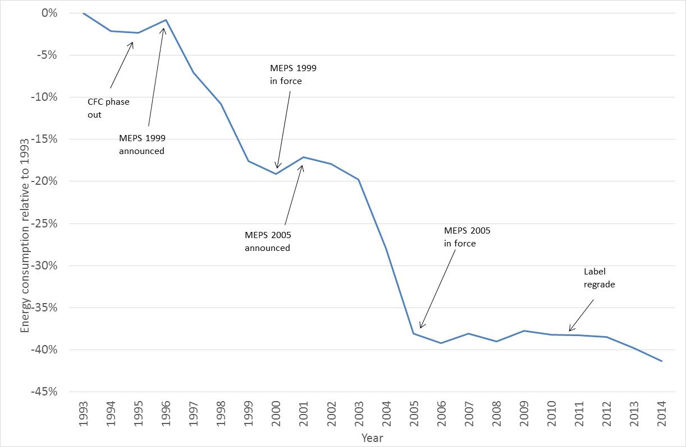

Figure 2: Energy and Real Price Trends for Refrigerators

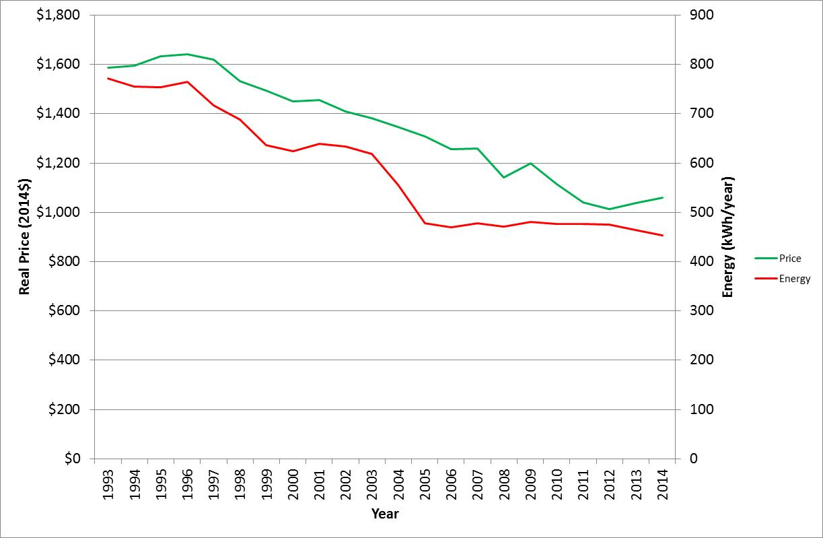

#### Freezers

*Market Trends*: Total sales grew at an average of 2.3% per annum, although the majority of this increase occurred in years 2003 to 2009 (sales before this date were fairly static and have been gradually decreasing since 2009). The average volume of freezers has decreased significantly from 1993 to 2014. The sales of frost free vertical freezers (Group 7) are mostly steady, while manual defrost vertical freezers (Group 6U) increased very sharply over the period 2003 to 2008, but have decreased since 2008. Chest freezer (Group 6C) sales constitute 43% of the market and their share has decreased slightly over the period, although it remained in the range 40% to 50% of all freezer sales.

Group 6U has experienced a decrease in nominal price over the analysis period (partly because average size has decreased) while Groups 6C and 7 have experienced fairly static nominal prices over the period. Group 7 products have also become smaller.

*Energy*: Energy consumption decreased at an average of 2.6% per annum from 1993 to 2014, with the most significant decline occurring in the lead up to 2005 (see Figure 3), linked to the introduction of the more stringent freezer MEPS in January 2005. Energy efficiency (taking account of changes in volume) increased at 2.2% per annum over the period. The average star rating under the original rating system climbed from 4.24 in 1993 to 5.48 in 2014. Under the 2000 star rating system this increased from 1.48 in 1993 to 3.81 in 2014. Under the 2010 star rating system, the average star rating for freezers increased from 0.57 in 1993 to 2.46 in 2014. Figure 4 shows trends in energy consumption and real price over the period 1993 to 2014.

Figure 3: Energy Consumption of Freezers

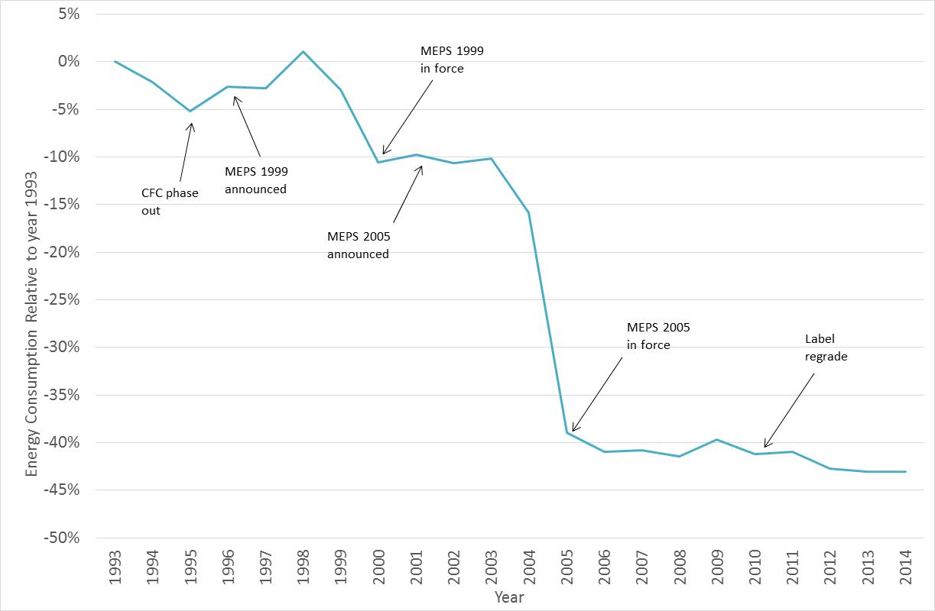

Figure 4: Energy and Real Price Trends for Freezers

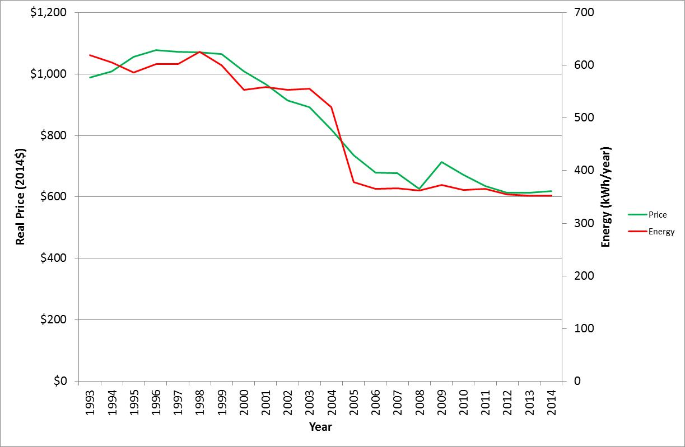

#### Clothes Washers

*Market Trends*: Total sales increased at 3.2% per annum over the analysis period. Front loading machines have dramatically increased their market share and constituted 49.1% of all machines sold in Australia in 2014, with the balance primarily made up of top loaders. Average capacity is increasing steadily for both front and top loading machines and is now 7.6kg and 7.3kg respectively for these types. The capacity of twin tubs types was 3.0 kg in 1993 and has steadily increased to 7.5 kg in 2014. The sales share of twin tubs has generally remained at less than 1% since 2005. Average water consumption for all washer types decreased by 3.0% per annum over the period. Prices decreased slightly in nominal terms for top loaders and have been steady in nominal terms for front loaders for the last decade. Combination washer-dryers peaked in market share at 4.5% in 2006, but have since decreased to 1.4% in 2014. Combination unit capacity has also increased to 8.1kg in 2014 (from 5.9kg in 2001), with nominal prices decreasing slightly over the study period.

*Energy*: Energy consumption showed a slight decrease until 1998, then an increase in energy in 1999 and 2000 (see Figure 5). This increase was present in top loading machines only. Since 2000, energy consumption has been declining, although there was a slight increase in 2005. The energy for front and top loaders increased somewhat from 2009 to 2011 – this appears to be mostly driven by increases in capacity during that period, although the energy intensity of both types increased slightly. Most of the overall decrease in average energy for clothes washers is a result of the increased market share of front loaders (which have lower energy) as the energy trends for each type have been relatively stable over time. The 2000 average star rating increased from 1.28 in 1993 to 3.92 in 2014. Figure 6 shows trends in energy consumption and real price over the period 1993 to 2014.

Figure 5: Energy Consumption of Clothes Washers

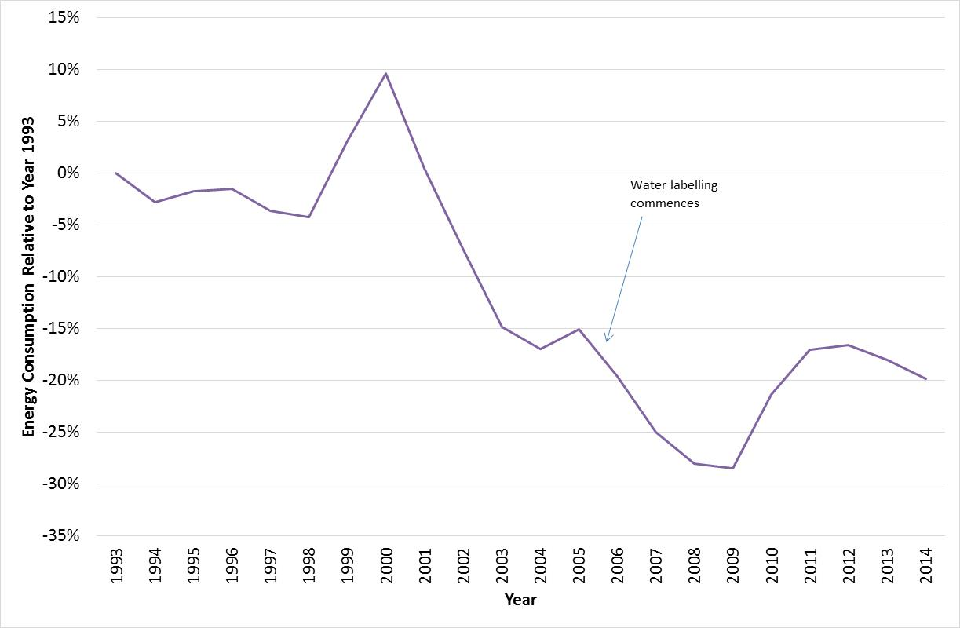

Figure 6: Energy and Real Price Trends for Clothes Washers

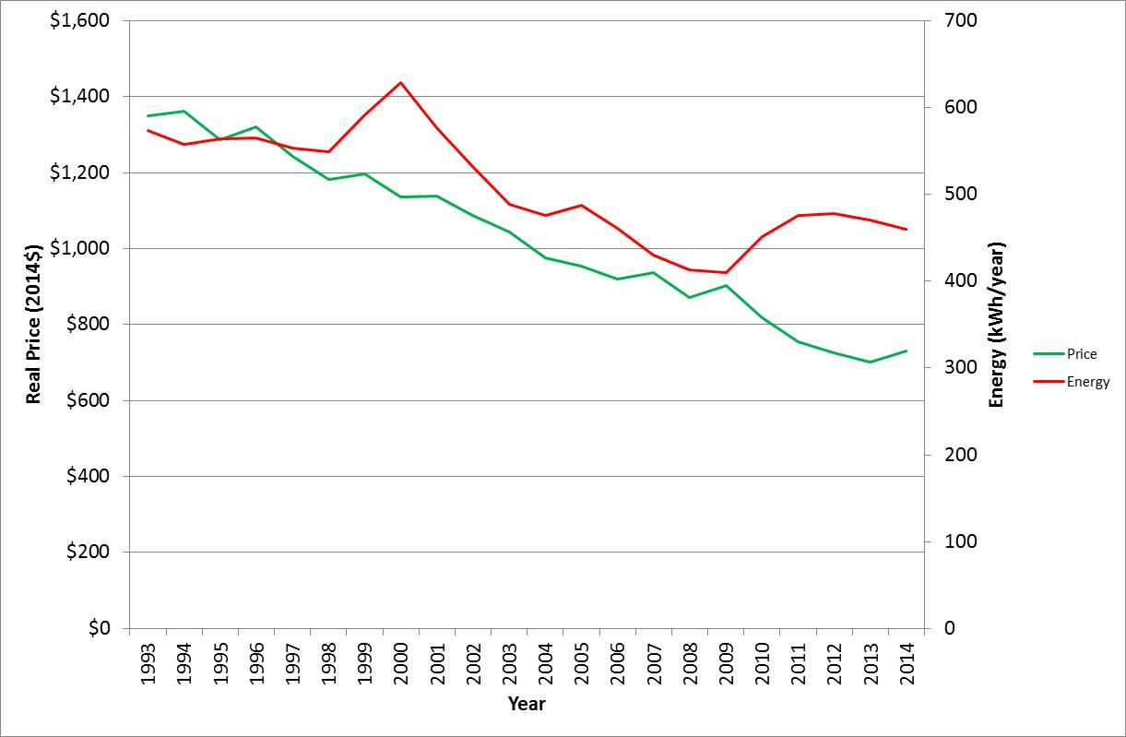

#### Clothes Dryers

*Market Trends*: Total sales increased at an average of about 3.7% per annum from 1993 to 2014, with a steady increasing trend in sales throughout the period, but with some variation from year-to-year (dryer sales are somewhat discretionary and annual sales are driven by weather and economic conditions). The market share of auto-sensing dryers has increased significantly from 10% in 1993 to 53% in 2014. Condenser dryers have only a small market share (around 10.1%). Heat pump dryers first appeared in significant numbers in 2010 and have climbed to a market share of nearly 4% in 2014. Average load capacity was relatively static from 1993 to 2007, but has increased since then by around 20% due small increases in capacity of all types and a small shift in sales to larger types (condensing dryers and heat pump dryers). The nominal average price of clothes dryers increased at around 1.9% per annum, mainly driven by increasing market share of auto-sensing models, and in later years, condenser models, which were generally more expensive than vented timer models. Heat pump dryers are also significantly more expensive and their increased share has pushed up average prices marginally. Nominal prices of vented dryers have been declining over time. Heat pump types and condensing dryers showed a strong decrease in average price.

About 10,000 combination washer-dryers were sold in 2014 – this is roughly an additional 4% of condensing dryer sales in that year which are in addition to the sales shown.

*Energy*: Energy consumption remained static from 1993 to 2014 (see Figure 7). Under the 2000 star rating system the average star rating increased from 1.22 in 1993 to 2.09 in 2014. These increases are primarily due to an increase in market share of auto-sensing dryers as well as an increase in capacity, rather than underlying improvements in dryer technology. The energy consumption of heat pump dryers is about half that of conventional dryers of the same capacity, so these are expected to have a significant impact in the future if they continue to gain increasing market share. Figure 8 shows trends in energy consumption and real price over the period 1993 to 2014.

Figure 7: Energy Consumption of Clothes Dryers

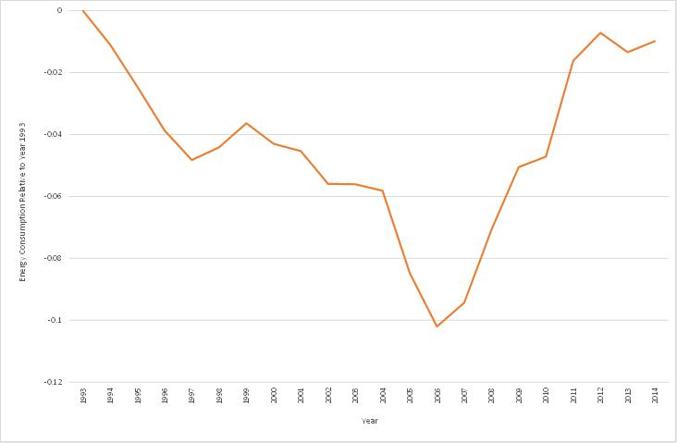

Figure 8: Energy and Real Price Trends for Clothes Dryers

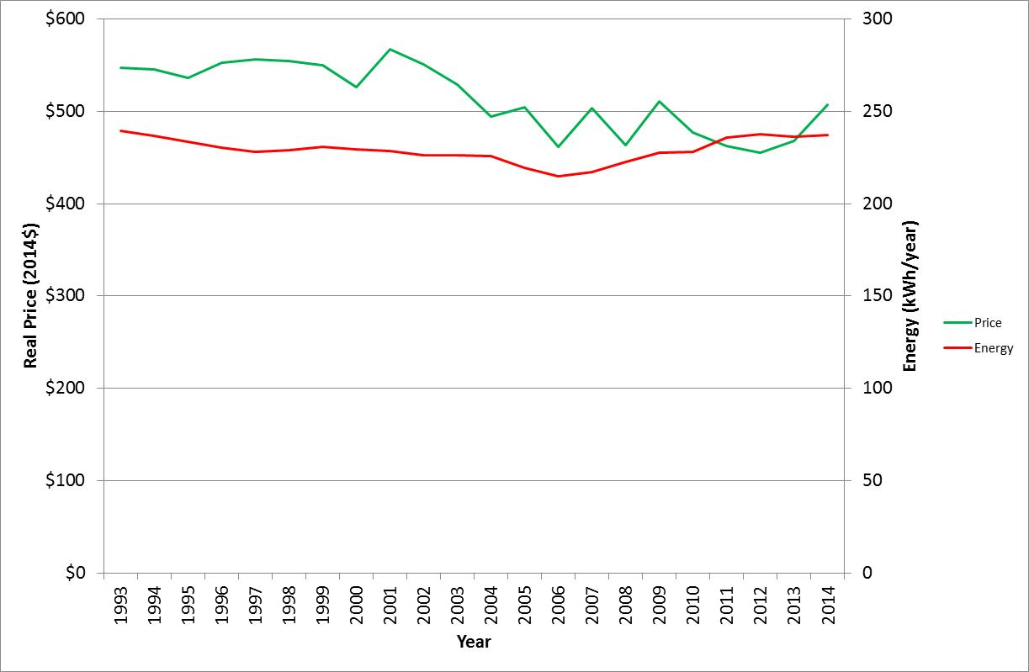

#### Dishwashers

*Market Trends*: Total sales increased strongly with a growth of 5.6% per annum from 1993 to 2014, which reflects the increasing penetration of this product in the residential sector. Average capacity (place settings) has been stable since 1996 although there was a slight decline from 2003 to 2007 and a slight increase to 2011. Water consumption decreased by over 3.9% per annum over the period. Prices declined slightly at -0.5% per annum in nominal terms over the study period.

*Energy*: Energy consumption decreased at an average of 2.7% per annum from 1993 to 2014 (see Figure 9), although the rate of decline has slowed since 2006. Under the 2000 star rating system the average star rating increased from 1.88 in 1993 to 3.3 in 2014. Figure 10 shows trends in energy consumption and real price over the period 1993 to 2014.

Figure 9: Energy Consumption of Dishwashers

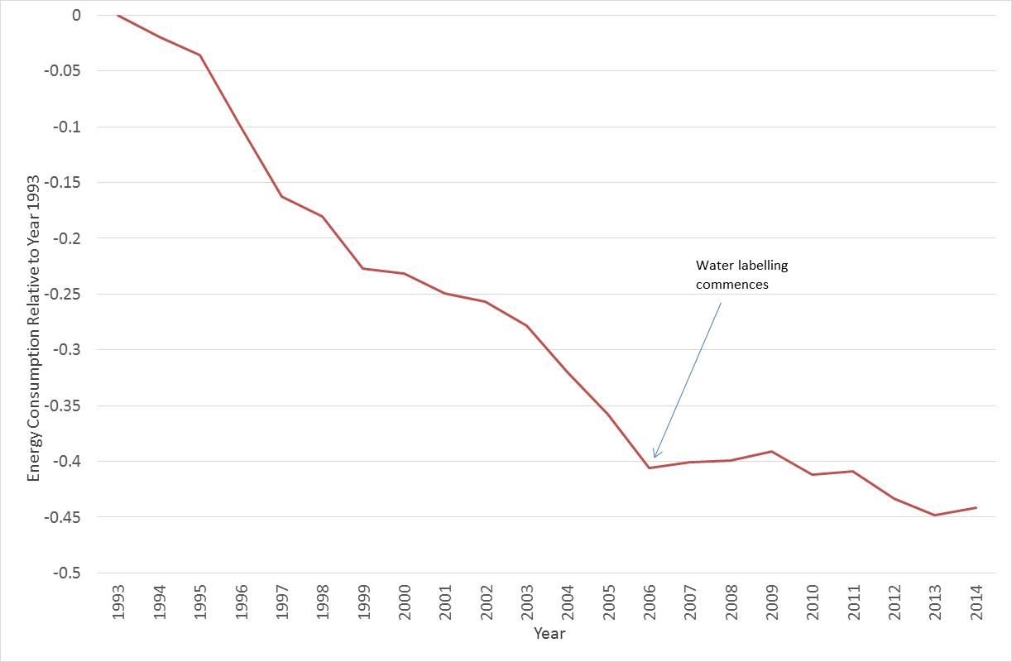

Figure 10: Energy and Real Price Trends for Dishwashers

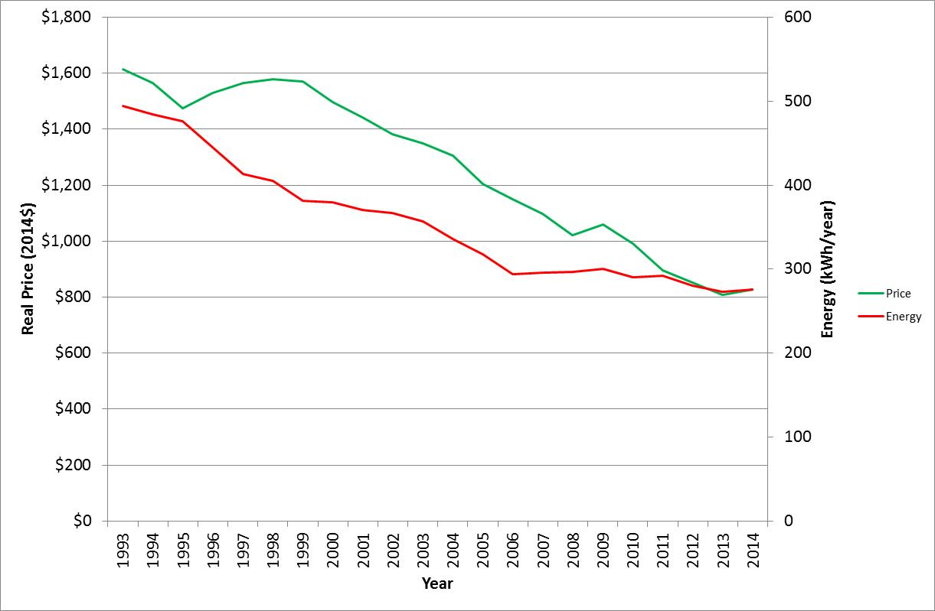

## Methodology

### Overview

This report provides a detailed analysis of the performance trends of whitegoods in Australia from 1993 to 2014. The whitegoods market grew significantly over this period: in 2014 alone this report covered the attributes of 2.25 million appliances with a total retail value of AU$2.2 billion. Generally, there has been a significant improvement in efficiency of all products, most likely as a result of energy rating labels. In the case of refrigerators and freezers, additional improvements have occurred as a result of MEPS, which were first introduced in 1999 and subsequently made more stringent in 2005[3].

Generally, sales of all appliance types have been increasing. This is a result of increasing numbers of households, increasing penetration and ownership of some appliance types (especially dishwashers) and the replacement of older appliances as they are retired. Note that some retail sales of the appliances included in this report are likely to be installed and used in the commercial sector (mainly certain types of refrigerators).

### Data Interpretation Issues

The detailed trends by appliance type are discussed in the following sections. Where trends are quoted in terms of change per annum, this usually refers to the 22 years of data from 1993 to 2014 inclusive (based on 21 data intervals), except where otherwise stated. A positive percentage change is an increase in the attribute while a negative percentage change is a decrease in the attribute. Note that for some characteristics a decrease is an improvement, while for others, an increase is an improvement.

The data shown in the following sections is based on the EES analysis of the product lists provided by GfK. For wet products (clothes washers, clothes dryers and dishwashers) the star rating frequency distributions for each appliance type are shown for both the original star rating (the original scale from the 1980’s) as well as the 2000 star rating (revised scale introduced in October 2000) in the detailed data tables up to 2010. From 2010 onwards, only the 2000 star rating scale is shown. In part, this is because the newer registrations no longer carry this data. For refrigerators and freezers, the original 1986 star rating as well as the 2000 and 2010 star rating is shown for all years. EES has calculated both star rating indices for every product identified by GfK and listed on the registration database of the Energy Rating Website since 1993.

For the 22 calendar years analysed, a clear trend for most performance characteristics has generally emerged, although, even at the detailed level, there is some variation in the results from year-to-year. Some caution is required in the interpretation of these results. Shifts in the various parameters from year-to-year may be due to a combination of actual sales weighted trends in appliances sold together with some effect from the actual mix of models for which GfK have provided sales data and the exact timeframe in which sales are reported. It is hoped these variations will now be minimised as full data sets have been used to track trends since 2001. Care is required when interpreting data where there are less than 5 models identified in a particular year and product category. This is particularly true where a product category starts with a small share or declines in share over time.

Since 2001, GfK have supplied a full data set for each appliance (excluding “exclusive” models which generally make up less than 1% of total sales for most product types). Up to the year 2000, data for approximately 75% to 90% of total sales for each of the appliance types was provided by GfK. Therefore some small data discontinuities may be apparent across the years 2000/2001 due to the way the data was provided by GfK. Some price discontinuities also occur as individual model prices for so called “exclusive” models were not provided in some years.

The prices shown in the report are actual prices paid by consumers at the retail outlet, and they include GST from 2000. Prices have not been corrected for changes in the Consumer Price Index (CPI) over the study period; these prices are called “nominal prices” in this report. The Australian Bureau of Statistics reports changes to the CPI in ABS6401.0, which shows that the average index for all types and cities increased by 74% from June 1993 to June 2014 (ABS 2014). Therefore, an appliance that costs the same in nominal dollars in 1993 and 2014 is in fact about 43% cheaper in 2014 dollars once the CPI correction is applied. These types of corrections need to be applied to individual products year by year to examine the trends in real appliance prices (adjusted for inflation) over time. Almost all appliances covered by this analysis have only experienced small increases (or even decreases) in nominal prices over the period 1993 to 2014, so in practice most have experienced substantial real price decreases over the past 22 years. Remarkably, there have been significant increases in the energy efficiency of appliances during the period for most products, which defies the common belief that increases in appliance efficiency will cost more. Some data on real price trends has been included in this edition of the report in addition to nominal price trends. Product types with the largest declines in energy consumption over time also appear to show the largest decline in real price, which suggests that higher levels of innovation by industry can improve both parameters in parallel.

While the data in this report and the associated detailed output tables provides a good basis for analysing appliance trends, it needs to be noted that the values reported are as registered for energy labelling, which are based on the relevant Australian Standards for determination of performance and energy consumption. While these provide good indicators of trends in performance for different models, anyone who intends to use this data to estimate energy consumption during normal use needs to have a good understanding of the definitions and requirements within these standards before drawing any conclusions with respect to the impact on actual energy consumption of these appliances under normal use in households. Under Australian Standards, products are generally tested at rated capacity and for a specified number of cycles per year under defined conditions. Actual use will vary for different consumers. For example, many consumers are known to run washing machines at lower than rated capacity for many cycles, many clothes loads are washed in cooler or cold water compared to the Australian Standard specification of a warm wash, so the energy consumed in these cases will be substantially lower than the energy label suggests (see Section 2.5 for more information on this issue). This may have a significant impact on the calculated energy savings during normal use.

In this report, trend data shown in figures and tables use the full data sets (sales data for all models provided by GfK). Detailed output tables by attribute, product type and year are shown in the detailed output tables provided in Appendices A to D (separate volume).

### Source Data

The information provided by GfK was in the form of national sales data, plus sales data for five state groupings (NSW+ACT, QLD, WA, SA+NT, VIC+TAS). State sheets for each product and year provide attributes for each product broken down by state grouping. These are provided in the detailed output tables (Appendices A to D) which are released as a separate document. Generally these show that attributes for almost all products are extremely consistent across the state groupings. There are some variations in sales share at a state level, for example front loading washer (drum) sales are lowest in Queensland and highest in South Australia and Victoria, but the attributes of those types of washers are very similar in all states.

The appliance lists provided by GfK up to 2000 showed the largest selling models for each of the main appliance categories. From 2001, GfK have provided full sales lists for all models. Models tagged as exclusive have some performance information but they do not show the model number and may not show the brand. GfK mask this data because some models are supplied exclusively to one retailer and provision of sales and price data for these models would reveal commercially confidential information. In some cases, the model can be identified and matched with an equivalent energy label registration – where this is the case the model is listed as identified. However, from 2001 to 2007 most exclusive models had no price information or any other attributes. Exclusive models have therefore been excluded from average price calculations by product type (even where the model has been identified) where there is no price data. Typically, exclusive models are either significantly cheaper or more expensive than the average, and thus need to be separated to give a more accurate price indicator by product type. From 2008, prices were reported for all models.

The format of the source data changed several times over the period 2008 to 2014. In some cases models listed by GfK are not registered for energy labelling. This is sometimes because the products are not within the scope of the regulations (e.g. gas dryers). Unregistered products covered by the scope of the relevant regulations are referred to regulators for action.

For years up to 2000, the sum of the state sales for a particular model do not necessarily equal the national sales for that model, as the top selling models listed at the state level are not necessarily the top selling models listed at the national level and vice versa. However, the total state sales add up to total national sales. From 2001 all models were identified in all states. However there were many models that appeared to have multiple entries at a state and national level. The data structure provided from 2011 changed again listing all model sales by state and month, with exclusive products partly de-identified. Sales data was only purchased for the first six months of 2014, so parameters such as sales and sales value have been scaled to be full year equivalents where shown as year to year trends. Analysis of all products for years 2011 to 2013 showed that data for January to June in each year is almost exactly 50% of annual sales for all products covered. The most recent data format also allowed seasonality of sales by product to be shown for the first time. While the sales data is nominally monthly, there appears to be some noise in month to month sales that may be associated with data collection and reporting techniques used by GfK.

GfK claim to cover more than 95% of total retail appliance sales in Australia for the products covered by this report. It is still unclear what proportion of total appliance sales would occur outside the retail system (possibly some large institutional buyers or other large direct wholesale purchases). This is probably most significant for refrigerators, but also possible for some dishwashers, which are often included in the total price of a newly built home.

In 2003, GfK expanded their client base to include a number of large retail chains that were not previously included. This appears as a jump in GfK listed sales in the year 2005 for the data provided (the expanded data set was not provided in 2003 and 2004, even though available). Prior to the inclusion of these new retailers, GfK retail cover had dropped to be as low as 65% for some products – it had been declining due to an increase in market share of these other retailers. Using a range of data sources such as BIS Shrapnel and EES appliance stock models together with information from GfK, EES has estimated the market cover that the GfK data sets represents since 1993. These figures provide some basis for estimating total market for each product type for the period since 1993. To estimate the total market, the sales reported in the Appendices should be divided by the market cover values in Table 1. For example, reported refrigerator sales in 1993 were 474,416 units (see separate Appendix A). EES estimates the cover to be 85% in that year, so the total market is approximately 558,000.

The appliance sales data is collected by GfK from all major retailers of appliances. GfK estimate that about 80% of this sales data is from retailers with full census information in recent years (via computerised listings at a model level), while the model breakdowns in the remaining 20% is estimated on the basis of sampling from selected stores within the various retail chains. It should be noted that the total sales figures (number sold and total value) for each appliance type will be accurate - only the market share by model is estimated by GfK by the use of sampling. The breakdown between census and sampling estimates was closer to 50%/50% for the data sets provided in the early 1990s and the share of full census data can be expected to increase as fully electronic sales systems become more common.

Prior to 2001, GfK supplied data for approximately 75% to 90% of total sales for each of the appliance types. The data included a list of models with the largest sales in order of decreasing sales (which typically only covered less than half of all available models). Since 2001, the analysis in this report is based on a full data set. The analysis provided in this report has concluded that the reduced data set used in earlier years does not unduly affect estimates of the key appliance parameters. The main improvement from the full data set is better identification of product types that have a small market share. This is particularly evident in clothes dryers (e.g. no condenser types were identified prior to 2001 due to low sales per model) and for clothes washers, where front loader and twin tub models were numerous but sales per model were generally fairly small and so few were individually identified prior to 2001. Fortunately in the case of clothes washers, GfK separately provided cross tabulations for all clothes washers by type for all years except for 2001 (where author estimates have been made based on trends). Data in the main report on share by clothes washer type are based on these primary cross tabulations. The same issue also applies to side by side refrigerators (Group 5S) prior to 2001 – there were a large number of models, each with few sales so many were not identified. Subsequently, the sales share and price appears to show a discontinuity over years 2000/2001.

Table 1: Estimated Market Cover by Year – GfK data provided to EES

|  |  |  |  |  |  |
| --- | --- | --- | --- | --- | --- |
| Year | Refrigerators | Freezers | Clothes Washers | Clothes Dryers | Dishwashers |
| 1993 | 85% | 78% | 90% | 90% | 85% |
| 1994 | 83% | 78% | 88% | 88% | 83% |
| 1995 | 81% | 77% | 86% | 86% | 81% |
| 1996 | 79% | 77% | 84% | 83% | 80% |
| 1997 | 77% | 76% | 81% | 81% | 78% |
| 1998 | 76% | 76% | 79% | 79% | 76% |
| 1999 | 74% | 75% | 77% | 77% | 74% |
| 2000 | 72% | 75% | 75% | 75% | 72% |
| 2001 | 70% | 74% | 73% | 72% | 71% |
| 2002 | 68% | 74% | 71% | 70% | 69% |
| 2003 | 66% | 73% | 69% | 68% | 67% |
| 2004 | 66% | 73% | 69% | 68% | 67% |
| 2005-2014 | 95% | 95% | 95% | 95% | 95% |

Note: Based on author estimates, EES models, BIS Shrapnel data and discussions with GfK.

For all appliances covered, GfK provided the following data for each model listed, both at the national and state levels:

* brand
* model number
* label comparative energy consumption (CEC)
* star rating
* unit sales
* average selling price

The GfK data for star ratings in years 2000 to 2002 were only a general guide as there was a mixture of original (1986) and 2000 star ratings recorded. Similarly, there were a mix of star rating for the period 2010 to 2012 for refrigerators and freezers after the label re-grade in 2010.

For refrigerators and freezers, the following additional data was provided for each model:

* nominal total gross volume
* number of external doors
* defrost type (manual, frost free, auto, push button)
* refrigerator type (standard, all refrigerator, upside down, side by side - or chest/upright for freezers)

For clothes washers, the following additional data was provided for each model:

* tub – single/double/drum (double = twin tub)
* loading type - top/front
* load capacity
* water rating

For clothes dryers, the following additional data was provided for each model:

* control – electronic or timer (most were recorded as “unidentified”)
* load capacity

For dishwashers, the following additional data was provided for each model:

* freestanding or built in (integrated)
* mechanical or electronic control
* water rating

GfK commenced data collections in February 1993, so no data is available prior to this date. GfK converted their databases to align with an international format within the company in 2003, so data sets prior to 2003 are no longer available from GfK. Data sets provided to EES by GfK prior to 2003 are still held by EES and the Department.

Initially, data was collected in 2 monthly periods, so the closest period which corresponded to a full calendar year is from February one year to January the next year (inclusive). Up to 1998 these periods have been used as nominal years for this analysis. From 1999 GfK collected data monthly so from 1999 true calendar years have been used.

One issue that has created analysis challenges is multiple records with seemingly the same appliance attributes (but usually a different price). Some manual adjustment of the data set within any single year is required in order to make each of these records unique for each state and the national sales listing. In recent years GfK have provided a unique record identifier for each model, which has helped the cross matching process.

### Analysis Methodology

In earlier years, the first step in the process was to compile all of the state based registers into a single complete listing of all models for each appliance that have ever been registered for labelling. This step was superseded in 1998 as the national appliance database was put into place and has since been used as the primary data source for all models.

For each model listed in the GfK list for each period, the correct national database registration number was identified then entered into a separate database together with the GfK data on sales and price for each model (national and state data). From 1999 GfK supplied electronic lists which made cross matching must faster and more streamlined. The data contained in the registration database for each model is considerably more detailed than the information collected by GfK. The analysis for years from 2001 was more labour intensive as the number of models in the full model listing was typically 3 to 4 times larger (of the order of 300 to 1000 models per product) when compared to the lists provided prior to 2001.

A separate sales database was created for each appliance type and for each year. The appliance attributes required for analysis in these yearly sales databases are imported from the master registration database, which was checked for completeness for each record used in the analysis. The yearly sales database then calculates the sales weighted attributes of interest that are tracked in the analysis. Where corrections to the master database are required (apparent incorrect data or missing data), these are coordinated with the relevant regulator.

An analysis database imports the relevant sales weighted information from each of the single yearly sales databases and compiles sales weighted information of interest for each year. This data is available at the national and state level. National trend data for all the years analysed is then compiled onto a single listing for further analysis.

A data issue that is also related to analysis, concerns the attributes that GfK report for a particular model. Typically GfK obtain information such as capacity and type from manufacturers or wholesalers (or more recently from the energy rating website) which is then recorded against a particular model in the retailer system and also in the GfK system. In subsequent years the same attributes may be reported against that particular model number into the future. The reality in the market, however, is that models are sometimes re-registered for energy labelling (and/or MEPS in the case of refrigerators and freezers). So newer registrations (and the attributes of appliances shipped into the market) in the current year may have different energy attributes to previous models with the same number which may have been recorded in the past by GfK (this can also apply to other attributes as well). In these cases, the GfK information usually provides an initial check of the model details, but for the analysis in this report the most recent registration for that exact model in the current year is used to perform the sales weighted analysis for that year. Sometimes GfK (or the retailers from whom they obtain data) retain older model numbers in their product listing, which can be obsolete in terms of products supplied to market. In broad terms, as much as 10% to 20% of the information recorded by GfK can be inconsistent with the energy rating registration database, so a degree of skill and judgement is required to accurately allocate GfK models to the registration database.

### Comparing label data to actual use in households

The data in this report relies on the registration database which is based on Australian Standards and test procedures relevant to each product type and it is useful to be aware of some of the issues related to these standards if extrapolating data and/or information from this report in order to estimate actual end use energy consumption. The main issues are outlined below for each product type.

#### Refrigerators and Freezers – AS/NZS 4474

Energy consumption for refrigerators and freezers is determined under steady state conditions at prescribed internal temperatures (e.g. +3°C for fresh food and -15°C for freezers). The ambient test temperature is +32°C but there are no external food loads or door openings during the test. The actual in use energy consumption in a consumer home is dependent on actual ambient temperature and the response temperature curve of individual refrigerators and freezers, which cannot be determined from test data and which will vary from model to model. The internal temperatures selected by the user and frequency and duration of door openings and warm food loads will all have some impact on energy consumption during normal use. The current energy test also provides no information on load processing efficiency – removal of heat from food loads and door openings.

#### Clothes Washers – AS/NZS 2040

Despite the apparent lack of improvement in top loader energy consumption over the analysis period, there are other factors that have an important influence on clothes washer energy consumption during actual use in households. Firstly, there has been an ongoing trend towards cold water washing in Australian households. The Australian Bureau of Statistics (see [www.abs.gov.au](http://www.abs.gov.au)) reported that in 2011 some 72% of households wash in cold water (up from 65% in 1994) (ABS4602.0, 2011 – Table 17). Note that the way the ABS asks the question will mean that the total share of cold washes is likely to be over-reported. Other data sources suggest that around 55% to 60% of washes were cold in recent years. This is critical because the energy values analysed for this report are to AS/NZS2040, which specifies a warm wash for the purposes of energy labelling (minimum wash temperature of 35°C[4]). The energy embodied in warm water for a clothes washer test constitutes typically around 80% of the total energy consumption of clothes washers. Most top loaders are able to wash in cold water, so the in use energy consumption of top loaders will be considerably lower than stated on the energy rating label for households that use cold washing frequently (as reported by ABS). The 2000 energy rating label now also shows on a voluntary basis, cold water energy for clothes washers – for top loading machines this is an average of 69 kWh/year compared to an average warm CEC of 518 kWh/year for products currently registered.

Connection to cold water only, or hot and cold water, will affect operating costs. Most top loaders have dual hot/cold water connection and use external hot water. In the 1990s, quite a few front loaders also had dual water connection (about 75%). However, the share of dual connected front loaders decreased as front loader sales increased – only about 30% now have dual hot and cold connection. This has created some consumer concern.

A related issue for consideration with respect to energy consumption is the capability to undertake so called “cold washes” as reported by the ABS. Very few front loaders have programs that can wash in temperatures less than 30°C and almost all have internal heaters to heat from cold or to boost wash temperatures if the fill temperature is too low during hot water intake. In contrast, virtually all top loaders have dual water connections, they have no internal heater and can wash in “cold water” (noting that some have variations to cold wash such as the ability to control and mix water to achieve a wash temperature of around 20°C without internal water heating). So estimating energy during normal use is somewhat complex in many cases – it depends on the water connection mode and the minimum program temperature available as well as consumer selected wash temperature.

The other factor that will influence in use energy consumption for clothes washers is frequency of use. The energy rating label assumes 7 washers per week for all models on the program recommended for a normally soiled load. The number of loads in an average house is thought to be similar (around 6 loads per week), but the average load size is likely to be much lower than rated capacity. Average household size (number of occupants) is continuing to decline while clothes washer capacity in recent years has increased. Presumably the total washing requirement per person is not increasing significantly, so it is reasonable to assume in average households that either there are less loads per week washed or a similar number of loads are washed at lower capacity.

The Australian Standard assumes all loads are at rated capacity. It is likely that many (if not most) consumers load their machines at somewhat less than rated capacity during normal use. The impact of this will depend on the ability of the particular machine to adjust its water and energy consumption to suit to reduced load. As a result of reduced loads and reduced wash temperatures, the resulting energy consumption is likely to be less than that stated on the energy rating label where the machine has load sensing capability. Currently the Australian Standard does not assess the ability of the washer to scale water and energy consumption under part load conditions, so concrete information in relation to these impacts is scarce. However, the energy rating label remains an important comparative tool for consumers. The change in energy and water consumption in response to smaller loads is being considered as part of a revision to AS/NZS2040.

#### Clothes Dryers – AS/NZS 2442

Energy consumption for clothes dryers is based on the 2000 energy labelling algorithm of 52 uses per year at rated capacity, so care is needed when comparing data in this report to values published in previous years (as this was based on 150 uses per year). Normal use is likely to be made up of more loads per year on average but at lower capacity.

Over-drying is another factor in actual use and this varies between different consumer types. Auto-sensing machines will reduce the likelihood of this occurring under normal circumstances and there is some field data to support this adjustment.

Another factor is actual load versus rated capacity (which is the basis of tests under the Australian Standard). It is known that many consumers load their machines at less than rated capacity during normal use. In reality, a larger number of smaller loads are dried in an average house than assumed in the standard. The impact of smaller loads is someone linear down to quite small loads, but this affects the overall energy consumption. Smaller loads are dried less efficiently but also use less energy. Dryer usage varies considerably by household with some households rarely using their dryers and others using it for every washing load (particularly in apartment living arrangements where line drying is limited or even non-existent).

#### Dishwashers – AS/NZS 2007

Energy consumption for dishwashers is based on 365 uses per year at rated capacity on the program recommended for a normally soiled load. The usage level was originally selected to align with clothes washers. The frequency of use, the loading (full or partly full) and use of economy or Eco programs will all affect energy consumption, although few dishwashers adjust their water and energy consumption significantly in response to consumer soil loads. Connection to cold water or hot water will affect operating costs (virtually no current models now have dual water connection). This is partly because fill volumes for dishwashers are now so small (typically of the order of 4 litres) that little, if any, hot water from a hot connection actually reaches the machine by the time the required intake volume has been reached, resulting in wasted hot water energy (hot water pipe losses). While most consumers do not fully load their dishwashers before starting the program, the impact of loading is generally small, except for auto-sensing models, which are not that uncommon. Average consumer use is thought to be about half the frequency assumed on the current energy label.

## Results for Refrigerators

Energy rating labels were introduced in NSW and Victoria in 1986 and introduced nationally in 1992. The energy labelling algorithm was revised in 2000 and again in 2010. MEPS for refrigerators were first introduced in October 1999 and new stringent MEPS levels (based on US 2001 levels) were introduced on 1 January 2005. Some adjustments were made to the MEPS definition in 2010, but this did not increase the technical stringency. Refrigerators in this report include single door models as well as refrigerator/freezers.

### Market Trends – Main Findings

In 2014[5], of the sales recorded by GfK, 849,730 unit sales were identifiable models that made up 99.4% of total retail sales recorded by GfK. The main findings were as follows:

* Total retail refrigerator sales for the period 1993 to 2014 increased at an average 2.8% per annum[6].
* The market share of Group 5T (2 door frost free refrigerator/freezer with top-mounted freezer) peaked in 2000 at 58% after which they have been gradually decreasing in sales share. In 2014, Group 5T made up 42.2% of all refrigerator sales, which is still the largest selling Group.
* The market share of Group 5B (2 door frost free refrigerator/freezer with bottom-mounted freezer) was fairly steady up until 2007 (between 10% to 13%), but then increased to 29.5% by 2014. Large Group 5B models (mostly French door configuration) appear to be displacing side by side models.
* The market share of Group 5S (side by side) refrigerators grew steadily to 2009 where it peaked at 15.7%. It has since declined to 10.3% market share in 2014.
* The market share of Group 2 (typically small bar refrigerators – many are used in commercial offices) was steady at around 12% to 14% share for the whole period, while the market share of Group 1 (all refrigerators) declined slightly from 9% in 1993 to 4.4% in 2014.
* Group 4 (2 door cyclic defrost refrigerator-freezers) made up 30% of the market in 1993. They had essentially disappeared from the market by 2005 with just a handful of models still available with few sales since then.
* Sales of Group 3 (refrigerator with short term freezer) have been virtually non-existent since the late 1990s, although there was a spike in units sold in the years 2005 to 2007 (up to around a 3.5% market share), this has since declined to 1.4% in 2014. These units are similar to Group 2 (Group 3 has a slightly colder freezer) and the total combined share of Group 2 & 3 has been fairly constant.

The market share by Group across the study period is shown in Figure 11. Group 5B appears to be gaining share from both Group 5T and Group 5S.

Figure 11: Market Share by Refrigerator Group

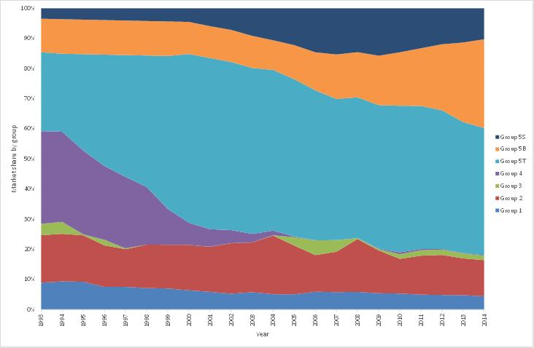Notes: Share of Groups 5B and 5S prior to 2001 have been estimated from a range of other data sources in addition to GfK sales.

A summary of the patterns emerging among the key characteristics of refrigerators and refrigerator/freezers in Australia is as follows:

* **Fresh food compartment volume:** the average fresh food compartment volume for all refrigerators and refrigerator/freezers has remained fairly stable since 1993. In 2014 the overall average volume was 282 litres. However, there have been notable changes within some of the Groups:
* Group 1 (all refrigerator) compartment volume increased sharply from 1998 (308 litres) to 2000 (359 litres), remained stable until 2005, then dropped sharply to 320 litres in 2006 and has since been fairly stable with the value of 312 litres in 2014.
* Group 3 and Group 4 show volatile changes in volume but their sales are now extremely small, so this has little impact on sales weighted trends.
* Group 5T showed a decline in fresh food volume during the 1990s but has been stable since 2000 at about 270 litres.
* Group 5B has showed a fairly steady increase in volume throughout the study period from 273 litres in 1993 to 343 litres in 2014.
* Group 5S (side by side frost free refrigerators) volume declined between 2001 and 2008 but increased slightly since 2008. In 2014 it was 382 litres.

Figure 12 illustrates the changes in fresh food compartment volume since 1993. There were no sales recorded for Group 3 models for the years from 1998 to 2000.

* **Freezer compartment volume:** Average freezer compartment volume has increased from 1993 (81 litres) to 2014 (116 litres). This is mostly driven by increased sales share of Groups with larger freezers. Within Groups, freezer volume has been mostly stable from 1993 to 2014, although there has been a slight decrease for Group 5T and a slight increase in Group 5B (in line with overall changes in volume for these Groups).

Figure 13 illustrates the changes in freezer compartment volume since 1993. Only Groups 4, 5T, 5B and 5S are shown as Groups 1, 2 and 3 do not contain any significant freezer volume, by definition.

Figure 12: Refrigerator Fresh Food Compartment Size Trends

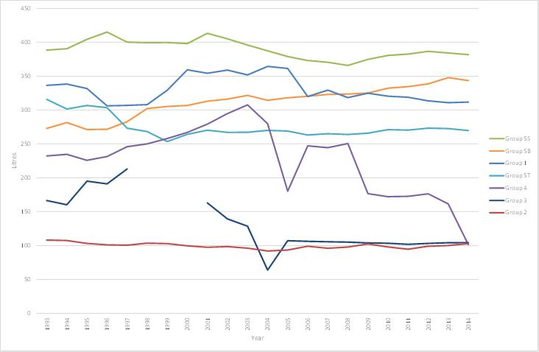Note: Sales of Group 3 are very small for all years, and sales of Group 4 in the years 2005 to 2014 were also very small.

Figure 13: Refrigerator Freezer Compartment Size Trends

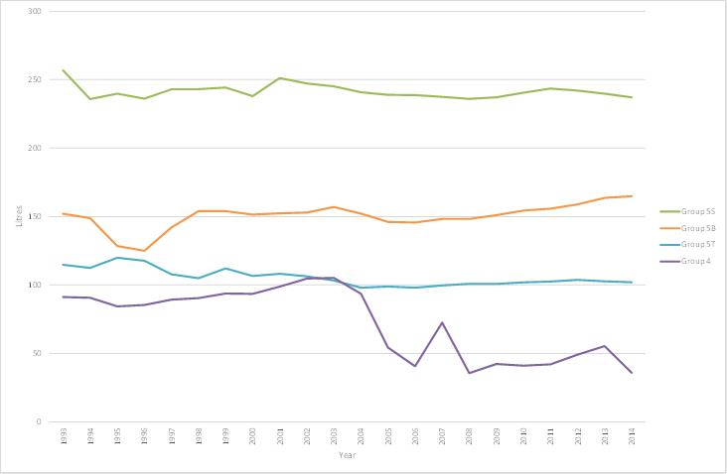Note: Sales of Group 4 in the years 2005 to 2009 were very small.

* **Purchase Price:** The nominal price of an average refrigerator increased at around 0.7% per annum. The overall price trends for refrigerators are made more complicated by the underlying change in sales share by Group (as illustrated in Figure 11). For instance:
* 2-door frost free models (Group 5T & 5B) are on average slightly larger and more expensive than 2-door cyclic defrost models (Group 4), so the increasing share of Group 5T/5B refrigerators over time increases the apparent price of an average refrigerator.
* Prices of Group 5S (side by side frost free) refrigerators have significantly declined since 2001 when the average nominal price was just under $3,000. In 2014 the average nominal price was $1,646. There is now strong market competition from Asian suppliers for these products.
* Group 5T and Group 5B prices changes are broadly in line with volume changes over the whole period.
* The price for Group 4 models increased from $672 in 2005 to $2,878 in 2008 (only a few high end European models remained on the market), but has now dropped back to $591 in 2014. The sample size for this Group is extremely small, so this volatility needs to be viewed with great caution. The remaining Groups were generally steady over the analysis period.

Within each Group, the average price has been steady or declining in nominal terms, apart from Group 5B. Figure 14 outlines the average nominal price per unit for refrigerators since 1993. Figure 15 outlines the average real price per unit (2014 $) for refrigerators since 1993 – all Groups have declined in real price over the period. Note that due to the small sample size for Groups 3 and 4, trends for these Groups should be viewed with caution. The discontinuity in price over 2000/2001 for Group 5S (see Figure 14) is a function of the way the sales of these models were reported by GfK pre and post-2001 and should not be treated as a real trend. Detailed output tables in Appendix A provide price trends at a Group and state level from 1993 to 2014.

Figure 14: Refrigerator Group Nominal Price Trends

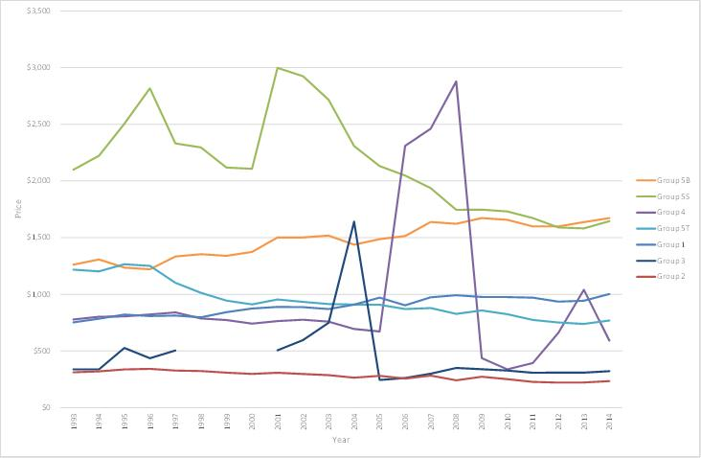

Figure 15: Refrigerator Group Real Price Trends

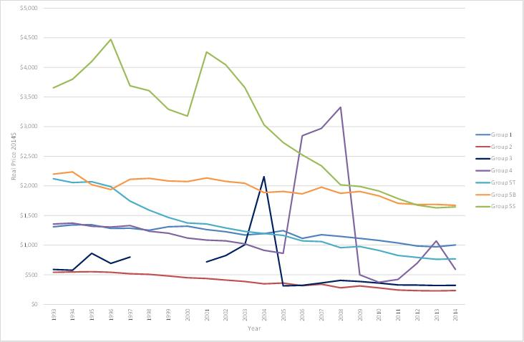

### Energy Efficiency Trends – Main Findings

* The energy consumption of refrigerators is trending downwards at -2.5% per annum over the 22 year period. The most significant falls in energy consumption occurred with the introduction of MEPS in late 1999 and with the more stringent MEPS levels in 2005. Average energy consumption across all refrigerators was 772 kWh/year in 1993, down to 619kWh/year in 2003 compared to a significantly lower 453kWh/year in 2014.
* The total adjusted volume[7] is still increasing very slowly, so the total energy efficiency of the refrigerator market is also increasing, at a rate of around +2.7% per annum (i.e. kWh per adjusted litre is trending downwards at –2.7% per annum). However, the change from year-to-year has varied substantially.

Table 2 summarises the key attributes from 1993 to 2014.

Table 2: Changes in Refrigerator Characteristics - 1993 to 2014

|  |  |  |  |
| --- | --- | --- | --- |
| Characteristic | 1993 Value | 2014 Value | Change pa |
| Fresh Food Volume (litres) | 250 | 282 | 0.6% |
| Freezer Volume (litres) | 81 | 116 | 1.7% |
| Other Volume (litres) | 4 | 3 | -0.7% |
| Energy (kWh/year) | 772 | 453 | -2.5% |
| Adjusted Volume (litres) | 385 | 472 | 1.0% |
| kWh/adjusted litre | 2.00 | 1.12 | -2.7% |
| 1986 SRI (star rating) | 3.58 | 5.46 | 2.0% |
| 2000 SRI (star rating) | 1.76 | 4.38 | 4.4% |
| 2010 SRI (star rating) | -0.04 | 2.43 | N/A |
| Nominal Price | $911 | $1,060 | 0.7% |
| Real Price (2014 $) | $1,586 | $1,060 | -1.9% |

A year by year breakdown of key performance characteristics is shown in Figure 16.

Figure 17 shows the long term trend in all three star rating systems from 1993 to 2014. Figure 18 shows the trend in the inverse of energy efficiency (expressed as kWh per adjusted litre of volume) for each of the main refrigerator Groups. Groups 3 and 4 are not shown because of their small market share. All Groups show a marked decline in energy intensity since the introduction of MEPS in 1999 and the more stringent MEPS of January 2005. Energy intensity is used in each of the refrigerator star rating algorithms, but the approach does vary under each system.

Figure 16: Annual Trends in Key Performance Characteristics since 1993 - Refrigerators

Figure 16 shows over 1993 - 2014 the following:
Freezer Volume has increased by 40%;
Adjusted Volume has increased by 20%
Price has increased by 18%;
Fresh Food has increased by 12%;
Energy has decreased by 40%; and
KWh/litre has decreased by 43% .

Figure 17: Long Term Trends in Star Rating for Refrigerators

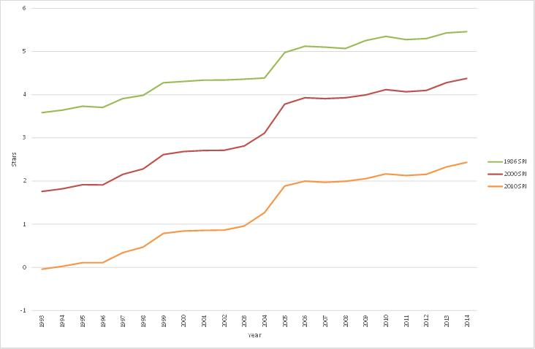

Figure 18: Energy Intensity Trends by Refrigerator Group

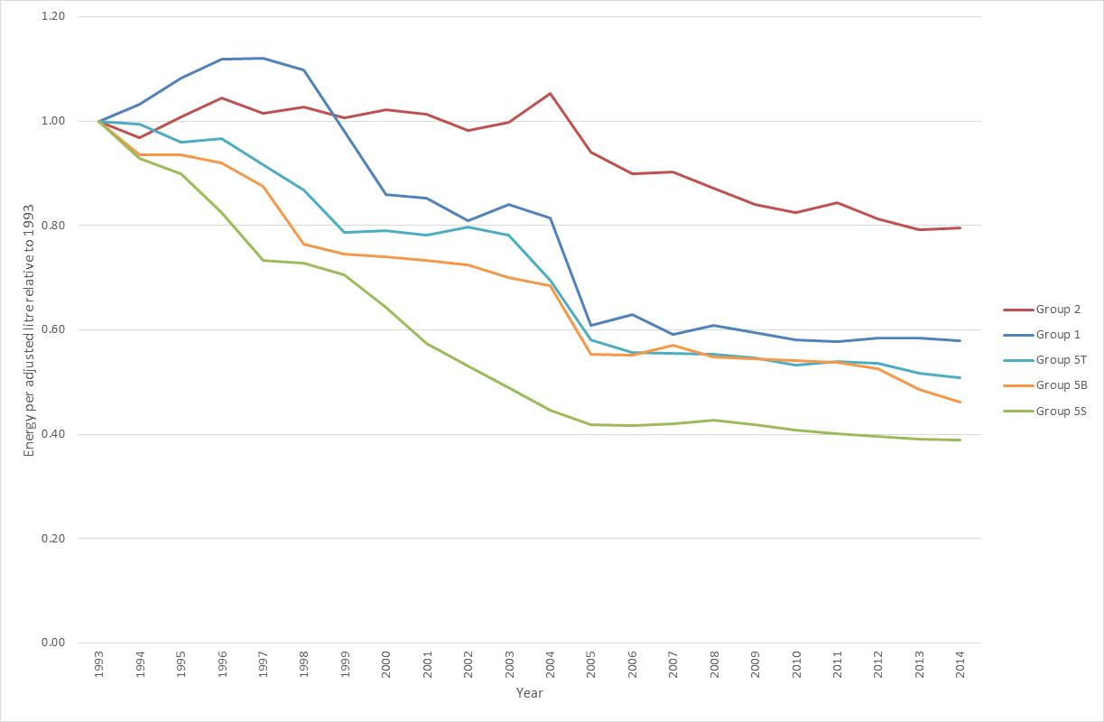

All product Groups clearly responded to the first round of MEPS in 1999 (apart from Group 2 and Group 3) and again in 2005, although post MEPS 2005 the improvements in most Groups generally flattened out. The impact of MEPS on Group 2 in 1999 was small because the MEPS levels for this group were relatively mild and most products in this Group are very small and their total energy consumption lies well within the defined MEPS levels (which tended to be a larger fixed energy and a smaller variable energy per litre of adjusted volume). The case of Group 5S in 2005 is more interesting – the energy consumption of this Group dropped continuously from about 1999. This was partly because of the very high energy consumption for this Group in the early 1990s, but also because most of these products are sourced from North America (or from Asian suppliers that export to North America) and the USA MEPS levels (on which the Australian 2005 levels were based) came into force in 2001. So the MEPS levels in the USA appeared to have some flow on effect in Australia well before our MEPS levels came into force in 2005.

Star ratings were re-graded again in 2010 for all refrigerators and freezers. Many Groups showed little improvement in energy efficiency immediately after MEPS in 2005. Some Groups visibly started to improve their efficiency after the label re-grade in 2010.

Figure 19 shows the distribution of refrigerator original star ratings (1986) for sales in selected years from 1994 to 2014. The overall market trend is a general reduction in the proportion of 2, 3, and 4 star units sold with a corresponding increase in the proportion of 5 and 6 star units sold. If the original star rating algorithms were still in force, the majority of products would rate 4 stars to 6 stars in 2014. Note in this figure that only products sold in 1994 were subjected to this star rating algorithm.

Figure 20 shows the distribution of refrigerator 2000 star ratings for sales in selected years from 1994 to 2014. The overall market trend is a general reduction in the proportion of 1 star units sold with an increase in those 3 stars and above. If the original star rating algorithms were still in force, almost all products would rate 5 stars or 6 stars in 2014. Note that in this figure, only products sold in 2004 were subjected to this star rating algorithm.

Figure 21 shows the distribution of refrigerator 2010 star ratings for sales in selected years from 1994 to 2014. 2014 products range from 1 to 4 stars. All products sold in 1994 would only rate 1 star. Note that in this figure, only products sold in 2014 were subjected to this star rating algorithm.

Detailed information for energy and other characteristics for all years and Groups are available in the separate output tables (Appendix A).

Figure 19: Original Star Rating (1986) for Models Sold in Selected Years – Refrigerators

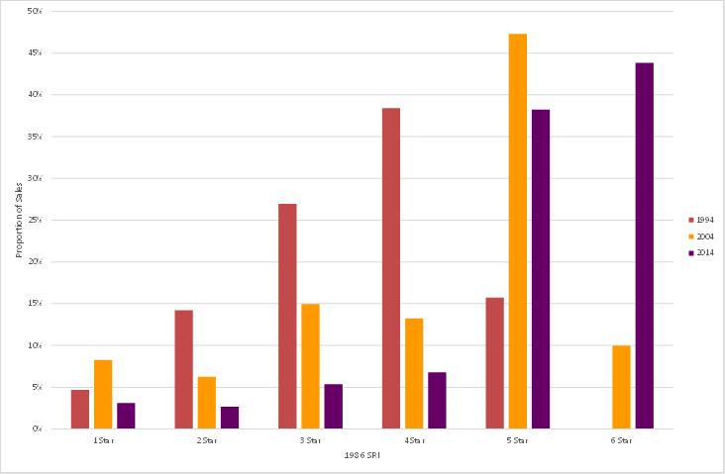

Figure 20: 2000 Star Rating for Models Sold in Selected Years – Refrigerators

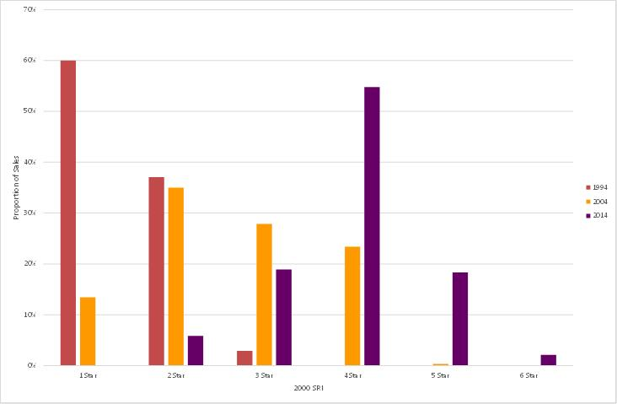

Figure 21: 2010 Star Rating for Models Sold in Selected Years – Refrigerators

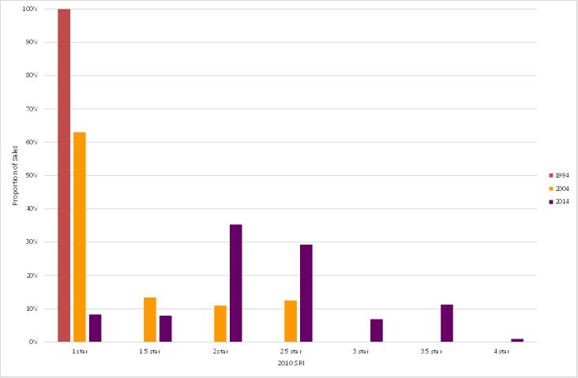

Since 2011 the underlying data for this project was provided on a monthly basis. This enabled sales data to be examined on a seasonal basis. This data shows that refrigerator sales are strongly seasonal, with the peak through the summer (December and January).

Figure 22: Seasonal Sales Pattern for Refrigerators in Australia

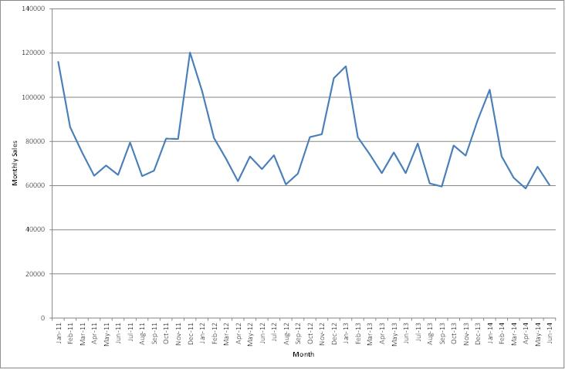

## Results for Separate Freezers

Energy rating labels for freezers were introduced in NSW and Victoria in 1986 and were introduced nationally in 1992, with the labelling algorithm being revised in 2000 and again in 2010. MEPS for freezers were first introduced in October 1999 and new stringent MEPS levels (based on US 2001 levels) were introduced on 1 January 2005. Some adjustments were made to the MEPS definition in 2010, but this did not increase the technical stringency. The category of freezer in this section includes only products that are separate stand-alone freezers (Groups 6U, 6C and 7).

### Market Trends – Main Findings

In 2014[8], of the sales recorded by GfK, 137,958 unit sales were identifiable models that made up 99.4% of total retail sales recorded by GfK. The main findings were as follows:

* Total retail freezer sales for the period 1993 to 2014 grew at an average of 2.3% per annum[9], although the majority of this increase occurred in the years 2004 to 2008 for reasons that are not clear (there was a large increase in small upright freezers sales – total freezer sales up to 2003 were fairly static).
* Chest freezer (Group 6C) sales constitute nearly 43% of the market in 2014 and this share has been fairly steady over the analysis period (typically from 40% to 50% share).
* The market share of vertical (or upright) manual defrost freezers (Group 6U) declined to 17% in 2003, peaked at 40% in 2008, and declined to 25% by 2014.
* The market share of vertical frost free freezers (Group 7) was 31.0% in 2014 and its market share has been gradually rising since 2007. Total sales have been stable since 2005.

Market share by Group is shown in Figure 23.

A summary of the main patterns emerging among the key characteristics of freezers in Australia is as follows:

* The average freezer volume for all freezers in Australia is 208 litres, which is a slight decrease (-0.2% pa) since 1993 when average volume was 218 litres.
* The average volume among each segment varies substantially (Group 6C = 221 litres, Group 6U = 122 litres, Group 7 = 260 litres). Chest freezers have been largely static in volume (a slight decline then an increase, noting that many different model sizes are sold), while vertical frost free units have been decreasing slightly in volume over time (at around 1% per annum). Vertical manual defrost freezers decreased from an average of around 180 litres in 1993 to about 122 litres in 2014, with the biggest falls coinciding with the large increase in sales in the years 2004 to 2008 (the average volume since 2004 has been stable).
* The average nominal price of all freezers is increasing at around 0.4% per annum, which is below the inflation rate.

Figure 23: Market Share by Freezer Group

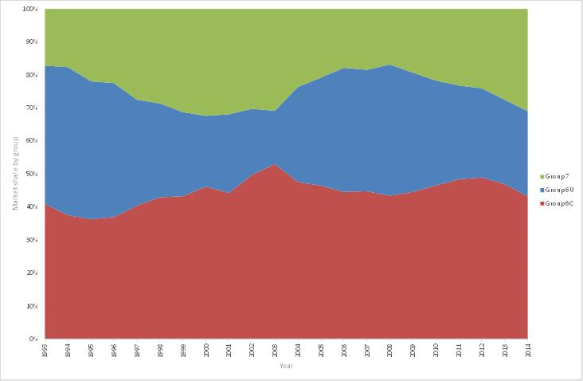

Figure 24: Separate Freezer Size Trends

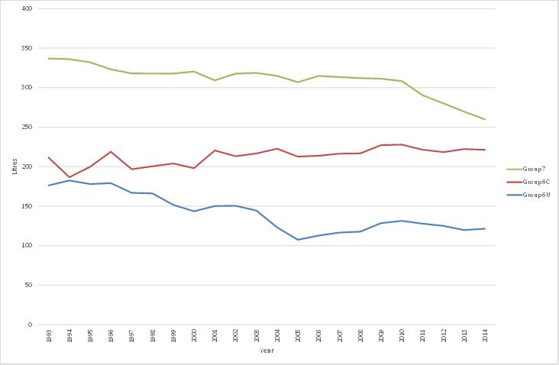

Figure 25: Separate Freezer Nominal Price Trends

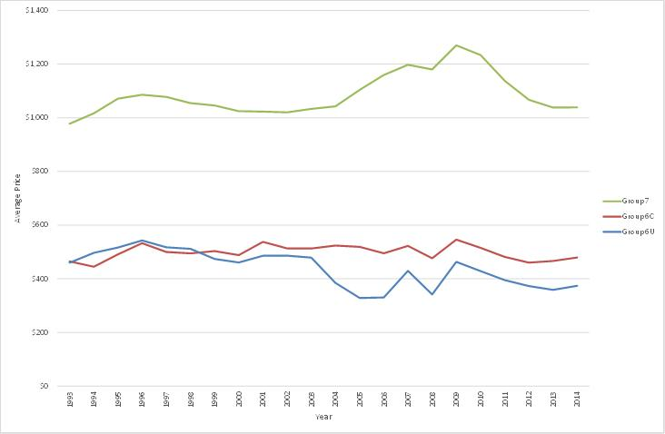

Figure 26: Separate Freezer Real Price Trends

Figure 26 outlines the average real price per unit (2014 $) for freezers since 1993. The raw data is based on the data in Figure 25 but with a CPI adustment applied - this increases the real price 0% in 2014 scaling back to an increase of 74% in 1993. The chart shows that real prices are declining for all Groups.


* The average price within each Group has varied. Group 6C was static in nominal terms over the 22 years. Group 6U has been decreasing at -1% apart from periodical fluctuations, but this is in line with decreases in volume. Group 7 increased in price from 2004 to 2010 (despite a decrease in average volume) but the average price declined to 2014. Figure 25 outlines the average nominal price per unit for separate freezers since 1993. Figure 26 outlines the average real price per unit (2014 $) for separate freezers since 1993 – all Groups have declined in real price over the period.

### Energy Efficiency Trends – Main Findings

* The energy consumption of freezers is trending downwards at -2.6% per annum, with the most significant gains in energy efficiency being made since 2003 in response to 2005 MEPS.
* As the volume is decreasing slightly, the total energy efficiency of the freezer market is increasing at a rate of around +2.2% per annum (i.e. kWh per adjusted litre is trending downward at -2.2% p.a.). Freezer energy efficiency improved markedly from 1998 to 2014.
* Table 3 summarises the key attributes from 1993 to 2014.

Table 3: Changes in Freezer Characteristics - 1993 to 2014

|  |  |  |  |
| --- | --- | --- | --- |
| Characteristic | 1993 Value | 2014 Value | Change pa |
| Freezer Volume (litres) | 218 | 208 | -0.2% |
| Energy (kWh/year) | 619 | 352 | -2.6% |
| Adjusted Volume (litres) | 349 | 332 | -0.2% |
| kWh/adjusted litre | 1.77 | 1.11 | -2.2% |
| 1986 SRI (star rating) | 4.24 | 5.48 | 1.2% |
| 2000 SRI (star rating) | 1.48 | 3.81 | 4.6% |
| 2010 SRI (star rating) | 0.57 | 2.46 | N/A |
| Nominal Price | $568 | $618 | 0.4% |
| Real Price (2014 $) | $989 | $618 | -2.2% |

A year by year breakdown of key performance characteristics is also shown in Figure 27. Figure 28 shows the trend in the inverse of energy efficiency (energy intensity, expressed as kWh per adjusted litre of volume) for each of the three freezer Groups. All Groups show a significant improvement from 2004 to 2006 as a result of the 2005 MEPS coming into force, although this effect flattened out in the following years. The energy intensity of Group 6U freezer deteriorated from 2003 due to a dramatic increase in the sales share of very small units (around 100 litres or less). This increases the apparent energy intensity as this parameter has some size bias. The energy intensity decreased after 2005 due to the impact of MEPS. Energy started to decrease after 2010 when re-graded star ratings came into force. Figure 29 shows the long term trend in all three star rating systems from 1993 to 2014.

Figure 27: Annual Trends in Key Performance Characteristics - Freezers

Figure 27 shows over 1993 - 2014 the following:
Price has increased by 14%;
Freezer Volume has decreased by 5%;
KWh/litre has decreased by 38%
Energy has decreased by 43%; 

Figure 28: Energy Intensity Trends by Freezer Group

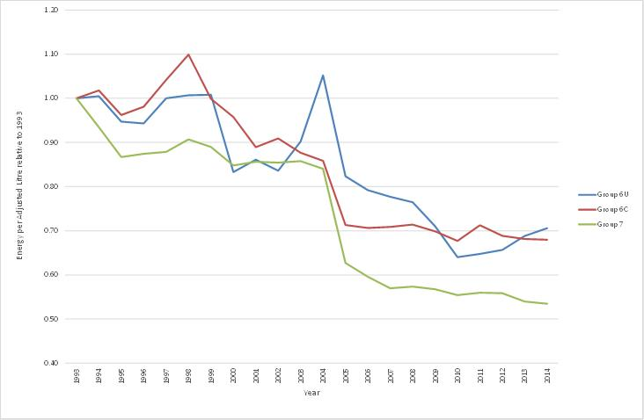

Figure 29: Long Term Trends in Star Rating for Freezers

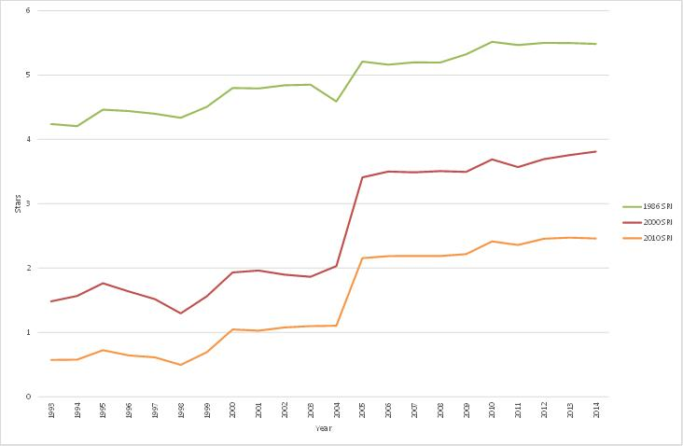

The overall efficiency of freezers decreased from 1995 to 1998. This is mostly due to a reduction in chest freezer efficiency, but also there was a decrease in efficiency for vertical manual defrost freezers and frost free freezers during this period. This is most likely to be associated with the phase out of Chloroflurocarbons (CFCs) in 1994 and 1995. HFC134a (the refrigerant used by local manufacturers after the conversion) is less efficient at lower evaporator temperatures when compared with CFC12, but has better heat transfer capabilities. The net efficiency impact appears to be smaller on models which have tube type evaporators and condensers (such as vertical freezers Group 6U) or where forced air is used (Group 7), as in these cases the heat transfer capacity is high, but in the case of chest freezers (Group 6U) where the heat exchangers tend to be less efficient (flat wall heat exchangers for both the evaporator and condenser), the change to HFC134a appears to have had a bigger negative impact. The CFC phase out was quite rapid and manufacturers had little time to optimise designs for the new refrigerants in the first few years. By 1999 MEPS also had some impact on all Groups. Many products now use R600a refrigerant (iso-butane).

Figure 30 and Figure 31 show the distribution of freezer original (1986) and 2000 star ratings for sales in selected years from 1994 to 2014, respectively. The graphs clearly show that the proportion of higher star rating freezers sold in the market place is increasing, particularly in 2014.

Figure 32 shows the distribution of freezer 2010 star ratings of sales in selected years from 1994 to 2014. 2014 products range from 1 to 3.5 stars. Ninety percent of products sold in 1994 would only rate 1 star. Note that in this figure, only products sold in 2014 were subjected to this star rating algorithm.

Detailed information for energy and other characteristics for all years and Groups are available in the separate output tables (Appendix A).

Figure 30: Original Star Rating (1986) for Models Sold in Selected Years - Freezers

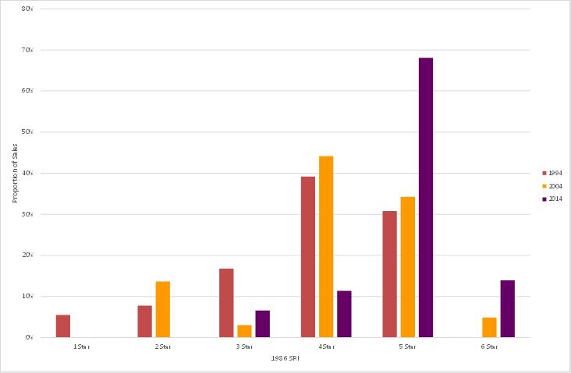

Figure 31: 2000 Star Rating for Models Sold in Selected Years - Freezers

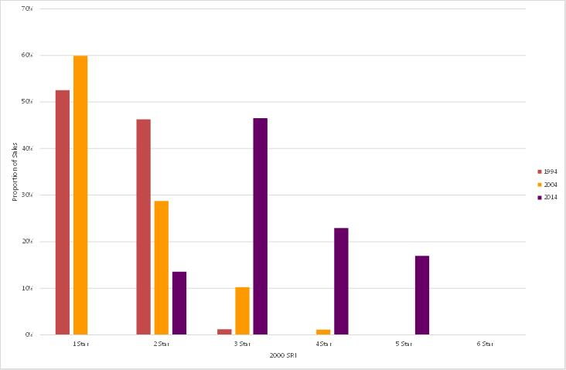

Figure 32: 2010 Star Rating for Models Sold in Selected Years - Freezers

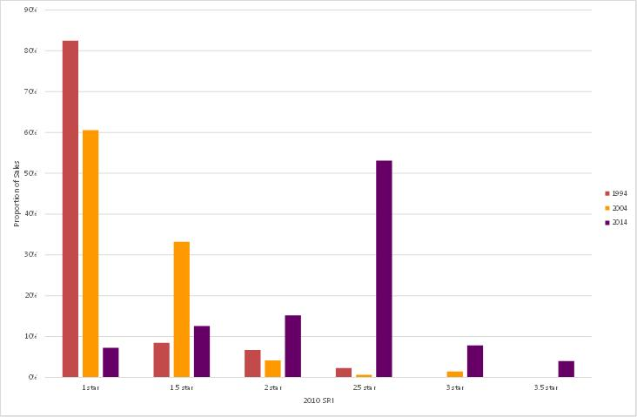

Since 2011 the underlying data for this project was provided on a monthly basis. This enabled sales data to be examined on a seasonal basis. This data shows that separate freezer sales are strongly seasonal, with the peak through the summer (December and January).

Figure 33: Seasonal Sales of Separate Freezers in Australia

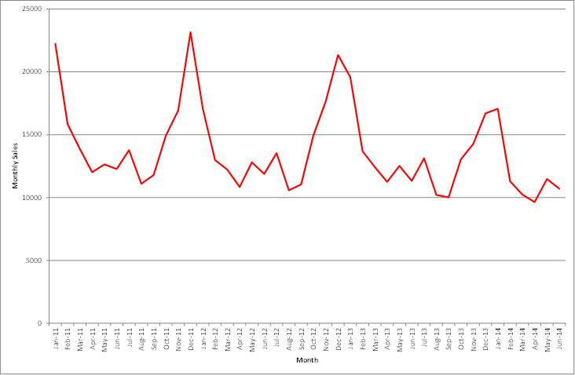

## Results for Clothes Washers

Energy labelling for clothes washers was introduced in Victoria in 1990 and then nationally in 1992 the labelling algorithm and energy label was revised in 2000. Voluntary water efficiency labelling commenced in the 1990s and mandatory water efficiency labelling commenced in July 2006.

In this report the term “front loaders” refers to drum type machines as defined in AS/NZS2040 (these are also called horizontal axis machines). All other types of machines are classified as non-drum in the standard – for this report these are broadly split into “top loaders” (agitator, impeller or other mechanical action with a vertical axis spin in the same chamber) and “twin tubs” (separate washing and spinning chambers). Note that a few drum machine models have access to the load through the top – these are classified as front loaders (drum machines) in this report.

### Market Trends – Main Findings

In 2014[10], of the sales recorded by GfK, 778,834 unit sales were identifiable models that made up 99.7% of total retail sales recorded by GfK. The main findings were as follows:

* Total retail sales for clothes washers for the period 1993 to 2014 increased at 3.2% per annum[11].
* Top loading and front loading machines made up an equal proportion of the Australian market in 2014, at 49.2% and 49.1% respectively. Front loading machines have dramatically increased their market share in recent years and will become the dominant type in the future if the current sales trajectory continues. In 2000, the market share of front loading machines was just 12% and in the early 1990s it was around 7%.
* The market share of twin tubs is small and has been slightly declining throughout the analysis period (4% in 1993, 2% in 2000, 1% in 2009, 0.3% in 2014).
* In this edition of the report, combination washer dryer units have been separately identified (previously they were included within drum types/front loaders, as they are effectively a drum machine). Their market share has increased from 0.5% in 2001 to a peak of 4.5% in 2006 and this has since declined to 1.4% in 2014. Sales share by washer type by year is shown in Figure 34.

A summary of the patterns emerging among the key characteristics of clothes washers in Australia is as follows:

* **Rated Capacity:** The average rated capacity for all clothes washers in Australia was 7.46 kg in 2014 and this has increased at about 1.7% per annum since 1993. Figure 35 illustrates how the market share by rated capacity has changed in selected years from 1993 to 2014. Clearly the market share of larger washer types is increasing. Among the clothes washer types:
  + Top loaders increased steadily in capacity from 5.4kg in 1993 to 7.3 kg in 2014.
  + Front loaders increased in capacity from 4.7kg in 1993 to 7.6 kg in 2014[12]. In 2000, the average was around 5.6kg.
  + Combination units increased from 5.9kg in 2001 to 8.1kg in 2014.
  + Figure 36 shows the distribution of rated capacity in 2014 for top loaders, front loaders, twin tubs and combination units.

Figure 34: Sales Share by Washer Type - 1993 to 2014

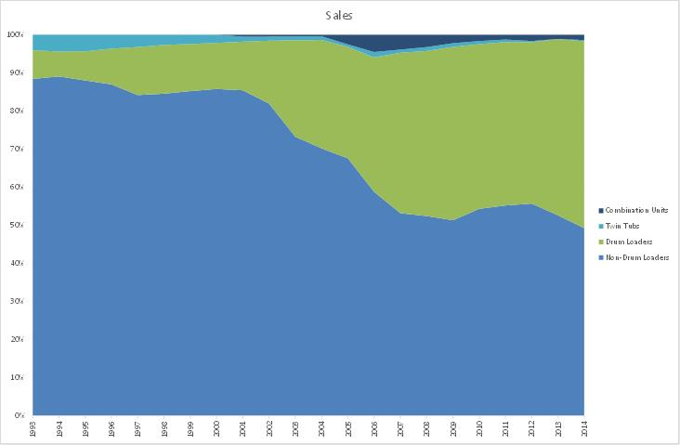Note: Market share prior to 2001 is accurate in Figure 34 and is based on separate cross tabulations of the whole GfK database. Data provided by GfK prior to 2001 in Appendix B does not include exclusive and small selling models so the market share for front loaders and twin tubs is less accurate in these years.

Figure 35: Rated Capacity Distribution for Selected Years - Washers

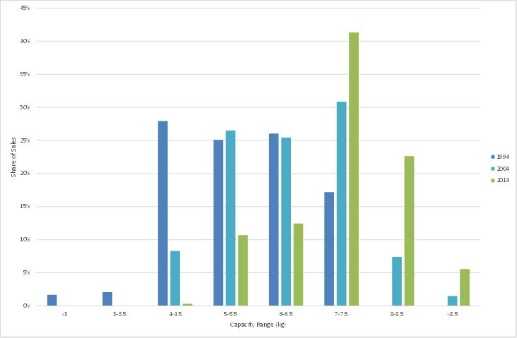

Figure 36: Rated Capacity Distribution by Washer Type – 2014

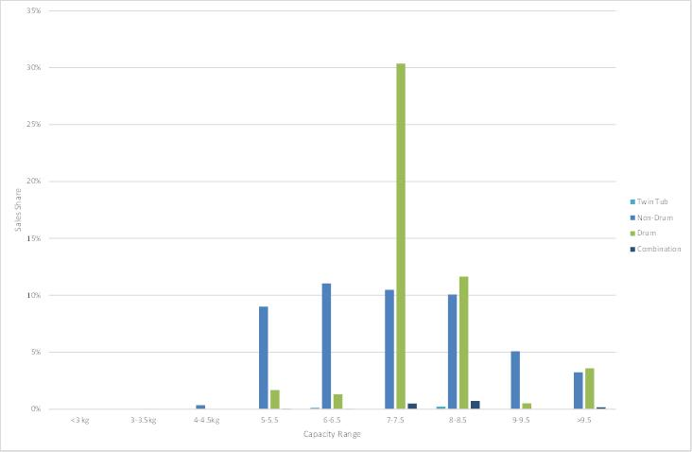

Figure 37: Trends in Average Rated Capacity by Washer Type

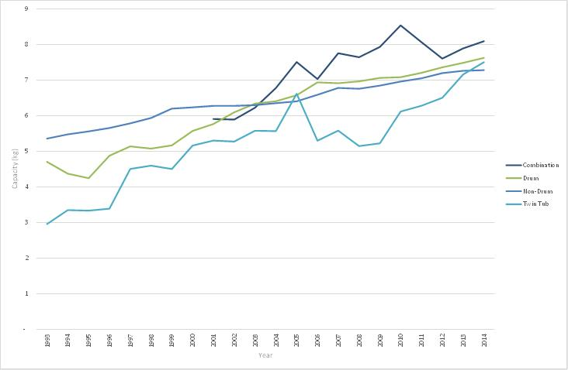

* **Water Consumption:** Figure 38 shows that water consumption of clothes washers has been trending downwards at a rate of -3.7% p.a. from 1993 to 2014. Voluntary water labelling was replaced with mandatory water labelling from 1 July 2006. Water consumption trends in this report would allow the effect of mandatory labelling on water efficiency to be assessed, although there are a number of other influences in the market to consider as well. Water authority rebates (common until 2010) appeared to also have some effect on the sales of water efficient products. However, the water consumption of all types has changed little since 2010. Water efficiency standards were introduced in around 2012 – these primarily affected top loaders.
  + Water consumption of front loaders declined significantly from 99 litres in 1994 to 67 litres in 2000, and has remained steady since.
  + The water consumption of top loaders has varied from year-to-year, although this is trending downwards with most significant improvement from 2003, where the average consumption was 139 litres, declining to 91 litres in 2009, where it has since remained.
  + The water consumption of combination units (for washing only[13]) has decreased from 91 litres in 2001 to 70 litres in 2014.

Figure 38: Trends in Water Consumption by Washer Type

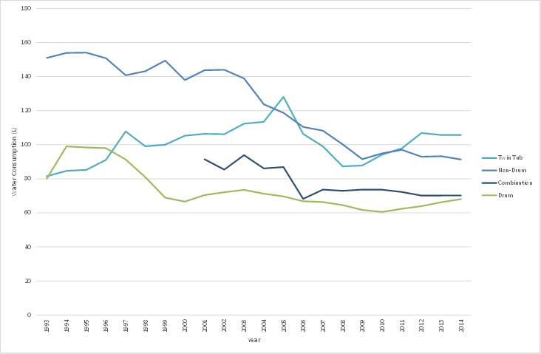

* **Spin performance:** Spin performance[14] of all clothes washers has shown a gradual and significant improvement since 1993, down from 0.85 to 0.62 in 2014. The average spin performance for front loading machines is somewhat better than top loading machines (top=0.67 average, front=0.57 average, combination=0.58 average in 2014) although there is significant variation in spin performance by model within each type and the best top loading machines are comparable to the best front loading machines.
* **Program time:** Program time for front loaders increased dramatically over the period from 47 minutes in 1993 to 236 minutes in 2014 (Figure 39). Over the same period, top loader program times increased from about 38 minutes to 78 minutes. The main driver for longer program times is likely to the maintenance of wash performance while reducing water consumption, which has been driven by water labelling and water efficiency standards.
* **Price:** The price of clothes washers decreased slightly over the period 1993 to 2014 in nominal terms (decreased at 0.4% per annum), which is well below inflation for the period. Front loader prices were a maximum of $1,191 in 1998 and the price decreased until 2006, where it stabilised (this was the point where front loader sales started to gain significant market share). The average front loader price in 2014 was $835. Top loader prices have been steadily declining as the proportion of sales in the market decreases.

Figure 40 illustrates the average nominal price per unit for clothes washers by year since 1993. Figure 41 illustrates the average real price per unit (2014 $) for clothes washers by year since 1993.

Figure 39: Trends in Program Time by Washer Type

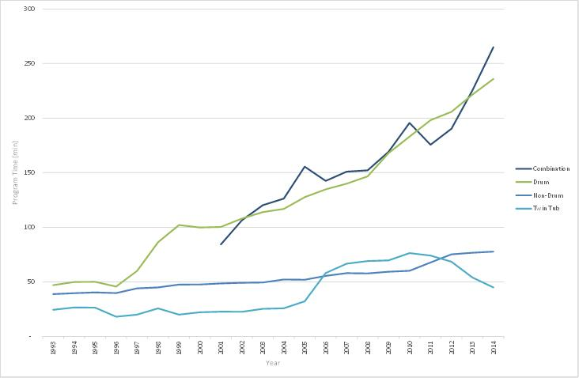

Figure 40: Nominal Price Trends by Washer Type

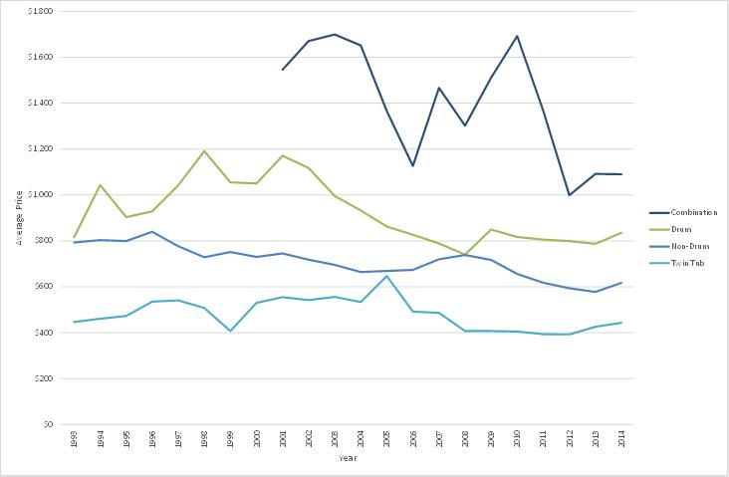

Figure 41: Real Price Trends by Washer Type

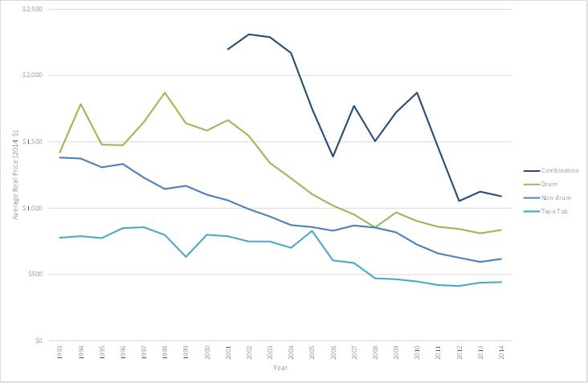

### Energy Efficiency Trends – Main Findings

* The average energy consumption of all clothes washers sold has been trending downwards since 1993 at 1.6% per annum, although there has been some variation year-to-year among clothes washer types. The overall energy trend is primarily driven by the increased market share of front loaders over time.
* Front loader energy consumption was relatively steady from 1998 to 2014, although there was an increase in energy from 236 kWh/year in 2003, to 334 kWh/year in 2014, which may be partly explained by the increase in the rated capacity of front loading machines to 2014.
* Trends in twin tub energy need to be interpreted with caution due to the very small market size, the limited number of models and the sharp increases in capacity in recent years.
* Combination washer-dryer energy has remained relatively steady over the study period. This trend needs to be used with caution though, due to the small market size and the limited number of models.
* Top loader energy consumption declined from 2000 to 2010, although the 2014 value is now similar to the 1993 value. These energy trends are illustrated in Figure 42. It should be noted that the trends are based on AS/NZS2040 which specifies a warm wash for the purposes of energy labelling. ABS has found that more than 74% of households wash clothes in cold water. More detail on the criteria used to analyse data for clothes washers in this report is summarised in the methodology section (2.5) of this report. Energy values need to be interpreted in the light of significant increases in rated capacity over the study period.

Figure 42: Trends in Average Clothes Washer Energy by Type

Figure 42 shows trends in average Clothes Washer Enery by Type by year from 1993. The raw data is contained in Appendix B on page 74 under Energy (kWh/year).


An average front loader uses 40% less energy when compared to an average top loader. In 2014, 37% of front loading machines had dual hot and cold water connections, which means that the majority of this washer type cannot take advantage of lower cost external hot water supplies such as gas, solar or off peak electric. With the rapid increase in front loader sales from 2004, the share of dual connect models fell from 75% to 35% (cold only connection is the most common configuration in Europe). While the difference in energy labelling data between these washer types is quite clear cut, the in-use energy consumption of a machine when used in a typical household setting will be much more complex. A more detailed discussion on the energy consumption of clothes washers and the Australian Standard is contained in Section 2.5 of this report.

Table 4 summarises the key clothes washer attributes from 1993 to 2014. A year by year breakdown of key performance characteristics is also shown in Figure 43.

Table 4: Changes in Clothes Washer Characteristics - 1993 to 2014

|  |  |  |  |
| --- | --- | --- | --- |
| Characteristic | 1993 Value | 2014 Value | Change pa |
| Capacity (kg) | 5.22 | 7.46 | 1.7% |
| Water Consumption (litres) | 146 | 80 | -2.8% |
| Spin Performance | 0.85 | 0.62 | -1.5% |
| Energy (kWh/year) | 574 | 460 | -1.0% |
| 2000 SRI (star rating) | 1.28 | 3.00 | 4.1% |
| Water Rating (star rating) | 1.18 | 3.92 | 5.9% |
| Program Time (mins) | 38.17 | 157.82 | 7.0% |
| Nominal Price | $802 | $730 | -0.4% |
| Real Price (2014 $) | $1,351 | $730 | -2.9% |

Figure 43: Annual Trends in Key Performance Characteristics - Clothes Washers

Figure 43 shows over 1993 - 2014 the following:
Water SRI has increased by 240%
Program Time has increased by 315%
Energy SRI has increased by 205%
Capacity has increased by 48%
Price has decreased by 10%
Energy has decreased by 20%
Spin index has decreased by 30%
Water has decreased by 48% 

Figure 44 shows the distribution of clothes washer 2000 star ratings for sales in selected years from 1994 to 2014. There is a decrease in 1 star units and an increase in 1.5, 2 and 2.5 star units being sold in later years. Detailed information for energy and other characteristics for all years and types are available in the separate output tables (Appendix B).

Figure 44: 2000 Star Rating for Models Sold in Selected Years - Clothes Washers

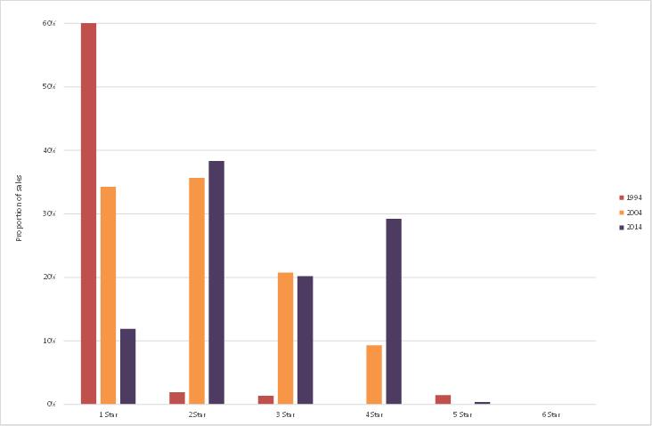

An analysis of star rating distribution by washer type in 2014 is shown in Figure 45.

Figure 45: Star Rating Distribution in 2014 by Washer Type

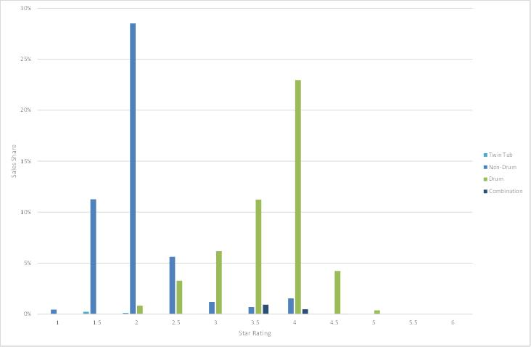

Since 2011 the underlying data for this project was provided on a monthly basis. This enabled sales data to be examined on a seasonal basis. This data shows there is some month to month variation in sales but there is no strong seasonal effect (small peaks in July and December). This may be partly due to the way that data is collected and reported by GfK.

Figure 46: Seasonal Sales of Clothes Washers in Australia

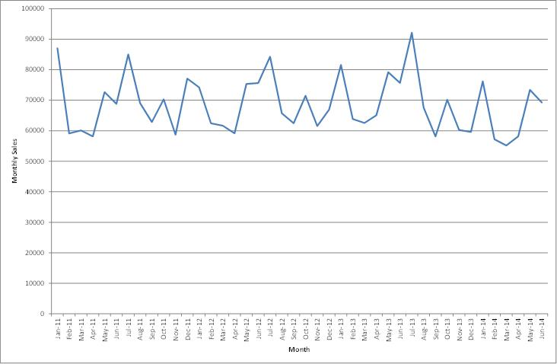

## Results for Clothes Dryers

The energy rating label for clothes dryers was introduced in Victoria in 1989 prior to expanding nationally in 1992, with a labelling algorithm revision occurring in 2000.

### Market Trends – Main Findings

In 2014[15], of the sales recorded by GfK, 273,605 unit sales were identifiable models that made up 100% of total retail sales recorded by GfK (i.e. all models were identified in the data set). An additional 10,830 combination washer-dryer units (washers with a dryer function) were also sold. The main findings are as follows:

* Total sales of stand-alone dryers increased at an average of about 3.7% per annum from 1993 to 2014, with a steadily increasing trend in sales throughout the period, but with some variation from year-to-year (dryer sales are somewhat discretionary and annual sales are driven by weather and economic conditions)[16].
* Combination washer-dryers had a few thousand sales up to 2004. Over the period 2005 to 2006 sales increased to a peak of about 35,000 units in 2009 and then declined to around 10,000 units in 2014.
* The vast majority of clothes dryers sold in Australia were the vented type – condenser dryers are available but are very uncommon in the market place (although their sales share seems to be increasing slowly). All combination washer-dryers are condenser dryers and they use external water to cool the drum during the drying process. All heat pump dryers (separately identified in this report for the first time) are also condenser dryers.
* Heat pump clothes dryers were introduced to the market in significant numbers in 2010. Sales of this type increased from 1,639 in 2010 to 10,757 units in 2014 and represent almost 4% of sales in 2014.
* Timer dryers made up about 45% of dryer sales in 2014. The market share of auto-sensing dryers has increased significantly from 10% in 1993 to 51% in 2014. Figure 47 illustrates the market share of each clothes dryer type. Stand-alone condenser dryers make up about 10.1% of the market, while a further 4% are combination washer-dryers and a further 4% are heat pump dryers, which are both of the condensing type.
* The average rated capacity for all clothes dryers in Australia was 5.4 kg in 2014, which is a 20% increase from the 1993 capacity of 4.4 kg. The five main capacities available in 2014 were: 4.0kg to 4.5kg (25% of sales), 5.0 to 5.5kg (35% of sales) and 6.0 to 6.5kg (26% of sales), 7.0 to 7.5 kg (8% of sales) and 8.0 to 8.5 (6% of sales). Other sizes ranging up to 9kg are available, but these have a negligible market share. Figure 48 shows the average rated capacity for each of the main clothes dryer types. Trends in attributes for condenser types need to be interpreted with caution due to the very small market share for these products. No condenser types were identified in the model lists provided prior to 2001 as the sales for each model were small. The average capacity for combination washer-dryers was 4.5 kg.
* Average program time for clothes dryers was around 148 minutes and this has remained relatively constant over the study period.
* The nominal price of clothes dryers increased at around 1.9% per annum, despite the increasing market share of auto-sensing models, which were generally more expensive than timer models. Figure 50 illustrates the average nominal price per unit for clothes dryers since 1993. Figure 51 the average real price per unit (2014 $) for clothes dryers since 1993. Note the very strong fall in prices for auto condensing and heat pump dryers in recent years.

The following figures are for separate dryers only.

Figure 47: Market Share of Clothes Dryer by Type

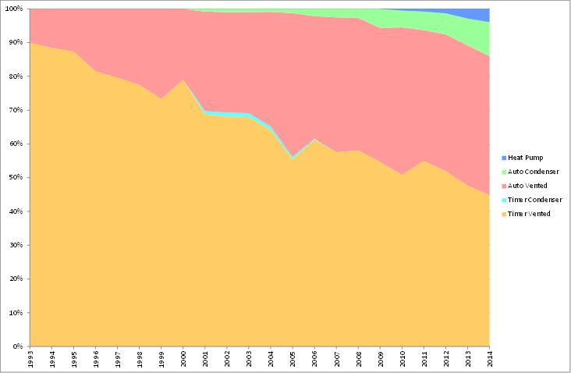Note: This figure excludes combination washer-dryers, which are generally 3% to 5% of the market.

Figure 48: Average Capacity of Clothes Dryer by Type

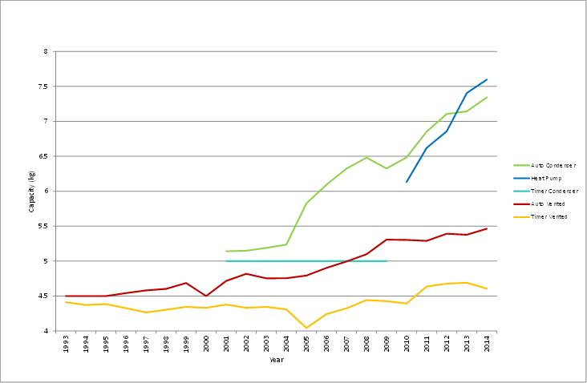

Figure 49: Rated Capacity Distribution for Selected Years - Dryers

Figure 49 shows the rated capacity distribution for selected years for Clothes Dryers. The raw data is contained in Appendix C on 1994: page 123: 2000 SRI (Stars) - share (row)
2004:: page 133: 2000 SRI (Stars) - share (row)
2014:: page 143: 2000 SRI (Stars) - share (column)


Figure 50: Clothes Dryer Nominal Price Trends by Type

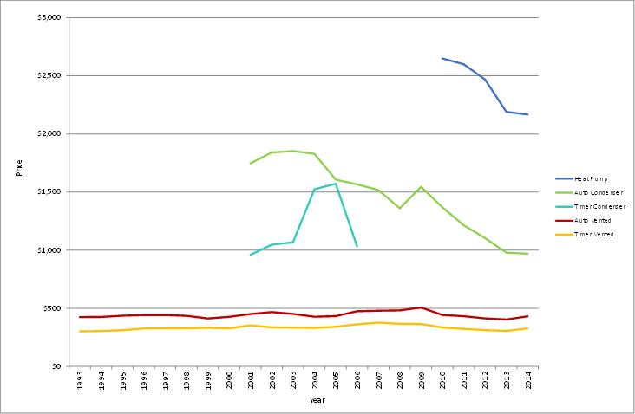

Figure 51: Clothes Dryer Real Price Trends by Type

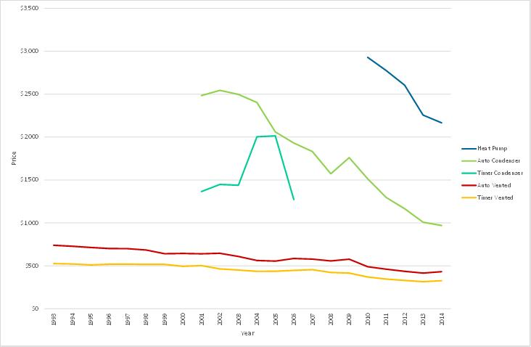

### Energy Efficiency Trends – Main Findings

The energy consumption of clothes dryers trended downwards at around -0.1% per annum, which is effectively stable over 22 years. The 2000 star rating for clothes dryers increased at 2.6% per annum, mainly due to increased rated capacity (the dryer star rating algorithm slightly favours larger machines). Table 5 summarises the key attributes from 1993 to 2014. A year by year breakdown of key performance characteristics is shown in Figure 52.

Table 5: Changes in Stand Alone Clothes Dryer Characteristics - 1993 to 2014

|  |  |  |  |
| --- | --- | --- | --- |
| Characteristic | 1993 Value | 2014 Value | Change pa |
| Capacity (kg) | 4.42 | 5.35 | 0.9% |
| Program Time (minutes) | 141 | 148 | 0.2% |
| Specific Energy (kWh/kg water removed) | 1.10 | 1.04 | -0.3% |
| Energy (kWh/year) | 240 | 237 | -0.1% |
| 2000 SRI (star rating) | 1.22 | 2.09 | 2.6% |
| Nominal Price | $339 | $507 | 1.9% |
| Real Price (2014 $) | $548 | $507 | -0.4% |

Note: The energy trend is affected by the share of timer and auto-sensing. The energy value reported in Table 5 is based on the 2000 algorithm of 52 uses/year introduced in 2000 (previously 150 uses/year).

Figure 52: Annual Trends in Key Performance Characteristics – Clothes Dryers

Figure 52 shows over 1993 - 2014 the following:
2000 SRI increased by 73%;
Price increased by 62%;
Capacity increased by 20%;
Program Time increased by 5%;
Energy decreased by 1%; and
Specific Energy decreased by 5.5%


Figure 53 shows the trend in label energy consumption by year and by type of dryer. Vented dryer energy has remained fairly stable, despite some increases in capacity. Auto condensing dryer energy has increased significantly, largely driven by increases in capacity (the technical efficiency has changed little). Heat pump dryers use about 50% of the energy of a conventional dryer (noting that on average these are quite large at about 7.5 kg).

Figure 53: Average Dryer Energy Consumption by Type

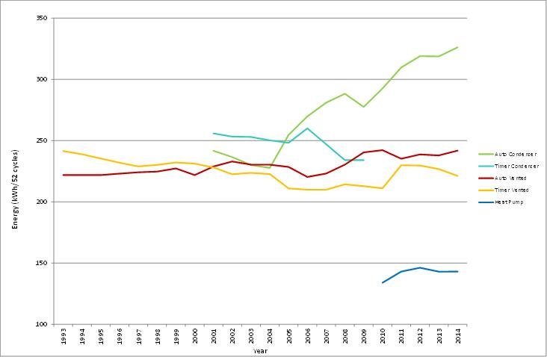

Figure 54 shows the national sales distribution of stand-alone clothes dryers by star rating for selected years from 1994 to 2014. Note that half star ratings (from 2000) have been amalgamated for this figure (e.g. 1 and 1.5 star sales share is shown as 1 star). The overall market trend in the 2000 star rating was a reduction in the proportion of 1 star units sold and an increase in the proportion of 2 star units sold. Given that a 1 star increment represents a 15% difference in energy consumption for the 2000 energy labelling algorithm (for a given size), the energy efficiency range is quite narrow for this product. In 2014, heat pumps, which generally rate at 6 stars or more, had a market share of almost 4%.

Detailed information for energy and other characteristics for all years and types are available in the separate output tables (Appendix C).

Figure 54: National Sales Distribution by 2000 Star Rating - Clothes Dryers

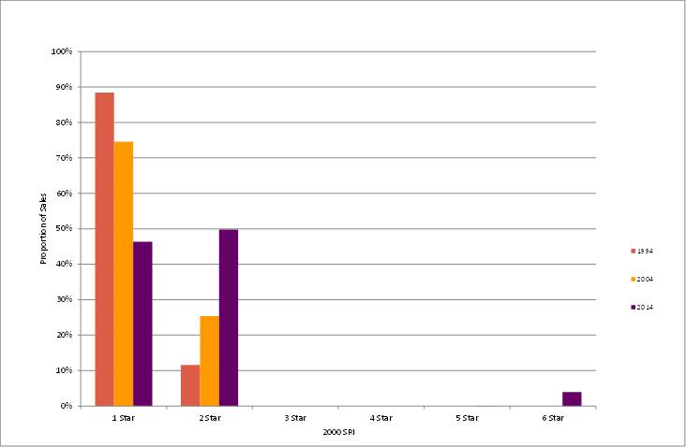

Since 2011 the underlying data for this project was provided on a monthly basis. This enabled sales data to be examined on a seasonal basis. This data shows there is a strong seasonal pattern to sales, with sales in the cold winter months at more than twice sales at other times of the year.

Figure 55: Seasonal Sales of Clothes Dryers in Australia

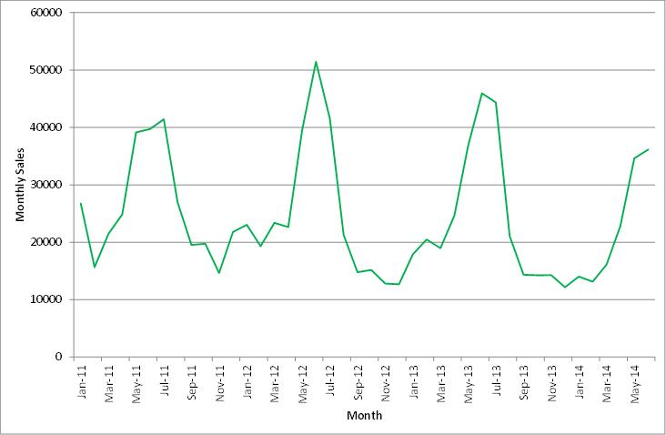

## Results for Dishwashers

The energy rating label for dishwashers was introduced in NSW and Victoria in 1988 before being expanded nationally in 1992 and undergoing a labelling algorithm revision in 2000. Voluntary water efficiency labelling commenced in the 1990s and mandatory water efficiency labelling commenced in July 2006.

### Market Trends – Main Findings

In 2014[17], of the sales recorded by GfK, 347,390 unit sales were identifiable models that made up 98.6% of total retail sales recorded by GfK. The main findings were as follows:

* Total sales are continuing to increase with a growth of 5.6% per annum from 1993 to 2014[18]. This reflects increasing penetration of this product in the residential sector, which in 2014 had reached 55% of households (ABS4602, 2014).
* The average place setting capacity for all dishwashers in Australia was 13.0 which is a slight decline in average capacity of 0.3% per annum since 1993[19].
* The vast majority of dishwashers sold in Australia (82%) are standard sized 600 mm wide units of 12 to 14 place setting capacity.
* Program times for dishwashers have increased from 69 minutes in 1993 to 150 minutes in 2014, a growth of 3.7% per annum.[20]
* The water consumption of dishwashers trended down at –3.9% per annum from 28.8 litres per wash in 1993 to 12.4 litres in 2014. However, the rate of decrease has slowed somewhat in recent years.
* The change in the nominal price of dishwashers is stable at -0.5% per annum which was well below inflation for the period. The average nominal price in 1993 was $927 compared to $830 in 2014[21]. Figure 56 outlines the average nominal and real price per unit for dishwashers since 1993.

Figure 56: Nominal and Real Price Trends for Dishwashers

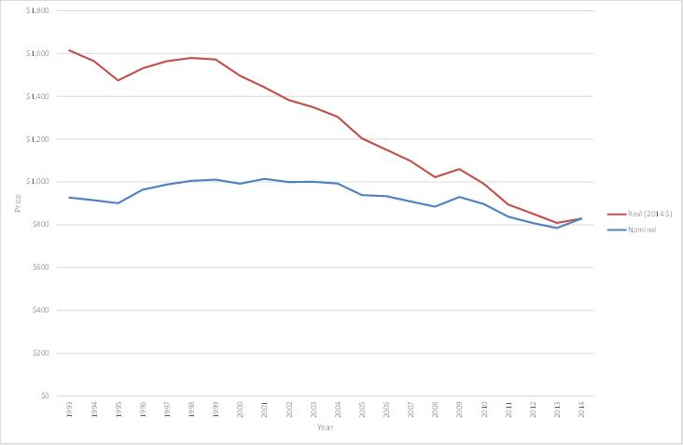

Figure 57: Trends in Energy Use versus Program Time for Dishwashers

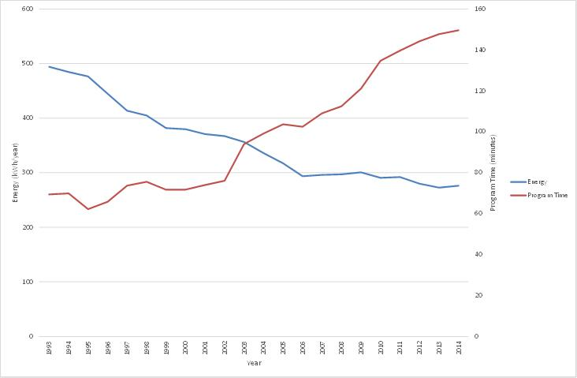

### Energy Efficiency Trends – Main Findings

The energy consumption of dishwashers trended downwards at -2.6% per annum from 1993 to 2014. The 2000 star rating increased at 2.7% per annum over the period. Table 6 summarises the key attributes from 1993 to 2014 using values obtained from analysis of the full data set. A year by year breakdown of key performance characteristics is shown in Figure 58.

Table 6: Changes in Dishwasher Characteristics - 1993 to 2014

|  |  |  |  |
| --- | --- | --- | --- |
| Characteristic | 1993 Value | 2014 Value | Change pa |
| Place Settings | 13.9 | 13.0 | -0.3% |
| Program Time (minutes) | 69.4 | 149.6 | 3.7% |
| Water Consumption | 28.8 | 12.4 | -3.7% |
| Energy (kWh/year) | 494.1 | 276.1 | -2.6% |
| 2000 SRI (star rating) | 1.9 | 3.3 | 2.7% |
| Water SRI (star rating) | 0.4 | 4.3 | 12.0% |
| Price | $927 | $830 | -0.53% |
| Real Price (2014 $) | $1,615 | $830 | -3.1% |

Figure 58: Annual Trends in Key Performance Characteristics - Dishwashers

Figure 58 shows over 1993 - 2014 the following:
Program Time increased 118%;
2000 SRI increased 78%;
Price decreased 5%;
Place Settings decreased 5%;
Energy decreased 43%; and
Water Consumption decreased 58%.

Figure 59 shows the improvements in energy and water consumption of dishwashers since 1993. This figure illustrates the ongoing effectiveness of Energy Rating Labels, which were introduced in 1988. The original water efficiency labelling scheme was introduced in the 1990s, although the market penetration was quite low during this period. Water consumption sharply declined between 1994 and 1998 before levelling off prior to another decline after 2003. Mandatory water efficiency labels for dishwashers were introduced in 1 July 2006. Some water utilities introduced rebates for water efficient appliances in the mid-2000s. Over the past 22 years, average energy consumption has decreased by 44% and average water consumption has decreased by 57%. Given that an average new dishwasher is using a total of less than 12 litres to wash an average load of 13 place settings, it is likely that technical limits to further reductions will be encountered – this is already evident in the period 2010 to 2014.

Figure 59: Sales Weighted Trends in Dishwasher Energy and Water Consumption

Figure 59 shows over 1993 - 2014 the following:
Energy Consumption decreased by 44%; and
Water Consumption decreased by 57%.

Figure 60 shows the distribution of dishwasher 2000 energy star ratings for selected years from 1994 to 2014. The overall market trend in the 2000 star rating is a reduction in the proportion of 1 star units sold and an increase in the proportion of 3 and 4 star units sold. Figure 61 shows the distribution of dishwasher water star ratings for selected years from 1994 to 2014. The overall market trend in the water star rating is a rapid increase in star ratings in recent years, with the majority of units achieving 4 stars and 5 stars in 2014.

Detailed information for energy and other characteristics for all years are available in the separate output tables (Appendix D).

Figure 60: National Sales Distribution by 2000 Energy Star Rating – Dishwashers

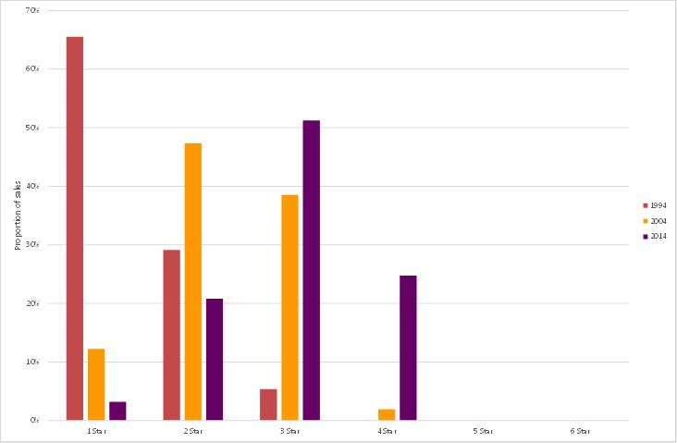

Figure 61: National Sales Distribution by Water Star Rating – Dishwashers

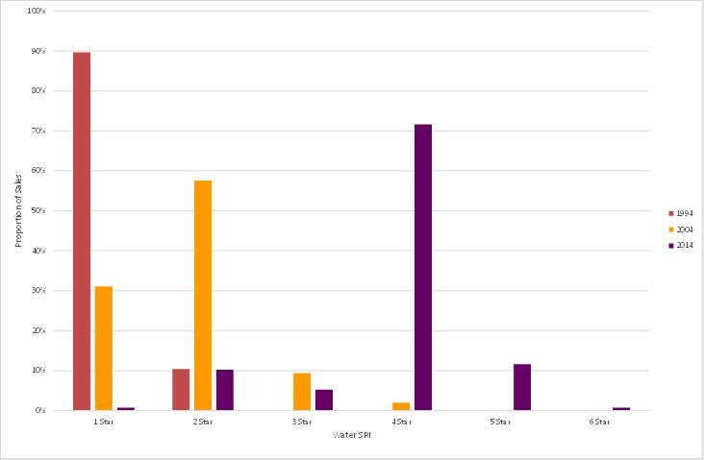

Since 2011 the underlying data for this project was provided on a monthly basis. This enabled sales data to be examined on a seasonal basis. This data shows there is some month to month variation in sales but there is no strong seasonal effect (small peaks in July and December and some intermediate months). This may be partly due to the way that data is collected and reported by GfK.

Figure 62: Seasonal Sales of Dishwashers in Australia

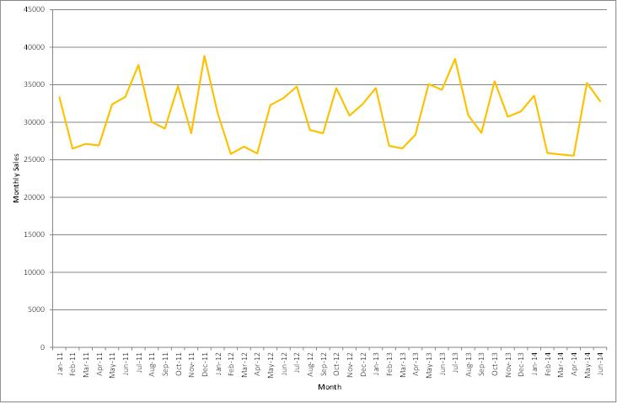

## Price – Efficiency Relationship for Refrigerators and Freezers

This sections sets out a detailed analysis of the relationship between price and energy efficiency (or energy consumption) for refrigerators and freezers. The first part (Sections 8.1 to 8.3) sets out the method to develop a sales weighted linear regression while the second part (Section 8.4) shows a number of key parameters such as volume, energy consumption, sales, models and price plotted by star rating and Group. Sales data for 2013 was used for the analysis as this is the last full year of sales data available. All analysis has been undertaken on the national sales data set.

### Cross-sectional Analysis of Product Price and Energy Efficiency

An analysis of the price-efficiency relationship in the Australian market has been conducted using 2013 sales data. The primary data source for the analysis was the GfK sales by model for the year 2013. This dataset reports each brand and model sold during the period January 2013 to December 2013 by retailers in Australia and includes the actual average retail price paid for each model (GfK data, 2013 – unpublished). It represents total sales of around 1.1 million products in that year, covering more than 95% of the total market.

Refrigerators and freezers range in complexity, size and energy consumption. As expected, the price and energy efficiency varies considerably by model. Some refrigerator types have historically shown some correlation between price and efficiency, but based on previous analysis, the overall relationship tends to be weak. The 2013 dataset obtained for analysis in this project is one of the most comprehensive available in Australia as energy and actual price data for virtually every model on the market has been reported. This is an update of the analysis undertaken for the 2008 Regulatory Impact Statement (EES 2008). However, this analysis has used an improved sales weighted regression approach, which gives more robust and reliable results.

### Methodology

The general approach was to split each model of refrigerator and freezer into their respective Groups in accordance with AS/NZS 4474.1. In total, there are 10 Groups for analysis (Groups 1, 2, 3, 4, 5B, 5T, 5S, 6C, 6U and 7).

Both the price and energy consumption are generally highly correlated with the volume of a refrigerator. However, the price per litre and the energy per litre vary considerably between Groups and also vary by model within a Group. Given that Groups are a convenient way of splitting products into categories with broadly similar designs and features, this analysis has considered each Group as a separate self-contained category for the purposes of analysis. The sales weighted approach adopted for this analysis allows every model to be included in the analysis and their influence on each overall regression is weighted by the sales of the model. The previous analysis only included models that had sales of greater than or equal to 100 units in an attempt to eliminate the influence of small or boutique models that were very expensive but had low sales.

The methodology has three steps as follows:

1. Establish a sales weighted relationship between volume and energy and between volume and price for each Group.
2. Using the sales weighted relationship established in Step 1, determine whether each model uses more or less energy than average (for its size) and whether it is more or less expensive than average (for its size) when compared to the sales weighted average for the Group. The normalised price and energy for each model is then calculated as the ratio of actual price/energy to the regression price/energy.
3. Perform a sales weighted regression of normalised energy versus normalised price to establish whether models that use more energy than average are more or less expensive than average.

#### Step 1: Sales weighted volume versus energy and price

The first step in the analysis was to determine a volume/energy relationship for each Group. This was done on the basis of the volume (in accordance with AS/NZS 4474.2) and the declared Comparative Energy Consumption (CEC) on the energy label. A comparison using total volume (unadjusted) and adjusted volume for this regression found that there was no significant difference in the correlation coefficient for the two approaches within a Group, so total volume has been selected as this is a more intuitive and understandable metric.

A least squares linear regression was calculated to establish a relationship between volume and energy for each model within each Group. The variation used in this analysis, compared to previous approaches, was that both the X and Y parameters were weighted by the square root of the sales for the specific model when determining the intercept and slope of the linear regression and the overall correlation coefficient. This provides a much heavier overall relative weighting to models with large sales and very low relative weighting to models with small sales. Similarly, a sales weighted linear regression was determined for volume and price for each model within each Group. These resulting regressions allow the establishment of a function to estimate sales weighted energy and price functions as a function of volume for each Group.

Sales Weighted Parameter = *Intercept* + *Slope* × *Volume*

Where volume is the volume in accordance with AS/NZS4474.1 (unadjusted) and intercept and slope are the results of the relevant linear regression analysis for the Group.

To illustrate this first step, sales weighted regressions for Group 5T (one of the largest Groups representing around 40% of all product sales and about 240 models) is shown in Figure 63 and Figure 64. Each point represents a model and models are categorised by their sales volume using different coloured and sized data points.

Figure 63: Sales Weighted Volume Energy Regression for Group 5T

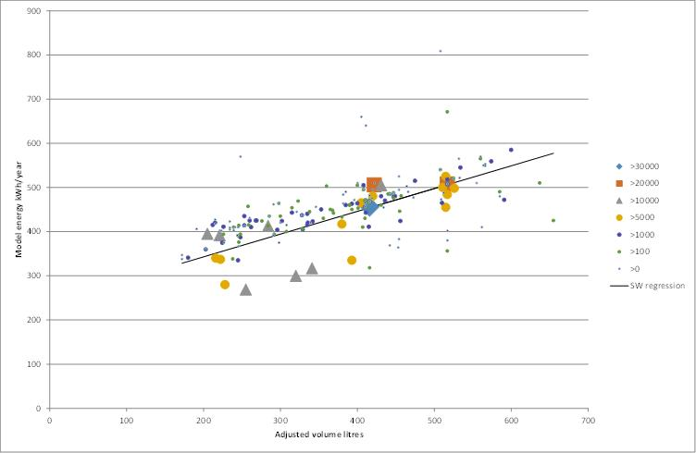

Figure 64: Sales Weighted Volume Price Regression for Group 5T

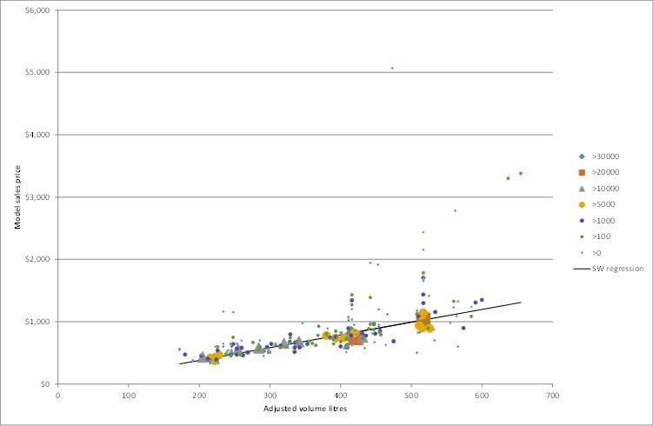

Figure 63 shows that there is some diversity in the energy consumption by volume within Group 5T products. However, Figure 64 shows that all of the models with larger sales tend to lie very close to the sales weighted regression trend. There are numerous models with very small sales that have much higher than average price and a few with a lower price. Some of these high price models may be boutique or specialised models and some represent more expensive options like stainless steel or built-in or custom panels that may have no impact on energy. Using this approach, these boutique models can be included in the analysis but have very little influence on the overall result.

#### Step 2: Calculation of normalised energy and normalised price for each model

The next step was to look at the price and energy consumption of each individual model sold in 2013 and compare these to the representative regression for price and energy determined for the Group as a whole. The ratio of actual price to the regression price for each model is then calculated: this is called normalised price. A normalised price of greater than 1.0 means that the model was more expensive than an average model in the Group for that size, while a normalised price of less than 1.0 means that the model was cheaper than average. Similarly, the ratio of actual energy to the regression energy for each model is then calculated: this is called the normalised energy. A normalised energy of greater than 1.0 means that the model uses more energy than an average model in the Group for that size, while a normalised energy of less than 1.0 means that the model had lower energy than average.

#### Step 3: Examine the relationship between normalised energy and normalised price

A plot of normalised energy versus normalised price is then examined for each Group to see if there is any relationship between the normalised energy consumption and the normalised price for the specific Group being examined. A sales weighted linear regression is again used to establish whether there is a relationship between these two parameters. The expected relationship is that models that are more expensive than average should use less energy than average (i.e. are more energy efficient). Where this is the case, a sales weighted regression would have a negative slope between normalised energy and normalised price (i.e. as normalised price increases, normalised energy should decrease = efficiency increases).

To illustrate this third step, the data for Group 5T is shown in Figure 65. This shows some increase in expected normalised price as normalised energy consumption falls.

Figure 65: Sales Weighted Regression of Normalised Energy Versus Normalised Price for Group 5T

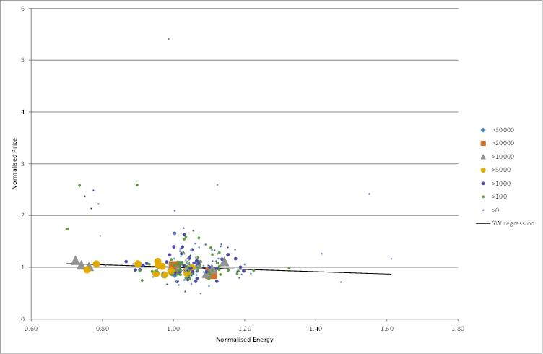

### Results of cross sectional analysis

A regression of normalised energy versus normalised price was conducted for each Group, with the results reported in the tables below. All regression parameters have been sales weighted as set out above.

Table 7: Summary of Sales Weighted Volume – Energy Regression by Group in 2013

|  |  |  |  |  |
| --- | --- | --- | --- | --- |
| Group | Group Description | Energy Slope | Energy Intercept | R2 |
| 1 | All refrigerator | 0.210 | 247.6 | 0.421 |
| 2 | Refrigerator with ice box | 0.409 | 201.8 | 0.206 |
| 3 | Refrigerator/short term freezer | 0.057 | 272.5 | 0.009 |
| 4 | Refrigerator-Freezer cyclic/manual | 0.397 | 274.6 | 0.465 |
| 5T | Refrigerator-Freezer frost free (frz @ top) | 0.515 | 240.0 | 0.568 |
| 5B | Refrigerator-Freezer frost free (frz @ bottom) | 0.814 | 142.4 | 0.681 |
| 5S | Refrigerator-Freezer frost free (side/side) | 0.492 | 371.3 | 0.245 |
| 6C | Chest freezer | 0.745 | 169.7 | 0.962 |
| 6U | Vertical freezer manual defrost | 0.512 | 216.4 | 0.389 |
| 7 | Vertical freezer automatic defrost | 1.292 | 104.5 | 0.731 |

Note: Unadjusted volume used for the regression. Intercept units are kWh/year. Slope units are kWh/year/litre.

Table 8: Summary of Sales Weighted Volume – Price Regression by Group in 2013

|  |  |  |  |  |
| --- | --- | --- | --- | --- |
| Group | Group Description | Price Slope | Price Intercept | R2 |
| 1 | All refrigerator | 3.487 | -158.7 | 0.392 |
| 2 | Refrigerator with ice box | 1.424 | 73.2 | 0.636 |
| 3 | Refrigerator/short term freezer | 12.398 | -1169.4 | 0.987 |
| 4 | Refrigerator-Freezer cyclic/manual | 11.737 | -1504.5 | 0.632 |
| 5T | Refrigerator-Freezer frost free (frz @ top) | 2.045 | -29.6 | 0.682 |
| 5B | Refrigerator-Freezer frost free (frz @ bottom) | 4.758 | -832.1 | 0.627 |
| 5S | Refrigerator-Freezer frost free (side/side) | 5.102 | -1608.8 | 0.334 |
| 6C | Chest freezer | 2.093 | 0.9 | 0.962 |
| 6U | Vertical freezer manual defrost | 2.233 | 90.9 | 0.538 |
| 7 | Vertical freezer automatic defrost | 3.969 | -32.4 | 0.362 |

Note: Unadjusted volume used for the regression. Intercept units are $. Slope units are $/litre.

The results of the sales weighted regression of normalised energy versus normalised price are shown in Table 9. The slope gives an indication of the relationship between energy and price. A slope of 0 means there is no apparent relationship between energy and price for the Group after removing the effect of size. A slope of -1.0 would mean that a 1% reduction in energy would be accompanied by a 1% increase in price. Similarly, a slope of -0.5 would mean that a 1% reduction in energy would be accompanied by a 0.5% increase in price. A zero slope indicates that products with lower or higher than average energy are neither likely to be more expensive or cheaper than an average product.

A price energy slope that is negative indicates that there appears to be a relationship between price and efficiency that is expected (i.e. the more expensive the product, the more efficient or lower the energy after taking size into account). The other important variable to consider is the correlation coefficient. The closer that the correlation coefficient (R2) value is to 1, the stronger the relationship (a correlation coefficient of 1 indicates that there is a perfect linear relationship between two variables). Conversely, a correlation coefficient of close to zero indicates that there is little or no relationship between two variables (even if there is a credible looking energy-price slope). A correlation coefficient (R2) of less than 0.5 is generally considered to be an indication of a weak statistical relationship. All Groups showed an R2 of less than 0.5, so the correlation of price and efficiency can be considered as weak in all Groups.

The analysis is based on the actual price paid (by consumers) and the energy consumption and size of 736 individual models sold in retailers. As noted above, all regressions in this analysis have been sales weighted so reflect realistic trends in the market and all models sold in 2013 have been included in the analysis. Table 9 sets out the results of the sales weighted linear regression for each Group.

Table 9: Normalised Energy–Normalised Price Regressions by Group in 2013

|  |  |  |  |  |  |  |
| --- | --- | --- | --- | --- | --- | --- |
| Group | Group Description | Energy-Price Slope | Intercept | R2 | Models | Comments |
| 1 | All refrigerator | -0.911 | 1.928 | 0.032 | 47 | Expected slope, low R2 |
| 2 | Refrigerator with ice box | -0.288 | 1.291 | 0.041 | 80 | Expected slope, low R2 |
| 3 | Refrigerator/short term freezer | -1.553 | 2.566 | 0.202 | 6 | Too few models |
| 4 | Refrigerator-Freezer cyclic/manual | -2.199 | 2.647 | 0.078 | 6 | Too few models |
| 5T | Refrigerator-Freezer frost free (freezer@top) | -0.222 | 1.227 | 0.027 | 154 | Expected slope, low R2 |
| 5B | Refrigerator-Freezer frost free (freezer@bottom) | 0.613 | 0.409 | 0.020 | 206 | Inverse slope, low R2 |
| 5S | Refrigerator-Freezer frost free (side/side) | 0.187 | 0.814 | 0.004 | 91 | Inverse slope, very low R2 |
| 6C | Chest freezer | 0.079 | 0.924 | 0.002 | 38 | Inverse slope, very low R2 |
| 6U | Vertical freezer man defrost | -1.615 | 2.613 | 0.400 | 68 | Expected slope |
| 7 | Vertical freezer auto defrost | -0.345 | 1.341 | 0.018 | 40 | Expected slope, low R2 |

In Table 9 a positive slope in the energy-price regression means that for this Group a unit which is more expensive also tends to use more energy. This does not make sense in terms of an expected price impact of efficiency. In these cases there must be other factors that have influenced the price of certain products in the Group which may or may not be related to efficiency. Features like stainless steel can have a large impact on price but have no direct impact on energy consumption. Groups 5B, 5S and 6C all showed positive slopes for the energy-price regression. However, in all three cases the correlation coefficient was almost zero, indicating that there is almost no practical correlation between energy consumption and price (irrespective of the estimated slope).

In the case of Group 5B, many of the larger units tend to have French doors, which have higher energy consumption (associated with longer door seals and electric anti-sweat heaters) but are also most expensive, so this is likely to influence the regression for this Group. Similarly, for Group 5S, features like through the door ice and water dispensers add a price premium and they also increase the overall energy consumption, so this is likely to explain the slightly positive energy-price correlation for this Group.

For Group 6C, there is a very strong correlation between volume and price and volume and energy (both with an R2 of 0.96), which is by far the strongest correlation for all Groups. This tends to suggests that there is very little deviation in price or energy for a given product size (on a sales weighted basis), so naturally there is almost no correlation between normalised energy and normalised price.

Regressions for Group 3 and Group 4 should not be used as there are only 6 models in each Group and together these account for less than 1.5% of sales.

Group 6U has a steep slope for normalised energy and price. This occurs as two of the largest selling models are a bit more expensive than average and have lower energy than average. Another large selling model is a bit less expensive than average and has higher than average energy. While the overall correlation R2 is still fairly weak at 0.4, this is the strongest correlation energy-price correlation of all Groups.

Even though analysis of the data suggests that there is only a weak price efficiency relationship, this assumption only holds true for the products on the market in 2013 and it does not mean that endless efficiency gains can be forced onto manufacturers with a low cost penalty. The analysis only holds true for the range of products currently on the market. This regression also needs to be considered in the context of long term price and energy trends for refrigerators. Analysis in previous sections has shown that average energy and average prices have fallen substantially together over the past 20 years, so the relationships found in 2013 need to be interpreted in the context of long term downward trends for both price and energy (refer to Figure 2 and Figure 4). So the relationships established here may change into the future as both price and energy continue to fall.

#### Price-Efficiency Relationship

It is generally assumed that if measures are taken that lead to an increase in the energy efficiency of products, the cost of those products will rise or, if not, there will be some other hidden penalty in reduced product performance or durability. This is usually true with products that are relatively simple in design, and where there is a direct relationship between material quality or quantity and energy efficiency. However, the relationship between price and energy is much more complex for products like refrigerators and freezers, where there are many ways to increase efficiency as well as possibilities for rationalising or eliminating some manufacturing costs along the way. At the start of energy labelling almost 30 years ago, the focus on efficiency led to the elimination of many costly components such as separate defrost tray heaters, anti-sweat heaters and butter conditioners. In effect, energy efficiency increased at negative cost. Once low cost options had been taken up, it was expected that a negative correlation between energy and price would emerge.

The 2001 RIS for the introduction of MEPS 2005 (GWA 2001) found that this was somewhat true for freezers, but less so for refrigerators. It was estimated that there would be an almost direct relationship between increases in the price and efficiency of freezers, despite the fact that the 1999 MEPS were accompanied by a reduction in real average price. For refrigerators, it was found that the trend over time was the opposite of what would be expected: price was found to decrease at almost the same rate as the efficiency increased. This was a remarkable finding as the quality of refrigeration services increased over the period (Ellis et al. 2007).

An analysis completed for the International Energy Agency (IEA) found that as the energy consumption of Australian refrigerators, has declined over time so has real price, even though average volumes have increased slightly. This real price has not fluctuated over time as much as seen in other countries (notably the USA) and this has been put down to energy labelling ‘smoothing’ the process for MEPS (energy labelling gives suppliers an incentive to design more efficient products, which in turn helps to alleviate the impacts of a MEPS at implementation). It was also found that when comparing product prices to CPI each year, at no point have price changes exceeded CPI, suggesting that the introduction of past MEPS regulations have not adversely affected the price of equipment compared to the general basket of goods and service (Ellis et al. 2007). Analysis of energy and price in 2010 (EES 2010) showed that there have been ongoing strong downward trends in real prices for more than 30 years and that the impact of aggressive MEPS in 2005 had no discernible effect on that trend, except for a possible slowing of real prices for Group 7 products for 2 years. This is not to say that the introduction of future MEPS has had no price impact (or would not in the future). It is just that the price impact will be relatively small within the context of long term real price reductions for all products. The implementation of future MEPS may result in slightly slower real price falls than may be the case in the absence of MEPS.

#### Real price trends

For each Group, the sales weighted nominal price as reported by GfK over the 22 years was compiled (1993 to 2014 inclusive). This covers virtually the whole Australian market and includes actual price paid by consumers, so is a very powerful data set. The CPI index (All Groups) weighted for 8 capital cities as published by the Australian Bureau of Statistics in ABS6401 was compiled for June each year from 1993 to 2014. Using the ratio of index for each year to the June 2014 value, a real price (in 2014 $) was calculated for each Group. Then the change in real price per annum over this period was calculated for each Group. This is shown in Table 10. Note that these include any price impacts from MEPS 1999 and MEPS 2005 as well as energy labelling from 1986.

Table 10: Changes in Refrigerator and Freezer Real Prices from 1993 to 2014

|  |  |  |
| --- | --- | --- |
| Group | Group Description | Real price change per annum 1993 to 2014 |
| 1 | All refrigerator | -1.3% |
| 2 | Refrigerator with ice box | -3.9% |
| 3 | Refrigerator/short term freezer | -2.8% |
| 4 | Refrigerator-Freezer cyclic/manual | -3.9% |
| 5T | Refrigerator-Freezer frost free (frz @ top) | -4.7% |
| 5B | Refrigerator-Freezer frost free (frz @ bottom) | -1.3% |
| 5S | Refrigerator-Freezer frost free (side/side) | -3.7% |
| 6C | Chest freezer | -2.5% |
| 6U | Vertical freezer manual defrost | -3.6% |
| 7 | Vertical freezer automatic defrost | -2.3% |

The following charts show the details of the sales weighted size, price and energy regressions used to generate the price coefficients. These are based on the full year of sales data for 2013 and cover more than 1 million products sold in that year. The equations for each Group are given in Table 7, Table 8 and Table 9.

Figure 66: Volume versus Price for Group 1

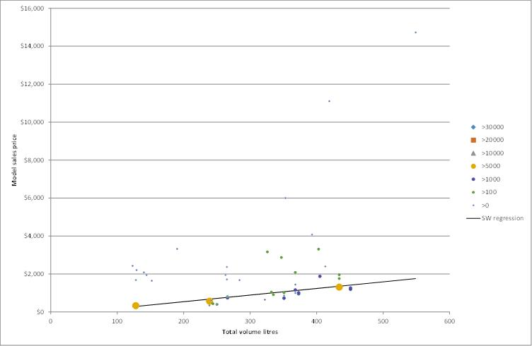

Figure 67: Volume versus Energy for Group 1

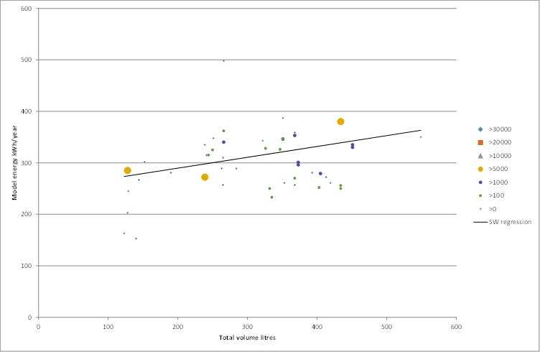

Figure 68: Normalised Energy versus Normalised Price for Group 1

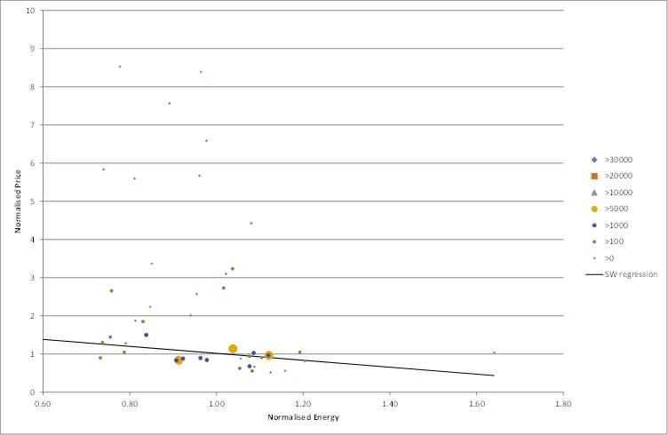

Figure 69: Volume versus Price for Group 2

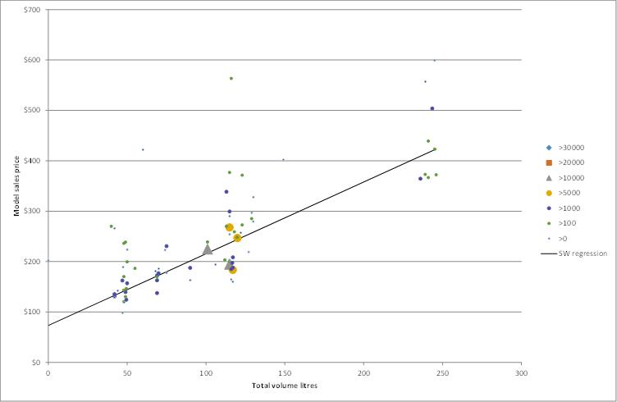

Figure 70: Volume versus Energy for Group 2

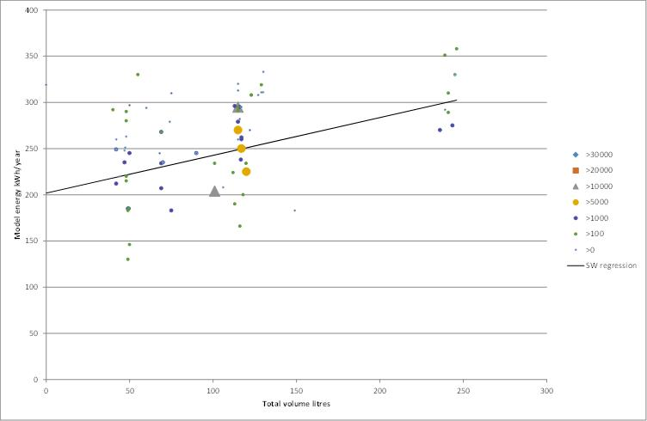

Figure 71: Normalised Energy versus Normalised Price for Group 2

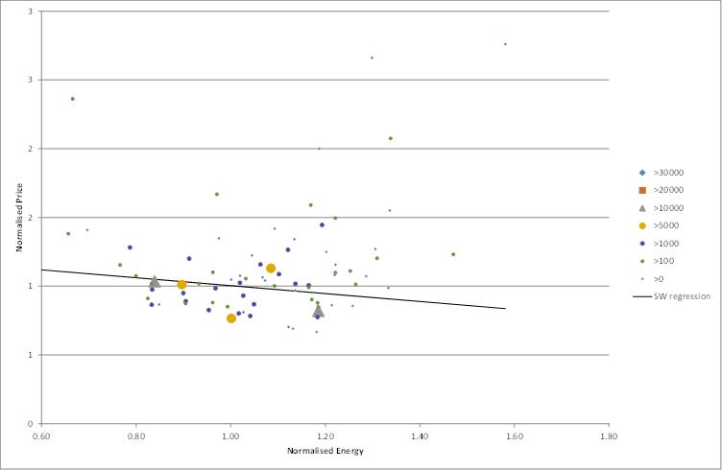

Figure 72: Volume versus Price for Group 5T

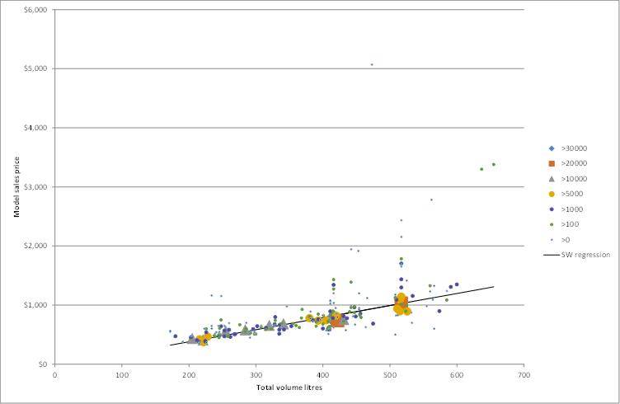

Figure 73: Volume versus Energy for Group 5T

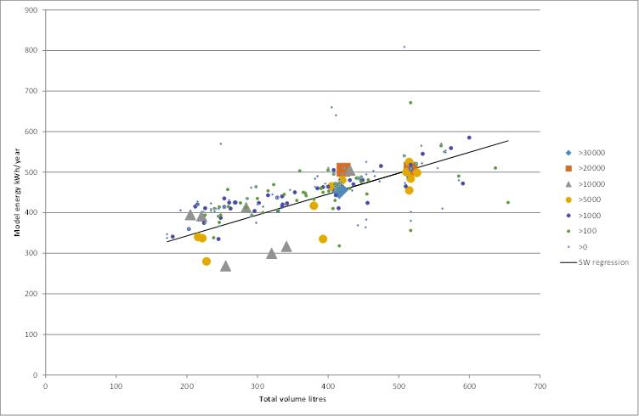

Figure 74: Normalised Energy versus Normalised Price for Group 5T

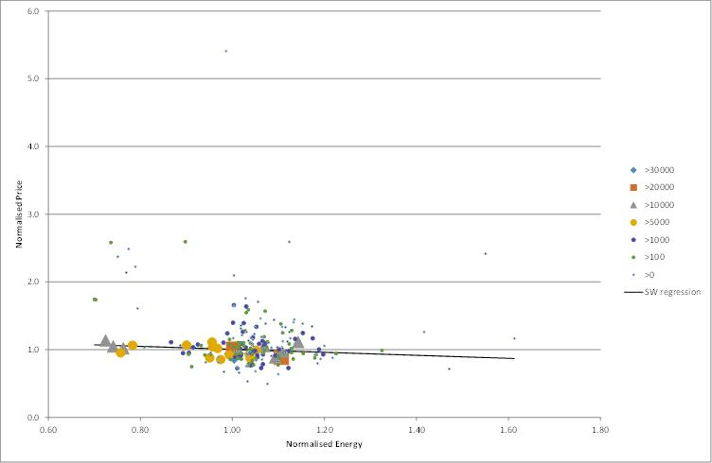

Figure 75: Volume versus Price for Group 5B

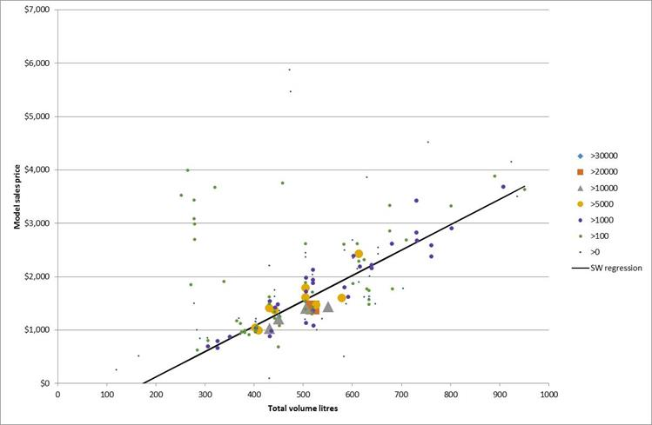

Figure 76: Volume versus Energy for Group 5B

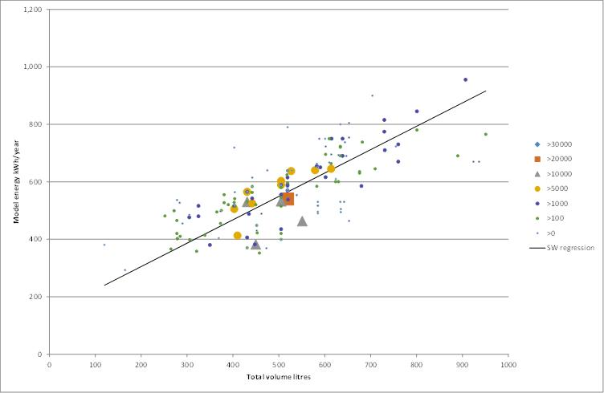

Figure 77: Normalised Energy versus Normalised Price for Group 5B

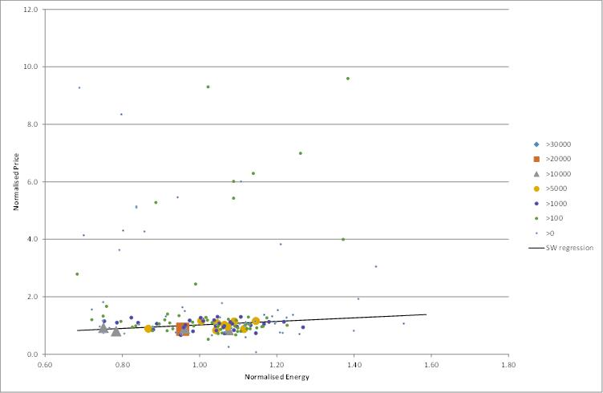

Figure 78: Volume versus Price for Group 5S

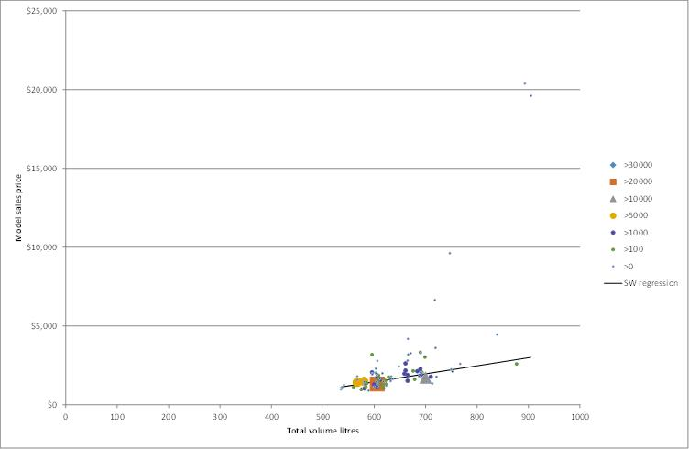

Figure 79: Volume versus Energy for Group5S

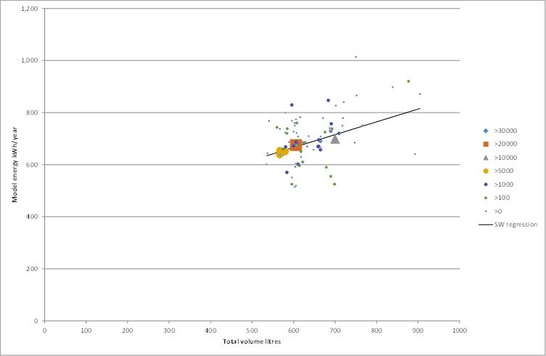

Figure 80: Normalised Energy versus Normalised Price for Group 5S

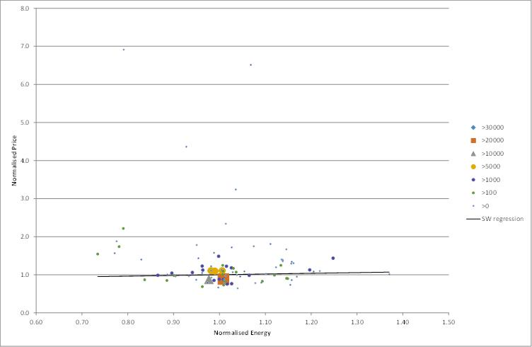

Figure 81: Volume versus Price for Group 6C

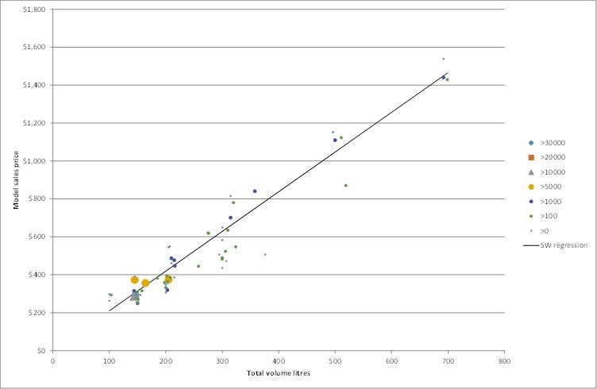

Figure 82: Volume versus Energy for Group 6C

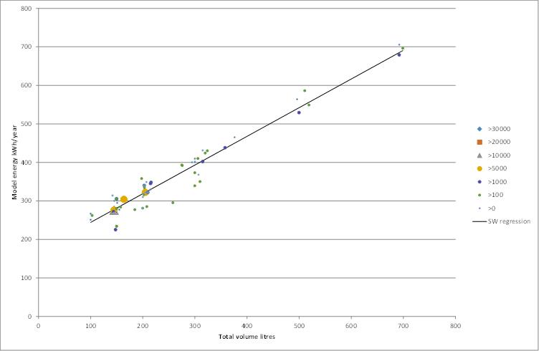

Figure 83: Normalised Energy versus Normalised Price for Group 6C

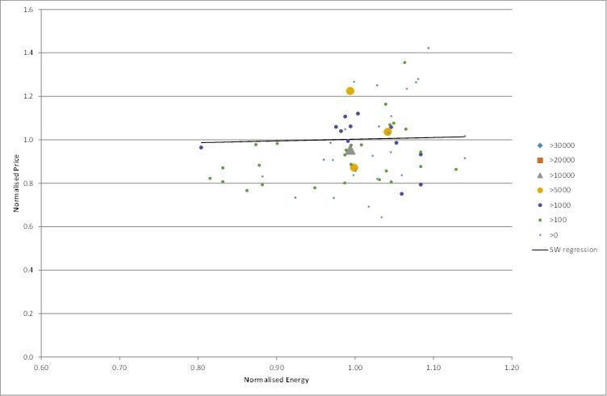

Figure 84: Volume versus Price for Group 6U

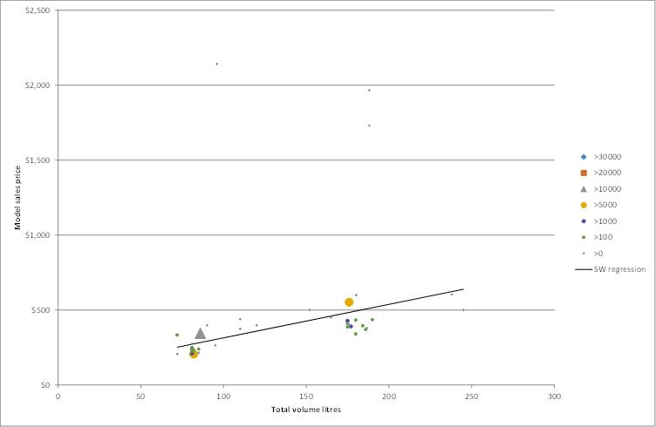

Figure 85: Volume versus Energy for Group 6U

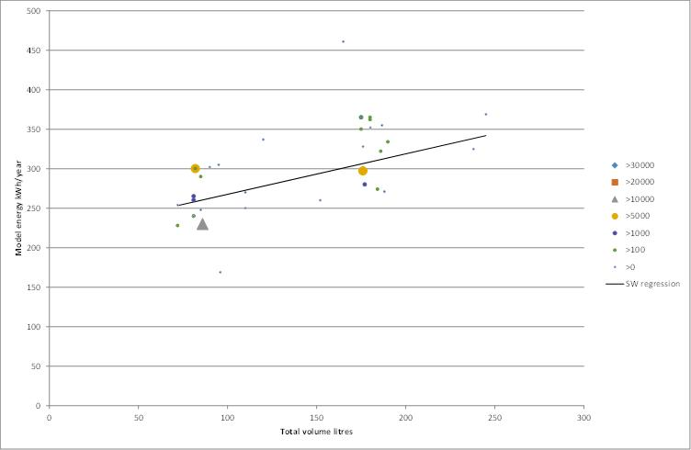

Figure 86: Normalised Energy versus Normalised Price for Group 6U

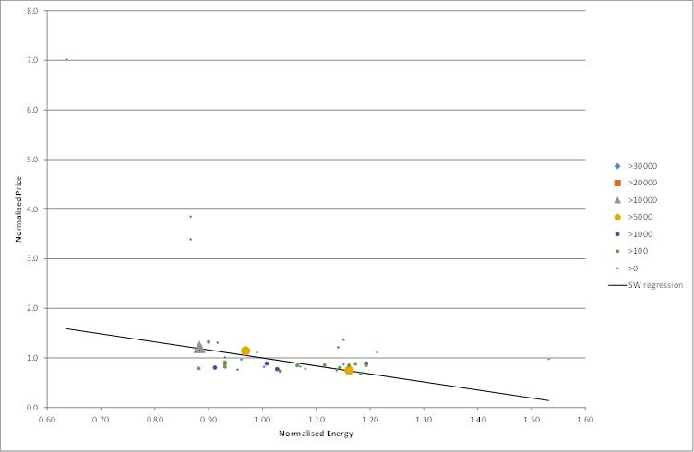

Figure 87: Volume versus Price for Group 7

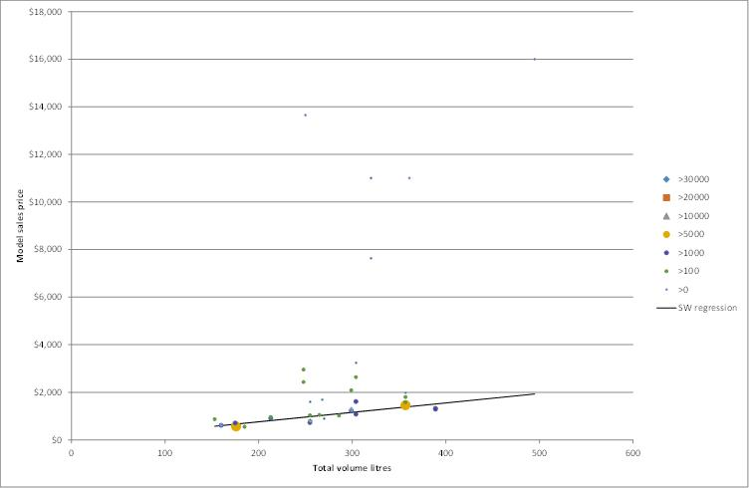

Figure 88: Volume versus Energy for Group 7

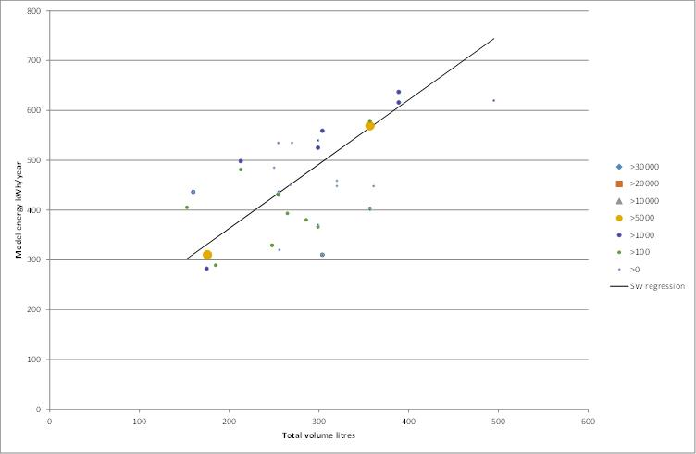

Figure 89: Normalised Energy versus Normalised Price for Group 7

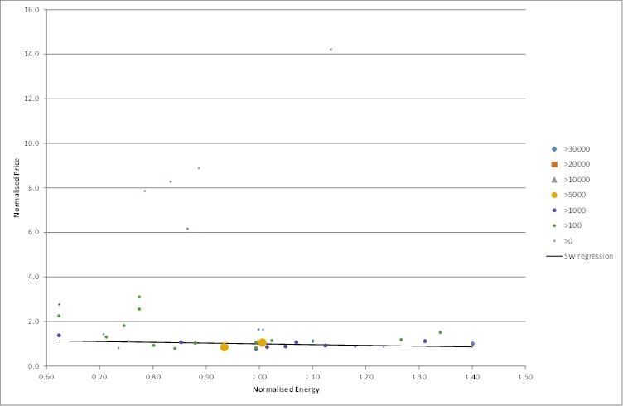

### Cost as a function of star rating by Group

An alternative way of looking at the issue of price and efficiency of appliance that carry an energy label is to examine the average price as a function of star rating for each Group. Some Groups do exhibit a higher than average price for the highest star rating on the market. However, this needs to be interpreted with care as some star rating bins only have a few models and few sales, so may not be fully representative. All distributions are based on the 2013 sales data set.

#### Group 1

|  |  |  |  |  |  |  |
| --- | --- | --- | --- | --- | --- | --- |
| Star Rating | 1 | 1.5 | 2 | 2.5 | 3 | 3.5 |
| Models | 10 | 14 | 8 | 9 | 5 | 1 |
| Sales | 10926 | 11522 | 18073 | 2258 | 652 | 74 |
| Volume | 150.6 | 391.0 | 349.3 | 395.2 | 403.6 | 140.0 |
| Price | $385 | $1,203 | $938 | $1,845 | $1,962 | $2,081 |
| Energy | 294.7 | 362.3 | 301.7 | 275.6 | 247.5 | 153.0 |
| $/L | $2.56 | $3.08 | $2.69 | $4.67 | $4.86 | $14.87 |
| kWh/L | 1.96 | 0.93 | 0.86 | 0.70 | 0.61 | 1.09 |

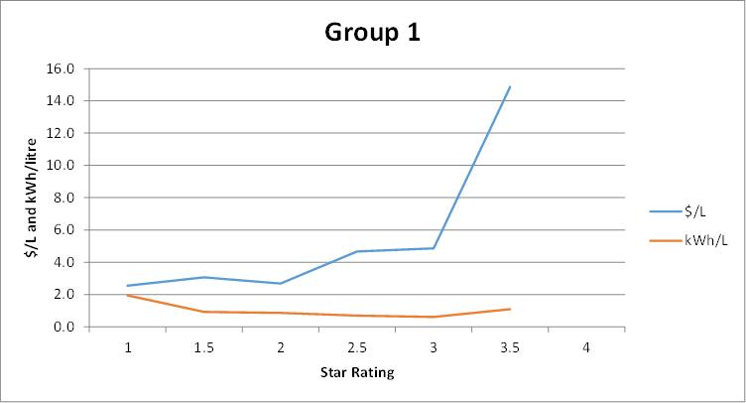Note that the highest star rating is 1 model with sales of less 100 and is a very small size.

#### Group 2

|  |  |  |  |  |  |  |
| --- | --- | --- | --- | --- | --- | --- |
| Star Rating | 1 | 1.5 | 2 | 2.5 | 3 | 3.5 |
| Models | 43 | 19 | 11 | 3 | 3 | 1 |
| Sales | 42220 | 23958 | 41075 | 2638 | 1279 | 118 |
| Volume | 100.0 | 100.2 | 113.4 | 83.4 | 86.8 | 49.0 |
| Price | $217 | $186 | $241 | $238 | $388 | $239 |
| Energy | 279.7 | 245.3 | 214.6 | 185.4 | 157.4 | 130.0 |
| $/L | $2.17 | $1.86 | $2.13 | $2.85 | $4.47 | $4.87 |
| kWh/L | 2.80 | 2.45 | 1.89 | 2.22 | 1.81 | 2.65 |

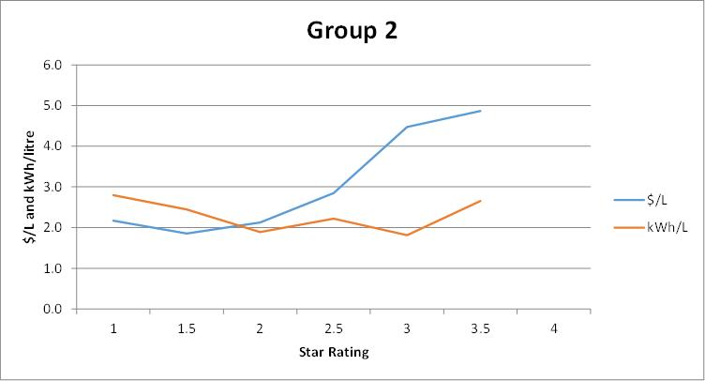Note that the highest star rating is 1 model with sales of around 100 and is a very small size.

#### Group 3

|  |  |  |  |
| --- | --- | --- | --- |
| Star Rating | 1 | 1.5 | 2 |
| Models | 2 | 1 | 3 |
| Sales | 13808 | 667 | 670 |
| Volume | 118.0 | 105.0 | 159.6 |
| Price | $290 | $211 | $808 |
| Energy | 282.0 | 256.0 | 245.2 |
| $/L | $2.46 | $2.01 | $5.06 |
| kWh/L | 2.39 | 2.44 | 1.54 |

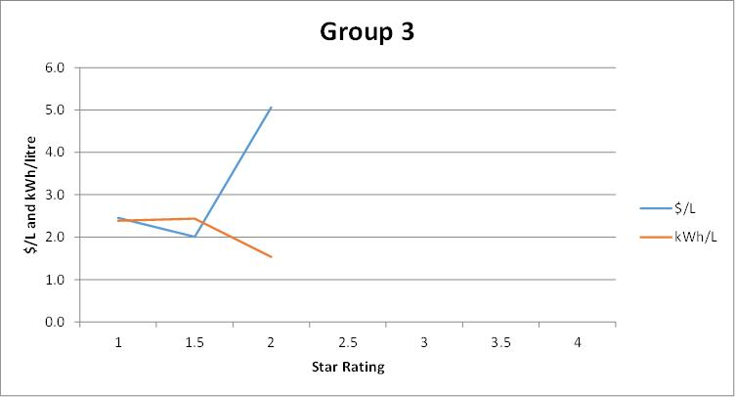Note few models in each star rating bin.

#### Group 4

|  |  |  |  |  |  |  |
| --- | --- | --- | --- | --- | --- | --- |
| Star Rating | 1 | 1.5 | 2 | 2.5 | 3 | 3.5 |
| Models | 0 | 1 | 2 | 1 | 1 | 1 |
| Sales | 0 | 190 | 553 | 222 | 3 | 52 |
| Volume | #N/A | 89.0 | 212.8 | 326.0 | 271.0 | 256.0 |
| Price | #N/A | $307 | $376 | $2,939 | $2,155 | $2,586 |
| Energy | #N/A | 299.0 | 374.9 | 406.0 | 312.0 | 246.0 |
| $/L | #N/A | $3.45 | $1.77 | $9.02 | $7.95 | $10.10 |
| kWh/L | #N/A | 3.36 | 1.76 | 1.25 | 1.15 | 0.96 |

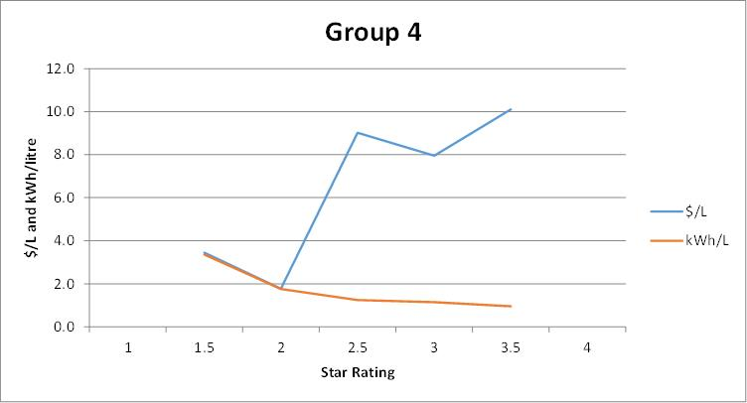Note few models and few sales in each star rating bin.

#### Group 5T

|  |  |  |  |  |  |  |  |
| --- | --- | --- | --- | --- | --- | --- | --- |
| Star Rating | 1 | 1.5 | 2 | 2.5 | 3 | 3.5 | 4 |
| Models | 4 | 16 | 73 | 90 | 10 | 11 | 2 |
| Sales | 16 | 22422 | 115391 | 190315 | 21794 | 45326 | 759 |
| Volume | 436.2 | 222.8 | 327.0 | 430.8 | 416.7 | 321.9 | 461.4 |
| Price | $954 | $464 | $614 | $840 | $921 | $660 | $1,588 |
| Energy | 706.6 | 413.4 | 444.8 | 464.7 | 395.2 | 302.9 | 335.1 |
| $/L | $2.19 | $2.08 | $1.88 | $1.95 | $2.21 | $2.05 | $3.44 |
| kWh/L | 1.62 | 1.86 | 1.36 | 1.08 | 0.95 | 0.94 | 0.73 |

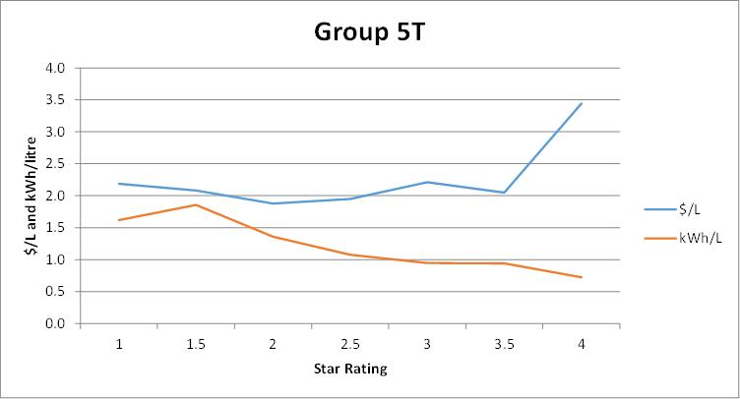Some price increase for the highest efficiency, only 2 models in this bin.

#### Group 5B

|  |  |  |  |  |  |  |
| --- | --- | --- | --- | --- | --- | --- |
| Star Rating | 1 | 1.5 | 2 | 2.5 | 3 | 3.5 |
| Models | 7 | 38 | 54 | 29 | 17 | 9 |
| Sales | 48 | 39133 | 109485 | 50996 | 24235 | 16254 |
| Volume | 436.4 | 604.6 | 501.3 | 530.8 | 481.5 | 451.1 |
| Price | $1,470 | $2,173 | $1,612 | $1,530 | $1,350 | $1,288 |
| Energy | 670.4 | 708.3 | 579.2 | 542.6 | 435.9 | 381.9 |
| $/L | $3.37 | $3.59 | $3.21 | $2.88 | $2.80 | $2.85 |
| kWh/L | 1.54 | 1.17 | 1.16 | 1.02 | 0.91 | 0.85 |

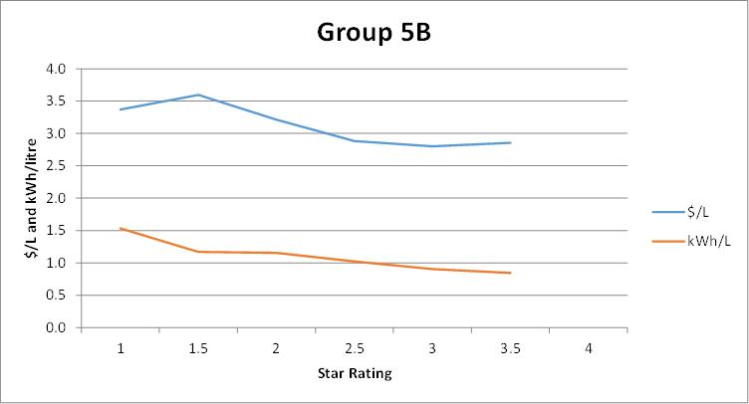No increase in price for higher star ratings. Significant models and sales in all bins.

#### Group 5S

|  |  |  |  |  |  |
| --- | --- | --- | --- | --- | --- |
| Star Rating | 1 | 1.5 | 2 | 2.5 | 3 |
| Models | 5 | 29 | 43 | 8 | 6 |
| Sales | 3753 | 3352 | 89314 | 6090 | 820 |
| Volume | 649.8 | 657.3 | 623.5 | 611.9 | 671.2 |
| Price | $2,091 | $1,775 | $1,545 | $1,484 | $3,173 |
| Energy | 840.1 | 759.8 | 676.2 | 590.1 | 536.6 |
| $/L | $3.22 | $2.70 | $2.48 | $2.42 | $4.73 |
| kWh/L | 1.29 | 1.16 | 1.08 | 0.96 | 0.80 |

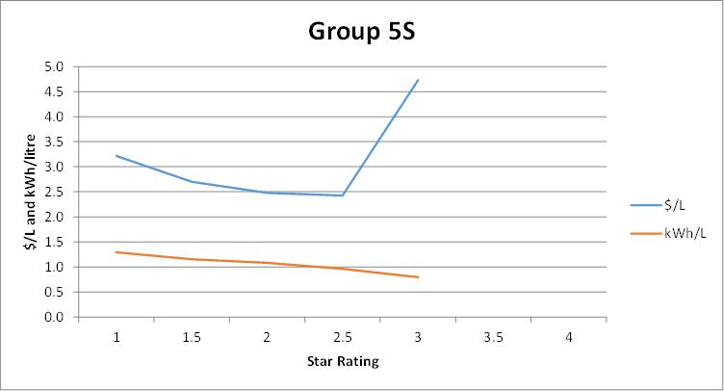Significant price increase for highest star rating.

#### Group 6C

|  |  |  |  |  |  |  |
| --- | --- | --- | --- | --- | --- | --- |
| Star Rating | 1 | 1.5 | 2 | 2.5 | 3 | 3.5 |
| Models | 0 | 0 | 17 | 40 | 9 | 2 |
| Sales | 0 | 0 | 7198 | 60556 | 2610 | 3490 |
| Volume | #N/A | #N/A | 388.4 | 207.5 | 193.4 | 159.2 |
| Price | #N/A | #N/A | $790 | $442 | $343 | $314 |
| Energy | #N/A | #N/A | 474.9 | 327.4 | 270.4 | 232.1 |
| $/L | #N/A | #N/A | $2.03 | $2.13 | $1.77 | $1.97 |
| kWh/L | #N/A | #N/A | 1.22 | 1.58 | 1.40 | 1.46 |

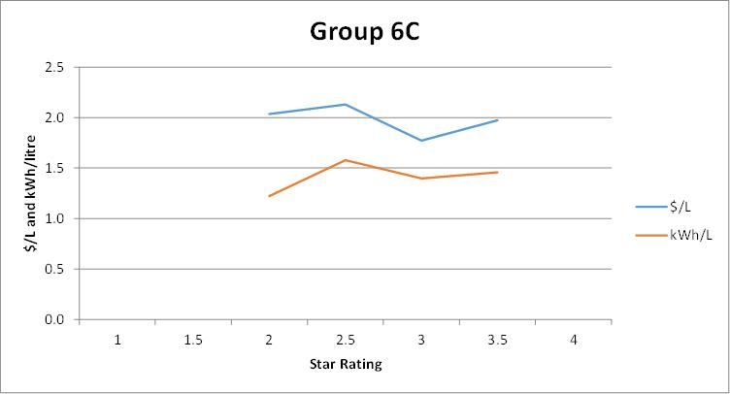Note declining volume for higher star ratings, but no trend in price by star rating.

#### Group 6U

|  |  |  |  |  |  |  |
| --- | --- | --- | --- | --- | --- | --- |
| Star Rating | 1 | 1.5 | 2 | 2.5 | 3 | 3.5 |
| Models | 1 | 6 | 18 | 6 | 6 | 1 |
| Sales | 1 | 8050 | 8372 | 21331 | 2468 | 37 |
| Volume | 165.0 | 82.3 | 111.3 | 130.7 | 179.1 | 96.0 |
| Price | $450 | $209 | $290 | $433 | $409 | $2,142 |
| Energy | 461.0 | 299.2 | 289.9 | 265.0 | 279.5 | 169.0 |
| $/L | $2.73 | $2.54 | $2.61 | $3.31 | $2.28 | $22.31 |
| kWh/L | 2.79 | 3.64 | 2.60 | 2.03 | 1.56 | 1.76 |

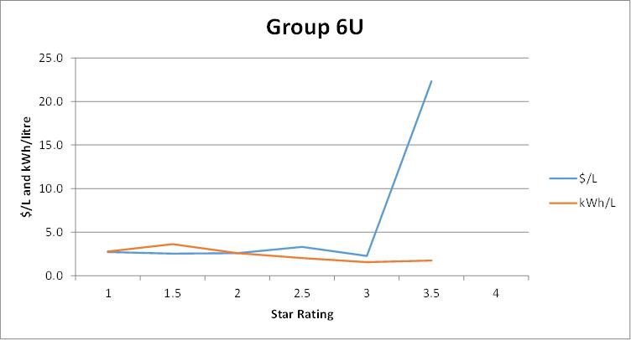Highest star rating is 1 model with low sales (high end European), this model is also very small.

#### Group 7

|  |  |  |  |  |  |  |
| --- | --- | --- | --- | --- | --- | --- |
| Star Rating | 1 | 1.5 | 2 | 2.5 | 3 | 3.5 |
| Models | 9 | 7 | 6 | 8 | 7 | 3 |
| Sales | 10542 | 11864 | 5148 | 8560 | 5161 | 2004 |
| Volume | 282.9 | 354.5 | 255.3 | 184.9 | 189.5 | 304.0 |
| Price | $1,031 | $1,399 | $789 | $616 | $915 | $1,690 |
| Energy | 546.1 | 573.0 | 431.5 | 315.7 | 291.3 | 310.0 |
| $/L | $3.64 | $3.95 | $3.09 | $3.33 | $4.83 | $5.56 |
| kWh/L | 1.93 | 1.62 | 1.69 | 1.71 | 1.54 | 1.02 |

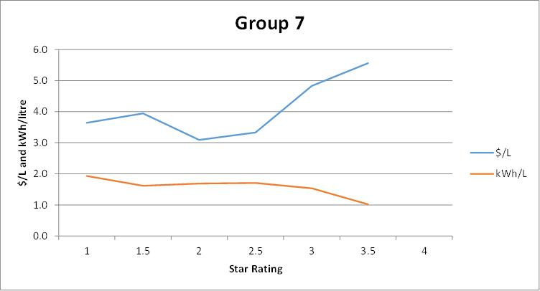Some increase in price with star rating. Note volume volatility by star rating bin.

## References

ABS4602.0, 2008, *Environmental Issues: Energy Use and Conservation*, Australian Bureau of Statistics, ABS Catalogue 4602.0, see <http://www.abs.gov.au/AUSSTATS/abs@.nsf/ProductsbyCatalogue/A38DDA7F40718E43CA25750E00112A97?OpenDocument>

ABS6401.0 2015, *Consumer Price Index, Australia*, September 2015, Australian Bureau of Statistics, ABS Catalogue 6401.0. See <http://www.abs.gov.au/ausstats/abs@.nsf/mf/6401.0>

AS/NZS 2007, *Performance of Household Electrical Appliances – Dishwashers* (Parts 1 and 2)

AS/NZS 2040, *Performance of Household Electrical Appliances – Clothes Washing Machines* (Parts 1 and 2)

AS/NZS 2442, *Performance of Household Electrical Appliances – Rotary Clothes Dryers* (Parts 1 and 2)

AS/NZS 4474, *Performance of Household Electrical Appliances – Refrigerators and Freezers* (Parts 1 and 2)

EES 2008, *Decision Regulatory Impact Statement: of proposed revisions to the method of test and energy labelling algorithms for household refrigerators and freezers*, EES for Department of Energy Efficiency and Climate Change, October 2008. <http://www.energyrating.gov.au/document/decision-ris-household-refrigerators-and-freezers>

EES 2010, *Evaluation of Energy Efficiency Policy Measures for Household Refrigeration in Australia: An assessment of energy savings since 1986*, prepared by Lloyd Harrington and Dr Kevin Lane, EES for Department of Energy Efficiency and Climate Change, December 2010. <http://www.energyrating.gov.au/document/report-evaluation-energy-efficiency-policy-measures-household-refrigeration-australia>

EES 2012, *Household Refrigeration Paper 3: MEPS3 in Australia and NZ – Preliminary Impact Assessment of New MEPS Levels*, EES for E3, May 2012. <http://www.energyrating.gov.au/document/household-refrigeration-paper-3-meps3-australia-and-nz-preliminary-impact-assessment-new>

Ellis et al. (2007), Do energy efficient appliances cost more?, by Mark Ellis, International Energy Agency, Nigel Jollands International Energy Agency, Lloyd Harrington Energy Efficient Strategies, Alan Meier Lawrence Berkley National Laboratory. Paper presented to the *ECEEE Summer Study*, France, 2007. Available from [www.eceee.org](http://www.eceee.org)

GWA (2001), *Regulatory Impact Statement; Revised Minimum Energy Performance Standards for Household Refrigerators and Freezers*, by George Wilkenfeld and Associates with Energy Efficient Strategies. <http://www.energyrating.gov.au/document/regulatory-impact-statement-revised-minimum-energy-performance-standards-household>

Unpublished GfK sales data for whitegoods 1993 to 2014 purchased by E3.

## Acknowledgements

This report was prepared by Energy Efficient Strategies under contract to the E3 Program and the Department of Industry, Innovation and Science.

The data analysis for this paper, including record checking and the review of historical data, was undertaken by Jack Brown with assistance from Lloyd Harrington. Compilation of databases and cross matching of records was undertaken by Jack Brown and Hilary Harrington. The report was written by Lloyd Harrington and information from 2010 to 2014 was updated by Lloyd Harrington and Hilary Harrington.

EES would like to acknowledge the assistance provided by the state energy efficiency regulators and E3 members during the preparation of this report and the data analysis.

While this report was commissioned by government, any views expressed are those of the authors. While the authors have taken every care to accurately report and analyse the data provided by GfK, the authors are not responsible for the accuracy of the source data or for any use or misuse of data and information provided in this report and the associated Appendices or any loss arising from the use of this data.

1. ‘Total sales’ = total sales of appliances of the retail stores from which GFK collect data. GfK claim to cover more than 95% of total retail appliance sales in Australia since 2007 for the appliance types covered by this report. The coverage in earlier years varies over time. See Section 2.3 for more details on estimated GfK market coverage.
2. “Sales weighted annual energy consumption” is based on the energy label consumption to the relevant Australian Standard (also called the comparative energy consumption) for each model weighted by the actual sales of each model. This is generally referred to as just “energy consumption” throughout the report. See Section 2.5 for notes regarding the conversion of this energy to in use energy in the home.
3. Changes to labelling and MEPS requirements for refrigerators and freezers were also made on 1 April 2010.
4. While the nominal wash temperature is 40°C for a warm wash, the standard requires a minimum wash temperature of 35°C to be achieved for a complying test.
5. This is scaled up sales data based on the first 6 months of 2014.
6. See Section 2.3 for an explanation of estimated total market cover by GfK and annual sales increase.
7. Adjusted volume is the sum of the total volume of each compartment which has been weighted to take account of its temperature of operation: fresh food compartment has a weighting factor of 1.0 while a freezer compartment has a weighting of 1.6 (this factor is also called a freezer adjustment factor) as specified in AS/NZS4474.2.
8. This is scaled up sales data based on the first 6 months of 2014.
9. See Section 2.3 for an explanation of estimated total market cover by GfK and annual sales increase.
10. This is scaled up sales data based on the first 6 months of 2014.
11. See Section 2.3 for an explanation of estimated total market cover by GfK and annual sales increase.
12. The average size of front loaders has increased (and surpassed) the average size of top loaders due to sales of some particularly large units (7.5kg, 8kg, 9kg and 10kg) in recent years.
13. Note that most combination washer-dryers use significant water when undertaking their drying function, which is not included here.
14. Spin performance is also called the water extraction index in the standard. This is a measure of the mass of water retained in the load at the end of the final spin operation. A spin performance of 1.00 represents a water mass that is equal to the dry mass of the clothes (quite wet). A spin performance of 0.5 represents a water mass that is equal to 50% of the dry mass of the clothes (quite dry). The best machines are around 0.5 while the worst machines may be over 1.0 (a regulated maximum permitted value is 1.1). This parameter is important as it can impact on dryer energy consumption and its value does influence the washer star rating.
15. This is scaled up sales data based on the first 6 months of 2014.
16. See Section 2.3 for an explanation of estimated total market cover by GfK and annual sales increase.
17. This is scaled up sales data based on the first 6 months of 2014.
18. See Section 2.3 for an explanation of estimated total market cover by GfK and annual sales increase.
19. A change in the standard AS/NZS2007.1-1998 provided a more objective basis for assessing capacity, which resulted in a small reduction and a normalisation of claimed capacity in the period 1998 to 2003.
20. Program times appear to be increasing, however this is in part due to the way that time is defined and recorded in the 2005 edition of the standard. In most cases the cycle time is recorded in the registration, which includes fan operation after the program is complete. The program time, which is when the consumer can access the load, is usually somewhat shorter.
21. Dishwasher price trends have varied since 1994 and were highest in 2001 when the average price was $1,018. However, the dishwasher market has become highly competitive with a large proportion of components now being sourced from low cost countries (such as Asia and Eastern Europe), which has driven price downwards since 2001.