User Guide on 2020 energy metrics in AS/NZS 1158 lighting for roads and public spaces

This work is licensed under the Creative Commons Attribution 3.0 Australia Licence. To view a copy of this license, visit the creative commons website.

The Department of Industry, Science, Energy and Resources on behalf of the Equipment Energy Efficiency Program asserts the right to be recognised as author of the original material in the following manner:



© Commonwealth of Australia (Department of Industry, Science, Energy and Resources) 2021.

This report was prepared by Strategic Lighting Partners for the Equipment Energy Efficiency (E3) program. This version has been updated to amend wording throughout the document.

The material in this publication is provided for general information only, and on the understanding that the Australian Government is not providing professional advice. Before any action or decision is taken on the basis of this material the reader should obtain appropriate independent professional advice.

This document is available at the Energy Rating website.

While reasonable efforts have been made to ensure that the contents of this publication are factually correct, E3 does not accept responsibility for the accuracy or completeness of the content, and shall not be liable for any loss or damage that may be occasioned directly or indirectly through the use of, or reliance on, the contents of this publication.

User Guide on 2020 energy metrics in AS/NZS 1158 Lighting for roads and public spaces

Department of Industry, Science, Energy and Resources (DISER)

# Introduction

Over the last decade public lighting technology worldwide has advanced rapidly and can now achieve 50% to 90% energy reductions. This has provided an opportunity to significantly reduce energy consumption, costs, and associated greenhouse gas emissions.

High performing LED luminaires can be combined with smart controls and their “Central Management System” (CMS). This combination facilitates adaptive lighting and provides practical energy and economic benefits as well as community living improvements.



Figure 1 Historical development of Australian public lighting technologies

Unlike pre-2015 legacy technologies shown above in Figure 1, modern public lighting can be variable. This delivers precisely adjustable lighting levels (and differing energy consumption) at selected time periods for greater efficiency and to improve public safety and amenity.

In 2020 *AS/NZS 1158.3.1* *Lighting for roads and public spaces - Pedestrian area (Category P) lighting—Performance and design* was updated. The update included new performance quantification techniques for lighting design energy efficiency based on international best practice.

This User Guide is intended to inform public lighting managers, advisors, and suppliers of the practical use of the new AS/NZS 1158 energy performance methods. This will assist with design, procurement, management, and audit of public lighting schemes.

The calculation methods used in the new AS/NZS 1158.3.1:2020 supplement lighting design requirements specified by the standard. The methods are for use on paths, roads, streets, and area lighting for spaces such as outdoor car parks. The methods accommodate both non-adaptive lighting as well as modern technologies that deliver adaptive lighting advantages.

The new AS/NZS 1158.3.1:2020 standard includes the metrics of Power Density Indicator (PDI) and Annual Energy Consumption Indicator (AECI), methods to calculate them, and performance reporting requirements. These are practical and informative tools to assess systemic energy use to optimise the energy performance of new and existing public lighting schemes and for continuous improvement.

# Adaptive Lighting for Public Lighting Energy Savings

With new equipment now available, public lighting can be variable rather than static as in the past. Internationally, the use of public lighting is increasingly being used only where, when, and to what level, it is needed.

For example, lighting can be:

* Switched off or dimmed at periods to a lower lighting subcategory , when vehicle or pedestrian activity is low;
* brightened at periods to improve public safety or amenity; or
* brightened short-term if incident safety needs dictate; or
* variable according to sensor detection of actual activity in real-time.

Regardless of use case, adaptive lighting must be used with appropriate risk management and in a way that recognises safety requirements.

Adaptive lighting techniques in the AS/NZS 1158 series include light adjustment techniques such as switching, dimming, brightening, trimming and constant light output (CLO). The control settings of a lighting scheme may change throughout the night and adapt to changes in vehicular, cyclist or pedestrian activity. Effectively, the settings need to meet the requirements of several lighting subcategories, each for different times. Adaptive lighting can be used in two ways:

* scheduled, to use planned light levels at specific times which are based on expected or historic traffic activity patterns; or
* light levels can be set using real-time presence sensors to detect the activity of prevailing pedestrian, cyclist or vehicular traffic.

**Figure 2** below shows three indicative examples of scheduled controls. These are “operational profiles”. The area-gaps (relative to the full-power business-as-usual operational profile) represent the energy savings of that profile.

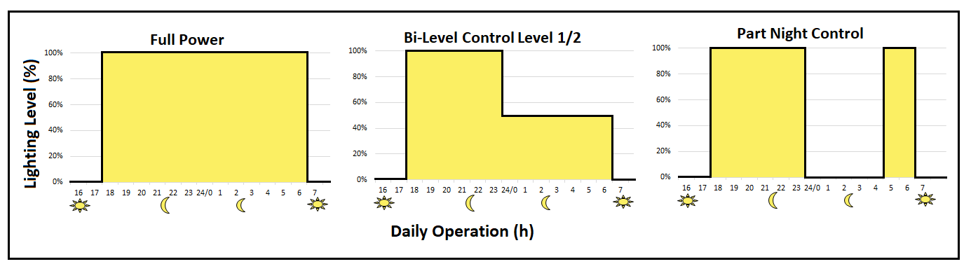**Figure 2 Operational profile examples**

Adaptive lighting is not new. Application guidance has been included in a range of regional and international technical standards over the last decade including:

* International Commission on Illumination. *CIE 115:2010 Lighting of roads for motor and pedestrian traffic;*
* European Committee for Standardization. *EN 13201-5:2015 Energy Performance Indicators;*
* British Standards Institute. *BS 5489-1:2013 Design of road lighting-Part 1: Lighting of roads and public amenity areas-Code of practice* (updated 2020).

# Overview of the 2020 AS/NZS 1158 Energy Performance Indicators

## Lighting Design Standard AS/NZS 1158.3.1:2020

Lighting design standard *AS/NZS 1158.3.1:2020 Lighting for roads and public spaces - Pedestrian area (Category P) lighting—Performance and design requirements* was published in March 2020. This includes updated Section 3.4: Energy Performance Assessment and Reporting, and a new Appendix F: Energy Performance Indicators.

These updates are based on a partial adoption of the metrics and calculation methods of European standard *EN 13201-5:2015 Energy Performance Indicators*, published in 2015.

The companion design standard for Category V main roads *AS/NZS 1158.1.1* is likely to be published late in 2021.

## Energy Terminology

The concepts of energy efficiency and energy performance and are frequently misapplied. The International Electrotechnical Commission *IEC Guide 118:2017* *Inclusion of energy efficiency aspects in electrotechnical publications* clarifies the differences.

* Energy Efficiency is the ratio between an output of performance and an input of energy
* Energy Performance is the measurable result of energy use and energy consumption

Energy performance is the appropriate term when calculating absolute measures of energy activity of a lighting scheme and is determined by the combination of the following factors:

(a) luminaire efficacy and photometric distribution

(b) lighting design suitability

(c) lighting system operation

## The Systems Approach

Public lighting schemes need to be analysed using a systems approach. This considers the energy performance of individual components, and also how efficiently these components work together in the system.

A systems approach to energy efficiency is likely to optimise performance as:

* there is consideration of components and application together;
* improvement of the system may be higher than that of an individual component;
* improvement at component level can be lost with inappropriate operation of that component.

## Energy Performance

Energy performance evaluation therefore requires calculating the combined effects of:

**Lighting Design + Luminaires + Controls + Operations**

The **design** of the lighting scheme dictates how, where and when light will be applied for safety and amenity. Selecting a **luminaire** is an integral part of the design process. How the **controls** are utilised has the role of delivering variable light levels and at different times. Finally, the road controlling authority operates the lighting scheme. The authority is the body responsible for community activities, risks, threats and amenity across all times of the night.

The relevant design standard Light Technical Parameter (LTP) that influences adaptive lighting selection and energy performance, is “average horizontal illuminance”. Each adaptive up or down adjustment to achieve the horizontal illuminance levels needs to meet a defined lighting subcategory. The subcategory (labelled in the 2020 update as “PRx” for local roads) is applicable to the area concerned, during the time period concerned.

Table 3.3 in *AS/NZS 1158.3.1:2020* provides the average horizontal illuminance values for roads in local areas. These illuminance levels must be maintained until the end of the luminaire life. This is achieved by over-illumination at the time of installation, allowing for lumen depreciation inherent in all luminaire types.

## Constant Light Output (CLO)

The calculation of energy performance in the standard provides for Constant Light Output (CLO) functionality. This approach uses controls to progressively increase power levels. This compensates for the light loss caused by the ageing of the light source over lifetime, and avoids the need for wasteful over-lighting during the lighting scheme life.

The luminaire system power will gradually increase until the light source end-of-life point, and the light output will be constant, so the average power over the design lifetime is used in the calculation, with the relevant application assumptions clearly noted.

*AS/NZS 1158.3.1:2020* requires the Lightsource Lumen Depreciation (LLD) value for LED luminaires be obtained from IESNA LM-80-15 tests and TM-21-11 life extrapolations for the light source and luminaire concerned.

## Networked Standby Mode Power

Controls, communication electronics, and sensor devices are part of modern lighting systems. These systems consume power even when lighting is not operational such as during the day (i.e. when they are in standby mode). Standby Modes are defined in the new international standard *IEC 63103:2020* *Lighting equipment – Non-active mode power measurement.* The standard describes methods of identification and measurement of power consumption in non-active modes for lighting equipment. The Power Density Indicator (PDI) calculation also includes networked standby mode power (see Section 4.2 below).

# Calculation of AS/NZS 1158 Energy Performance Indicators

This section provides a guide to calculating *AS/NZS 1158.3.1:2020* Power Density Indicator (PDI) and Annual Energy Consumption Indicator (AECI).

The first step requires the calculation of System Power.

## System Power

System Power is the sum of the operational power of all the light points, including control gear and other electrical devices directly associated with the lighting scheme application area.

**System Power = (Number of Light Points x Operational Power) + Additional Power**

Where:

1. **Number of Light Points** associated with the lighting scheme, or a representative section;
2. **Operational Power** is the power of the light point, which includes the power of the luminaire and the light point controller. Examples of a light point controller are an ANSI/NEMA C136.10 connected photo-electric cell, ANSI/NEMA C136.41 connected smart controller or a Zhaga Book 18 controller or sensor where applicable;
3. **Additional Power** is the total power of additional system devices (where applicable) such as control communication gateways, base stations etc.

## Power Density Indicator (PDI)

The Power Density Indicator (PDI) is the number of watts per lux per metre squared of the road area concerned. It is divided into sub-areas for a given state of operation:

1. where the lighting subcategory changes nightly or seasonally the power density is calculated for each subcategory, and;
2. where multiple lighting subcategories are used, nightly or yearly, the power density is calculated as an average.

Section 5 provides worked examples of the approach to including more than one state of operation in a PDI.

**PDI = System Power / (Illuminance x Area) x No. of Sub-Areas**

The following technical parameters apply:

1. **System Power** (as above);
2. **Illuminance** is the calculated maintained average horizontal illuminance value according to *AS/NZS 1158.3.1:2020*, for the area and subcategory concerned;
3. **Area** is identical to the area used for the lighting design calculations for the scheme concerned. The area is the road design width, multiplied by the length of road, both in metres;
4. **Number of Sub-Areas** is the number of sub-areas to be lit.

## Annual Energy Consumption Indicator (AECI)

The Annual Energy Consumption Indicator (AECI) is the annual energy used by the lighting scheme. For a road lighting scheme this depends on a number of factors:

1. Time: Operating hours
2. Subcategory: Lighting standards subcategory for each lighting period
3. Efficiency: Efficiency of the lighting scheme
4. Adaptive Control: Way the lighting control system adapts to changes in visual needs
5. Standby Power: Networked standby mode power when lighting is not operating

AECI is measured in watt hours per square metre (of the illuminated area) and is calculated according to the following formula:

**AECI = (Operational Power x Annual Operating Hr) for Each State / Area**

1. **Operational Power** is the power associated with the state of operation;
2. **Annual Operating Hours** is the duration of the operational profile over a year;
3. **Number of periods** for each different operational state. This includes any non-active power consumed when the lighting is not operational, i.e. daylight hours and any night period that does not require lighting;

**Illuminated Area** is the area used for the lighting design calculations.

Section 6 shows the results of the calculations and the listing of the parameters and assumptions used.

## Category V Main Roads - Luminance Calculations

In the AS/NZ 1158 series, lighting design requirements where pedestrians are predominant (Category P) are different to lighting where vehicles are predominant (Category V). This is similar to practice in other regional lighting design standards. Category P lighting uses illuminance (i.e. light delivered to the road, or other surface) to determine the visual conditions. In contrast, Category V lighting is where luminance (i.e. light reflected off the road surface) determines the visual conditions.

Therefore, in contrast to Category P application where average horizontal illuminance (lx) is the principal light technical parameter, Category V applications use average carriageway luminance (cd/m2). In order to calculate the energy performance of Category V lighting schemes, some conversion steps are necessary:

1. Design for normal Category V luminance (cd/m2) requirements, to calculate the luminaire power required;
2. Using this luminaire power level (and the other scheme parameters) calculate the scheme illuminance (lx). This is done using the same design grid points as used for the luminance calculations;
3. Use this illuminance value for the calculation of PDI, and then AECI.

All subsequent calculations for energy performance for Category V applications are the same as those for Category P.

# Worked Examples in AS/NZS 1158.3.1:2020 Appendix F

## PR3 State Operation (100% power)

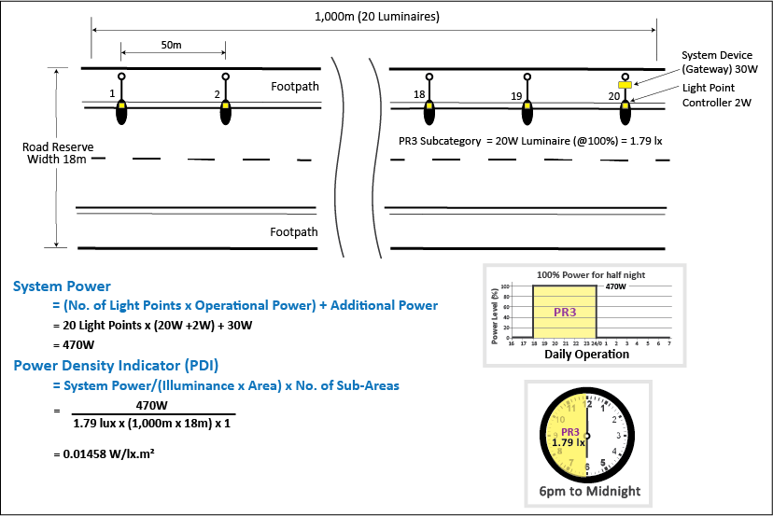

Figure 3 PR3 State Operation 100% Power (note that the actual total hours of operation will vary across the year due to variations in sunrise and sunset, with increased opportunities for savings in the winter months).

## PR5 State Operation (50% power)

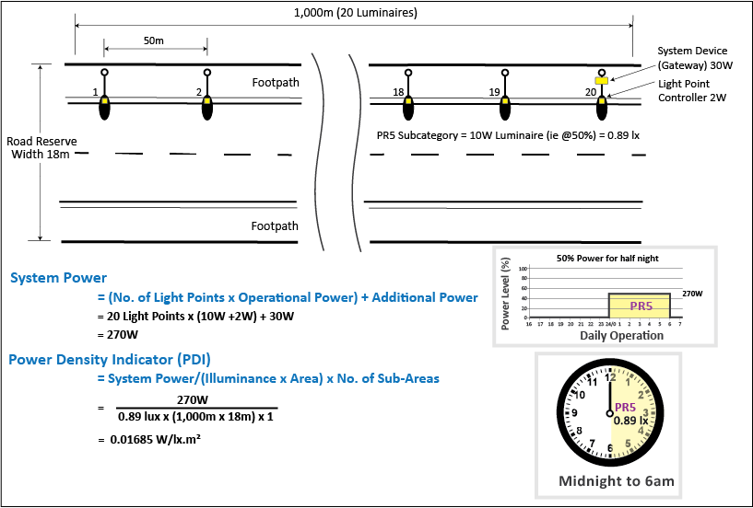

Figure 4 PR5 State Operation 50% Power

## Overall PDI for Combined PR3 and PR5 Operation

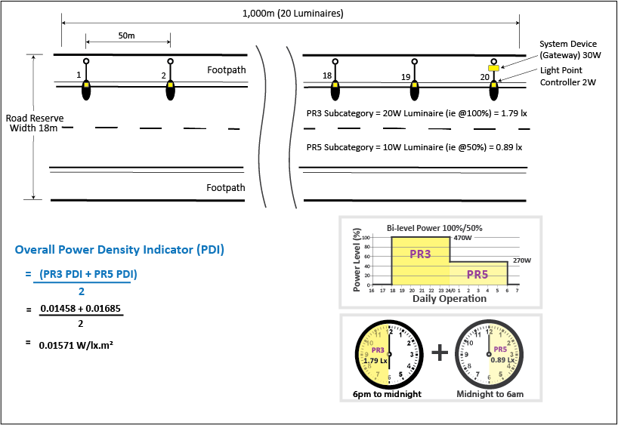

Figure 5 Overall PDI for Combined PR3 and PR5 Operation

## AECI Calculation

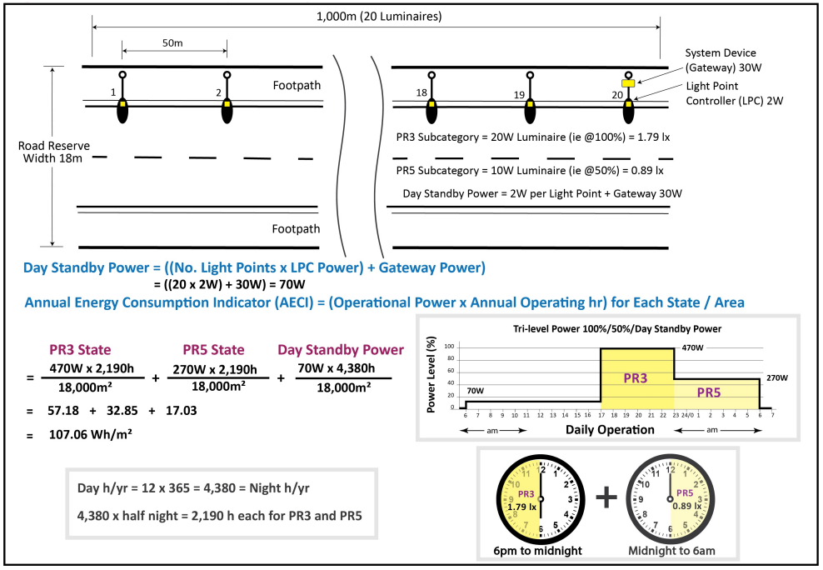

Figure 6 AECI calculation for combined PR3, PR5 Operation and Day standby

## Constant Lighting Output (CLO) Example

All lighting design calculations establish light levels at end of life of the lighting scheme, thus over-lighting to allow for lumen depreciation. CLO corrects that by starting at a lower power and finishing at full power at end of life. System Power is the only energy parameter in the calculation method that changes with CLO. Where CLO is used, System Power uses the average power value over the lifetime of the luminaire.

The example provided in the Appendix F2.5.2 of *AS/NZS 1158.3.1:2020* shows the calculation of PDI for a CLO lighting installation. The only difference caused by the use of CLO in these calculations is in the value of the operational power used for System Power and PDI calculations. It is a simple straight-line average of the power used over the luminaire lifetime as shown in Figure 7.

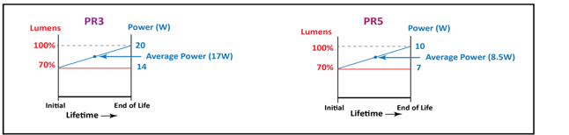

Figure 7 System Power with CLO

# Reporting of Energy Performance Indicators

*AS/NZS 1158.3.1:2020* provides general information on energy performance reporting.

PDI and AECI are compound parameters and should reported together, along with the calculation input parameter values and lighting scheme application assumptions. Graphical representation of the operational profile is an effective means of presentation.

The worked example shown in Figure 9 below provides an example of a possible format for reporting. This format is adapted from *EN 13201-5:2015*, with modifications for AS/NZS terminology. The table can extend to accommodate additional luminaires, sub-areas or time periods if needed. This example table extends beyond the PDI and AECI energy calculations to include:

* the purchased electricity generation emission factor (Scope 2) applicable to the illuminated area (NSW, ACT, QLD emission factor example shown);
* the calculated annual operational emissions per square metre (kg CO2-e.m-2) and;
* the absolute emissions (kg CO2-e), for the illuminated area concerned.

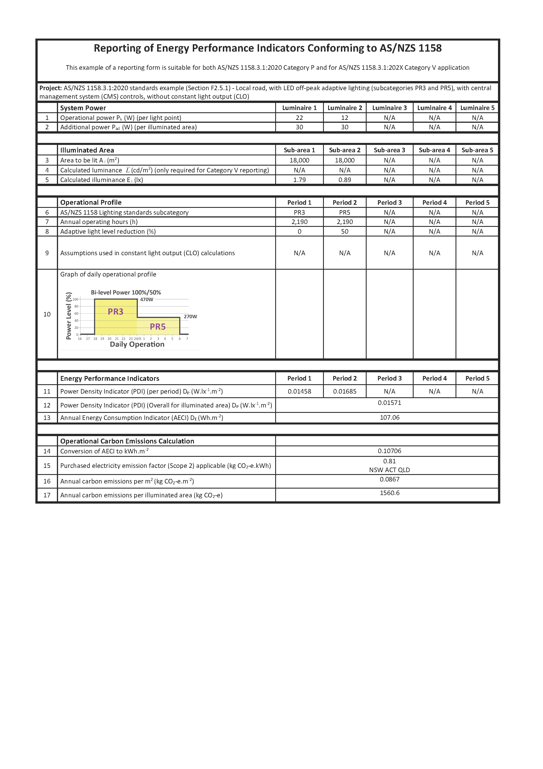

Figure 8 Possible format for reporting of energy performance indicators

The report in Figure 9 is for a worked example without CLO. Figure 9 below shows a report excerpt for the same example, but with CLO. This is an example of information regarding assumptions about the luminaire power values used in CLO calculations.

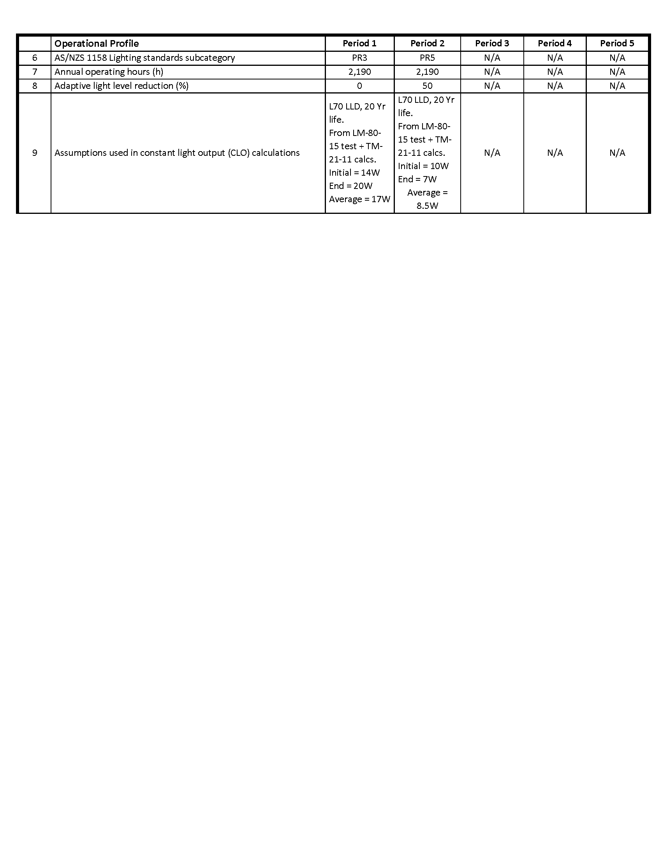

Figure 9 Reporting example with assumptions for CLO

# Software for Energy Performance Calculation and Reporting

Self-developed Excel spreadsheet calculation methods for PDI and AECI are satisfactory for energy performance analysis using data inputs from lighting design calculations. However, there is a lack of a seamless link between the lighting design software and the energy performance calculation spreadsheet. This means that the iterative optimisation processes can be cumbersome owing to the need for manual data transfer from the lighting design calculations to the energy performance calculations.

Local suppliers of commercial lighting design calculation software have all signalled the intention of incorporating AS/NZS 1158 energy performance indicator calculation and reporting into their product functionality. The actual availability is very limited at present.

The major European lighting design software packages all include integrated energy performance indicator calculation and reporting. This is in accord with European standard *EN 13201-5:2015* *Road lighting - Part 5: Energy performance indicators.* Local software suppliers are likely to follow in due course with integrated energy performance indicator calculation and reporting for AS/NZS 1158 Parts 3.1 and 1.1.

# Summary

Standardised Energy Performance Indicator metrics enable designers, suppliers, operators and owners to use calculated energy and carbon key performance indicators (KPI’s) for:

* Lighting design tuning to iterate lighting equipment choices and design parameters to maximise the savings of energy, carbon and money;
* evidence-based evaluation and ranking of energy and carbon emission performance in public lighting procurement tenders;
* auditing, benchmarking and continuously improving existing public lighting schemes.

Standardised carbon accounting conventions and reporting methods facilitate evidence-based comparable reporting to:

* Meet any obligatory user-organisation carbon emissions targets;
* meet any voluntary user-organisation carbon emissions targets;
* support supplier performance claims in commercial marketing and promotion.

# Further Information

For further information on efficient street lighting see the Institute of Public Works Engineering Australasia (IPWEA) Street Lighting and Smart Controls (SLSC) website – Access [here](https://www.slsc.org.au/home)

To purchase the AS/NZS 1158.3.1:2020 standard, see the following websites:

* **Standards Australia** - Access [here](https://www.techstreet.com/standards/as-nzs-1158-3-1-2020?product_id=2104204)
* **SAI Global** - Access [here](https://infostore.saiglobal.com/en-au/standards/AS-NZS-1158-3-1-2020-117844_SAIG_AS_AS_2808804/)
* **Standards New Zealand** - Access [here](https://shop.standards.govt.nz/catalog/1158.3.1%3A2020%28AS%7CNZS%29/view)

The updated AS/NZS 1158.1.1:2020 Category V lighting standard should be available from the same sources in early 2021.

For reference, the European Standard *BS EN 13201-5:2015 Road lighting. Energy performance indicators* is the model for the AS/NZS energy performance methods.

To purchase the BS EN 13201-5:2015 standard, see the following websites:

* **SAI Global** – Access [here](https://infostore.saiglobal.com/en-us/standards/bs-en-13201-5-2015-287407_saig_bsi_bsi_665423/)
* **Standards New Zealand** - Access [here](https://shop.standards.govt.nz/catalog/13201-5%3A2015%28BS+EN%29/view)

# List of Acronyms

AECI – Annual Energy Consumption Indicator

ANSI – American National Standards Institute

BS – British Standard

BSI – British Standards Institution

CEN - European Committee for Standardization

CIE – International Commission on Illumination

CLO – Constant Light Output

CMS - Central Management System

DISER - Department of Industry, Science, Energy and Resources

EN – European Standard

IEC – International Electrotechnical Commission

IESANZ - Illuminating Engineering Society of Australia and New Zealand

IESNA – Illuminating Engineering Society of North America

IPWEA - Institute of Public Works Engineering Australasia

ISO – International Organization for Standardization

LLD – Lightsource Lumen Depreciation

LTP – Light Technical Parameter

NEMA – National Electrical Manufacturers Association

PDI – Power Density Indicator

SA – Standards Australia

SLSC - Street Lighting and Smart Controls

SNZ – Standards New Zealand