The Equipment Energy Efficiency (E3) Program is a multi-jurisdictional initiative delivering a single, integrated approach to energy efficiency standards and energy labelling for new household and business equipment and appliances sold into the Australian and New Zealand markets. The E3 Program operationalises the Inter-Governmental Agreement (IGA) for the Greenhouse and Energy Minimum Standards (GEMS) Act 2012. Its objective is to increase the energy efficiency of new appliances and equipment sold in Australian and New Zealand, thereby reducing energy consumption and associated greenhouse gas emissions.
Setting priorities for the E3 Program is critical to ensuring opportunities to save energy, reduce emissions and lower energy costs for households and business, are realised as soon as possible. Evidence-based prioritisation of opportunities provides a basis for planning and resource allocation.
The 2019 independent review of the GEMS Act recommended a prioritisation process be implemented, to ensure activities that provide the greatest benefit are actioned first.
The E3 Prioritisation Plan for 2021-2022 has been developed to support this by prioritising products and focusing resources on a smaller number of higher-value policies so they can be delivered earlier.
How this was developed?
The Plan shortlists 34 products/projects and identifies 26 of these as ‘top priority’ and 8 as ‘medium term’ priority.
- The top priority items include projects which are currently underway, comprising 10 determinations that are due to expire (sunset) in the next 4 years.
- There are 13 possible new products/projects – 5 prioritised as ‘top priority’ and 8 as ‘medium term’. For each of these new products, the plan sets out a brief rationale for their inclusion, based on research commissioned by E3.
- In addition to this, there is work underway to update administrative and other elements of the GEMS Act in light of the GEMS Act Review and the need to take into account emerging technology and product development.
The prioritisation table at Attachment A will influence development of the detailed E3 work program, taking into account current projects, regulatory reform efforts, the resources allocated to the E3 Program, and stakeholder views. The items listed are at various stages of development – from preliminary investigation to Ministerial approval and implementation. Their inclusion does not imply all products will be regulated immediately (or at all). The E3 Program will target policy development to deliver outcomes consistent with program objectives – energy and emissions reductions – and further investigation will inform advice to Energy Ministers on next steps.
Sunsetting of GEMS Determinations
It is standard process for determinations to automatically sunset 10 years after registration on the Federal Register of Legislation, unless a review finds sufficient reason for the determination to continue. The review process for sunsetting determinations includes public consultation, to help decide whether to:
- allow the determination to sunset
- remake the determination with minimal changes
- undertake a new regulation impact statement process to test different regulatory requirements.
E3 Program Processes
The regulatory development process comprises several steps and can vary depending on the:
- complexity of the product category
- scope of products
- complexity of regulating the product
- estimated impact on industry.

Figure 1 shows the product developmental process stages to deliver a regulatory E3 project. This assumes activity or decision points are not repeated as a result of feedback. Non-regulatory projects (for example, research and development of consumer tools, voluntary certification schemes, website improvements, voluntary guidance and education campaigns) would be subject to different processes following Stage 2 below.

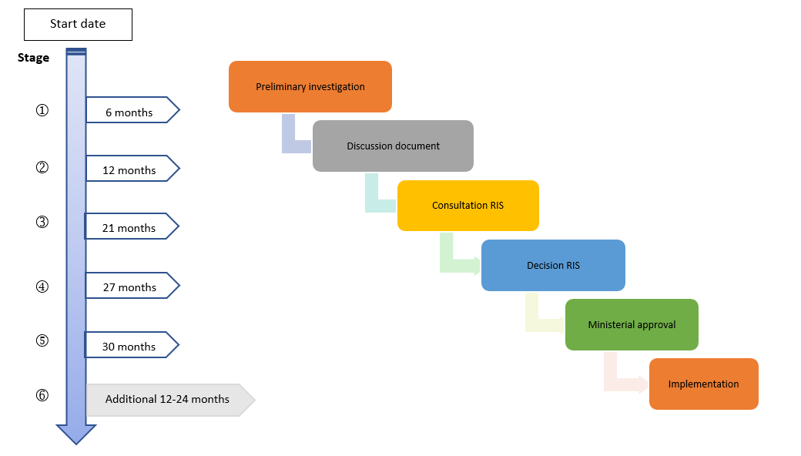
Figure 1: Approximate regulatory development stages and timing

This Prioritisation Plan was developed by the E3 Committee. If you have any questions please contact the Energy Efficiency Secretariat: EnergyEfficiencySecretariat@industry.gov.au.

E3 Prioritisation | Category | Product/Project | Product Development Stage# | Lead Agency
 |  |  | (Due date for sunsetting)
Top priority – Current / new E3 products/projects
Immediate attention will focus on these work streams | Sunsetting Products | Ballasts for fluorescent lamps | 1 (1 April 2023) | Cth - DISER
 |  | Close control air conditioners | 1 (1 April 2023) | Cth - DISER
 |  | Distribution transformers  - Regulation Impact Statement 2022. | 2 (1 April 2023) | State - Vic
 |  | Electric Water Heaters | 1 (1 April 2023) | Cth - DISER
 |  | Liquid chilling packages (‘chillers’)  - Decision Regulation Impact Statement 2022 | 4 (1 April 2023) | Cth DISER
 |  | Transformers and converters for ELV lamps | 1 (1 April 2023) | Cth - DISER
 |  | Computers | 1 (1 October 2023) | Cth - DISER
 |  | Televisions  - Regulation Impact Statement 2022 | 2 (1 October 2023) | Cth - DISER
 |  | Computer monitors  - Regulation Impact Statement 2022. | 2 (1 October 2024) | Cth - DISER
 |  | External power supplies | 1 (1 April 2025) | Cth - DISER
 | Residential, Commercial/  Industrial (Other) | Household fridges and freezers  - Determination entered into force on 15 August 2021. | 6 | Cth - DISER
 |  | Clothes washers, clothes dryers and dishwashers  - New determinations citing new standards to be progressed in 2022. | 6 | Cth - DISER
 |  | Swimming Pool Pumps (Australia only)  - Determination enters into force on 1 October 2022. | 6 | Cth - DISER
 |  | Incandescent & Halogen phase-out & LED Lamp MEPS  - Drafting, consultation and approval of determinations (new for LED MEPS; updated for Halogen and incandescent) will be progressed in 2022. | 5 | Cth - DISER
 |  | Residential space heating | 2 | Cth - DISER
 |  | Hot Water Project - Residential water heating  - Information and tools for consumers. | 2 | NZ
 |  | Residential cooking equipment (ovens, cooktops, rangehoods)  - Regulation Impact Statement 2022. | 2 | State - NSW
 |  | Industrial Products (pumps, air compressors, industrial boilers)  - Cost benefit analysis carried out. Further investigation into these industrial products will be carried out in 2022. | 2 | Cth - DISER
 |  | Electric motors  - Regulation Impact Statement 2022. | 2 | NZ
 |  | Commercial ice makers  - Regulation Impact Statement 2022. | 2 | State - NSW
 |  | Commercial catering equipment (Dishwashers, Deep fryers, Ovens, Food holding cabinets)  - Regulation Impact Statement 2022. | 2 | State - NSW
 |  | Battery Chargers, External and Uninterruptible Power Supplies, and LED Drivers  - Investigate possible alignment with international regulations, i.e. the United States are revising standards for battery chargers, uninterruptible power supplies and wireless chargers.  - There is considerable potential for energy savings from battery charging products, external power supplies, uninterruptible power supplies and LED Drivers. | 1 | Cth - DISER
 |  | Network standby and small network equipment  - Investigate possible adoption of European regulations as these devices consume significant power 24 hours per day, even when not required by users. | 1 | Cth - DISER
 |  | Heat Pump Water Heaters  - Investigate potential options to develop MEPS and/or labelling for heat pump water heaters. | 1 | Cth - DISER
 | Facilitation | GEMS Legislative Review  - Changes to the GEMS Act may be required to progress the response to the Review of the GEMS Act. | Government considering response | Cth - DISER
 |  | Omnibus Regulatory Reform Bill  - The Regulator Performance Omnibus Bill 2022 includes proposed amendments to the GEMS Act, to streamline administration and reduce burden on business. | Bill introduced | Cth - DISER
Medium term priority (1-3 years)
Preliminary development and scoping work has commenced / will commence for these work streams in 2021-22  The E3 Program also remains committed to ongoing work as it develops future work plans | Residential, Commercial/  Industrial | Cool rooms  - Investigate United States regulations and European Union proposals for cool rooms and potentially the refrigeration compressor / condenser units that supply them.  - The energy costs for cool rooms is significant and there is opportunity to potentially reduce those costs. | 1 | Cth - DISER
 |  | Lighting equipment (including products not yet regulated, plus some existing products)  - Investigate developments in lighting equipment regulation in Europe.  - Potential energy savings are significant for lighting products not yet regulated and revisions for some products currently regulated, meriting further investigation for Australia and New Zealand. | 1 | Cth - DISER
 |  | Electric Vehicles (EV) Charging Smartness and Efficiency  - Investigate existing regulations overseas for possible options in regulatory and non-regulatory standards for electric vehicle chargers.  - New Zealand is currently leading a project to identify electric vehicle charging smartness, which will have the potential for significant energy savings. | 2 | NZ
 |  | Local regulatory instruments for Demand Response  - Investigate alternative options to deliver the November 2019 Australian Energy Ministers decision to require demand response capabilities for smart appliances.  - Implementation of the Australian Energy Ministers decision is pending changes to the GEMS Act in light of the GEMS Act review. | 1 | State - SA
 | Facilitation | Energy Rating Label (ERL) information online  - With increases in online purchasing, investigate potential benefits of providing ERL information on products online.  - ERL information in online environments and advertising media will enable consumers to make more informed decisions. | 1 | Cth - DISER
 |  | Fans certification scheme  - Investigate a possible scheme either regulatory or non-regulatory for the certification of fans.  - This is because there are potentially significant energy savings available from the implementation of an energy efficiency scheme for fans. | 1 | Cth - DISER
 | Building Products | Bulk insulation  - Investigate international compliance mechanisms to regulate bulk insulation materials to ensure they are performing as rated, i.e. that their R-value performs as claimed.  - Regulation of bulk insulation has the potential to deliver significant energy savings. | 1 | Cth - DISER
 | Other | Motor vehicle tyres  - Investigate opportunities to leverage the European approach, as there are many products common to both markets.  - Motor vehicle tyres represent a significant energy savings opportunity. | 1 | Cth - DISER
#Product Development Stage: 1. Preliminary investigation; 2. Discussion document; 3. Consultation RIS; 4. Decision RIS; 5. Ministerial approval; 6. Implementation
Key: | Cth- DISER | New Zealand | State – NSW | State - Vic | State - SA | New products/projects
Total projects | 26 | 3 | 3 | 1 | 1 | Current products/projects

